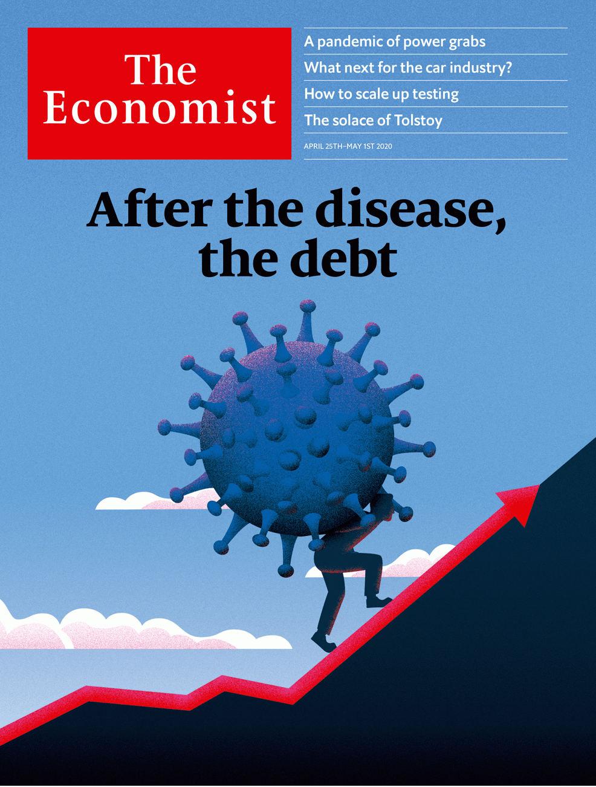

# Table of Contents

The world this week

Politics this week

Business this week

KAL’s cartoon

Leaders

Government finances: After the disease, the debt

Government under covid-19: A pandemic of power grabs

Migrants and the virus: Essential workers

Carmakers in trouble: Pimp the ride

Climate change: An Earth Day in the life of a plague

Letters

Letters to the editor: On wet markets, Thailand, abortion, covid-19, house names, management

By Invitation

The world after covid-19: Bill Gates on how to fight future pandemics

Briefing

Covid-19 and public finances: Undercut

The crisis in carmaking: From 60 to zero

Better batteries: Charging up for a long ride

United States

Reopening America: Stir craziness

Environmental regulation: Mercury rising

Biodefence: Spore wars

The Hua-war: Some body to hold

Catholic voters: Cathechismic

Lexington: The limits of energy independence

The Americas

Argentina: The Peronist and the pandemic

Bolivian wine: High varietals

Bello: Cuba on the edge

Asia

When the epidemic is over: A process of elimination

Moonshine in Sri Lanka: Worth a shot

India on lockdown: Impossible sums

Ignoring covid-19 in Central Asia: What pandemic?

Banyan: Fin pickings

China

Politics in Hong Kong: The long arm of Beijing

Table manners: Safer ways to use chopsticks

Chaguan: When children say #MeToo

Middle East and Africa

The Gulf’s outbreak: Covid in the camps

Israeli politics: Bibi wins again

Food distribution: The race to feed Africa

Abba Kyari: The parable of the bag of cash

Europe

Germany and covid-19: Top of the class?

A French conundrum: Rush-hour running

Turkey, refugees and covid-19: A crisis within a crisis

NATO in Europe: Yankees go home

Charlemagne: Testing the faith

Britain

The BBC’s future: The next episode

Politics: Jolly difficult

The price isn’t right: Not just a problem for economists

Covid communities: Neighbourhood watch

Food and the economy: Pret A Ouvrir

Freemasons: Out of the shadows

Bagehot: Back to abnormal

International

Covid-19 and autocracy: Protection racket

Business

Corporate innovation: Crucible of creative disruption

Facebook in India: Jiostrategic

Television: Medium and message

The data economy: Tear down this wall

Bartleby: Play’s the thing

Schumpeter: Minting it

Finance and economics

Hedge funds: Back in the game

Risk parity: Under the weather

Commodities: Tick tock

Financial technology: Virtually money

Buttonwood: Hard money

Free exchange: Tough love

Schools brief

Tackling climate change: The challenge without precedent

Science and technology

Covid-19: Tests of reason

Pandemics past and present: A lesson from history

Books and arts

The solace of Tolstoy: Unhappy in the same way

Power in Russia: Made men

Coffee and capitalism: The big grind

Dutch fiction: Cold comfort farm

Home Entertainment: “The Shining” is perfect quarantine viewing

Home Entertainment: Try painting in watercolours

Perspectives: How previous contagions changed cities

Economic and financial indicators

Economic data, commodities and markets

Graphic detail

Vulnerability to covid-19: Dixie in the crosshairs

Obituary

John Conway: The game of maths



### Friday, April 24, 2020

|  |  |
| --- | --- |
| The world this week | 3 |
| Leaders | 5 |
| Letters | 1 |
| By Invitation | 1 |
| Briefing | 3 |
| United States | 6 |
| The Americas | 3 |
| Asia | 5 |
| China | 3 |
| Middle East and Africa | 4 |
| Europe | 5 |
| Britain | 7 |
| International | 1 |
| Business | 6 |
| Finance and economics | 6 |
| Schools brief | 1 |
| Science and technology | 2 |
| Books and arts | 7 |
| Economic and financial indicators | 1 |
| Graphic detail | 1 |
| Obituary | 1 |

|  |  |  |
| --- | --- | --- |
|  | Sections | Leaders |

The world this week

Politics this week

.

Business this week

.

KAL’s cartoon

.

|  |  |  |
| --- | --- | --- |
|  | Sections | Leaders |

|  |  |  |  |
| --- | --- | --- | --- |
|  | Articles | Sections | Next |

# Politics this week

Apr 23rd 2020 |

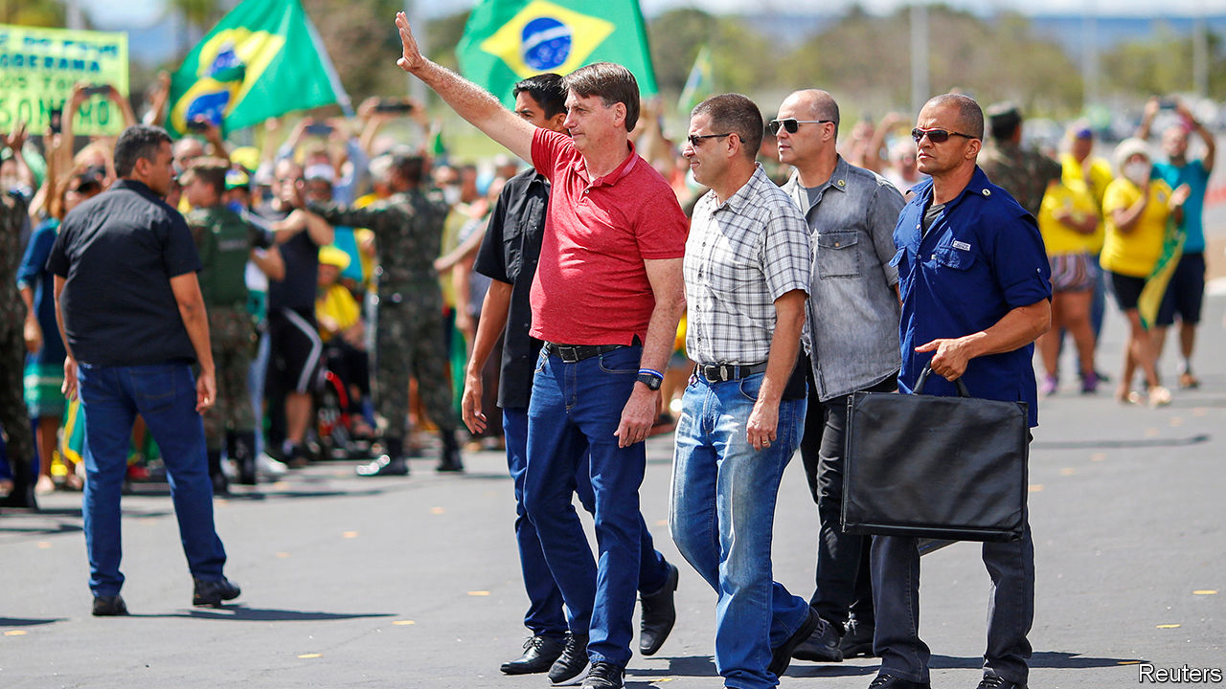

Brazil’s president, Jair Bolsonaro, who has dismissed covid-19 as “sniffles”, spoke outside the army’s headquarters at a rally against lockdowns. Some of the protesters called for a shutdown of Congress and the Supreme Court and urged the army to take control of the pandemic response. Mr Bolsonaro has said: “Really, I am the constitution.” He also sacked a health minister who supported lockdowns and replaced him with one who favours a return to business-as-usual “as quickly as possible”.

Sporadic protests broke out in several American state capitals against lockdown measures. Some states took steps to reopen businesses. Georgia’s governor went as far as allowing cinemas and restaurants to resume service from April 27th, subject to social-distancing rules. President Donald Trump said he disagreed with this “totally egregious” decision. See [article](https://www.economist.com/node/21784514).

Spain followed France and Britain in extending its lockdown, the toughest in Europe, until at least May 9th. However, it slightly relaxed the rules, so that people can leave home for brief exercise.

A man dressed as a royal Canadian mounted policeman murdered at least 22 people in a shooting spree in Nova Scotia. The killer was a denture-maker said to be obsessed with the federal police. A member of that force eventually killed him. It was the worst mass shooting in Canada’s history.

Argentina’s government asked creditors to accept big losses in the value of the bonds they hold. It proposed that those who hold $65bn-worth of paper, nearly 40% of foreign-currency debt, accept sharply lower interest payments and wait three years to receive them. The plan was rejected. See [article](https://www.economist.com/node/21784571).

China tightened controls on movement in the north-eastern city of Harbin, the capital of Heilongjiang province, to keep covid-19 in check. Heilongjiang borders Russia, where the disease appears far more rampant than in China.

China announced the establishment of two districts within a municipality that it says has jurisdiction over the South China Sea. The districts are called Xisha and Nansha, the Chinese words for the Paracel and the Spratly islands. Vietnam, which also claims the Paracels, expressed outrage.

Police in Hong Kong arrested 15 well-known pro-democracy activists. China blew a hole in Hong Kong’s Basic Law, a mini-constitution that protects Hong Kongers’ freedoms. Its Liaison Office in Hong Kong said it was not bound by a provision that bars the mainland’s government departments from interfering in Hong Kong’s affairs. See [article](https://www.economist.com/node/21784556).

Kim Jong Un, North Korea’s dictator, missed an annual ceremony to commemorate the birthday of his grandfather, who was North Korea’s first president, prompting speculation that he is ill.

Data on burials suggested that there have been many more deaths from covid-19 in Jakarta, Indonesia’s capital, than have been officially recorded. The Indonesian government reversed itself and banned migrant workers from returning to their home villages to celebrate the end of Ramadan in May. It fears the massive annual migration would accelerate the spread of the disease across the archipelago.

After three elections in a year, Israel at last has a new government. Binyamin Netanyahu, the prime minister, made a deal with Benny Gantz, the former opposition leader, which will see Mr Netanyahu stay in office for 18 months. Then Mr Gantz will take over. Both men were under pressure to avoid another election and co-operate to tackle covid-19. See [article](https://www.economist.com/middle-east-and-africa/2020/04/25/israel-has-a-new-government-at-last).

Donald Trump told the American navy to “shoot down [sic] and destroy any and all Iranian gunboats if they harass our ships at sea.” America recently reported that 11 vessels from Iran’s Revolutionary Guards Corps came close to American ships in what it described as “dangerous” manoeuvres.

Reports emerged of a massacre by jihadist rebels in northern Mozambique. Dozens of villagers were shot or beheaded after refusing to join the group. The insurgents have reportedly also killed 20-30 members of the security forces.

The UN warned that millions of people in Africa face an increased risk of famine because of the economic dislocation caused by covid-19. Many were already in need of food or cash aid because of drought in places such as Zimbabwe and locusts in Kenya. See [article](https://www.economist.com/middle-east-and-africa/2020/04/25/the-race-to-feed-africa-during-a-pandemic).

Donald Trump suspended for at least 60 days the provision of green cards to people who are immigrating legally to the United States. He said he was doing this to protect American workers from foreign competition during the crisis, but he backed away from stopping visas for guest workers after businesses complained that they would suffer.

NASA set May 27th as the date for the first launch of “American astronauts on American rockets from American soil” since the end of the space- shuttle programme. The vessel has been built by Space X, one of Elon Musk’s companies. Since 2011 Americans travelling to the International Space Station have had to hitch a ride on Russian rockets.

## Coronavirus briefs

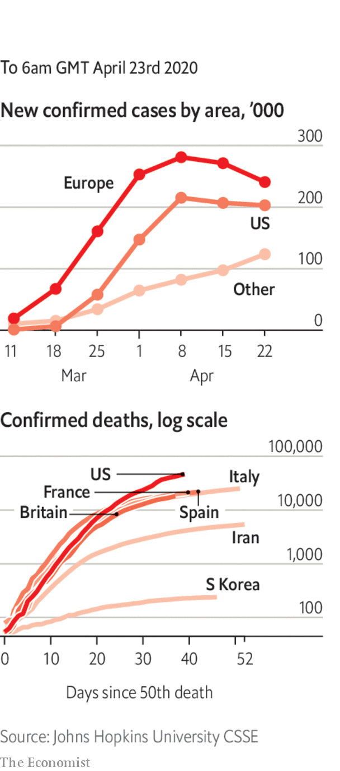

Officials in Wuhan, the Chinese city where covid-19 was first detected, raised the death toll there by 50%, to 3,869. The true extent of the outbreak in China remains unclear.

Having thought it had contained the spread of the disease, Singapore reported a spike in infections, mostly among migrant workers.

The port city of Guayaquil, Ecuador’s commercial hub, was overwhelmed with deaths from covid-19. Many corpses have been left in the streets.

Chile said it would issue immunity cards to people who have recovered.

Nearly 1,100 sailors aboard the Charles de Gaulle, a French aircraft-carrier, tested positive.

The German state of Bavaria cancelled the Oktoberfest beer festival. The mayor of Munich supported the decision, but said it was still a bitter blow.

This article was downloaded by calibre from <https://www.economist.com/the-world-this-week/2020/04/23/politics-this-week>

|  |  |  |  |
| --- | --- | --- | --- |
|  | Articles | Sections | Next |

|  |  |  |  |
| --- | --- | --- | --- |
| Previous | Articles | Sections | Next |

# Business this week

Apr 23rd 2020 |

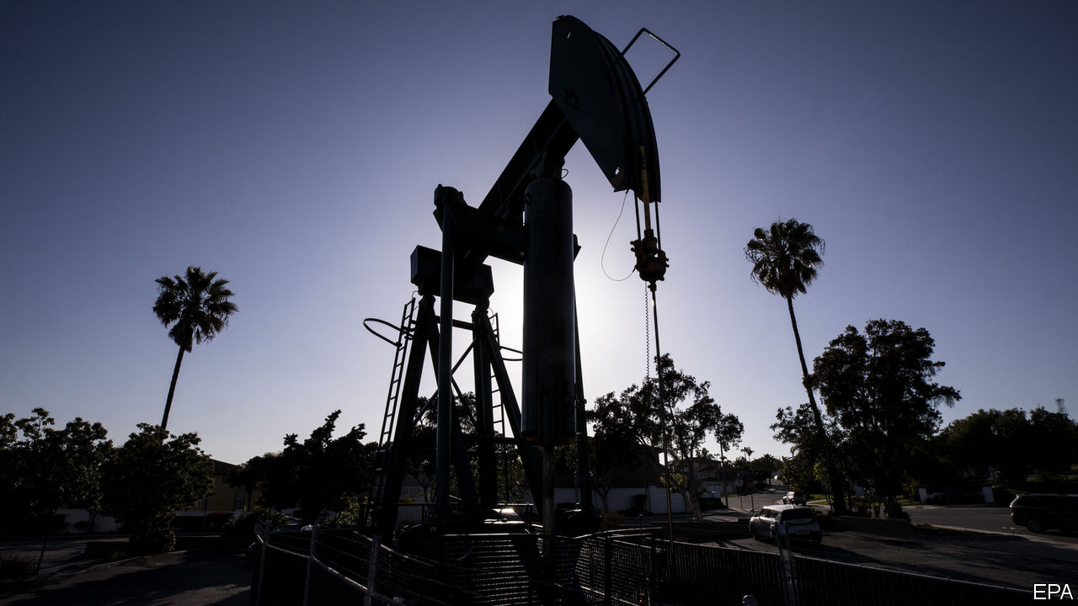

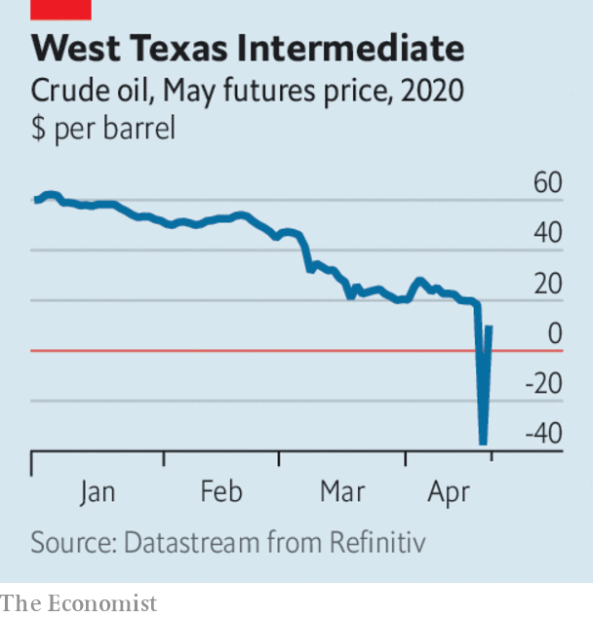

Oil prices tanked amid forecasts that demand will tumble this year. Brent crude dropped below $16.50 a barrel, a two-decade low. May contracts for West Texas Intermediate, the benchmark for American oil, fell into negative territory for the first time, plunging at one point to -$40 a barrel, meaning traders in effect paid for someone else to hold the commodity. Concern that storage facilities at a key delivery point were full, just as the contracts were due to be settled, added to the panic. Prices surged later in the week after Donald Trump stoked tensions with Iran. See article.

Baker Hughes, one of the world’s biggest providers of oilfield services, recorded a $10bn quarterly loss, in part because it has had to write down the value of its assets.

## Puff goes the dragon

China’s GDP shrank by 6.8% in the first quarter, year on year, the first contraction in decades. The economy is expected to pick up later this year, though not enough to meet the government’s ambitions. China’s untrammelled growth since the end of the Mao era has boosted countless global industries. Many hope that the quarter’s decline is just a pause, not an end, to the boom.

The news about the Chinese economy did not stop BHP and Rio Tinto, the world’s two biggest mining companies, from giving upbeat assessments about their business in China. BHP noted that most industrial activity had restarted there and that if a second wave of infections was avoided, steel production could rise this year.

Alibaba, China’s biggest e-commerce company, said it would invest 200bn yuan ($28bn) in cloud computing over the next three years. Alibaba faces fierce competition over cloud services in its home market, and is eager to challenge Amazon and Microsoft in international markets.

Cyril Ramaphosa, South Africa’s president, announced a huge stimulus package worth 500bn rand ($26bn) to shore up the economy, which was already struggling before covid-19, and fell into recession late last year. Millions of people rely on informal work to make ends meet, which has been made harder by a strict lockdown enforced by the army. The government has turned to the IMF and other global institutions for emergency health-care funding.

Legislation to provide more than $300bn in additional aid to small businesses wound its way through Congress. The money earmarked for firms to retain workers in the recent $2trn stimulus act has already run out amid huge demand.

Facebook invested $5.7bn in Jio Platforms, a telecoms and tech firm that is part of the Reliance Industries empire in India, giving it a stake of 10%. Over the past five years, 560m people in India have gained access to the internet. Facebook wants to tap that potential, noting the opportunity for connecting Jio’s small-business service with WhatsApp so that shoppers can have “a seamless mobile experience”. See [article](https://www.economist.com/business/2020/04/25/facebook-bets-on-a-different-sort-of-e-commerce-in-india).

Revenue at Huawei rose by 1.4% in the first quarter compared with the same three months last year, to 182bn yuan ($25.7bn). That was fairly impressive given the trade war and the outbreak of covid-19 in China, the telecoms-equipment maker’s base country, though it was far below the 39% growth it chalked up a year earlier. The pandemic has delayed the roll-out of 5G networks in many countries, a key and controversial element of Huawei’s business. The company, which is privately held, did not state a net profit.

United Airlines raised $1bn in a sale of new shares, a week after securing from the government a direct grant worth $3.5bn and a low-interest loan of $1.5bn in a rescue deal.

After the British Treasury reportedly asked Virgin Atlantic to re-submit its request for a bail-out, said to be worth £500m ($620m), Sir Richard Branson offered to put his private island in the Caribbean up as collateral in order to secure the funds. His Virgin Group retains a 51% stake in the airline. Meanwhile, Virgin Australia fell into administration after failing to obtain a bail-out in Canberra.

Netflix signed up another 15.8m subscribers in the first quarter, twice as many as it had forecast, as people confined to their homes binged on its programming. Netflix now has 183m users worldwide. Its share price is trading at record highs. One potential hitch is that its production pipeline, the source of recent hits such as “Tiger King”, has ground to a halt because of the lockdowns. See [article](https://www.economist.com/node/21784550).

## Coke isn’t it

Coca-Cola said that despite a solid start to the year, revenue fell in the latest quarter, when lockdowns came into force. For this month, its sales of soft drinks have tumbled by 25%, as restaurants and small stores shut. By contrast Procter & Gamble reported a bumper quarter, boosted by shoppers stockpiling toilet roll, cleaning products and washing powder. However, sales from grooming gear were down a snip.

This article was downloaded by calibre from <https://www.economist.com/the-world-this-week/2020/04/23/business-this-week>

|  |  |  |  |
| --- | --- | --- | --- |
| Previous | Articles | Sections | Next |

|  |  |  |  |
| --- | --- | --- | --- |
| Previous | Articles | Sections | Next |

# KAL’s cartoon

Apr 23rd 2020 |

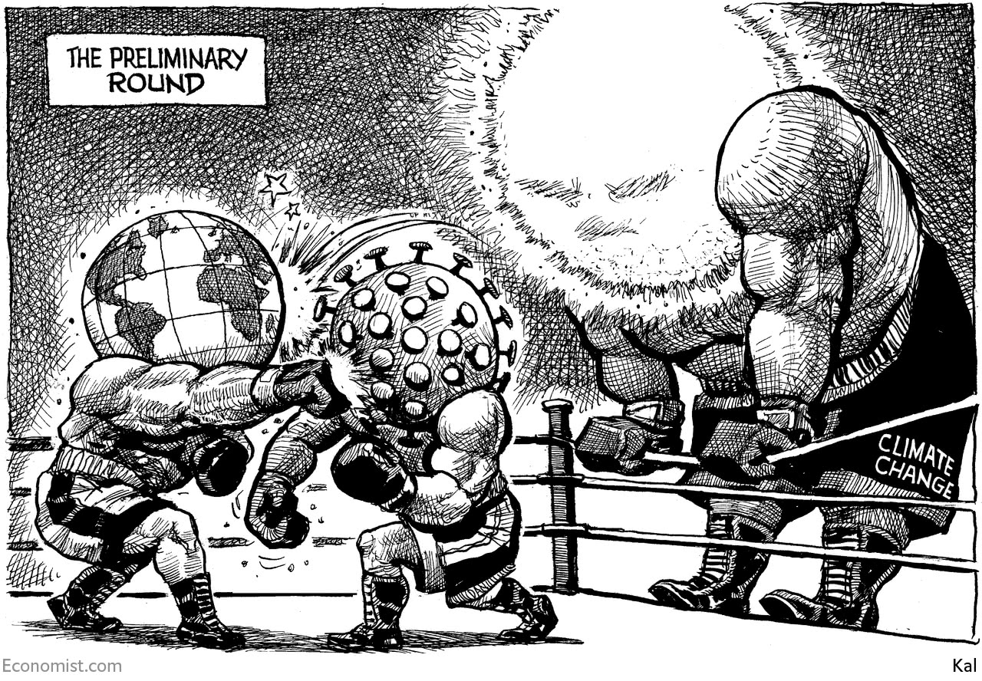

This article was downloaded by calibre from <https://www.economist.com/the-world-this-week/2020/04/23/kals-cartoon>

|  |  |  |  |
| --- | --- | --- | --- |
| Previous | Articles | Sections | Next |

|  |  |  |
| --- | --- | --- |
| The world this week | Sections | Letters |

Leaders

Government finances: After the disease, the debt

.

Government under covid-19: A pandemic of power grabs

.

Migrants and the virus: Essential workers

.

Carmakers in trouble: Pimp the ride

.

Climate change: An Earth Day in the life of a plague

.

|  |  |  |
| --- | --- | --- |
| The world this week | Sections | Letters |

|  |  |  |  |
| --- | --- | --- | --- |
|  | Articles | Sections | Next |

#### Government finances

# After the disease, the debt

To cope with the expensive legacy of the pandemic, governments will have to find the right path between stimulus and restraint

Apr 23rd 2020 |

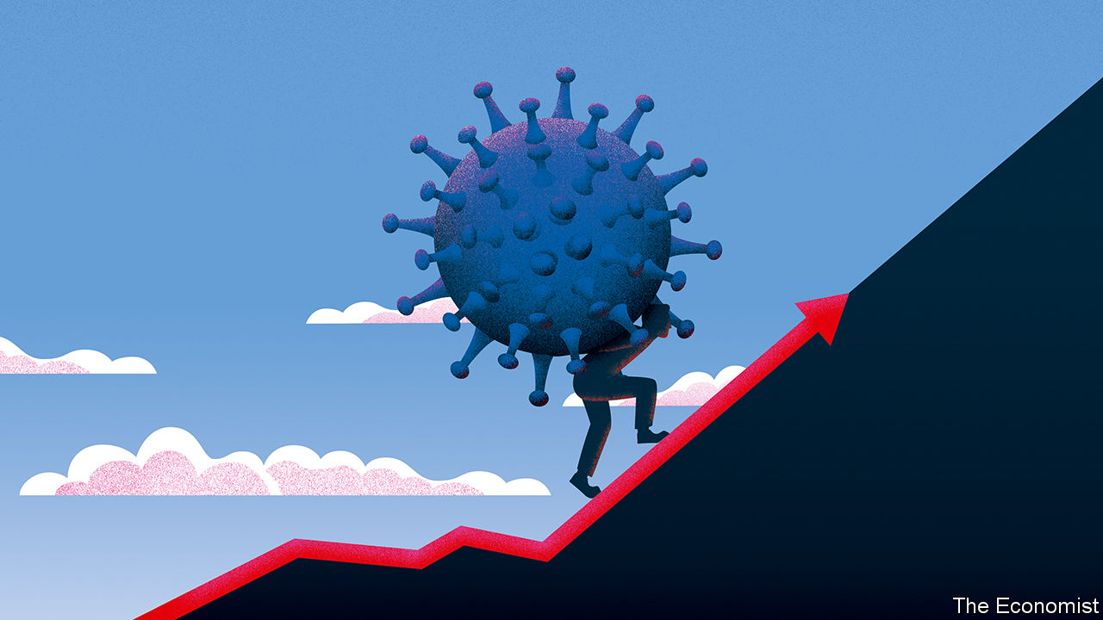

Editor’s note: The Economist is making some of its most important coverage of the covid-19 pandemic freely available to readers of The Economist Today, our daily newsletter. To receive it, register [here](https://www.economist.com/newslettersignup). For our coronavirus tracker and more coverage, see our [hub](https://www.economist.com/coronavirus)

NATIONAL LEADERS like to talk about the struggle against covid-19 as a war. Mostly this is a figure of speech, but in one respect they are right. Public borrowing in the rich world is set to soar to levels last seen amid the rubble and smoke of 1945. As the economy falls into ruins, governments are writing millions of cheques to households and firms in order to help them survive lockdowns. At the same time, with factories, shops and offices shut, tax revenues are collapsing. Long after the covid-19 wards have emptied, countries will be living with the consequences.

An astonishing deterioration in the public finances is unfolding (see article). America’s government is set to run a deficit of 15% of GDP this year—a figure that will go up if more stimulus is needed. Across the rich world, the IMF says gross government debt will rise by $6trn, to $66trn at the end of this year, or from 105% of GDP to 122%—a greater increase than was seen in any year during the global financial crisis. If the lockdowns last longer, the load will be greater. Managing such colossal debts will burden Western societies for decades to come.

Few subjects in economics attract more scaremongering than government borrowing. The national-debt clock ticking near Times Square in New York has warned of imminent fiscal Armageddon since 1989. In fact a country’s public debt is not like a household’s credit-card balance. When the national debt is owned by its citizens, a country in effect owes money to itself. Debt may be high, but what matters is the cost of servicing it and, as long as interest rates are low, this is still cheap. In 2019 America spent 1.8% of GDP on debt interest, less than it did 20 years ago. In 2019 Japan’s gross public debt was already almost 240% of GDP, but there were few signs that it could not be sustained. In countries that print their own money, central banks can hold down interest rates by buying bonds, as they have in recent weeks on an unprecedented scale (the Federal Reserve has bought more Treasuries in five weeks than were issued, on net, in the year to March). Just now there is no risk of inflation, particularly since oil prices have collapsed. Most economists worry less that governments will borrow recklessly, than that they will be too timid because of an irrational fear of rising public debt. Inadequate fiscal support today risks pushing the economy into a spiral of decline.

Yet while spending freely now to avoid a deeper slump is the only sensible path, wild borrowing for years would eventually threaten trouble. America has strong defences against an outright debt crisis, because the dollar is the world’s reserve currency and foreigners want to own its bonds. But other rich countries do not have that luxury. Italy’s towering debt and membership of the euro zone condemn it to live with the perennial threat of a financial panic should the ECB stop buying its bonds.

The good news is that financial markets suggest rates will stay comfortingly low for decades. But so much is still unknown about the virus and its effects that, now of all times, investors cannot see clearly very far into the future. Some economists worry, that once the virus abates, a price-and-interest-rate spiral could get under way as a burst of demand runs up against supply chains that have been wrecked by the pandemic.

Governments will thus have to walk a treacherous path between stimulus today and prudence tomorrow. Success is not guaranteed. After the second world war countries shrank their debts over the course of decades, but only by using a bossy combination of high taxes on capital, financial repression (forcing domestic investors to hold debt at artificially low interest rates) and inflation, which erodes the real value of debts over time. A baby boom and rapidly rising levels of education made it easier for economies to grow their way out of debt. Japan has not faced a bond-market crisis since the 1990s, but its debt-to-GDP ratio has continued to rise. After the financial crisis in 2007-09 some European countries opted for budget cuts in order to cut debts, with mixed results and a big political backlash.

The politics of deficit reduction will be toxic. The pandemic will increase calls for lavish spending, not belt-tightening, especially on medical services. Ageing populations mean that there will be surging demand for pension and health spending in the 2030s and 2040s. It will get more expensive to maintain public services, let alone improve them. Politicians who trim benefits for pensioners will be punished by legions of elderly voters. There will be less spare cash to fight future crises, such as climate change or even another pandemic.

Faced with this daunting reality, rich-world governments will make a big mistake if they succumb to premature and excessive worries about budgets. While they are in the throes of the pandemic, the withdrawal of emergency support would be self-defeating.

Modestly higher inflation would help, by boosting the economy’s nominal growth rate. When this exceeds the interest rate, existing debts shrink relative to GDP over time. Unfortunately, central banks have recently undershot their inflation targets. Over the past ten years the cumulative shortfall in America and the euro zone has been about 5-6%. Central banks should pledge to make up the shortfall with catch-up inflation in the future. This would ease debt burdens without breaking past promises to hew to inflation targets.

And governments should prepare for the grim business of balancing budgets later in the decade. Done right, this would be fairer and more efficient than keeping rates low and letting inflation rip, which would transfer wealth in regressive and arbitrary ways, for example by reducing the debts of recklessly leveraged companies and homeowners. Better to raise taxes on land, inheritance, carbon emissions and, in America, consumption—and at least try to trim spending on the elderly.

## National-debt service

Perhaps interest rates really will stay low while growth rebounds and inflation rises just slightly, easing the burden of debt. More likely is that living with high debts will be a nerve-racking and gruelling slog. Making budgets add up looks as if it will be a defining challenge of the post-covid world—one that today’s politicians have not yet even started to confront.■

Dig deeper:  
For our latest coverage of the covid-19 pandemic, register for The Economist Today, our daily [newsletter](https://www.economist.com/newslettersignup), or visit our [coronavirus tracker and story hub](https://www.economist.com/coronavirus)

This article was downloaded by calibre from <https://www.economist.com/leaders/2020/04/23/after-the-disease-the-debt>

|  |  |  |  |
| --- | --- | --- | --- |
|  | Articles | Sections | Next |

|  |  |  |  |
| --- | --- | --- | --- |
| Previous | Articles | Sections | Next |

#### A pandemic of power grabs

# Autocrats see opportunity in disaster

The world is distracted and the public need saving. It is a strongman’s dream

Apr 23rd 2020 |

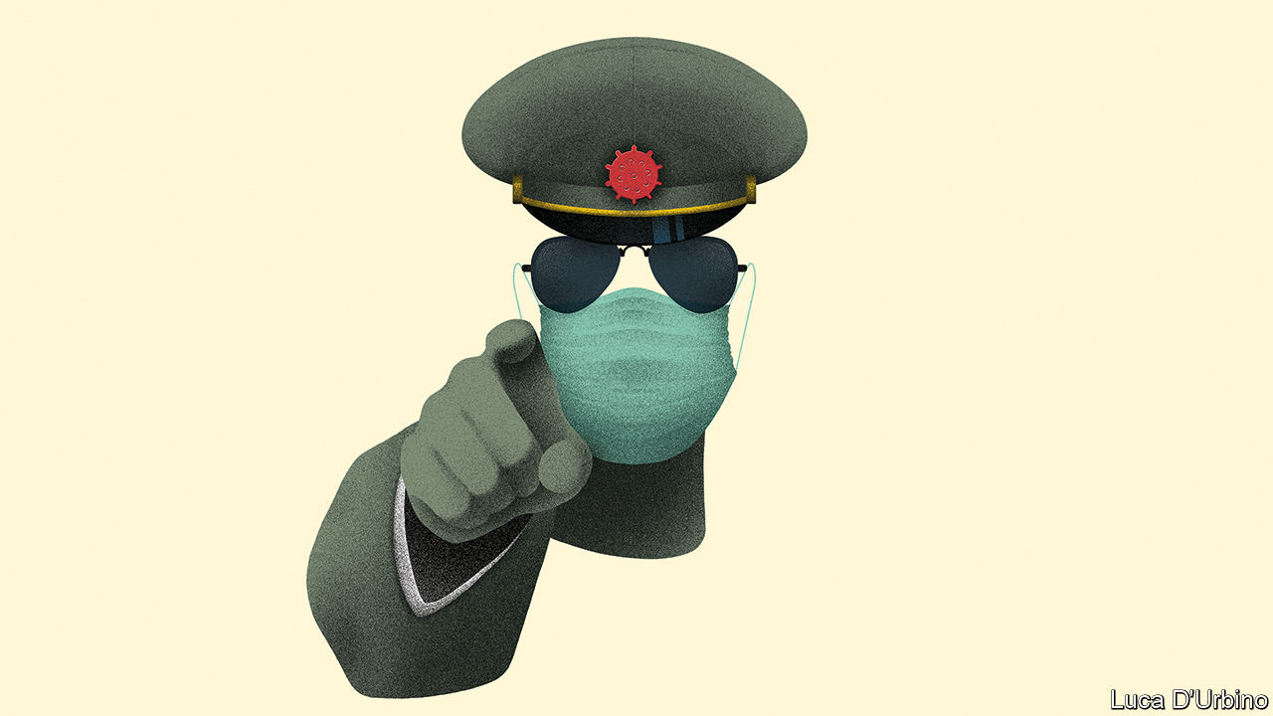

Editor’s note: The Economist is making some of its most important coverage of the covid-19 pandemic freely available to readers of The Economist Today, our daily newsletter. To receive it, register [here](https://www.economist.com/newslettersignup). For our coronavirus tracker and more coverage, see our [hub](https://www.economist.com/coronavirus)

ALL THE world’s attention is on covid-19. Perhaps it was a coincidence that China chose this moment to tighten its control around disputed reefs in the South China Sea, arrest the most prominent democrats in Hong Kong and tear a hole in Hong Kong’s Basic Law (see article). But perhaps not. Rulers everywhere have realised that now is the perfect time to do outrageous things, safe in the knowledge that the rest of the world will barely notice. Many are taking advantage of the pandemic to grab more power for themselves (see article).

China’s actions in Hong Kong are especially troubling. Since Britain handed the territory back to China in 1997, Hong Kong has been governed under the formula of “one country, two systems”. By and large, its people enjoy the benefits of free speech, free assembly and the rule of law. Foreign firms have always felt safe there, which is why Hong Kong is such an important financial hub. But China’s ruling Communist Party has long yearned to crush Hong Kong’s culture of protest. Article 22 of the Basic Law (a kind of mini-constitution) bans Chinese government offices from interfering in Hong Kong’s internal affairs. That was always understood to include its Liaison Office in Hong Kong. But on April 17th the office, China’s main representative body in the territory, said it was not bound by Article 22. This suggests that it plans to step up its campaign to curtail Hong Kong’s freedoms.

Xi Jinping’s incremental power grab in Hong Kong is one of many. All around the world, autocrats and would-be autocrats spy an unprecedented opportunity. Covid-19 is an emergency like no other. Governments need extra tools to cope with it. No fewer than 84 have enacted emergency laws vesting extra powers in the executive. In some cases these powers are necessary to fight the pandemic and will be relinquished when it is over. But in many cases they are not, and won’t be. The places most at risk are those where democracy’s roots are shallow and institutional checks are weak.

Take Hungary, where the prime minister, Viktor Orban, has been eroding checks and balances for a decade. Under a new coronavirus law, he can now rule by decree. He has become, in effect, a dictator, and will remain so until parliament revokes his new powers. Since it is controlled by his party, that may not be for a while. Hungary is a member of the European Union, a club of rich democracies, yet it is acting like Togo or Serbia, whose leaders have just assumed similar powers on the same pretext.

Everywhere people are scared. Many wish to be led to safety. Wannabe strongmen are grabbing coercive tools they have always craved—in order, they say, to protect public health. Large gatherings can be sources of infection; even the most liberal governments are restricting them. Autocrats are delighted to have such a respectable excuse for banning mass protests, which over the past year have rocked India, Russia and whole swathes of Africa and Latin America. The pandemic gives a reason to postpone elections, as in Bolivia, or to press ahead with a vote while the opposition cannot campaign, as in Guinea. Lockdown rules can be selectively enforced. Azerbaijan’s president openly threatens to use them to “isolate” the opposition. Relief cash can be selectively distributed. In Togo you need a voter ID, which opposition supporters who boycotted a recent election tend to lack. Minorities can be scapegoated. India’s ruling party is firing up Hindu support by portraying Muslims as covid-19 vectors.

Fighting the virus requires finding out who is infected, tracing their contacts and quarantining them. That means more invasions of privacy than people would accept in normal times. Democracies with proper safeguards, like South Korea or Norway, will probably not abuse this power much. Regimes like China’s and Russia’s are eagerly deploying high-tech kit to snoop on practically everyone, and they are not alone. Cambodia’s new emergency law places no limits on such surveillance.

False information about the disease can be dangerous. Many regimes are using this truism as an excuse to ban “fake news”, by which they often mean honest criticism. Peddlers of “falsehood” in Zimbabwe now face 20 years in prison. The head of a covid-19 committee under Khalifa Haftar, a Libyan warlord, says: “We consider anyone who criticises to be a traitor.” Jordan, Oman, Yemen and the United Arab Emirates have banned print newspapers, claiming that they might transmit the virus.

Judging by what has already been reported, power grabbers on every continent are exploiting covid-19 to entrench themselves. But with journalists and human-rights activists unable to venture out, nobody knows whether the unreported abuses are worse. How many dissidents have been jailed for “violating quarantine rules”? Of the vast sums being mobilised to tackle the pandemic, how much has been stolen by strongmen and their flunkeys? A recent World Bank study found that big inflows of aid to poor countries coincided with big outflows to offshore havens with secretive shell companies and banks—and that was before autocrats started grabbing covid-related emergency powers. Better checks are needed.

“Right now it is health over liberty,” says Thailand’s autocratic prime minister, Prayuth Chan-ocha. Yet many of the liberty-constricting actions taken by regimes like his are bad for public health. Censorship blocks the flow of information, frustrating an evidence-based response to the virus. It also lets corruption thrive. Partisan enforcement of social distancing destroys the trust in government needed if people are to follow the rules.

## Cruel, but inept

Where does this lead? Covid-19 will make people poorer, sicker and angrier. The coronavirus is impervious to propaganda and the secret police. Even as some leaders exploit the pandemic, their inability to deal with popular suffering will act against the myth that they and their regimes are impregnable. In countries where families are hungry, where baton-happy police enforce lockdowns and where cronies’ pickings from the abuse of office dwindle along with the economy, that may eventually cause some regimes to lose control. For the time being, though, the traffic is in the other direction. Unscrupulous autocrats are exploiting the pandemic to do what they always do: grab power at the expense of the people they govern. ■

Dig deeper:  
For our latest coverage of the covid-19 pandemic, register for The Economist Today, our daily [newsletter](https://www.economist.com/newslettersignup), or visit our [coronavirus tracker and story hub](https://www.economist.com/coronavirus)

This article was downloaded by calibre from <https://www.economist.com/leaders/2020/04/23/autocrats-see-opportunity-in-disaster>

|  |  |  |  |
| --- | --- | --- | --- |
| Previous | Articles | Sections | Next |

|  |  |  |  |
| --- | --- | --- | --- |
| Previous | Articles | Sections | Next |

#### Essential workers

# The Gulf states should take better care of their migrant workers

It is not only humane, it is practical

Apr 25th 2020 |

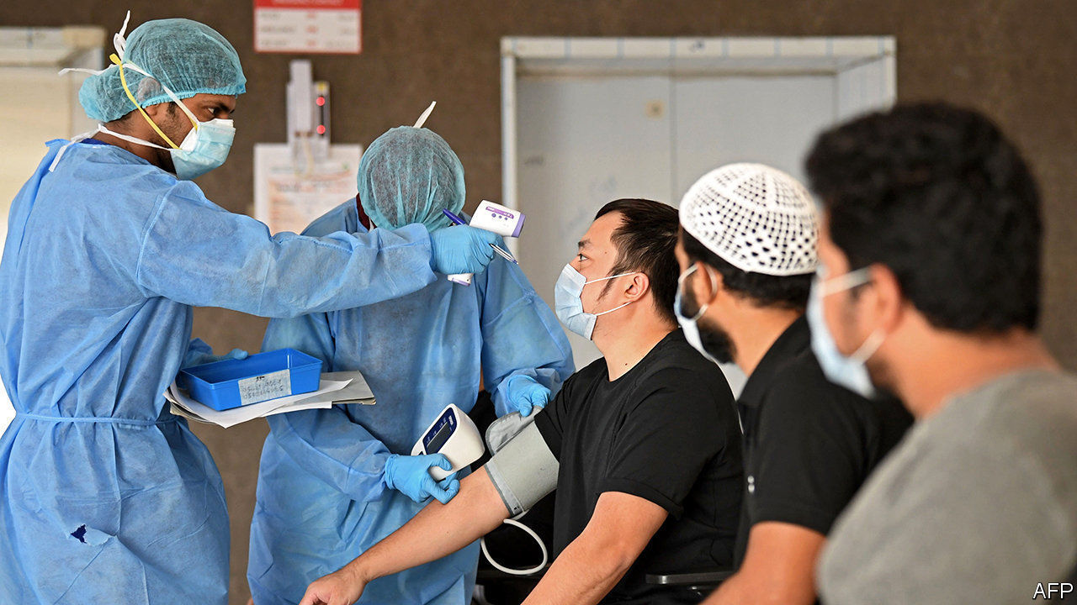

Editor’s note: The Economist is making some of its most important coverage of the covid-19 pandemic freely available to readers of The Economist Today, our daily newsletter. To receive it, register [here](https://www.economist.com/newslettersignup). For our coronavirus tracker and more coverage, see our [hub](https://www.economist.com/coronavirus)

LIFE HAS never been easy for the Gulf’s migrant workers. Though they are around half of the region’s population and are essential to its economy, the locals give them little respect. Coming from poorer countries such as India, Pakistan and Nepal, most work long hours for wages that are high compared with salaries back home but low by any other standard. They care for Kuwaiti children, nurse sick Saudis and build Dubai’s skyscrapers. When their workday is done, many are crammed into spartan dormitories by their employers. Whether visiting workers have lived in the Gulf for two months or two decades, they are deemed to be “temporary” and are left out of the social contract. Most citizens treat them as a subservient underclass.

The outbreak of covid-19 has made life even harder for migrants, who probably account for most of the recorded infections in the Gulf and are also bearing the brunt of the economic fallout. Many are locked down, out of work and unable to go home because of restrictions on travel (see [article](https://www.economist.com/middle-east-and-africa/2020/04/25/migrant-workers-in-cramped-gulf-dorms-fear-infection)). Some struggle to afford food. Governments should take better care of them. That is not only humane, it is also practical. If the Gulf states do not start treating their guests with more compassion, they are likely to find that their outbreaks last longer and that their economies recover more slowly.

So far, the pandemic has revealed more bigotry than benevolence. An MP in Kuwait wants to “purify” the country of illegal workers. “Put them in the desert,” says a famous Kuwaiti actress. A viral video in Bahrain featured a man complaining of migrants being treated next to citizens—never mind that half the nurses in Bahrain come from abroad. In hospitals across the region foreigners are on the front line fighting the virus.

Discrimination is bad enough, but the dormitories where migrants live are incubators for covid-19. With four or more to a room, there is no space for social distancing. At a big labour camp in Qatar one infection quickly became hundreds. Far from the Gulf, Singapore, which treats migrant workers somewhat better, thought it had the virus under control until it broke out in their dormitories. Now infections are rising fast and the authorities have had to extend restrictions on work and travel.

Neglecting migrants hurts citizens, too. The dormitory outbreaks stand a good chance of spreading to the permanent population, lengthening lockdowns. Xenophobes see this as yet another reason to banish foreigners. But countries such as India, which have their hands full, are not co-operating with efforts to return their jobless, potentially ailing expatriates.

The Gulf states are at last taking steps to stem the virus in migrant areas. Some have launched mass-screening and are testing those with symptoms. Temporary housing has been set up to allow social distancing. Most countries are treating covid-19 patients, including migrants, without charging them. Saudi Arabia has also released dozens of migrants held for minor immigration offences, so that prisons do not become plague factories. The United Arab Emirates is automatically renewing the paperwork for migrant workers so that they don’t find themselves on the wrong side of the law just because they are locked down.

That is all to the good, but more needs to be done. Some migrants are still working—building stadiums for the World Cup in 2022 or facilities for the World Expo next year. Employers should be held accountable for their safety. Many migrants cannot work, though, and states should care for them, too. Gulf countries can afford to guarantee a portion of their wages during the outbreak. That will not only ensure that they do not go hungry—it will mean that someone is there to turn the lights back on when businesses start to open up again. ■

Dig deeper:  
For our latest coverage of the covid-19 pandemic, register for The Economist Today, our daily [newsletter](https://www.economist.com/newslettersignup), or visit our [coronavirus tracker and story hub](https://www.economist.com/coronavirus)

This article was downloaded by calibre from <https://www.economist.com/leaders/2020/04/25/the-gulf-states-should-take-better-care-of-their-migrant-workers>

|  |  |  |  |
| --- | --- | --- | --- |
| Previous | Articles | Sections | Next |

|  |  |  |  |
| --- | --- | --- | --- |
| Previous | Articles | Sections | Next |

#### Pimp the ride

# The car industry faces a short-term crisis and long-term decline

It can still be viable, with the right fixes

Apr 23rd 2020 |

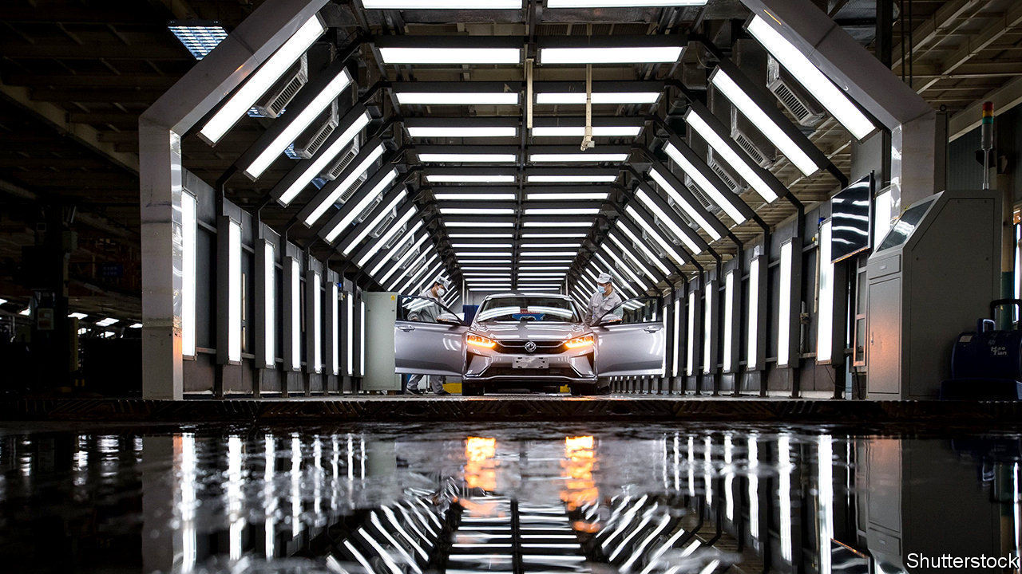

EVEN BEFORE the recession, investors were deeply pessimistic about the car industry. Sitting on $1.3trn-worth of legacy investments in factories that rely on a technology that ought to become obsolete—the internal-combustion engine—the likes of Ford, Renault and Volkswagen don’t exactly look well positioned for the 21st century. Now, with car sales collapsing, a dinosaur business that employs 10m people directly faces a moment of truth (see [article](https://www.economist.com/briefing/2020/04/25/the-worlds-car-giants-need-to-move-fast-and-break-things)). Long synonymous with hubris and the inept allocation of capital, it needs to look to the future.

Executives say they are better placed today than in 2008-09, when General Motors and others received bail-outs. Most firms have more cash and bigger margins. But this logic gets them only so far. Production in Europe and North America is now 50-70% lower than a year ago. Car firms have high fixed costs, so when they run below capacity they lose money fast. The top eight Western carmakers could burn over $50bn of cash this quarter, reckons Jefferies, a bank. At that rate, they may run out of money by the end of the year.

There are other dangers. As recession bites, people may default on car loans, many of which are owed to carmakers’ finance arms. The value of second-hand cars is dropping, harming these finance arms through their leasing operations. There may be a permanent fall in commuting, as more people work from home—road-passenger numbers in China are still 57% below their pre-covid level. This prospect helps explain why oil prices have collapsed (see article). Investors are jumpy—on April 17th Ford raised $8bn of debt at painful interest rates of 8.5-9.6%. The only firm that commands their confidence is Tesla, an electric-car specialist, whose shares are up by 64% this year.

Given its carbon footprint, isn’t there an argument for the creative destruction of the car industry? If only it were that simple. Millions of jobs are at risk and the big firms account for about 60% of the industry’s investment, a rising share of which is, belatedly, going into green technologies. Adaptation would be far preferable to extinction. And yet there is a risk that government aid ossifies car firms before they have modernised. State “cash for clunkers” subsidies—which are on the menu in Germany—could encourage consumers to buy dirty, internal-combustion-engine cars. On March 31st America watered down emissions standards in order to help Detroit. Subsidies for idling workers help in the short run, but if they go on for long they risk preventing firms from shifting resources from old to new technologies.

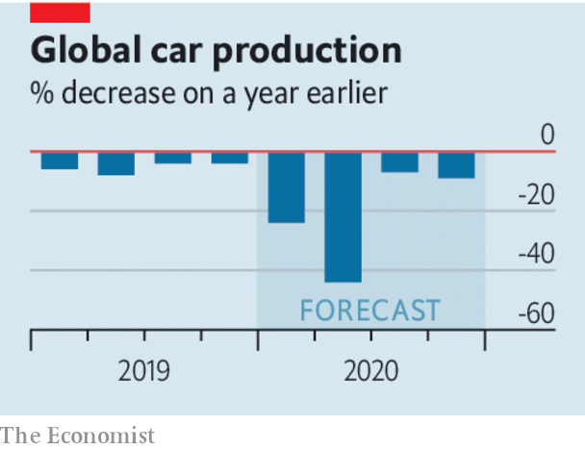

The industry should take control of its own fate. Car firms need to be pioneers in operating factories under new health protocols, from redesigning the choreography of assembly lines to providing health tests for workers. Big Western firms are starting to re-open some plants. This won’t be lucrative, but it will stem short-term losses.

Firms should also avoid slashing investment indiscriminately, as they did in 2007-09 when capital spending dropped by 29%. Most car firms have two parts, a vast legacy operation and a small, loss-making, fast-growing one making hybrid and fully electric cars. The danger is that they cut spending on the new bit, slowing the development of battery technologies and the launch of new electric models. Better to pare dividends, loss-making foreign adventures and legacy investments.

The final priority is consolidation. Too many mid-sized carmakers are clinging to their global aspirations, despite a number of mergers in recent years, such as Geely’s purchase of Volvo and Fiat Chrysler’s planned union with PSA (Fiat’s biggest shareholder owns shares in the parent company of The Economist). The world still has more than 1,000 factories making legacy cars. Renault and Nissan continue their halfway house of an alliance, which brings more complexity than synergy. Adapt, invest in the future and join forces. That is the way to a viable car industry—for the climate, workers and investors, too.■

This article was downloaded by calibre from <https://www.economist.com/leaders/2020/04/23/the-car-industry-faces-a-short-term-crisis-and-long-term-decline>

|  |  |  |  |
| --- | --- | --- | --- |
| Previous | Articles | Sections | Next |

|  |  |  |  |
| --- | --- | --- | --- |
| Previous | Articles | Sections | Next |

#### An Earth Day in the life of a plague

# Covid-19 and the climate

The pandemic should neither distract people from action on climate change nor confuse them about it

Apr 23rd 2020 |

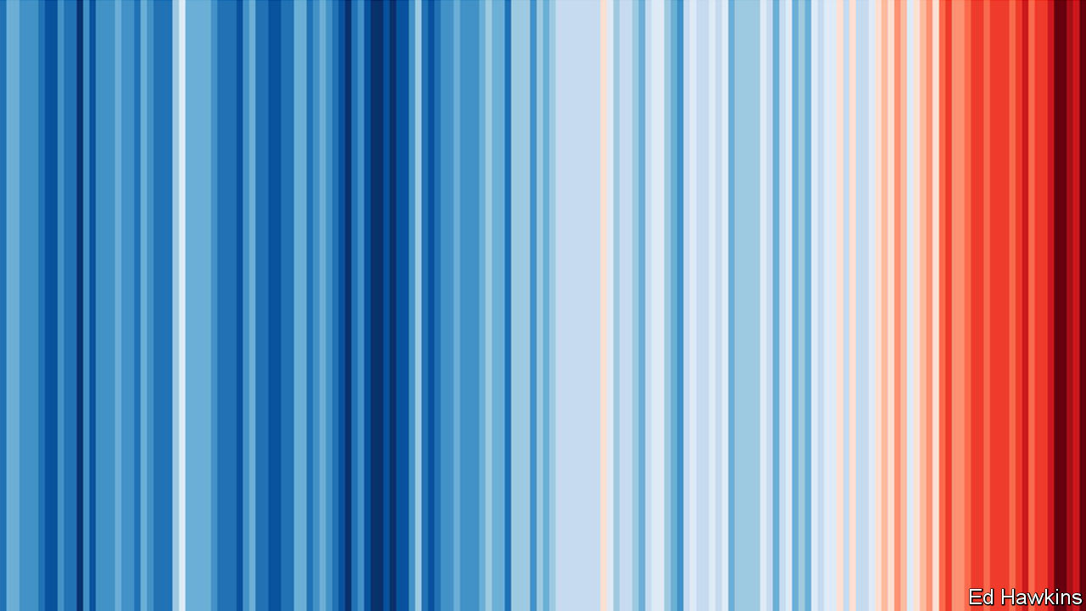

APRIL 22ND WAS doubly disrupted. If it had not been messed up by the covid-19 pandemic, as all days now are, parts of it would have been brought to a halt by activism about the climate. This was the 50th anniversary of the first Earth Day, a festival of demonstrations, marches and teach-ins that took place mostly in America and is widely seen as marking the birth of modern environmentalism. Organisers had hoped that this year’s would see hundreds of millions take to the streets around the world. A huge school strike of the sort pioneered by Greta Thunberg, a Swedish activist, was planned, as well as who-knows-what by way of direct action. A new generation of environmental activists intended to demand a better future more loudly than ever.

The pandemic means that this widespread and co-ordinated youthful passion, one of the most striking developments in recent climate politics, is instead being expressed indoors and online. This in itself will inevitably lead some to contemplate how climate change and covid-19 fit together. One of the slogans of the first Earth Day was what the pioneering environmentalist Barry Commoner called “The first law of Ecology”—that “Everything Is Connected With Everything Else”.

Both scourges bear this out. Some 200,000 deathbeds in 170 countries have been connected by an unbroken web of viral spread. So have bat caves in China and test tubes in California, as well as silent airports, deserted shops and crowded food banks all across the planet. The connections which underlie climate change are even more pervasive. They tie together almost all the 21st century’s means of transport, manufacture and growth, its buried geological past and its melting Arctic ice. The workings of the great round world, as revealed by pictures of the blue-white filigreed Earth from space that were so inspirational in 1970, really do link all its components.

Covid-19 and climate change are both global problems, and proper responses to both require levels of co-operation that the countries of the world find hard. Responses to the effects of covid-19 on the coal industry, among others, or to the need for economic stimulus once the virus has abated, will offer opportunities to further or impede decarbonisation. And both have their origin in a strange mixture of human action and the unbiddable, indifferent forces of nature, provoking contradictory feelings of culpability and a complete lack of control.

Connectedness, though, is no excuse for sloppy thinking. The two scourges are not usefully treated as the same problem—of excessive economic growth clogging the sky as it encroaches on the wildernesses where new pathogens lurk. There is no single rethinking or rejection of the way humans live today that will solve both. Nor is the pandemic a response to environmental degradation. To hear sweet birds singing in the streets of Vancouver as fish swim the unsilted canals of Venice and goats throng the streets of north Wales lifts locked-down spirits. But the pandemic is not, as some say, “nature’s reset”. Such thinking easily slips into the misanthropy that can lead environmentalists to see people themselves as the problem.

To help readers appreciate each challenge for what it is, this week our newspaper, full of covid-19 news, makes room for the first of a series of six climate briefs. We begin by looking at the politics of climate change. Later themes will include climate science, carbon cycles and the energy transition. When they started in the 1970s, “Schools briefs” were intended as primers for students; this year they will be more along the lines of “Home-school briefs”. We hope they will help all generations seized with the importance of climate change—and not just Ms Thunberg’s—to further their understanding of what lies ahead.■

Sign up to our fortnightly climate-change newsletter [here](https://www.economist.com/theclimateissue/)

This article was downloaded by calibre from <https://www.economist.com/leaders/2020/04/23/covid-19-and-the-climate>

|  |  |  |  |
| --- | --- | --- | --- |
| Previous | Articles | Sections | Next |

|  |  |  |
| --- | --- | --- |
| Leaders | Sections | By Invitation |

Letters

Letters to the editor: On wet markets, Thailand, abortion, covid-19, house names, management

.

|  |  |  |
| --- | --- | --- |
| Leaders | Sections | By Invitation |

|  |  |  |  |
| --- | --- | --- | --- |
|  | Articles | Sections | Next |

#### On wet markets, Thailand, abortion, covid-19, house names, management

# Letters to the editor

A selection of correspondence

Apr 23rd 2020 |

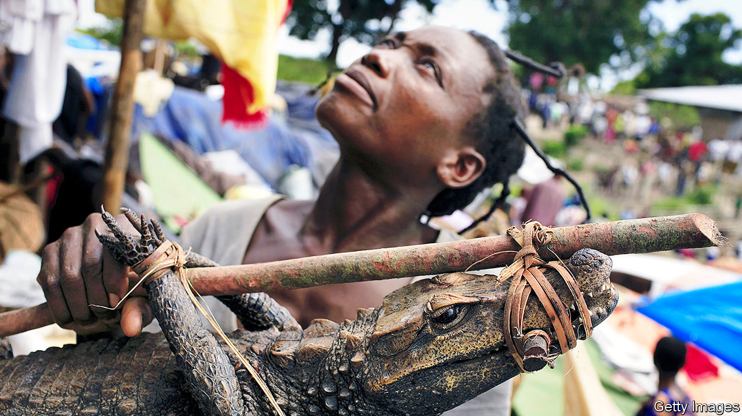

## Diseased meat

I read your article on the trade in African bush meat (“[A crocodile hunter’s tears](https://www.economist.com/middle-east-and-africa/2020/03/19/the-toils-and-spoils-of-congos-crocodile-killers)”, March 21st). HIV may have been transmitted from chimpanzees to people as a result of bush meat. The SARS epidemic probably jumped from an animal to people in a shop selling traditional Chinese medicines in Guangdong province. These shops often have cages with live animals, such as civet cats and ant-eating pangolins. A million pangolins may have been exported from Africa to China in the past decade, and the pangolin is a possible origin of covid-19.

The Chinese government has closed traditional-medicine shops in Wuhan and elsewhere. They did the same after SARS, but then allowed them to reopen as the number of cases fell. We need an international effort to abolish all trade in exotic mammals and to push back in every way possible against the bush-meat market. Chinese traditional-medicine shops and bush meat expose all of us to lethal animal viruses capable of killing millions, destroying the world economy and threatening the extinction of some species. It needs only a tiny step to stop pandemics before they start.

I was once taken to an African restaurant in Gabon and given roast civet cat and fricassee of pangolin, and yes, you are expected to eat the scales.

MALCOLM POTTS  
School of Public Health  
University of California, Berkeley

It is only fair to make those responsible for the outbreak of covid-19 share in the costs. That should motivate a change in attitude that reduces the risk of similar events in the future. One possibility is to tax exports from countries that allow wet markets that trade in wild or exotic animals. Such a tax can be easily avoided if a country can prove that it has closed those markets.

This is not a populist or nationalist proposal. The world must simply change its attitude towards this trade and not let it revert to how it was before the outbreak, which is what happened after SARS.

TORBEN JUNG LAURSEN  
Flensburg, Germany

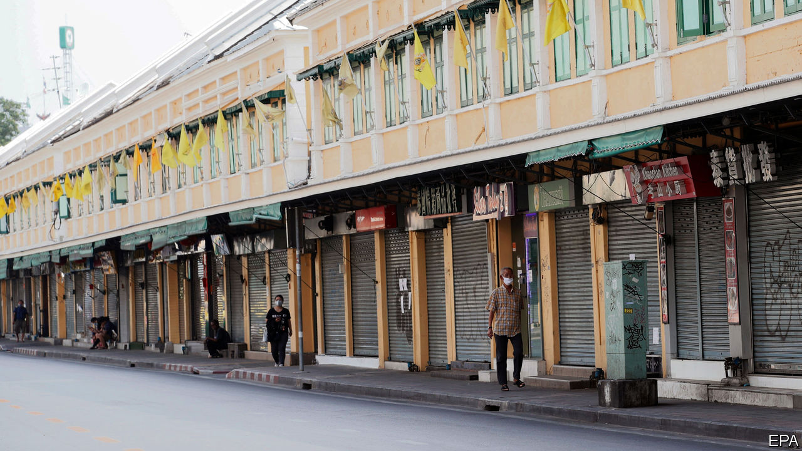

## Thailand’s economy

Regarding your article on Thailand’s handling of covid-19 (“[Sigh-am](https://www.economist.com/asia/2020/04/02/thailands-economy-was-suffering-before-the-virus)”, April 4th), the Thai authorities have been praised for their comprehensive response. Johns Hopkins University ranked Thailand as the sixth-most prepared country in the world for pandemics. Thailand’s economic fundamentals remain strong and should propel further growth after the crisis eases. The government has responded with stimulus packages and relief measures equal to 12% of GDP.

Moreover, it is not correct to say that measures such as the Eastern Economic Corridor (EEC) have been ineffective. Since its launch, the value of investment applications in the EEC has nearly quadrupled, to $22bn in 2018. The total planned investment from 2019 to 2023 is set at around $50bn.

Finally, Thailand’s international standing has become stronger after last year’s elections and our chairmanship of ASEAN. As far as free-trade agreements are concerned, Thailand is pursuing talks with many partners, including the European Union, which has announced its readiness to resume negotiations.

PISANU SUVANAJATA  
Ambassador of Thailand  
London

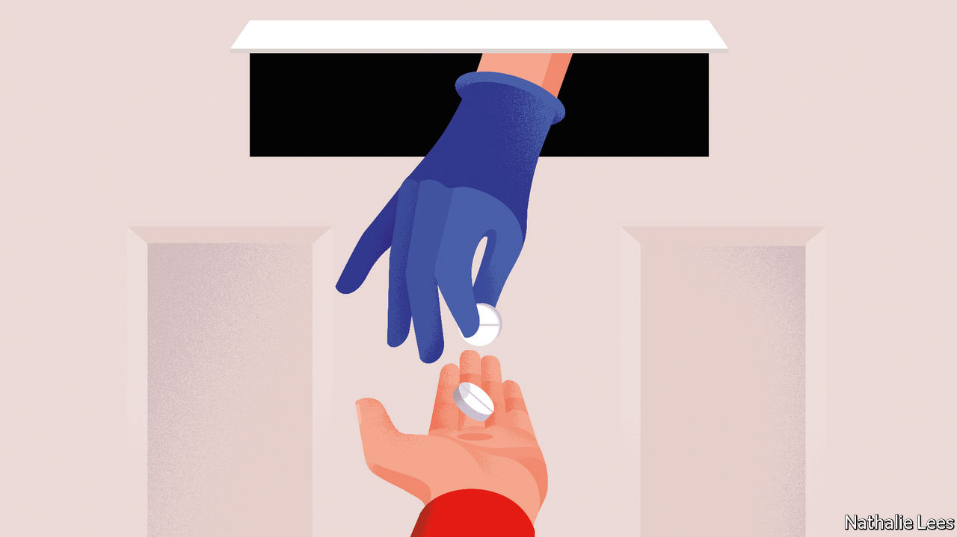

## Reinforce the right to choose

I was encouraged to see The Economist report on the increasing access to safe abortions around the world (“[From backstreet to mail-order](https://www.economist.com/international/2020/03/05/abortions-are-becoming-safer-and-easier-to-obtain-even-where-they-are-illegal)”, March 7th). As you noted, “in America abortion is a battleground”. In Australia, however, the issue of providing access to safe abortions is rarely discussed, least of all in Parliament, despite general public support. The issue is particularly relevant as the legislature in Western Australia is currently discussing legislation that would create 150-metre safe-access zones around reproductive-health clinics, making it the second-last Australian state to do so (Tasmania first introduced safe-access zones in 2013).

My hope is that these shielded areas, along with increased access to clinics and work to reduce the stigma of the procedure, will help secure a future where girls (I am 16) and women in my community truly have unimpeded access to safe abortions.

MIA FRASER  
Perth, Australia

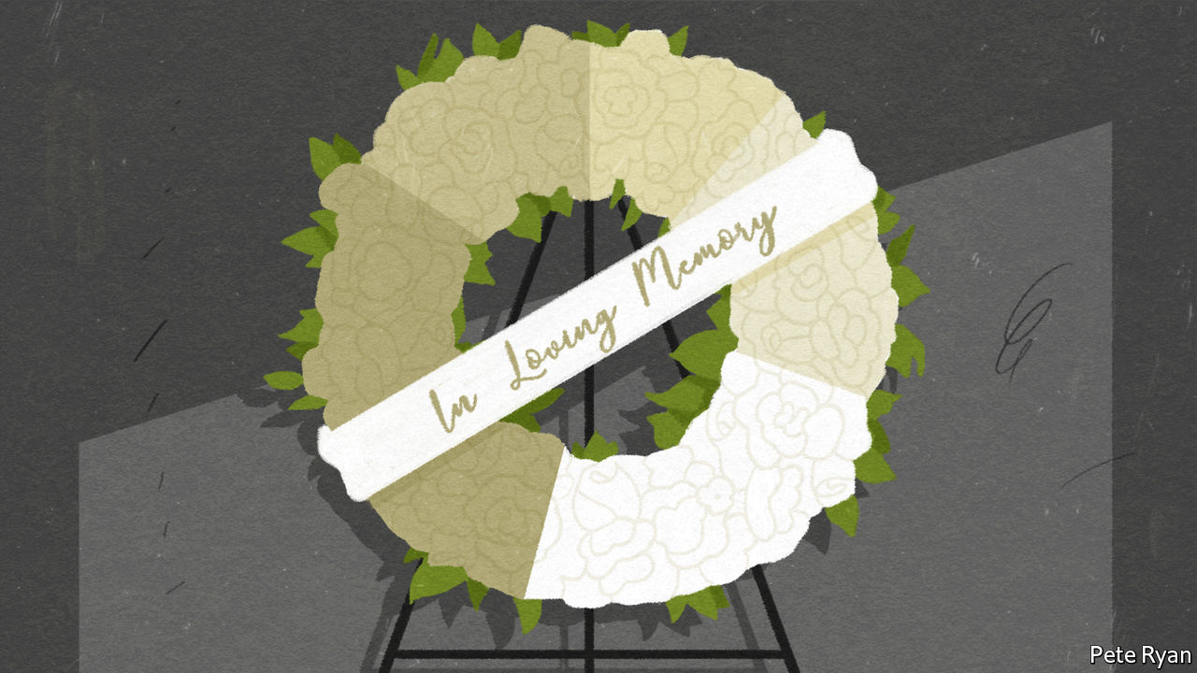

## An awkward truth

I know of no evidence to support your contention that “the fatality rate in any country will depend primarily on the quality of care it can provide” in treating covid-19 (“[Where will it be the worst?](https://www.economist.com/international/2020/03/12/fatality-rates-for-covid-19-could-vary-enormously)”, March 14th). Rather, it will depend primarily on the immunological resilience of the populations affected, whether weakened by age, chronic disease or malnutrition, and whether or not critical public-health interventions have been adopted. Without virucidal drugs, respiratory support will alter the course of infection in fewer people than we doctors care to admit.

The reality, seldom appreciated by the public, is that health care will play a relatively small part in reducing overall mortality in this as in previous pandemics. Vaccines will in time help damp down the incidence of disease but only long after the first waves have abated. Dismal scientists, using models as fantastical as those of epidemiologists, will attempt to weigh the health benefits of lockdown against its costs in terms of reduced economic productivity, lost public-sector investment and quality of lost life years in a multitude of ways.

The National Health Service, the central pillar of Britain’s welfare state, symbolises collective endeavour. All health systems form part of the fabric of civic life. They reinforce societal norms through the personal experiences of providers and users. This strengthening of communal bonds and mutual responsibility may, for all we know, be as salutogenic as the biomedical interventions that health services have to offer.

DR STEPHEN GILLAMHolt, Norfolk

Looking at covid hotspots reminds me of a dialogue from Daniel Defoe’s “A Journal of the Plague Year”, in which the narrator’s brother tries to persuade him to flee plague-stricken London, over his objections that his business would suffer. “Is it not as reasonable,” the brother asks, “that you should trust God with the chance or risque of losing your trade, as that you should stay in so imminent a point of danger, and trust him with your life?”

AUGUSTUS HANEY  
New York

## Dun namin’

Just to add to readers’ letters on naming houses in Britain ([March 28th](https://www.economist.com/letters/2020/03/26/letters-to-the-editor)), arriving in St Andrews to take up a post at the university in the 1960s, and being informed by the town council that it would not supply his house with a number, but require him to choose a name for it, a young don erected the following sign: High Entropy.

ANDREW DAWSON  
Worcester

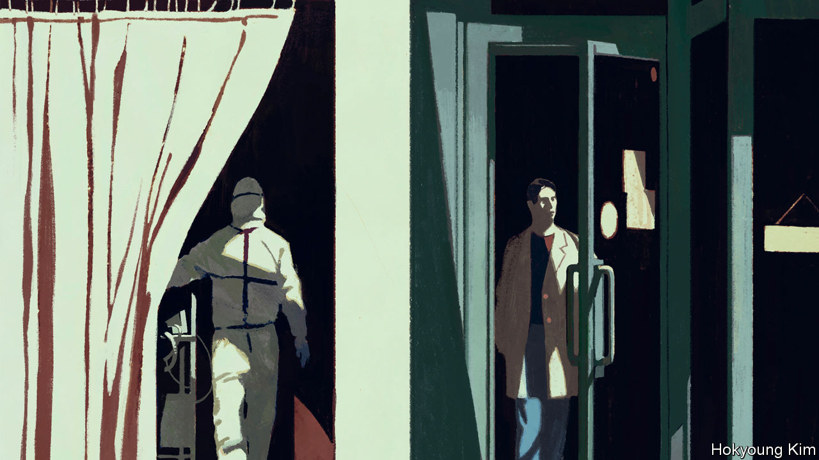

## Painful options

The “[Hard choices](https://www.economist.com/briefing/2020/04/04/the-hard-choices-covid-policymakers-face)” (April 4th) being made because of the pandemic, and the methods used to assess the likely path of the disease, sound like an adage familiar to any risk manager: all models are wrong, but some are useful.

CHRIS MATTENLondon

This article was downloaded by calibre from <https://www.economist.com/letters/2020/04/23/letters-to-the-editor>

|  |  |  |  |
| --- | --- | --- | --- |
|  | Articles | Sections | Next |

|  |  |  |
| --- | --- | --- |
| Letters | Sections | Briefing |

By Invitation

The world after covid-19: Bill Gates on how to fight future pandemics

.

|  |  |  |
| --- | --- | --- |
| Letters | Sections | Briefing |

|  |  |  |  |
| --- | --- | --- | --- |
|  | Articles | Sections | Next |

#### The world after covid-19

# Bill Gates on how to fight future pandemics

The coronavirus will hasten three big medical breakthroughs. That is just a start

Apr 23rd 2020 |

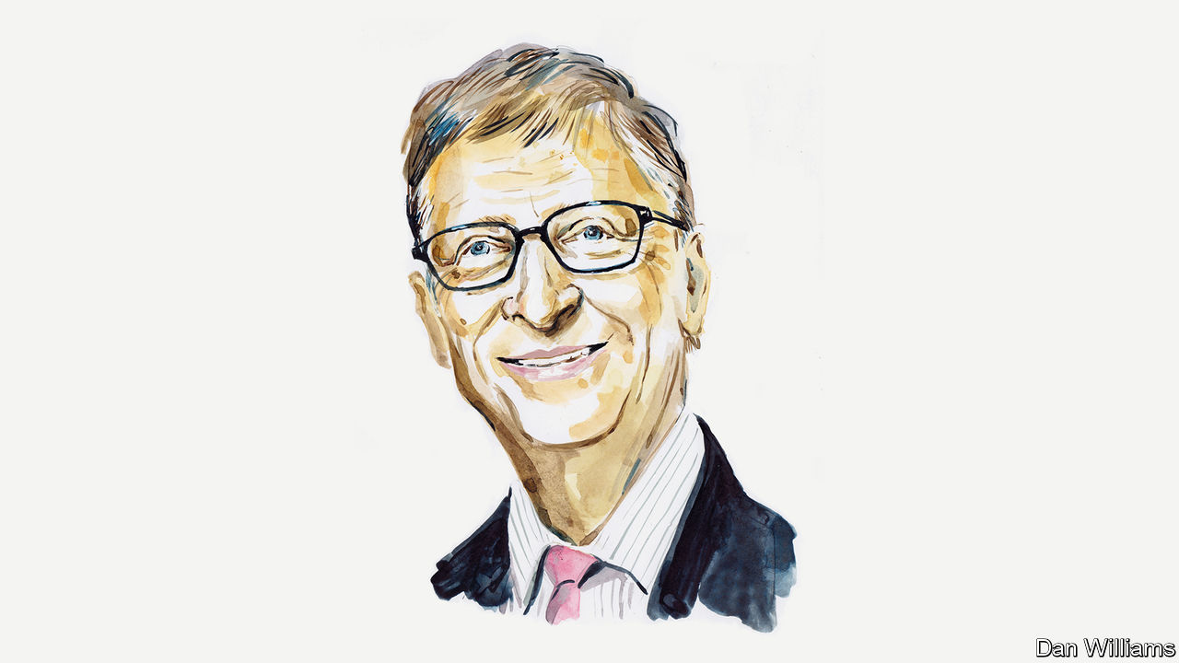

Editor’s note: The Economist is making some of its most important coverage of the covid-19 pandemic freely available to readers of The Economist Today, our daily newsletter. To receive it, register [here](https://www.economist.com/newslettersignup). For our coronavirus tracker and more coverage, see our [hub](https://www.economist.com/coronavirus)

WHEN HISTORIANS write the book on the covid-19 pandemic, what we’ve lived through so far will probably take up only the first third or so. The bulk of the story will be what happens next.

In most of Europe, East Asia and North America the peak of the pandemic will probably have passed by the end of this month. In a few weeks’ time, many hope, things will return to the way they were in December. Unfortunately, that won’t happen.

I believe that humanity will beat this pandemic, but only when most of the population is vaccinated. Until then, life will not return to normal. Even if governments lift shelter-in-place orders and businesses reopen their doors, humans have a natural aversion to exposing themselves to disease. Airports won’t have large crowds. Sports will be played in basically empty stadiums. And the world economy will be depressed because demand will stay low and people will spend more conservatively.

As the pandemic slows in developed nations, it will accelerate in developing ones. Their experience, however, will be worse. In poorer countries, where fewer jobs can be done remotely, distancing measures won’t work as well. The virus will spread quickly, and health systems won’t be able to care for the infected. Covid-19 overwhelmed cities like New York, but the data suggest that even a single Manhattan hospital has more intensive-care beds than most African countries. Millions could die.

Wealthy nations can help, for example, by making sure critical supplies don’t just go to the highest bidder. But people in rich and poor places alike will be safe only once we have an effective medical solution for this virus, which means a vaccine.

Over the next year, medical researchers will be among the most important people in the world. Fortunately, even before this pandemic, they were making giant leaps in vaccinology. Conventional vaccines teach your body to recognise the shape of a pathogen, usually by introducing a dead or weakened form of the virus. But there’s also a new kind of immunisation that doesn’t require researchers to spend time growing large volumes of pathogens. These mRNA vaccines use genetic code to give your cells instructions for how to mount an immune response. They can probably be produced faster than traditional vaccines.

My hope is that, by the second half of 2021, facilities around the world will be manufacturing a vaccine. If that’s the case, it will be a history-making achievement: the fastest humankind has ever gone from recognising a new disease to immunising against it.

Apart from this progress in vaccines, two other big medical breakthroughs will emerge from the pandemic. One will be in the field of diagnostics. The next time a novel virus crops up, people will probably be able to test for it at home in the same way they test for pregnancy. Instead of peeing on a stick, though, they’ll swab their nostrils. Researchers could have such a test ready within a few months of identifying a new disease.

The third breakthrough will be in antiviral drugs. These have been an underinvested branch of science. We haven’t been as effective at developing drugs to fight viruses as we have those to fight bacteria. But that will change. Researchers will develop large, diverse libraries of antivirals, which they’ll be able to scan through and quickly find effective treatments for novel viruses.

All three technologies will prepare us for the next pandemic by allowing us to intervene early, when the number of cases is still very low. But the underlying research will also assist us in fighting existing infectious diseases—and even help advance cures for cancer. (Scientists have long thought mRNA vaccines could lead to an eventual cancer vaccine. Until covid-19, though, there wasn’t much research into how they could be produced en masse at even somewhat affordable prices.)

Our progress won’t be in science alone. It will also be in our ability to make sure everyone benefits from that science. In the years after 2021, I think we’ll learn from the years after 1945. With the end of the second world war, leaders built international institutions like the UN to prevent more conflicts. After covid-19, leaders will prepare institutions to prevent the next pandemic.

These will be a mix of national, regional and global organisations. I expect they will participate in regular “germ games” in the same way as armed forces take part in war games. These will keep us ready for the next time a novel virus jumps from bats or birds to humans. They will also prepare us should a bad actor create an infectious disease in a home-made lab and try to weaponise it. By practising for a pandemic, the world will also be defending itself against an act of bioterrorism.

## Keep it global

I hope wealthy nations include poorer ones in these preparations, especially by devoting more foreign aid to building up their primary health-care systems. Even the most self-interested person—or isolationist government—should agree with this by now. This pandemic has shown us that viruses don’t obey border laws and that we are all connected biologically by a network of microscopic germs, whether we like it or not. If a novel virus appears in a poor country, we want its doctors to have the ability to spot it and contain it as soon as possible.

None of this is inevitable. History doesn’t follow a set course. People choose which direction to take, and may make the wrong turn. The years after 2021 may resemble the years after 1945. But the best analogy for today might be November 10th 1942. Britain had just won its first land victory of the war, and Winston Churchill declared in a speech: “This is not the end. It is not even the beginning of the end. But it is, perhaps, the end of the beginning.” ■

Bill Gates is the co-founder of Microsoft and co-chair of the Bill & Melinda Gates Foundation. This is part of a series on the world after covid-19 which can be found at [Economist.com/coronavirus](http://Economist.com/coronavirus)

Dig deeper:  
For our latest coverage of the covid-19 pandemic, register for The Economist Today, our daily [newsletter](https://www.economist.com/newslettersignup), or visit our [coronavirus tracker and story hub](https://www.economist.com/coronavirus)

This article was downloaded by calibre from <https://www.economist.com/by-invitation/2020/04/23/bill-gates-on-how-to-fight-future-pandemics>

|  |  |  |  |
| --- | --- | --- | --- |
|  | Articles | Sections | Next |

|  |  |  |
| --- | --- | --- |
| By Invitation | Sections | United States |

Briefing

Covid-19 and public finances: Undercut

.

The crisis in carmaking: From 60 to zero

.

Better batteries: Charging up for a long ride

.

|  |  |  |
| --- | --- | --- |
| By Invitation | Sections | United States |

|  |  |  |  |
| --- | --- | --- | --- |
|  | Articles | Sections | Next |

#### What would Keynes do?

# The pandemic will leave the rich world deep in debt, and force some hard choices

Who takes the pain, and can there be gain

Apr 23rd 2020 |

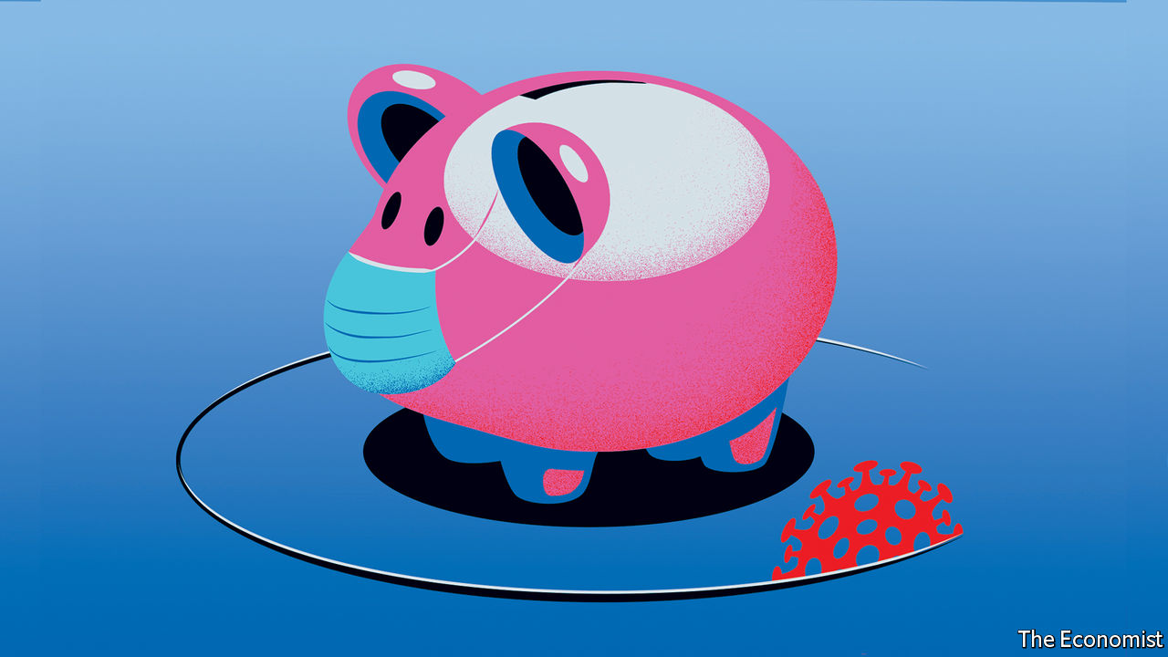

Editor’s note: The Economist is making some of its most important coverage of the covid-19 pandemic freely available to readers of The Economist Today, our daily newsletter. To receive it, register [here](https://www.economist.com/newslettersignup). For our coronavirus tracker and more coverage, see our [hub](https://www.economist.com/coronavirus)

IN “HOW TO PAY FOR THE WAR”, a pamphlet published in 1940, John Maynard Keynes looked back on the way that the British government had, in the late 1910s, tried to pay off enormous quantities of debt with a combination of higher taxes and inflation. Wages had not kept up with inflation, meaning “that consumers’ incomes pass[ed] into the hands of the capitalist class”. Meanwhile the rich, as bondholders, had benefited from interest on the loans.

This time, Keynes argued, it would be better to take money from the workers directly by forcing them to lend to the government while the war was on and there was little to spend money on anyway. Later the government could pay the workers back the money they had lent it with interest, using the proceeds of a substantial wealth tax. “I have endeavoured”, Keynes wrote, “to snatch from the exigency of war positive social improvements.”

Like a war, the fight against covid-19 has seen governments, particularly those in the rich world, rack up debts so large that the way in which they are paid off could have a long-lasting effect on their economies, and significantly affect the distribution of wealth. There are deep differences between today’s circumstances and those which Keynes surveyed, perhaps foremost among which is that advanced economies now routinely shoulder a level of debt that Keynes would have seen as an unmanageable burden (see chart 1). But those dealing with the aftermath of this year’s remarkable borrowing should still heed his example in looking for the right way to distribute the pain as they do so.

## Debt before dishonour

The numbers involved are enormous. Advanced economies will run an average deficit this year of 11% of GDP, according to the IMF, even if the second half of the year sees no more lockdowns and a gradual recovery. Rich-world public debt could run to $66trn, which might be 122% of GDP by year’s end.

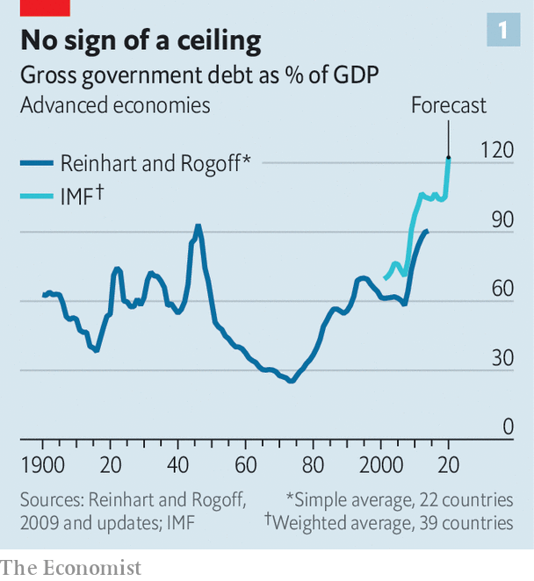

Governments wishing to see such debt burdens diminish must tread one of three broadly defined paths. First, they can pay back the borrowing using taxation. Second, they can decide not to pay, or agree with creditors to pay less than they owe. Third, they can wait it out, rolling over their debts while hoping that they shrink relative to the economy over time.

The likely constraint on paying off debt with future tax revenues is politics. Such a strategy requires some mix of raising taxes—which upsets quite a few people—and cutting spending on other things—which also upsets quite a few people, including some who will not have liked the tax increases either. Nevertheless, after the global financial crisis of 2007-09, which increased debt levels by about a third in advanced economies, many countries chose to reduce public spending as a share of the economy. Between 2010 and 2019 America and the euro zone cut their public-spending-to-GDP ratios by about 3.5 percentage points. Britain’s fell by 6 percentage points. Taxation, meanwhile, rose by between 1 and 2 percentage points of GDP.

Public appetite for paying off pandemic debts through a return to such austerity seems likely to be scant. The emotional, as opposed to economic, logic of austerity—people had spent too much, and must rein themselves in—does not apply. What is more, post-covid publics are likely to want more spent on their health, not less. More than half of Britons supported tax increases that would pay for more spending on the National Health Service even before the pandemic struck. Ageing populations are also increasing the demand for public spending, as are investments needed to tackle climate change.

The second option—defaulting or restructuring debts—may be forced on to emerging economies which lack any other way out. If it is, that will cause significant suffering. In advanced economies, though, such things have been increasingly rare since Keynes’s day, and look unlikely to make a comeback. A modern economy integrated into global financial markets has a huge problem if capital markets lock it out as a bad risk.

That said, there may be more than one way to default. Kenneth Rogoff of Harvard University argues that promises to increase health-care and pension spending in coming decades should also be viewed as government debt of a sort, and that this sort of debt is easier to back out of than obligations to bondholders. It is hard to ascertain whether the “default” risk in these debts—ie, the risk that politicians cut health-care and pension spending, reneging on their promises to ageing populations—is rising. Unlike bonds they are not traded on financial markets that provide signals of such things. But it almost surely is, especially in countries, like Italy, where pension spending is already enormous.

Rich-country politicians unwilling to shift away from spending and towards taxing, or to risk finding out how terrible a default would be, are likely to choose to grow their way out of hock. The secret to this is ensuring that the economy’s combined level of real economic growth and inflation stays handily above the interest rate the government pays on its debt. That allows the debt-to-GDP ratio to shrink over time.

In a much-noted speech in 2019 which called for a “richer discussion” about the costs of debt, Olivier Blanchard of the Peterson Institute for International Economics, a think-tank, argued that such a strategy was more plausible than many might think. In the United States, he pointed out, nominal growth rates higher than interest rates are the historical norm.

Many rich-world governments pursued this sort of strategy after the second world war with some success. At its wartime height, America’s public debt was 112% of GDP, Britain’s 259%. By 1980 America’s debt-to-GDP ratio had fallen to 26% and Britain’s to 43%. Achieving those results involved both a high tolerance for inflation and an ability to stop interest rates from following it upwards. The second of these feats was achieved by means of a regulatory system which, by depriving citizens of better investment options, forced them in effect to lend to governments at low interest rates. By the 1970s economists were calling this “financial repression”.

In a paper published in 2015, Carmen Reinhart of Harvard University and Belen Sbrancia of the IMF calculated that France, Italy, Japan, Britain and America spent at least half of that period in so-called “liquidation” years in which interest rates adjusted for inflation were negative. They estimated that the average annual “liquidation tax” to governments resulting from real interest kept low by inflation and financial repression ranged from 1.9% of GDP in America to 7.2% in Japan.

## The violence inherent in the system

To attempt such repression today, though, would require redeploying tools used by post-war governments—tools such as capital controls, fixed exchange rates, rationed bank lending and caps on interest rates. This would be offensive to lovers of economic freedom. It would also be sufficiently contrary to the interests of investors and savers to be politically very demanding. That said, the coming years could prove to be politically demanding times. But if governments did enact such changes, they would spur responses unavailable to investors of the 1950s and 1960s, such as investment in cryptocurrencies and other immaterial products.

Even without a mechanism for keeping interest rates low, inflation can go some way to lessening the debt burden. “My gut instinct is that we will need higher inflation to wash away some of the debt,” says Maurice Obstfeld of the University of California, Berkeley (who, like Mr Blanchard and Mr Rogoff, was once chief economist at the IMF). Yet though inflation may be necessary if debt burdens are to shrink, it may not be readily forthcoming. A few economists think inflation will surge of its own accord when the enormous economic stimulus they expect butts up against the supply disruptions imposed by lockdowns. But Mr Obstfeld and many others worry instead about deflation, or at least less inflation than they would like.

For some, the cause of this is “debt overhang”—the idea that debts sap the economy of demand. Wealthy bondholders, by definition, prefer saving to spending. Many others make a simpler judgment. The circumstances of the pandemic which made massive borrowing necessary in the first place—such as surging unemployment—are also likely to cause a deflationary slump. Since the pandemic started, the cost of insuring against inflation through financial markets has fallen, reflecting a belief that there is unlikely to be much of it about. Investors seem to be predicting that five to ten years from now the Bank of Japan, the European Central Bank (ECB) and the Federal Reserve will all be undershooting their inflation targets.

Low inflation is bad for nominal growth. But it does at least reduce borrowing costs. Central banks can cut interest rates, if they have any room left to do so, and create money with impunity. In the five weeks leading up to April 16th, the Fed bought $1.3trn of American government debt: 5.9% of 2019 GDP and more than the entire budget deficit.

Thanks in part to the Fed’s actions, the American government can borrow for ten years at an interest rate of just 0.6%. In low-growth, lower-inflation Japan ten-year bonds are pegged at around 0%. Only in indebted countries in the euro zone, such as Italy, do bond yields threaten to exceed recent nominal growth rates.

These low interest rates make the fiscal picture seem less bleak. Vitor Gaspar, a senior official at the IMF, says the fund expects a combination of low rates and rebounding growth to see debt burdens stabilise or decline in the “vast majority” of countries in 2021. And bond-buying by central banks takes much of the worry out of some of the debt.

Take Japan. Its gross-debt-to-GDP ratio in 2019 was around 240% of GDP, which sounds truly astonishing. But years of quantitative easing (QE) have left the Bank of Japan with government bonds worth nearly 85% of GDP. And the government could, in theory, sell financial assets of a similar magnitude if it had to. Adjust the debt to take these things into account and what remains is a little over 70% of GDP—less than a third of the gross figure and roughly comparable to what the figure is for America if you make the same adjustments (see chart 2).

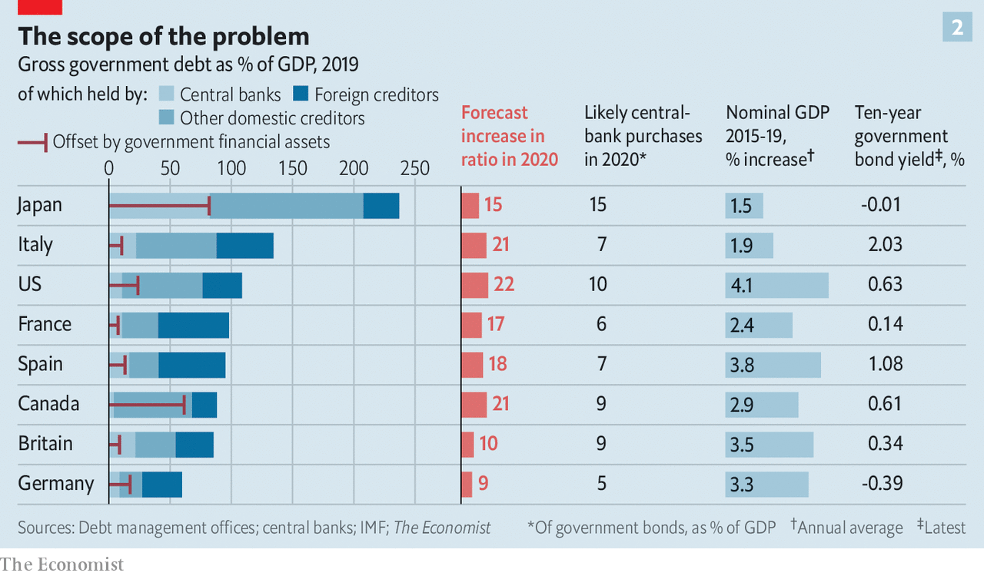

Well before the pandemic such analysis had led many influential economists to start treating higher public debt as sustainable in a low-inflation, low-interest-rate world. Because the pandemic has pushed both inflation and interest rates the same way—down—their logic still holds. However, there are reasons for scepticism.

Start with central-bank debt holdings. QE does not really neutralise public debt. Central banks buy government bonds by creating new money which sits in the banking system in the form of reserves. And central banks pay interest on those reserves. Because the central bank is ultimately owned by the government, QE replaces one government debt-interest bill, interest payments on bonds, with another, interest payment on bank reserves. And although the latter are very low today—negative, in fact, in several places—they will stay so only so long as central banks do not need to raise rates to fight inflation.

Since the global financial crisis, betting on low rates has paid off; some have gone so far as to see them as a new normal, part of a low-growth economy in which demand needs constant stimulation. But that brings out another flaw in the sanguine view of public debt: it assumes that the future will be like the past. Although markets expect rates to remain low, it is not a sure thing. There is, for example, the possibility that lockdowns and stimulus in close succession do indeed bring on price rises. There is also the possibility that a great deal of the deflationary pressure has been due to oil prices, which as of today really do seem to have no further to fall.

An alternative critique is that the past may not offer the reassurance some might seek there. A preliminary working paper by Paolo Mauro and Jing Zhou of the IMF, riffing on Mr Blanchard’s theme, examines borrowing costs and economic growth for 55 advanced and emerging economies over, in some cases, as much as 200 years.

The 24 advanced economies they study have on average benefited from interest rates which are below the nominal growth rate 61% of the time. Yet they find that such differentials are “essentially useless” for predicting sovereign defaults. “Can we sleep more soundly” with interest rates below growth rates? they ask. “Not really,” they answer.

The first sign of any debt trouble in the rich world would probably be rising inflation. At first, that might be a relief, given the present deflationary risk and the recent history of persistently insufficient inflation. It would be a sign that the economy was recovering. By reducing real interest rates it would further boost growth. And central banks that have long fallen a percentage point or so short of their inflation targets might feel comfortable seeing inflation ride a percentage point or so proud of it. But a somewhat relaxed attitude to 3% does not mean a willingness to accept 6%.

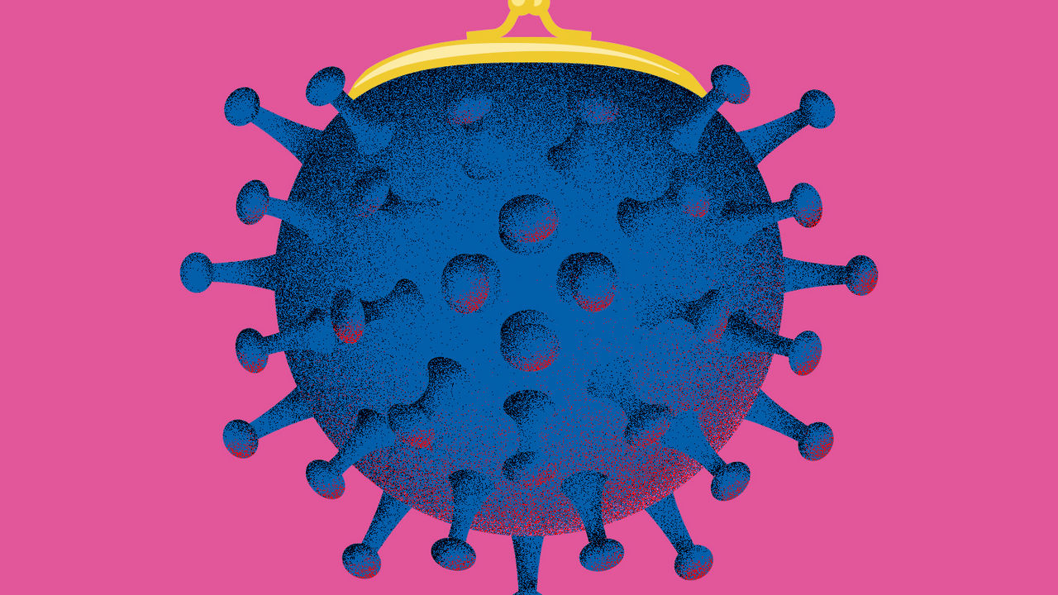

Inflation rising further above targets than it has been below them would bring on a stark choice for heavily indebted governments. Should they leave the central bank alone, let it raise rates to keep inflation at target, and look to taxpayers—or pensioners—to pay for the resulting rise in debt-interest costs? Or should they lean on their central banks to keep interest rates low, permitting inflation to rise and thereby easing their debt burdens?

Some context for that question comes from the blurring between fiscal and monetary policy the pandemic has already seen. Steve Mnuchin, America’s treasury secretary, has said that on some days he has spoken to Jerome Powell, chairman of the Federal Reserve, more than 30 times. The Bank of England has co-ordinated interest-rate cuts with Britain’s treasury and recently agreed to increase the government’s overdraft. The Bank of Japan has long been an enthusiastic partner in the economic agenda of Abe Shinzo, the prime minister. The outlier is the euro zone where, because of the horror of inflation found in countries such as Germany and the Netherlands, political pressure on the ECB is just as likely to result in hawkish policy.

## Facing the exigencies

Conveniently for politicians, some of the pain of high inflation would be borne by foreign investors, whose share of public debt exceeds 30% in many rich countries. “In a crunch, will Chinese debt-holders be treated as senior to US pensioners?” asks Mr Rogoff. But less foreign investment in years to come would need to be set against that advantage. A perception that a nominally independent central bank was in fact a creature of politicians would create a risk premium on investment that would slow growth throughout the economy.

Inflation would bring arbitrary redistributions of wealth to the disadvantage of the poor, just as Keynes observed it to have done in the late 1910s. Richer people are more likely to hold the houses and shares that rise in value with inflation, not to mention mortgages that would be inflated away alongside government debt. Higher inflation would also provide a bail-out that favoured more indebted companies over the less indebted.

Higher taxes, tried a little in the wake of the financial crisis, could be targeted more precisely to reduce inequality—much as they were in some countries after the second world war. Wealth taxes, as favoured by Keynes back then and increasingly discussed by academics and left-wing politicians today, could find that their time had come. Post-pandemic populations may welcome the sort of cost-free-to-most all-in-it-togetherness they might provide. Less radically, a value-added tax in America (which lacks one), higher taxes on land or inheritance, or new taxes on carbon emissions could be on the cards. Like inflation, however, tax rises inhibit and distort the economy while producing a backlash among those who must pay.

While the world’s chief problem is battling an economic slump in which inflation is falling, such choices are tomorrow’s business. They will not weigh heavily on policymakers’ minds. Even economists with reputations as fiscal hawks tend to support today’s emergency spending, and some want it enlarged. Yet one way or another, the bills will eventually come due. When they do, there may not be a painless way of settling them. ■

Dig deeper:  
For our latest coverage of the covid-19 pandemic, register for The Economist Today, our daily [newsletter](https://www.economist.com/newslettersignup), or visit our [coronavirus tracker and story hub](https://www.economist.com/coronavirus)

This article was downloaded by calibre from <https://www.economist.com/briefing/2020/04/23/the-pandemic-will-leave-the-rich-world-deep-in-debt-and-force-some-hard-choices>

|  |  |  |  |
| --- | --- | --- | --- |
|  | Articles | Sections | Next |

|  |  |  |  |
| --- | --- | --- | --- |
| Previous | Articles | Sections | Next |

#### From 60 to zero

# The world’s car giants need to move fast and break things

They have dawdled for too long

Apr 23rd 2020 |

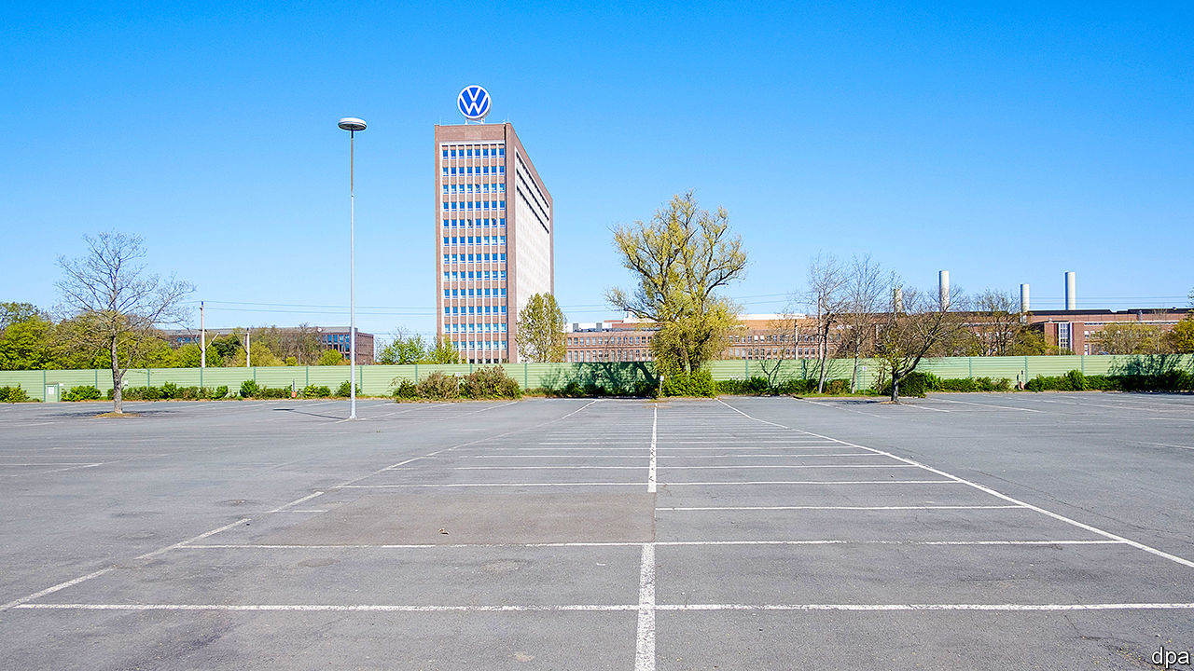

WHEN CARMAKERS sold 95m cars and commercial vehicles in 2017 the 100m mark seemed just around the corner. After a disappointing 2018 and 2019, this year was forecast to be a turning point. And it will be—in the wrong direction. As governments around the world have ordered factories to close and locked-down buyers put off purchases, car sales are expected to plummet by a fifth (see chart 1), to a level last seen in the depths of the global financial crisis of 2007-09. A feared second wave of covid-19 makes prospects for 2021 uncertain. The industry, already facing a precarious and colossally expensive shift to electric cars, will emerge from the pandemic transformed—not necessarily for the better.

Most carmakers were fitter going into this crisis than the last recession a decade ago. Back then America’s General Motors (GM) and Chrysler entered bankruptcy and needed bail-outs. This time balance-sheets looked stronger, costs had been tamed and firms had restructured to concentrate on profitable businesses. Nothing, though, prepared them for the coronavirus. First China and then the world went into lockdown. Car firms, parts suppliers, showrooms and repair shops shut.

The immediate concern is survival. Firms are tapping old and new credit lines despite high borrowing costs. Ford, an American firm, is paying a punishing 9% interest on its newly issued bonds. The price of insuring its debt against default has soared since December. Other companies, too, have seen their creditworthiness increasingly questioned.

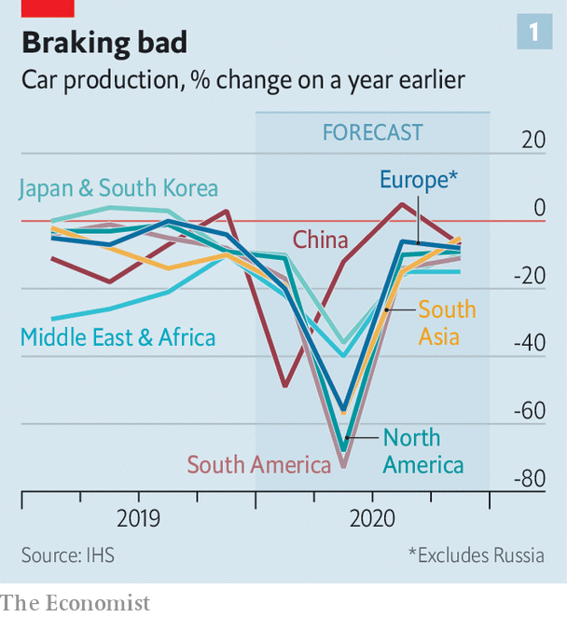

They have no choice but to borrow. Credit Suisse, a bank, expects GM and Ford to burn through $10bn and $14bn of cash, respectively, in the first half of 2020. France’s PSA Group, which reported first-quarter results on April 21st, and enjoyed record profitability before production stopped, used up €4bn ($4.4bn) of cash between January and March, leaving it with gross liquidity of €19bn. Analysts at Jefferies, a bank, estimate that the eight biggest carmakers in Europe and America could, in all, burn over $50bn of cash in the second quarter. At that rate, they may run out of money by the end of the year (see chart 2).

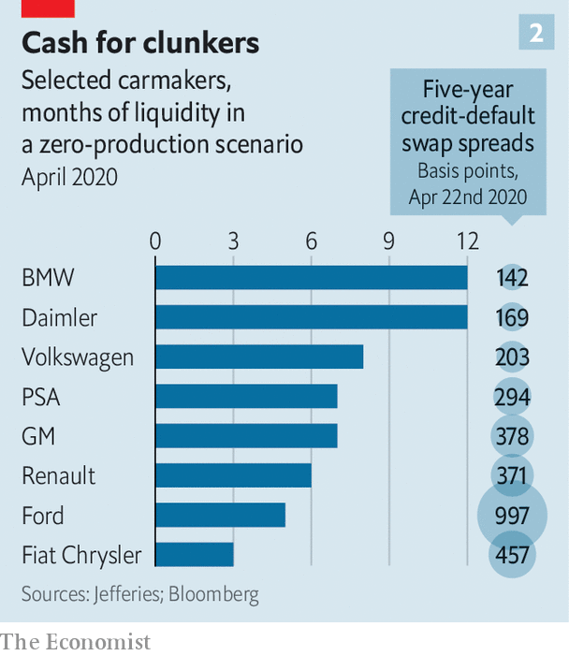

Companies are cancelling dividends and begging governments for assistance. Across the rich world governments will pay furloughed workers, whose wages eat up around 15% of car firms’ revenues, according to Morgan Stanley, a bank. In Germany Volkswagen, BMW and Daimler will use a videoconference with Angela Merkel on May 5th to implore the chancellor to revive a “cash-for-clunkers” scheme like the one introduced after the financial crisis.

At least factories are opening after having been shut for weeks. Those in China are already up and running. Chinese dealerships are, too. Early signs offer some encouragement. Chinese sales collapsed by 80% in February, year on year, according to the China Passenger Car Association, an industry body. In March they were down by two-fifths—still dismal but less so. April promises to be better. In the first 19 days of the month sales were down by just 7% from the same period last year.

Even if sales recover, scars will remain. Capacity utilisation in Chinese factories was already low by global standards, at 75%. It is surely even lower now—possibly below the 65% that, according to an industry rule of thumb, carmakers need to break even. Social distancing is hard on an assembly line, where even highly automated procedures, such as robotically attaching windscreens, require half a dozen workers in attendance.

Labour shortages caused by illness, the need for more deep-cleaning and other safety measures will be a drag on firms’ productivity for a while. VW, one of several European firms that will slowly restart from April 27th, will use experience from reopening 32 of its 33 plants in China. Its 100-point plan will safeguard workers’ health—but make their jobs harder.

Bigger question-marks hang over the supply chain. Natural disasters such as a devastating earthquake and tsunami in Japan in 2011 taught car companies to diversify their suppliers and have alternatives to fall back on. But not all parts can be sourced from several parts-makers. As Matteo Fini of IHS Markit explains, bulky ones like door panels tend to be made close to factories, where you are unlikely to find multiple producers. Doubling up capacity for those that require pricey tooling, such as dashboards, is prohibitively expensive.

Suppliers are also financially feebler than the carmakers they serve. AlixPartners, a consultancy, finds that nearly a quarter of 400-odd stockmarket-listed parts-makers face immediate cash shortfalls. Continental, a German producer of everything automotive from electronics to tyres, which itself supplies carmakers, warned that dozens of its suppliers are on the brink. Without parts and people, factories cannot run at full steam.

## Turning back the clock

The depressing mix of stifled production and uncertain future sales will crimp profits. Margins were under pressure before the pandemic slump, in part owing to investments in electric vehicles (EVs), particularly in Europe, where emissions targets are tightening. Now capital spending and research-and-development budgets are under review. The thorny question of what resources to allocate to EVs and other future technologies has gained new urgency.

In the words of Dan Levy of Credit Suisse, the industry is running on “two clocks”. The first marks time in the near term, when investment in fossil-fuelled vehicles, which provide the bulk of profits, has to continue, not least to ensure that firms have money to invest in electric ones (as well as self-driving cars and mobility services). On this clock companies will keep selling EVs at a loss for several years. On the second, longer-term clock, battery prices will fall enough to ensure profitability (see [article](https://www.economist.com/briefing/2020/04/25/lithium-remains-the-car-battery-material-of-choice)). But margins on EVs may not match those of conventional automobiles for a while, if ever.

Herbert Diess, VW’s boss, alluded to the complicated equation when he said in January that the car industry would have to “slaughter some sacred cows”. VW has made a start with the industry’s biggest bet on the future, vowing to plough €60bn into EVs and other new technologies over the next five years.

The question is whether motorists are interested. The take-up of electric cars has been slow except in China, where the government has lavished subsidies on the technology to turn its carmakers into world leaders. In Europe, where consumers worry about range, charging infrastructure and cost, only two in every 100 cars sold last year ran on pure battery power.

Carmakers have not (yet) asked for relief from Europe’s tougher emissions rules, so the proportion of EV sales will have to rise (it may not in America, however, where emissions standards were recently relaxed). But buyers will be pulled in two directions, says Andrew Bergbaum of AlixPartners. The pleasure of breathing cleaner city air during lockdowns may persuade some to go for EVs. Many others will hold on to older petrol cars for longer—especially with falling oil prices, a glut of cheap second-hand cars foreclosed from unpaid leases and fewer incentives from cash-strapped governments to buy electric.

Covid-19 may, then, slow electrification—but will not derail it. Car firms must sooner or later press ahead with efforts to make EVs profitable. Some are pooling resources in areas where profits are highest. GM’s decision to sell its loss-making Opel unit to PSA in 2017 and get out of Europe was an early example. The mega-merger announced last year between PSA, which has turned a profit at Opel by wrapping it in its larger European business, and Fiat Chrysler is still on track. (The chairman of Fiat Chrysler, John Elkann, sits on the board of The Economist’s parent company.)

More consolidation looks certain, though perhaps not through full mergers, which have a mixed record in carmaking. Investors would welcome efforts to reduce the duplication of investment, which has long depressed returns. They can expect more alliances to pool scarce resources, such as one announced last year by BMW and Jaguar Land Rover to jointly develop EVs. Another between Ford and VW to share electrification costs could become more intimate. Morgan Stanley sees “no limit” to their collaboration. Patrick Hummel of UBS thinks that even joint development of next-generation petrol engines may make sense. Alliances, though, are complicated. The biggest, between Renault and two Japanese firms, Nissan and Mitsubishi, may finally snap under the strain of coronavirus.

## Elongated

The pandemic will not hurt everyone equally. Tesla in particular has had a good crisis. The electric-carmaker enjoys a big backlog of orders, enough liquidity to see it through the downturn—and no petrol-engine legacy to shed. Its share price has regained ground since a dip in March. Only Toyota has a higher market capitalisation.

The Japanese giant and VW, which make roughly 10m cars each annually, should weather the storm. Chinese companies may look for cheap bargains abroad. Two of them, Geely and BAIC, already hold big stakes in Daimler (maker of Mercedes cars), which does not have strategic shareholders of the sort that protect VW and BMW from takeover. Mass-market firms, mostly operating on wafer-thin margins, will struggle. Taxpayers look likely to prop up some weaklings, like Renault.

The biggest concern may be that the virus changes attitudes to cars. On the one hand, fear of infection may put commuters off trains, buses or ride-hailing, and into automobiles. On the other, more home-working may reduce commuting of any kind, including with your own set of wheels. A prolonged recession could damage sales for good. Carmakers of the future may yet look back nostalgically to 2017 as their industry’s peak. ■

This article was downloaded by calibre from <https://www.economist.com/briefing/2020/04/23/the-worlds-car-giants-need-to-move-fast-and-break-things>

|  |  |  |  |
| --- | --- | --- | --- |
| Previous | Articles | Sections | Next |

|  |  |  |  |
| --- | --- | --- | --- |
| Previous | Articles | Sections | Next |

#### Charging up for a long ride

# Lithium remains the car-battery material of choice

But future designs may have double the storage

Apr 23rd 2020 |

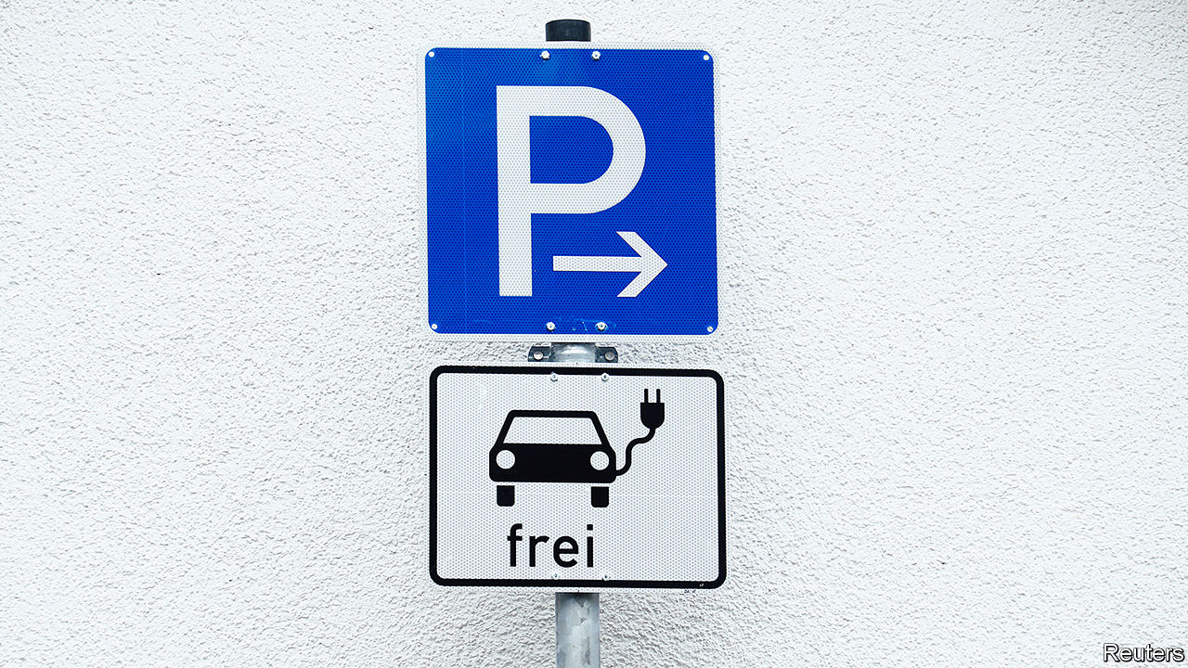

WHEN, A DECADE ago, a new generation of electric vehicles (EVs) started to appear on the roads, researchers at the Georgia Institute of Technology spent a year tracking the habits of almost 500 American motorists to see how suitable such vehicles would be for them. Nearly a third, they found, could have completed most of their journeys using an EV with a range of only 100 miles (160km). On the half a dozen or so occasions that people needed to travel farther, they could have charged up en route, or hired a petrol-powered car.

These days, things are better. Many EVs are able to travel more than twice that distance on a single charge—and some big and expensive models can manage 400km or so. Still, a lot of potential buyers worry about running out of juice. The long-range batteries that would settle their nerves are coming, but a few pot-holes await.

The batteries that have made electric cars possible are composed of lithium-ion (Li-ion) cells—a design commercialised by Sony in 1991. What makes Li-ion batteries special is their high energy-storage capacity. A modern one is able to pack 200 watt-hours of electrical potential into a single kilogram of kit, for an energy density of 200Wh/kg. That is a fivefold improvement on the old lead-acid battery—and researchers are constantly fiddling to do better.

Li-ion cells get their name from the movement within them of lithium ions (lithium atoms with a missing electron, and so a positive electrical charge). When such a cell is discharging, the ions are created at one electrode, the anode. They then shuttle, via a separator which only they can pass, through a liquid electrolyte to a second electrode, the cathode. The electrons stripped away at the anode, meanwhile, travel towards the cathode along an external electrical circuit. This creates a current that can be used to power an electric motor. At the cathode, ions and electrons are re-united—and remain so until the battery is plugged into a charger and the whole process is reversed.

Handily for weight-sensitive applications like cars, Lithium is the lightest metal in the periodic table. But it is also reactive. The cells need careful construction to avoid flaws that can cause short circuits, and possibly a fire. Anodes usually consist of a carbon-rich material. The lithium in the cathode tends to be part of an oxide, typically lithium cobalt oxide. Cobalt is the costliest material in the battery and producers are trying to reduce its use. A lot of cobalt also comes from the Democratic Republic of Congo, where conditions for miners are grim. One popular way of reducing cobalt use is by replacing some of it with nickel and manganese, to produce what are known as NMC cells.

Last year China’s biggest maker of electric-car batteries, CATL, began the mass production of NMC batteries with an energy density of 240Wh/kg. Some other firms, including Tesla, hope to go further and get rid of cobalt altogether—though in Tesla’s case they are cagey about the details. Reducing the cost of materials, together with economies of scale from the huge factories that CATL, Tesla and their rivals operate, are steadily bringing down the price of batteries. In 2010, according to BloombergNEF, a research firm, that price averaged $1,160 per kWh. By 2024 it may drop below $100 (see chart). At that point EVs will be more competitive with combustion-engined cars.

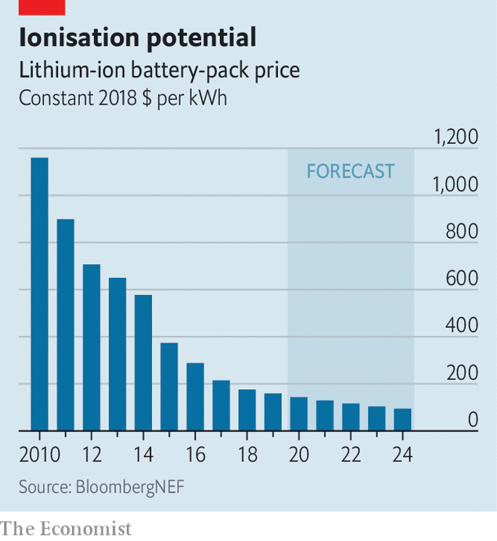

As for greater range, many people in the field are pinning their hopes on batteries that have solid rather than liquid electrolytes. Lithium ions can tunnel through certain solid electrolytes. Such cells would be safer and provide the possibility of using other electrode materials for much higher energy densities. Among the latest of these solid-state proposals is a design developed at Samsung’s research laboratories in South Korea and Japan by a group led by Dongmin Im. This uses an NMC cathode, an anode made of a composite of silver and carbon, and a solid electrolyte based on a substance called argyrodite that is a compound of silver, germanium and sulphur.

According to a paper the team published in March, these cells have an energy density of 900Wh per litre. That means they have double the capacity, for a given volume, of a conventional Li-ion cell. The group estimate the cell delivers 430Wh/kg, which would power an electric car for something like 800km. And argyrodite cells do not grow damaging needle-like crystals called dendrites, which can develop while Li-ion cells charge.

This battery should be “more cost-effective” than current cells, the team reckons. Unfortunately for actual motorists, they are unable to say when or how it could be mass-produced. This is a common problem with such devices. Arumugam Manthiram, a battery expert at the University of Texas at Austin, points to two main obstacles in the way of solid-state batteries.

First, two solids placed face to face have only limited points of contact through which ions can pass between electrode and electrolyte. Contact between a liquid and a solid is, by contrast, continuous. One way to overcome this is to use a polymer electrolyte that is flexible enough to conform itself to the surface of a solid electrode. Alas, as Dr Manthiram observes, “We do not yet have a good polymer electrolyte.”

The second problem is manufacturing. Many solid electrolytes are ceramics, and so brittle. That makes them tricky to produce in large sheets. Polymers avoid this. But they face the original problem.

Moreover, newish though it is, the Li-ion technology is well established enough for vested interests to exist. Shifting from liquid to solid electrolytes would mean building a lot of expensive new plant. Developing better liquid electrolytes, and new electrodes to match them, may be the surest route towards safer, more powerful Li-ion batteries. ■

This article was downloaded by calibre from <https://www.economist.com/briefing/2020/04/23/lithium-remains-the-car-battery-material-of-choice>

|  |  |  |  |
| --- | --- | --- | --- |
| Previous | Articles | Sections | Next |

|  |  |  |
| --- | --- | --- |
| Briefing | Sections | The Americas |

United States

Reopening America: Stir craziness

.

Environmental regulation: Mercury rising

.

Biodefence: Spore wars

.

The Hua-war: Some body to hold

.

Catholic voters: Cathechismic

.

Lexington: The limits of energy independence

.

|  |  |  |
| --- | --- | --- |
| Briefing | Sections | The Americas |

|  |  |  |  |
| --- | --- | --- | --- |
|  | Articles | Sections | Next |

#### Stir-craziness

# America begins easing restrictions

The country is adopting a half-in, half-out approach to lockdowns

Apr 23rd 2020 | WASHINGTON, DC

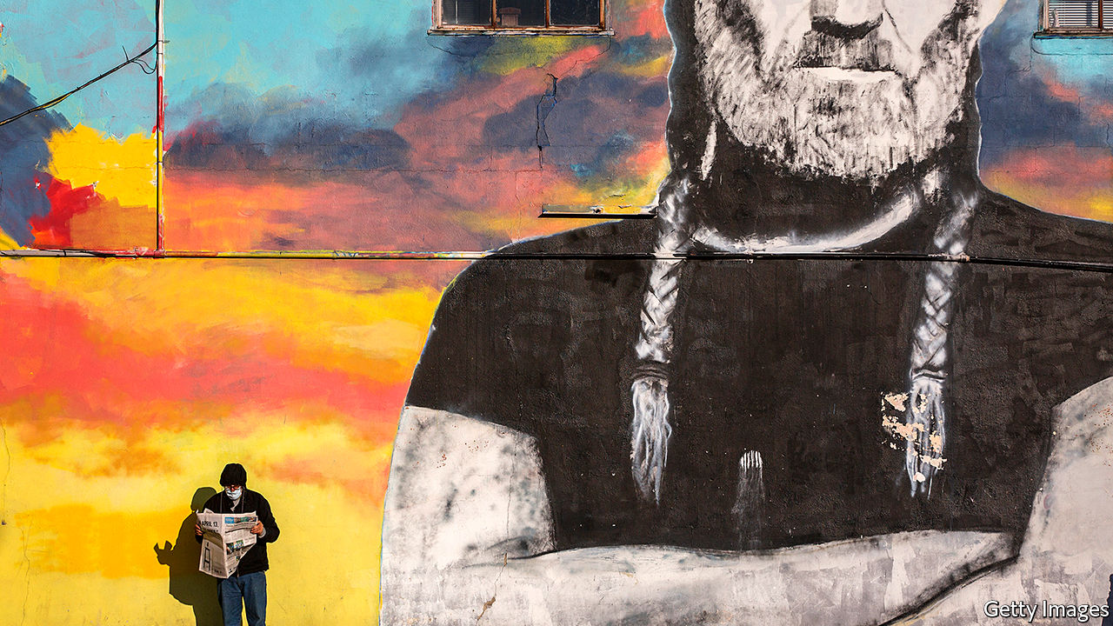

Editor’s note: The Economist is making some of its most important coverage of the covid-19 pandemic freely available to readers of The Economist Today, our daily newsletter. To receive it, register [here](https://www.economist.com/newslettersignup). For our coronavirus tracker and more coverage, see our [hub](https://www.economist.com/coronavirus)

“WE ARE starting our life again,” said President Donald Trump on April 16th, as he unveiled the federal government’s plan to reopen America. The next day Greg Abbott, Texas’s governor, echoed the president’s optimism. “We have demonstrated that we can corral the coronavirus,” he said. (That same day Texas reported 916 new covid-19 cases, roughly in line with the previous week.) Mr Abbott is gradually reopening his state; his stay-at-home order will expire on April 30th.

Other Republican governors have followed suit. South Carolinians returned to beaches and shops this week. Georgia’s governor planned to let barbershops, hair salons and gyms reopen by April 24th, with restaurants and cinemas opening the Monday after. Bill Lee, Tennessee’s governor, will let his stay-at-home order expire on April 30th. They are all models of prudence compared with Ron DeSantis, Florida’s governor, who deemed pro wrestling an “essential business” and allowed beaches to fill with crowds. Democratic and independent minded Republican governors, meanwhile, have been more circumspect.

The point of the lockdown was to accept short-term economic pain as the price of getting the virus under control. Ideally it would ease once the country brought its infection rate down, and prepared itself—through widespread testing, an army of contact-tracers and infrastructure to support extended isolation and quarantine—to box in future outbreaks. America currently has none of the above. And, because viruses and people can easily cross state lines, an America in which Democratic governors keep citizens at home while Republicans do not risks the worst of both worlds: poorly controlled spread requiring repeated future lockdowns, which extend economic pain and uncertainty.

The handmaiden of eagerness is partially justified optimism. Just one month ago an epidemiological model warned that covid-19 could kill 2.2m Americans. Mr Trump has said that keeping American deaths under 200,000 would constitute “a very good job.” Thus far about 47,000 have died. Some hotspots have begun bringing the disease to heel. There seem to be fewer sirens screaming towards Elmhurst Hospital in Queens, the centre of New York’s outbreak. On April 20th the state reported its fewest new cases in a month, and the death toll was below 500 for the first time in weeks. A Gallup poll showed that the share of Americans who think things are improving rose between early and late April.

But these developments testify to the success of social distancing. Abandoning it now risks being like throwing away an umbrella in a rainstorm because it has stopped its bearer from getting soaked—particularly because America seems unprepared for the next stage of the fight. A recent report from Harvard’s Safra Centre for Ethics suggests that to safely and fully reopen, America needs 5m tests per day by early June—six weeks from now—and 20m by late July. That figure would let local health authorities swiftly catch and isolate asymptomatic transmitters whose jobs put them in contact with vulnerable populations—nursing-home or health-care workers, for instance—or who cannot isolate themselves (people in jails and prisons). Ashish Jha, who heads Harvard’s Global Health Institute, argues that 500,000 tests per day is an acceptable minimum.

Throughout April the number of daily tests has averaged around 150,000, with the share of positive tests staying around 20%. That suggests America is testing only people who are probably infected (in Taiwan, for instance, one in every 132 tests is positive), which in turn suggests that many mild or asymptomatic cases are going undetected. America may have 15 to 20 times more actual infected people than confirmed cases. Material shortages and laboratory backlogs, not helped by a lack of co-ordination and sharply increased demand, have hampered America’s testing capacity. Mr Trump’s repeated reassurance that anyone who wants a test can get one seems to have stopped firms from making tests in sufficient quantity (everyone assumed someone else was doing it). Those problems seem solvable, but only with decisive, concerted federal action.

America also has a shortage of contact-tracers—people who investigate where someone caught the disease and who else he may have infected. Tom Frieden, who headed the Centres for Disease Control (CDC) until 2017, believes America needs 300,000. It currently has around 2,200. Some states and cities have begun training more, but not nearly enough (Wuhan alone had 9,000). America also lacks places to isolate the infected so they do not spread the virus to their families and neighbours.

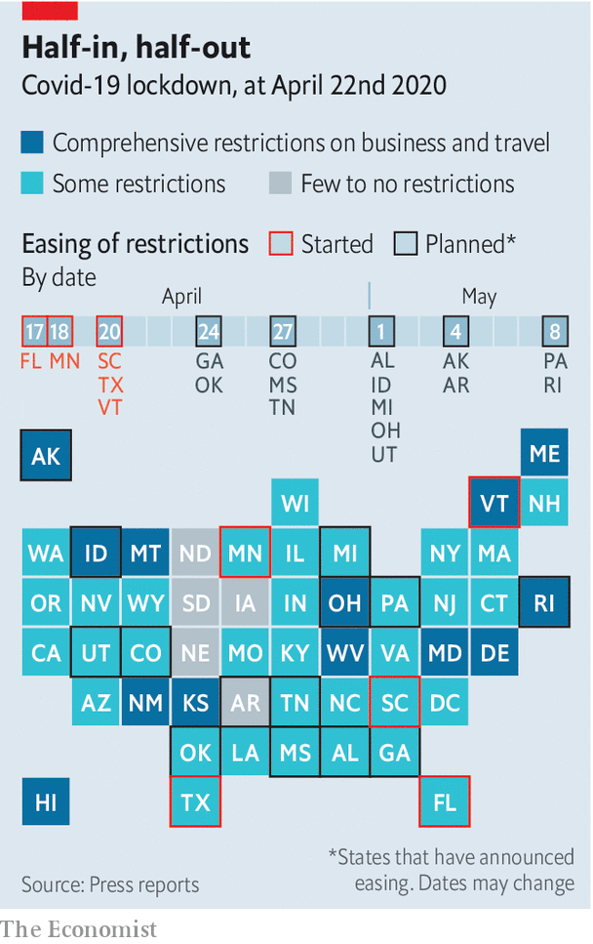

Indeed, the federal government’s own guidelines suggest that before a state reopens, it should see a declining number of covid-19 cases and positive tests over 14 days, and have in place a “robust testing programme”—criteria that none of the reopening states satisfies. Yet throughout the pandemic Mr Trump has played both sides: appearing onstage nightly with public-health experts and chastising Georgia’s governor for reopening too soon, while also encouraging anti-lockdown protesters on Twitter; claiming “total” authority while also saying, “I don’t take responsibility at all.” He seems to want to reap any public-health gains from the lockdown while forcing governors to accept culpability for any economic hardship.

Perhaps the opening southern states will suffer no ill effects. Some lifting of restrictions make sense—Texas has opened some state parks, for instance, but only for daytime use, and visitors must make reservations, wear masks and not gather in groups of more than five people. South Carolina’s governor requires shops to admit no more than five people per 1,000 square feet, and follow CDC sanitation practices. Perhaps the virus will fade in warm weather, or mutate to become less dangerous. But, as Mr Frieden says, “it will be a trial-and-error experiment, and the errors can result in lost lives” (see article).

Should that happen—should Texans and Georgians fall ill and look balefully northward, or blame their Trump-aligned governors—Mr Trump has pre-emptively found a scapegoat. On April 20th he announced, “In light of the attack from the Invisible Enemy...I will be signing an Executive Order to temporarily suspend immigration into the United States!” In practice this will not change much. With visa-processing at embassies suspended, the northern and southern borders shut to non-essential travel and court dates for asylum-seekers postponed, immigration has already slowed to a trickle. Court challenges will start before Mr Trump’s signature on the executive order is dry.

Keeping immigrants out will not make the country healthier. Although immigrants comprise 14% of America’s population, they account for nearly 30% of its doctors. Yet the president is arguing in a different register. He may not be able to control the virus, but he has more power to choose the territory where the election is fought. Natives versus foreigners worked well in the past—why not try it again?■

Dig deeper:  
For our latest coverage of the covid-19 pandemic, register for The Economist Today, our daily [newsletter](https://www.economist.com/newslettersignup), or visit our [coronavirus tracker and story hub](https://www.economist.com/coronavirus)

This article was downloaded by calibre from <https://www.economist.com/united-states/2020/04/23/america-begins-easing-restrictions>

|  |  |  |  |
| --- | --- | --- | --- |
|  | Articles | Sections | Next |

|  |  |  |  |
| --- | --- | --- | --- |
| Previous | Articles | Sections | Next |

#### Mercury rising

# Think a respiratory virus pandemic is a good time to cut air-quality regulations?

If so, the White House agrees with you

Apr 23rd 2020 | WASHINGTON, DC

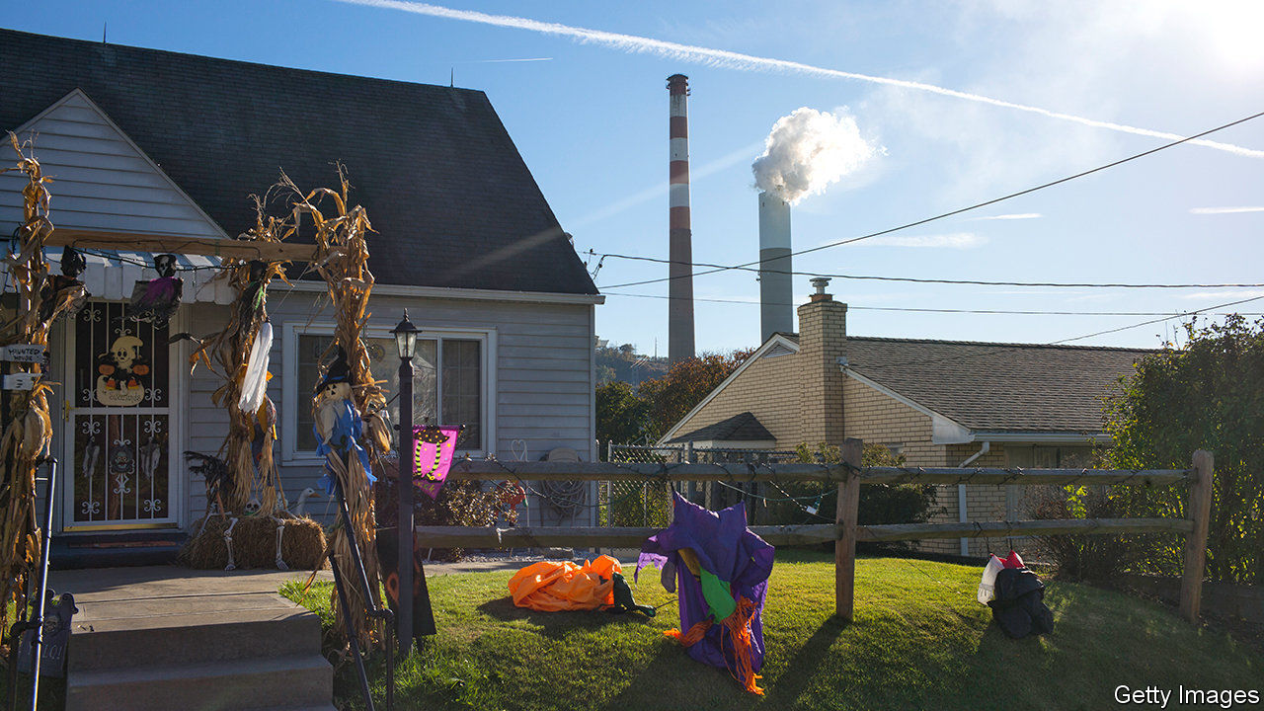

Editor’s note: The Economist is making some of its most important coverage of the covid-19 pandemic freely available to readers of The Economist Today, our daily newsletter. To receive it, register [here](https://www.economist.com/newslettersignup). For our coronavirus tracker and more coverage, see our [hub](https://www.economist.com/coronavirus)

IS THE MIDDLE of a global pandemic of covid-19, a respiratory illness, a sensible time for America to roll back air-pollution regulations? The White House seems to think so. On April 16th the Environmental Protection Agency (EPA) issued a final recommendation that it was no longer “appropriate and necessary” to regulate the emissions of mercury and other toxins from coal- and oil-fired power plants. Though existing limits remain in place for now, they could well be challenged in court and struck down. Excessive exposure to mercury in utero produces birth defects and lifelong brain damage in children.

The mercury move is not an aberration. Two weeks before, on March 31st, as the country was transfixed by covid-19, the EPA and a federal transport agency finalised another deregulation—this one to substantially cut fuel-efficiency standards for future fleets of cars. If these rules ever come into force, and there will be legal challenges to them, they would be consequential. The laxer car rules will, according to the government’s own projections, lead to an additional 923m tonnes of carbon-dioxide emissions. Given that the country as a whole emitted 5.4bn tonnes in 2018, the effect would be considerable.

Though the two actions represent a continuation of Donald Trump’s effort to unravel existing environmental regulations of all kinds, the rush now may be prompted by a more concrete concern: a somewhat arcane law known as the Congressional Review Act. This allows Congress to revoke recently issued regulations without going through the typically lengthy bureaucratic fuss. Before Mr Trump’s presidency, the rule had been used just once before. But in the early days of his administration, the Republican-led Congress used it to great effect—cancelling Obama-era rules on the environment, labour and consumer protection. The administration seems to be rushing now to inoculate its actions against future repeal, says Ann Carlson, a professor of environmental law at the University of California, Los Angeles.

Any new regulations—including repeals—must be rigorously costed, or else they risk being overturned in the courts. The environmental rules that the Trump administration is rewriting were signed just a few years ago. Their costings then showed social benefits vastly exceeding the compliance costs.

To show the opposite now, the Trump administration is employing funny maths. The direct benefits of mercury-pollution reduction are counted very narrowly (only for the children of recreational freshwater fishermen), while the side benefits of pollution controls (such as reduced emissions of particulate fine matter which is especially damaging to human lungs) are not counted. Similar head-scratching assumptions plague the justifications for reduced car-emissions standards. In both cases the EPA’s own scientific advisory board wrote long critiques of the methodologies used, which seem to have roundly ignored.

Carmakers have tepidly welcomed the reduced fuel-economy standards, which will oblige cars to become 1.5% more efficient each year (measured by miles per gallon) instead of 5%. Electricity utilities have ranged from receptive to outright hostile to the mercury-rule decision—in part because they have already implemented the costly pollution controls.

The benefits of these rules, which the EPA maintains should not be considered, are also of unfortunately topical importance. Scientists at Harvard have noted that increased exposure, of one microgram per cubic metre, to the fine particulate matter generated by cars and power plants in American counties is associated with a 15% rise in covid-19 deaths. The consequences add up, even if the EPA does not.■

Dig deeper:  
For our latest coverage of the covid-19 pandemic, register for The Economist Today, our daily [newsletter](https://www.economist.com/newslettersignup), or visit our [coronavirus tracker and story hub](https://www.economist.com/coronavirus)

This article was downloaded by calibre from <https://www.economist.com/united-states/2020/04/23/think-a-respiratory-virus-pandemic-is-a-good-time-to-cut-air-quality-regulations>

|  |  |  |  |
| --- | --- | --- | --- |
| Previous | Articles | Sections | Next |

|  |  |  |  |
| --- | --- | --- | --- |
| Previous | Articles | Sections | Next |

#### Spore wars

# The havoc wrought by covid-19 will spark new concern over bio-weapons

In theory they are banned, but some countries produce them covertly

Apr 23rd 2020 |

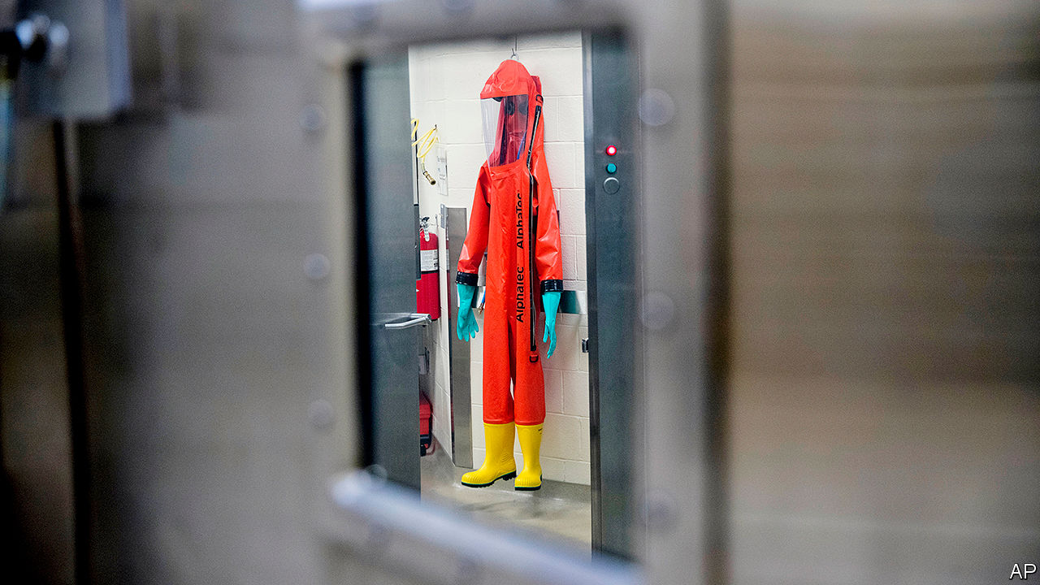

Editor’s note: The Economist is making some of its most important coverage of the covid-19 pandemic freely available to readers of The Economist Today, our daily newsletter. To receive it, register [here](https://www.economist.com/newslettersignup). For our coronavirus tracker and more coverage, see our [hub](https://www.economist.com/coronavirus)

THE CORONAVIRUS that has killed over 180,000 people worldwide was not created with malice. Analysis of its genome suggests that, like many new pathogens, it originated by natural selection rather than human design. But if SARS-COV-2 had been deliberately engineered or launched into the world by malefactors, the consequences might have been much the same. “Covid-19 has demonstrated the vulnerability of the US and global economy to biological threats, which exponentially increases the potential impact of an attack,” says Richard Pilch of the Middlebury Institute of International Studies. Those concerns are prompting renewed interest in the threat from biological weapons, a lurid corner of warfare that normally languishes in happy obscurity.

In theory, bioweapons are banned. Most countries in the world are party to the Biological Weapons Convention (BWC) of 1975, which outlaws making or stockpiling biological agents for anything other than peaceful purposes. But some countries probably make them secretly, or keep the option close at hand. America accuses North Korea of maintaining an offensive biological-weapons programme, and alleges that China, Iran and Russia dabble in dual-use research. Toxins like ricin have also been bought and sold on shady recesses of the internet known as the dark web.

Germ warfare briefly rose to prominence in September 2001, when letters laced with anthrax spores were mailed to American news organisations and senators, killing five people. That was a wake-up call. Public health became part of national security. BioWatch, a network of aerosol sensors, was installed in more than 30 cities across America. But in recent years threats from chemical weapons, like the sarin dropped by Syria’s air force and the Novichok smeared on door handles by Russian assassins, took priority.

Though the Trump administration published a national biodefence strategy in 2018, it shut down the National Security Council’s relevant directorate and proposed cuts to the laboratories that would test for biological threats. Funding for civilian biosecurity fell 27% between fiscal years 2015 and 2019, down to $1.61bn—less than was spent on buying Black Hawk helicopters. “It’s the kind of thing that’s very easy to cut where you don’t see the damage you’re doing until you’re in a situation like this,” says Gigi Gronvall of the Johns Hopkins Centre for Health Security.

Biological weapons are now likely to rise up the agenda, though the lessons from covid-19 are not clear-cut. The Department of Homeland Security warns that extremist groups have sought to spread the virus deliberately, and Mr Pilch says that it “has challenged some long-standing assumptions regarding what biological agent may be used as a weapon”. Yet many pathogens used as weapons tend to differ from respiratory viruses in important ways.

Those like anthrax, caused by bacteria which form rugged and sprayable spores, but do not spread from human to human, have the advantage of minimising the risk of rebound to the attacker. With the notable exception of smallpox—a highly contagious and lethal virus that was eradicated in 1979 but preserved by the Soviet Union for use against America (but not Europe), and now exists only in two laboratories, in America and Russia—most biological weapons would therefore have more localised effects than the new coronavirus.

Even so, the slow and stuttering response to the pandemic has exposed great weaknesses in how governments would cope. “This outbreak has put stress on pretty much every element you need to respond to a biological attack,” says Gregory Koblentz of George Mason University, “and yet what we’re seeing is every part of our public-health infrastructure is either broken or stretched to the max.” The centrepiece of America’s biosurveillance programme, a network of laboratories designed for rapid testing, failed, says Mr Koblentz, while the national stockpile of face masks had not been substantially replenished in over a decade. Would-be attackers will take note.

Governments are also worried about a new generation of biological threats. In 2016 American intelligence agencies singled out genome editing as a national-security threat for the first time. Two years later a major study by the National Academies of Sciences, Engineering, and Medicine warned that synthetic biology, a potent set of methods for tinkering with or creating organisms, could, in time, be used to re-create viruses like smallpox or make existing pathogens more dangerous, such as resistant to antibiotics.

In 2011 Dutch and Japanese scientists said that they had created a version of bird flu that could be transmitted between mammals by the respiratory route—an announcement that prompted the Netherlands to treat the relevant academic papers as sensitive goods subject to export controls. In January Canadian scientists funded by an American biotech company used synthetic DNA from Germany to synthesise a microbe closely related to smallpox, indicating the ease with which it could be done. “If a potential bad actor pursues a weapons capability using SARS-COV-2, the virus is now attainable in laboratories all around the world, and blueprints for assembling it from scratch have been published in the scientific literature,” notes Mr Pilch.

The trouble is that biodefence has evolved slowly, says Dan Kaszeta, a former biological weapons adviser to the White House. Compact devices that can detect chemical threats and warn soldiers to don a gas mask have long been available. “That doesn’t exist for anthrax or any of the other aerosol pathogens,” says Mr Kaszeta. “Telling the difference between an anthrax spore and a bit of tree pollen is not something you can do in a couple of seconds.”

Internationally, the issue is largely neglected. “There’s no single facilitator in the UN system for a high-consequence biological event of unknown origin,” says Beth Cameron of the Nuclear Threat Initiative, an NGO. The BWC, she says, operates on a “shoe-string budget”.

Military labs across the world are already heavily involved in the fight against covid-19, but government money is a drop in the ocean compared with the billions of dollars of private funds now being unleashed against the virus. One hope is that the crash efforts to develop better tests and a vaccine may yield so-called platform technologies that would have utility not only against coronavirus, but also a wide range of other biological threats. Anthrax, for instance, has a vaccine but requires a cumbersome five doses. The “holy grail”, says Mr Kaszeta, would be a broad-spectrum antiviral or vaccine—a shield against natural and human foes alike.■

Dig deeper:  
For our latest coverage of the covid-19 pandemic, register for The Economist Today, our daily [newsletter](https://www.economist.com/newslettersignup), or visit our [coronavirus tracker and story hub](https://www.economist.com/coronavirus)

This article was downloaded by calibre from <https://www.economist.com/united-states/2020/04/23/the-havoc-wrought-by-covid-19-will-spark-new-concern-over-bio-weapons>

|  |  |  |  |
| --- | --- | --- | --- |
| Previous | Articles | Sections | Next |

|  |  |  |  |
| --- | --- | --- | --- |
| Previous | Articles | Sections | Next |

#### Some body to hold

# The fight with Huawei means America can’t shape tech rules

The protocols for the future are being written in standards bodies that US companies cannot attend

Apr 23rd 2020 |

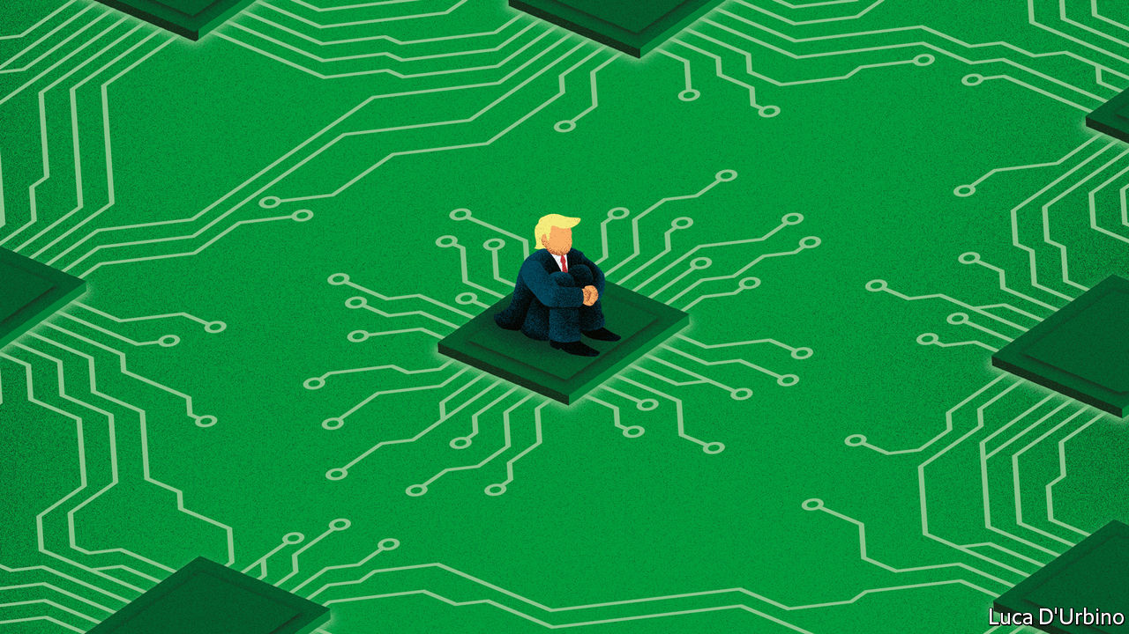

THE PROCESS of setting standards attracts little attention, probably because it is very boring. Its magi gather regularly to seek consensus on mind-numbing technical details for the running of things like cell phone networks, artificial intelligence services and global shipping. Meetings are arranged through bodies with names like ISO (International Organisation for Standardisation) or 5GAA (the 5G Automotive Association, a specialist body focused on building 5G connectivity into autonomous cars). There are hundreds of these things.

Standards are important, despite appearances. The internet protocol, written by Vint Cerf and Bob Kahn in California in 1973, is the fundamental standard on which the rest of the internet runs. Mr Cerf now works for Google, and America holds significant sway over the net. Those who set the rules for a piece of technical infrastructure, such as the internet, gain power over its future workings. This is why America worries about China’s growing contributions to standards for 5G networks and other technologies. Yet for the past year technology companies with operations in America have been frozen out of some standard-setting as an accidental consequence of the American government’s attack on the Chinese tech giant, Huawei.

This started with the addition of Huawei to the entity list in May 2019. That made it illegal for any company to export products to Huawei that had been made in America. Tech-company lawyers looked at the regulations and decided that the law prohibited interaction with Huawei during the course of standard-setting, too. They worried that, in the course of discussion, American-made technologies would in effect be transferred to Huawei, placing their employer in breach of the rules.

That legal decision created a problem. Huawei plays a big role in setting standards on artificial intelligence, 5G and other connectivity technologies, so avoiding interactions with the firm while simultaneously getting involved in the rigorous nerdery of standard-setting was impossible. As a result, some companies with American operations have removed themselves from the standard-setting processes in which they used to join. In areas where Huawei is active, this has left America voiceless in setting the tech rules of the future.

The effect has been particularly acute at standards bodies that convene outside America, where the organisers are less inclined to make arrangements to accommodate firms that are subject to export-control rules. At those meetings, in some instances, Huawei and other Chinese companies have had a voice where American companies have not. Some, such as 3GPP, a body that deals with 5G, and IEEE, an engineering body, have declared themselves to be “open” meetings, in an attempt to remove liability from firms with American operations. But uncertainty persists.

Standards bodies with American operations, such as the Wi-Fi Alliance in Austin, Texas, or the Bluetooth Special Interest Group in Kirkland, Washington, have faced their own version of the problem. Some have excluded Huawei. While this does mean that American companies can take part in Huawei-free discussions, it threatens to undermine the standards bodies’ legitimacy as the single forum for the issues they cover. There is talk of competing bodies being set up outside America, to make truly global discussion possible.

American lawmakers have noticed. On April 14th a group of Republican senators wrote to the Departments of Commerce, Defence, Energy and State fretting that American companies had been locked out of standards discussions on 5G and urging the departments to fix it. The senators said they were “deeply concerned” about the loss of soft power America derives from standard-setting by American companies.

Few in Washington disagree, yet the fix is not straightforward. Tweaking rules in favour of engagement with Huawei is politically unpalatable, even when that engagement is in forums as innocuous and dull as standards bodies. Meanwhile, Huawei is still building 5G networks around the world, networks which will carry the whizzy internet services of the future. And for almost a year, by its own hand, America’s best companies have been frozen out of discussions which define that future.■

This article was downloaded by calibre from <https://www.economist.com/united-states/2020/04/23/the-fight-with-huawei-means-america-cant-shape-tech-rules>

|  |  |  |  |
| --- | --- | --- | --- |
| Previous | Articles | Sections | Next |

|  |  |  |  |
| --- | --- | --- | --- |
| Previous | Articles | Sections | Next |

#### Cathechismic

# The Trump campaign makes its pitch to Catholic voters

Abortion may not be the clinching argument it once was

Apr 23rd 2020 | WASHINGTON, DC

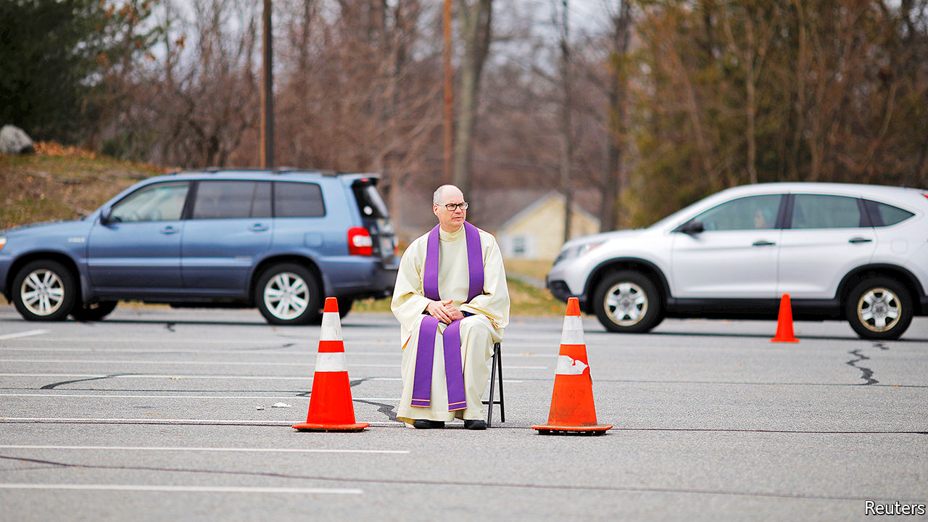

THE TRUMP CAMPAIGN’S big push to woo Catholics, who helped elect the president in 2016, did not get off to a great start in 2020. Even before the kick-off rally for “Catholics for Trump”, scheduled for mid-March, became one of the first political casualties of social distancing, a high-profile church leader in an important swing state had given the outfit a gentle kicking. On learning that the organisation was planning to launch in his city, Archbishop Jerome Listecki of Milwaukee, Wisconsin, who had previously criticised the president’s immigration policies, declared that the church was “in no way affiliated to or sponsoring this event or campaign, locally, statewide or nationally”.

That is unlikely to deter the organisers of Catholics for Trump, which was launched this month as a mostly digital effort. The group, whose advisory board includes Newt Gingrich, a prominent conservative convert, is not trying to reach all Catholics. That is because there is no homogenous “Catholic vote” in America. Rather, members of the country’s single biggest religious group vote along a hotchpotch of social and demographic lines. Most notably, African-American and Hispanic Catholics lean Democratic while white Catholics lean Republican.

The president’s desire to appeal to white Catholics is especially pressing because they constitute a crucial constituency in the rustbelt states he won by a narrow margin in 2016. Nationally, Catholics constitute 22% of the population. In Wisconsin, which Mr Trump won by around 20,000 votes, 1.7m people—29% of the population is Catholic. Pennsylvania, which Mr Trump won by fewer than 50,000 votes, has 3.6m Catholics. Though whites will soon be a minority among American Catholics, they are a strong majority in these states.

Mr Trump cannot rely on their support. White Catholics vote Republican by a smaller margin than white Protestants do. Some heavily Catholic counties in rustbelt states that voted Republican in 2016 did so for the first time. They could flip back.

The president’s courtship of Catholics is made more urgent by the fact that he will face one in November. Joe Biden makes frequent allusions to his Catholicism on the trail—especially when he is in areas with significant Catholic populations—including to his Catholic schooling, his fondness for nuns, and the succour his faith has given him in personal tragedy. That could play well with both devout and non-observant cultural Catholics.

Yet the Trump campaign hopes that the chief issue on which it means to appeal to Catholics—abortion—will also be its most powerful weapon against Mr Biden. The transformation of the president, who in 1999 described himself as “very pro-choice,” into an anti-abortion warrior has endeared him to some Catholic groups that once criticised him. CatholicVote.org, which in 2016 condemned Mr Trump after the release of footage in which he boasted of groping women, is mobilising Catholics to vote for him. Tim Huelskamp, a former Republican congressman from Kansas, who is involved with both organisations, says that while some areas of church teaching require interpretation, when it comes to abortion, “the teaching is the policy”.

Another high-profile anti-abortion crusader in Catholics for Trump is Frank Pavone, a priest and national director of Priests for Life, who in 2016 posted a video on social media in which he asked for votes for Mr Trump while standing behind an altar on which he had claimed to have placed the body of an aborted fetus. Mr Biden, by contrast, has a nuanced view of abortion: he dislikes it but does not want to make it illegal. This has earned him criticism on both sides of the abortion debate.

Though the former vice-president has said he supports Roe v Wade, the Supreme Court ruling which in 1973 made abortion a constitutional right, he has, for most of the past four decades, supported the Hyde Amendment, which bans the use of federal money for abortions. In 2019, to align himself with an ever more progressive Democratic Party, he changed his mind on that—a reversal Catholics for Trump is keen to exploit. During its online launch, Mercedes Schlapp, a former White House communications adviser, described Mr Biden as “an extremist” on abortion.

Yet abortion may not be quite the clinching issue for Catholics that Mr Trump hopes. Catholic Republican politicians and the United States Conference of Catholic Bishops (USCCB) paint it as a voting issue of singular importance. But even within the church hierarchy there is disagreement about that. At a recent meeting of the USCCB, a row broke out after a liberal group of bishops argued that its characterisation of abortion as the “pre-eminent” issue” (not official church teaching) should be scrapped from its voter-guidance document. Though the guide does not tell Catholics how to vote, its emphasis on abortion, echoed by many priests from the pulpit, can look like a nudge to vote Republican.

## Presidential absolution

The row illustrates the two strains in the American church: one that emphasises personal morality, chiefly characterised by opposition to gay marriage and abortion, and another, promoted by Pope Francis, that focuses on issues of social justice, like the plight of immigrants. The strength of both traditions in America means that Catholics minded to follow church teaching could vote for either party.

In fact, when it comes to voting, few Catholics pay much heed to what their church tells them, even on abortion. When asked by researchers from Public Religion Research Institute if they would plump for a candidate who shared their views on abortion, less than one-quarter of white Catholics or Hispanic Catholics said they would do so.

In a closely fought battle, that minority could make a critical difference. But it also suggests that the appeal of Mr Trump for white Catholics is not so very different from his appeal for other white Americans. The online chat that constituted Catholics for Trump’s launch suggested as much. It began with a discussion about how well Mr Trump was tackling “the Chinese coronavirus” and progressed to an analysis of how the president’s values, exemplified in his immigration policies, which protected families and neighbourhoods, were in fact “Catholic values”. Mr Biden might also claim to represent Catholic values, albeit rather different ones.■

This article was downloaded by calibre from <https://www.economist.com/united-states/2020/04/23/the-trump-campaign-makes-its-pitch-to-catholic-voters>

|  |  |  |  |
| --- | --- | --- | --- |
| Previous | Articles | Sections | Next |

|  |  |  |  |
| --- | --- | --- | --- |
| Previous | Articles | Sections | Next |

#### Lexington

# The limits of energy independence

The Trump administration is ill-equipped for a Middle-East crisis that looks increasingly likely

Apr 23rd 2020 |

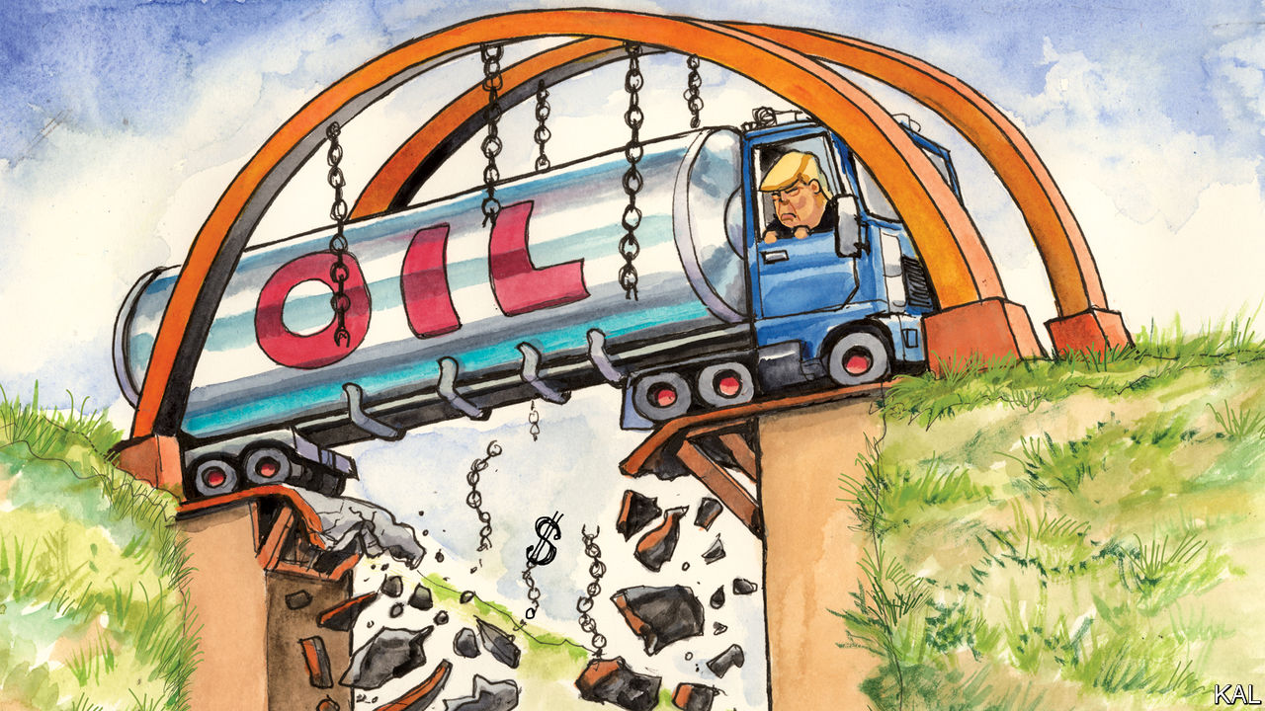

EVEN WHEN American policy in the Middle East has been about more than oil, it has been about oil. That has sometimes been jarringly obvious, as when Dwight Eisenhower justified his decision to send troops to the region in 1958 on the basis that it was the “birthplace of three great religions”, as well as having “two-thirds of the presently known oil deposits”. At other times the oiliness of America’s policy has been more subtle, or partial. George W. Bush invaded Iraq in 2003 for several reasons: to secure its weapons of mass destruction, to spread democracy, and, his would-be successor John McCain acknowledged, to guarantee America’s oil supply.

Donald Trump’s commitment to reducing America’s involvement in the Middle East also relates to the black stuff. It is justified in part by the shale-oil revolution that has made America the world’s biggest producer, lessening its dependence on the region. The administration’s effort to promote Saudi Arabia as a regional proxy, to help effect its withdrawal, is also somehow oleaginous. The president’s Middle East consigliere, Jared Kushner, sees the country’s crown prince, Mohammad bin Salman, as an oil-important ally against Iran and potential ally for Israel. Mr Trump views the Saudis as oil-rich buyers of American arms and property.

Both oil-related struts of his Middle East policy looked shaky even before the meltdown in oil markets that began last month. A spike in the oil price in September, after a drone strike on a Saudi installation, was a reminder that America is still at the mercy of the global oil market and therefore Middle Eastern instability. The Saudis have proved to be an embarrassing proxy. They have additionally failed to make good on almost any of the arms deals the president trumpeted. And the more he has pushed the bilateral relationship, the more politically toxic it has become.

There are many such contradictions in the administration’s Middle East plans. They are at once ambitious—Mr Trump pledged to end regional terrorism, the Israeli-Palestinian conflict and the Iranian threat—and undermined by his serial reluctance to take strong or consistent action. His statements on Iran have been so contradictory it is unclear what his policy is there: regime change or a footling renegotiation of Barack Obama’s nuclear deal. Yet in the absence of a major regional crisis, the sum of the administration’s faltering efforts has looked no worse than that of its recent predecessors. This could be about to change, with a pair of historic crises—an unprecedented calamity on oil markets and a global pandemic—threatening American oil production, Middle Eastern stability and in turn the administration’s diplomatic grip.

The coming decimation of America’s shale-oil firms could eventually lead to renewed dependence on Saudi oil. American production is predicted to fall to 10m barrels a day, around half the country’s pre-pandemic consumption. In the meantime near-universal anti-Saudi feeling in Washington is putting the bilateral relationship under great strain. Last month Republican senators in oil-producing states, who had been almost the Saudis’ last defenders on the Hill, turned furiously against the kingdom. Kevin Cramer of North Dakota and Dan Sullivan of Alaska introduced legislation to withdraw American troops and missile-defence systems if it did not cut its oil production. Reports this week that a fleet of laden Saudi tankers was en route to oil-glutted America caused fresh fury. Mr Trump suggested he might close the country’s ports to it. The notion of American-Saudi co-operation to reorder the Middle East has rarely looked more fanciful.

Meanwhile a region whose stability America has considered supremely important for seven decades is experiencing two black swans in one swoop. Oil-poor countries such as Egypt, Jordan and Bahrain are facing a health-care crisis which their oil-rich neighbours would in normal times send them cash to stave off. Yet the Saudis, in need of an oil price of around $80 a barrel to balance their budget, are focused on fiscal problems at home. A normal American administration might be expected to rally multilateral agencies to make up the shortfall for the poorer Arab states. Mr Trump is instead trying to defund the World Health Organisation.

This represents a threat of instability that Iran will try to exploit. Though badly afflicted by the coronavirus, it shows no sign of reducing its operations in Iraq, Syria, Yemen and elsewhere. Meanwhile Israel could soon start annexing the West Bank. All in all, the chances of a regional blowout, which America will either be drawn into or castigated for neglecting, are rising again.

A couple of lessons can already be drawn from this troubling prospect. One is that America’s reduced dependence on the Middle East is not making its regional policymaking any easier. Quite the contrary: where there was once bipartisan backing for bold interventions, finding support for modest commitments would now be hard even if Mr Trump had not politicised every aspect of his foreign policy. Instead of bragging of “American energy dominance”, a phrase that now looks especially foolish, a wiser administration would have sought to build support for a more nuanced Middle East policy: more modest than Mr Bush’s, more resolute than Mr Obama’s, and consistent in its aims.

## Oleaginous and always with us

Another lesson is that a lighter American footprint in the region requires broad-based alliances, not headstrong proxies. The first are a means to rise above the region’s interminable petty rivalries, the second almost a guarantee of being dragged into them. America has a rich legacy of the right sort of partnership, including the trans-Atlantic ones behind Mr Obama’s nuclear deal and a patchwork of regional allies. But Mr Trump has squandered them.

The trans-Atlantic pact has foundered on his attack on the nuclear deal. And when asked on American television who was helping his country through the pandemic, King Abdullah of Jordan, a longtime ally, gave a startling answer. He was grateful, he said, to the United Arab Emirates and the Chinese entrepreneur Jack Ma.■

This article was downloaded by calibre from <https://www.economist.com/united-states/2020/04/23/the-limits-of-energy-independence>

|  |  |  |  |
| --- | --- | --- | --- |
| Previous | Articles | Sections | Next |

|  |  |  |
| --- | --- | --- |
| United States | Sections | Asia |

The Americas

Argentina: The Peronist and the pandemic

.

Bolivian wine: High varietals

.

Bello: Cuba on the edge

.

|  |  |  |
| --- | --- | --- |
| United States | Sections | Asia |

|  |  |  |  |
| --- | --- | --- | --- |
|  | Articles | Sections | Next |

#### The Peronist and the pandemic

# Argentina’s make-or-break moment

President Alberto Fernández has dealt well with the pandemic. Debt talks may be harder

Apr 23rd 2020 | BUENOS AIRES

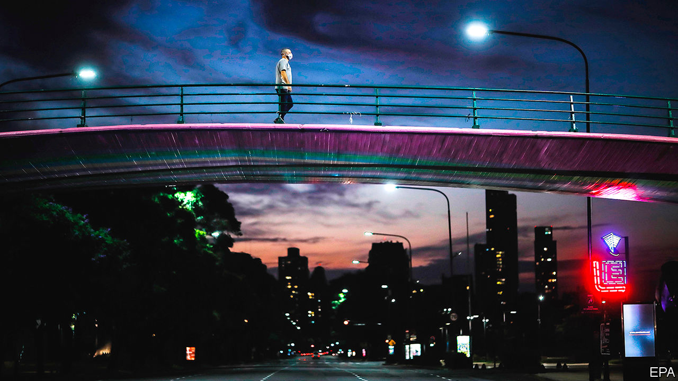

Editor’s note: The Economist is making some of its most important coverage of the covid-19 pandemic freely available to readers of The Economist Today, our daily newsletter. To receive it, register [here](https://www.economist.com/newslettersignup). For our coronavirus tracker and more coverage, see our [hub](https://www.economist.com/coronavirus)

UNTIL RECENTLY advisers to Argentina’s president, Alberto Fernández, quoted the old saw that crisis brings opportunity. Inaugurated in December, he is dealing with two calamities that no one can blame him for: a deep recession inherited from his predecessor, Mauricio Macri, and the covid-19 pandemic. Argentines give Mr Fernández high marks for his response. On becoming president he raised taxes and froze pensions and salaries to stabilise public finances. He acted early to slow the spread of covid-19, shutting borders, business and most transport by decree on March 12th. People who break the rules face fines and prison sentences.

The lockdown is having an effect. On April 23rd Argentina had 3,288 confirmed cases of covid-19 and 159 deaths from it. That is far fewer than in Spain, which has roughly the same number of people (though it may be an underestimate). Mr Fernández’s approval rating has soared. A recent poll by Poliarquía puts it at 81%. “I didn’t think of him as a leader,” says Gabriel Más, a farm worker. “I do now.”

But both Mr Fernández and the country he leads are entering a dangerous phase. Pressure to ease the lockdown is building before the pandemic has peaked. And the government has begun a gambit to support the economy that may end up weakening it further. Success would be the making of his presidency and brighten the future of his Peronist political movement. Failure could be disastrous for both. “Will he be the creator of a new political hegemony, or author of social chaos if he generates economic havoc?” asked Jorge Fontevecchia, a media mogul, in a newspaper column.

On April 16th the economy minister, Martín Guzmán, demanded that creditors accept new securities to replace $65bn-worth of bonds, almost 40% of foreign-currency debt. This does not come out of the blue. Mr Macri had sought to stretch out debt payments. In appointing Mr Guzmán, a specialist in debt negotiation, Mr Fernández made it clear that he would give greater priority to restoring growth than to paying creditors.

The pandemic greatly increases the urgency. With revenue crushed by recession, the government is on track to run a primary deficit, ie, before interest payments, of at least 4% of GDP this year. The Central Bank is printing money to keep the government going, which risks driving up inflation, already at 50%. Over the next two years Argentina’s scheduled payments of foreign-currency debt are nearly as large as its foreign-exchange reserves of less than $44bn. “Argentina can’t pay [creditors] anything right now,” says Mr Guzmán. So far, though, bondholders are unsympathetic. Argentina’s demand “does not represent the product of good-faith negotiations”, complained one group that holds about 16% of the debt.

The mood in the Casa Rosada, the presidential palace, is grim. Argentina may be headed for its ninth default. “Between pandemic and debt, now maybe default, it looks like double jeopardy,” says a presidential adviser. The consequences of default would be grisly. Output, squeezed by the lockdown, would shrink by far more than the 5.7% forecast by the IMF for this year. The peso would plunge, pushing inflation even higher. Unemployment and poverty would soar. Despite a history of default, “even we may not recognise what’s coming: economic meltdown and social unrest, alongside a pandemic,” warns Sergio Berensztein, a political analyst.

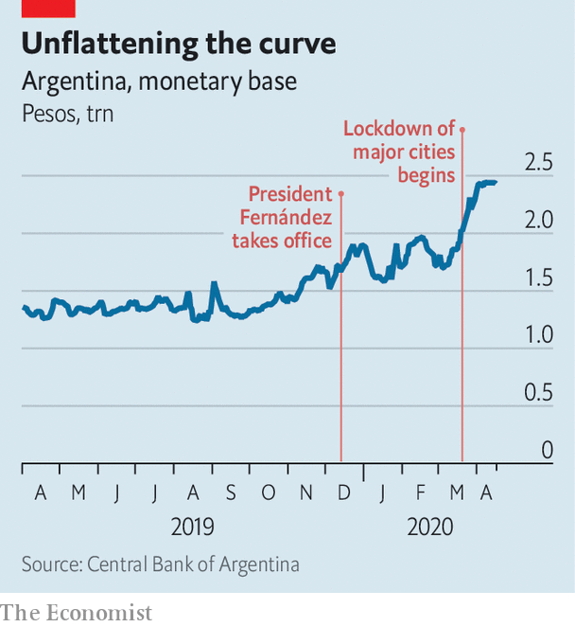

The government wants to wring the maximum relief it can from bondholders without triggering that disaster. Mr Guzmán is seeking a modest “haircut” of 5.4% on the principal (which would save the government $3.6bn) and a dramatic 62% cut in interest payments. These payments would start low, at just 0.5%, and late, beginning in 2023, when an election is due. They would peak in 2029 at less than 5%. Under this plan, the government would save $37.9bn on its interest bill.

The absence of even a token payment until May 2023 will stiffen creditors’ resistance. With no prospect of money coming in, they could spend the next three years lobbying and litigating for a better deal. They complain that the government has been slow to disclose its strategy for servicing the debt that would remain. The plans it has released so far do not take into account the effects of covid-19. “If you’re a creditor, told to wait three years, you need to hear the plan,” says a source close to both investors and the government.

There is little time to resolve the tussle. The Fernández team put a 20-day limit on negotiations. But the real deadline is May 22nd, the end of the 30-day grace period for a missed $500m payment. “There is recognition that default is much more likely than not,” says the presidential adviser.

Veterans of past renegotiations hold out hope of an agreement. Argentina’s offer preserves much of the face value of the debt. There may be wriggle-room in the schedule for repayment. The price of Argentina’s existing bonds rose after it made its proposal, a sign that the offer is more appealing than investors were expecting. Government negotiators are “pushing it to the cliff-edge, as they must, to remind all that default is a disaster for all”, says a former finance minister.

Mr Fernández is using brinkmanship, too, in his battle with the pandemic. “Quarantine, social distancing, will extend beyond April,” said Pedro Cahn, a government epidemiologist. Even then, “we have to expect many more cases and many more deaths.” Workers in private hospitals say that the government’s low numbers for covid-19 cases and fatalities reflect a lack of testing. They fear “dramatic loss of life” when the virus peaks, probably in early June, in poor neighbourhoods that ring Buenos Aires and in other cities.

Mr Fernández is trying to shield poor Argentines from the consequences of the lockdown, in part by taxing richer ones. The government has given bonus payments to welfare recipients, informal workers and people who work in health care, policing and supermarkets. It has imposed new freezes on prices of food and medical supplies. Congress may reconvene to levy a tax on Argentines’ worldwide assets. The “patriotic” tax will “kill the chicken that lays the eggs for future recovery”, warns Aldo Abram, an economist.

The pre-existing recession makes the trade-off between public health and economic growth even more painful than it is for most countries. Under pressure from trade unions and business, Mr Fernández has allowed organisations in 11 sectors, including export industries and refuges for victims of domestic violence, to reopen. But he is likely to rule out a quick return to normality like that advocated by Brazil’s president, Jair Bolsonaro, who makes light of covid-19. Mr Fernández knows that the pandemic is more merciless than Argentina’s creditors. ■

Dig deeper:  
For our latest coverage of the covid-19 pandemic, register for The Economist Today, our daily [newsletter](https://www.economist.com/newslettersignup), or visit our [coronavirus tracker and story hub](https://www.economist.com/coronavirus)

This article was downloaded by calibre from <https://www.economist.com/the-americas/2020/04/23/argentinas-make-or-break-moment>

|  |  |  |  |
| --- | --- | --- | --- |
|  | Articles | Sections | Next |

|  |  |  |  |
| --- | --- | --- | --- |
| Previous | Articles | Sections | Next |

#### High varietals

# Bolivia’s other intoxicating export—fine wine

A newcomer to tipple’s top table

Apr 23rd 2020 | LA PAZ

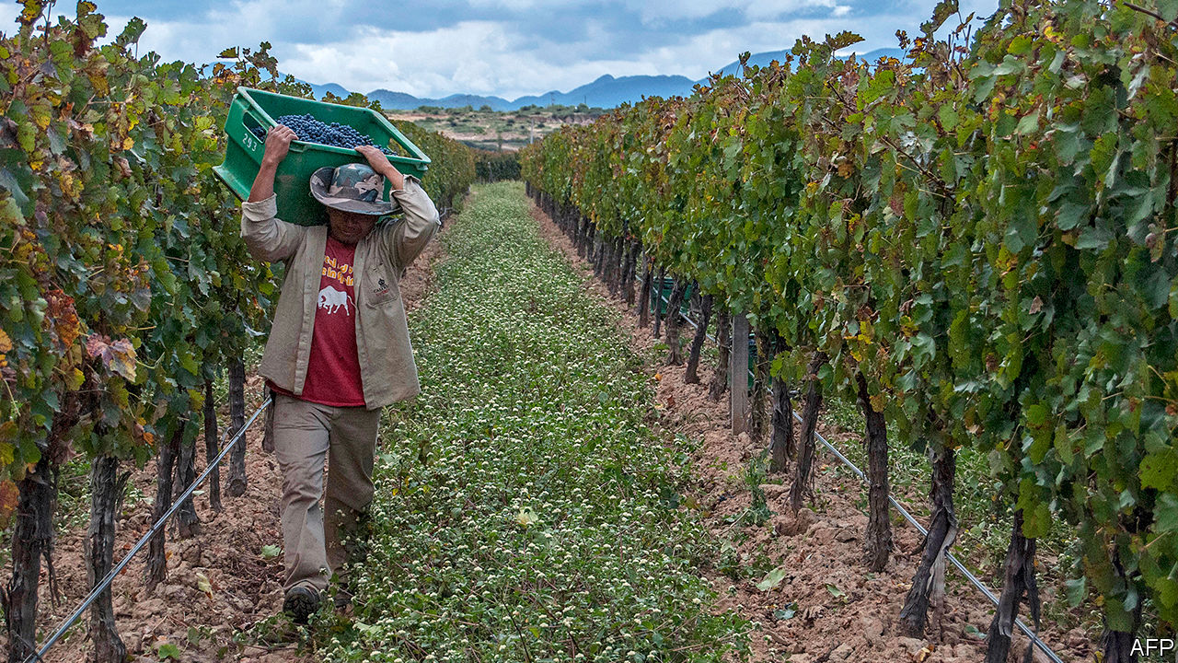

IN 2010 the Netherlands’ Centre for the Promotion of Imports from developing countries, which is financed by the government, sent Cees van Casteren to Bolivia. His mission was to help Bolivia’s vintners break into Europe. It was a tough assignment. Back then, Bolivia’s main winemakers—Kohlberg, Campos de Solana and Aranjuez, all family-owned—competed fiercely to sell cheap wine to a tiny protected domestic market. The intoxicating export for which Bolivia is famous is cocaine.

The idea that Bolivia might aspire to bottle something better is not silly. Spanish priests made wines there in the 16th century. The modern industry started in the 1960s, when the Kohlbergs brought vines from Europe to make wine to relieve a family member’s heart condition.

Bolivia’s vineyards in the Andean region of Tarija are among the world’s highest, at 2,000 metres (6,500 feet) above sea level. Intense sunshine gives grapes’ skins more tannin and wide daily temperature swings increase the acidity of their juice. That makes tannats, malbecs and cabernet sauvignons “fresh”, and “spicier” than lower-altitude wines, says Mr van Casteren, one of 394 “masters of wine”.

But putting them on European tables has not been easy. The first step was to bring the feuding families together to agree on how to spend the Dutch aid and to come up with a shared brand for Bolivian wines. “They wouldn’t even sit together at the same table,” says Mr van Casteren. No one showed up to the first meeting he called. Eventually, they forged friendships on tours of European vineyards.

Bolivian vintners cannot compete against Argentines and Chileans as mass producers for a global market. The cost of planting a hectare of vines is 20% higher than in Mendoza, Argentina’s top winemaking region, says Luis Pablo Granier, a co-owner of Campos de Solana. Bolivian vineyards have one-third of Mendoza’s yield per hectare. Bolivia is landlocked, so freight costs are high. An overvalued currency makes the Bolivians less competitive. So the families agreed to make better wines. Prodded by Mr van Casteren, they bought oak casks for ageing and upgraded irrigation systems. Prizes followed.

Big sales and high profits have not. Bolivia’s producers are too small to attract interest from European distributors and cannot themselves afford to market and distribute. To expand they would need to buy more land. But arable land in Tarija suitable for irrigation is scarce and expensive. Bolivian vintners have planted just 4,000 hectares (10,000 acres), a fraction of Argentina’s 220,000 hectares of vineyards.

They hope that locals will develop more of a thirst for the good stuff. Bolivia’s 11m people drink just 14m litres (3m gallons) of wine a year, a 20th of consumption in Belgium, which has the same number of people. Before covid-19, the National Association of Winegrowing Industries predicted volume would grow by 7% a year. Bolivian producers are protected by tariffs on imports of up to 40%. But those encourage contraband wine, especially from Argentina. A third of wine consumed in Bolivia is smuggled through the southern border.

The temptation is to go down-market, especially after the economic shock from covid-19. But the Bolivians are loth to give up their newly won reputation for quality. “We’ve realised that is where our strength is,” says Mr Granier. Now they have to convince oenophiles at home and abroad.■

This article was downloaded by calibre from <https://www.economist.com/the-americas/2020/04/23/bolivias-other-intoxicating-export-fine-wine>

|  |  |  |  |
| --- | --- | --- | --- |
| Previous | Articles | Sections | Next |

|  |  |  |  |
| --- | --- | --- | --- |
| Previous | Articles | Sections | Next |

#### Bello

# Cuba on the edge

It is better placed to tackle covid-19 than to cope with its economic impact

Apr 23rd 2020 |

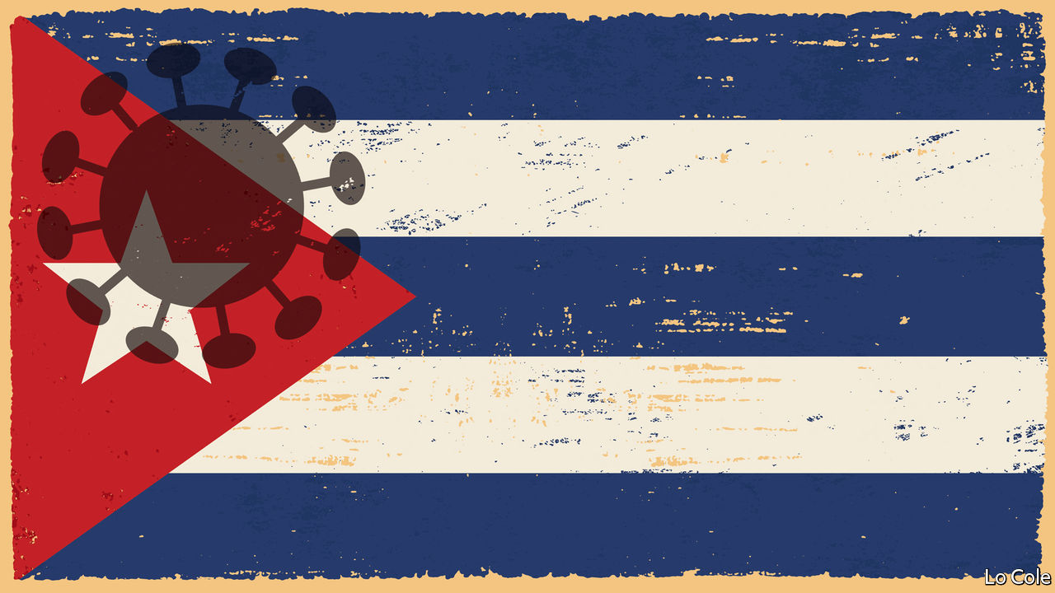

Editor’s note: The Economist is making some of its most important coverage of the covid-19 pandemic freely available to readers of The Economist Today, our daily newsletter. To receive it, register [here](https://www.economist.com/newslettersignup). For our coronavirus tracker and more coverage, see our [hub](https://www.economist.com/coronavirus)

IT IS THE dream of every exile to die in the home country, but not in the circumstances of Víctor Batista Falla. A member of a wealthy banking family, he left his native Cuba in 1960 when Fidel Castro’s revolution moved towards communism. He devoted his life to publishing the work of exiled writers and thinkers, especially of social-democratic and liberal persuasions. Last month he visited Cuba for the first time in 60 years. On April 12th he died, aged 87, in a Havana hospital, of covid-19. He had probably brought it with him from Madrid, where he had lived for decades.

Since the 1990s Cuba has been open to mass tourism and family visits. It is not surprising that it is vulnerable to covid-19, like the rest of Latin America and the Caribbean. As of April 23rd it had reported 1,189 cases and 40 deaths. In proportion to its population, that is similar to Argentina’s caseload.

Even as it has failed to offer Cubans prosperity or freedom, communism has provided them with good health. For decades the regime has overproduced doctors and spent more than the regional average on health care as a share of GDP. That has paid off in another way, too. Sending health professionals abroad generates 46% of the island’s export earnings, not to mention diplomatic prestige. (The state, for which they all work, keeps most of their foreign wages.)

A particular Cuban strength is the health system’s ability, characteristic of a dictatorship, to mobilise the population for public-health action. The government prepared for the virus as early as January. When cases were reported from March 11th it was quick to isolate the patients, and trace and test their contacts. On March 20th, with only 21 confirmed cases, it banned all tourist arrivals, confined vulnerable groups, shut down educational facilities and suspended interprovincial public transport.

Yet neither health care nor the economy are what they were when Cuba enjoyed lavish subsidies from the Soviet Union. The health system has suffered spending cuts, the loss of doctors who no longer practise because of low official salaries, and shortages of supplies. Drought and poor infrastructure have led to water shortages. There is another risk factor: almost 20% of Cubans are over 60, more than anywhere else in Latin America.

So covid-19 poses a severe test, just as it does elsewhere in Latin America. It comes when Cuba’s economy was already under great strain. Cuba failed to reform even as the United States, under Donald Trump, has stepped up sanctions and Venezuela, Cuba’s ally, has cut subsidised oil.

These pressures have exacerbated the state-dominated economy’s chronic inability to generate foreign exchange. The closure of the tourist industry makes that even worse. The Economist Intelligence Unit, our sister company, reckons that imports will fall to $9.1bn this year, from $11.7bn in 2015.

Shutting borders has ended black-market food imports, while the curbs on transport have cut domestic deliveries to Havana, the capital. The government lacks sufficient supplies to add items to the state ration-book all Cubans receive. There are long queues outside meagrely stocked state supermarkets. Miguel Díaz-Canel, who replaced Fidel’s brother, Raúl, as Cuba’s president two years ago, admitted this month that social distancing has been hard to impose and complained of the “indiscipline and irresponsibility” of some Cubans.

Worse may be in store. At the front of Cubans’ minds is fear of another “special period”, as Fidel Castro called it, when the economy shrank by 35% in the early 1990s with the end of Soviet aid. That came with widespread power cuts and other shortages. Pavel Vidal, a Cuban economist at the Javeriana University in Cali, Colombia, reckons that GDP could fall by around 10% this year. Although the plunge in global oil prices will help, Cuba will still need shipments from Venezuela. “On that depends whether or not there are power cuts and another special period,” he says.

The Trump administration, in which Cuban-Americans play a significant role, is counting on tightening pressure to cause the collapse of communism. That is unlikely. In its island fastness, with its mixture of coercion and paternalism, the regime Fidel created has outlasted not just him but the lifelong resistance of people like Mr Batista. The immediate result of Mr Trump’s reversal of Barack Obama’s opening towards Cuba was to halt a cautious process of market reform. Coronavirus is likely to push it off the agenda altogether.

Dig deeper:  
For our latest coverage of the covid-19 pandemic, register for The Economist Today, our daily [newsletter](https://www.economist.com/newslettersignup), or visit our [coronavirus tracker and story hub](https://www.economist.com/coronavirus)

This article was downloaded by calibre from <https://www.economist.com/the-americas/2020/04/23/cuba-on-the-edge>

|  |  |  |  |
| --- | --- | --- | --- |
| Previous | Articles | Sections | Next |

|  |  |  |
| --- | --- | --- |
| The Americas | Sections | China |

Asia

When the epidemic is over: A process of elimination

.

Moonshine in Sri Lanka: Worth a shot

.

India on lockdown: Impossible sums

.

Ignoring covid-19 in Central Asia: What pandemic?

.

Banyan: Fin pickings

.

|  |  |  |
| --- | --- | --- |
| The Americas | Sections | China |

|  |  |  |  |
| --- | --- | --- | --- |
|  | Articles | Sections | Next |

#### A process of elimination

# What next for countries that are nearly covid-free?

Australia, New Zealand, South Korea and Taiwan contemplate life beyond the virus

Apr 23rd 2020 | NELSON, NEW ZEALAND

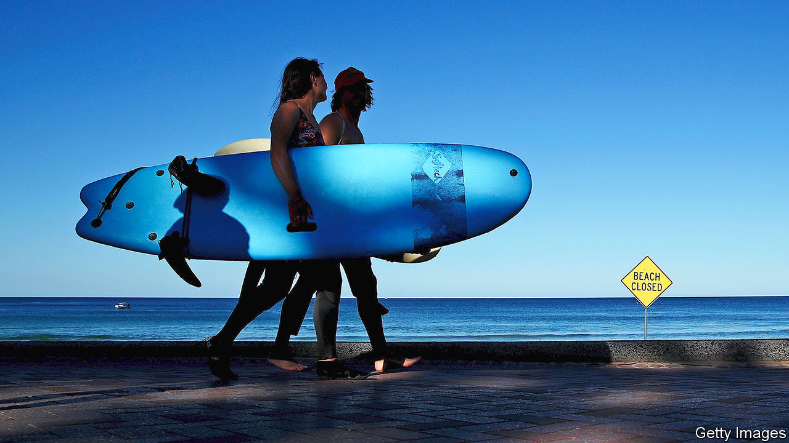

Editor’s note: The Economist is making some of its most important coverage of the covid-19 pandemic freely available to readers of The Economist Today, our daily newsletter. To receive it, register [here](https://www.economist.com/newslettersignup). For our coronavirus tracker and more coverage, see our [hub](https://www.economist.com/coronavirus)

OF ALL THE new rules police in Australia and New Zealand have found themselves trying to enforce in recent weeks, one of the trickiest has been preventing surfing. Officers have had, on occasion, to wade into the water to remonstrate with wave-catching scofflaws, many of whom scaled fences or clambered down cliffs to ride the breakers. Deliverance is at hand, however—in more than one sense. Restrictions on surfing are being eased, since the new coronavirus appears to be under control in both countries.

In New Zealand, a country of 5m people, new cases have been in the single digits for most of the past week. Australia reported just seven new infections on April 23rd. That puts the pair in the very small group of countries that seem to have vanquished covid-19, including South Korea and, barring a fresh wave of infections from a recent outbreak on a naval vessel, Taiwan. Australia has already reopened some popular beaches (for swimming and surfing only) and will soon resume elective surgeries, dental care and fertility treatment. South Korea is allowing domestic tourism, although one county cut down fields of tulips to avoid attracting the usual crowds of sightseers. Taiwan, remarkably, never shut all schools, restaurants or bars.

In all four places officials caution that life is not going back to normal yet. For one thing, there can be no letting down their guard. The authorities have warned that a second wave of the virus may hit in winter. To ward that off, South Korea intends to keep up extensive testing and vigorous contact-tracing using security-camera footage, credit-card statements and mobile-phone location data. The movements of confirmed cases are made public, worrying privacy activists and adulterers alike. Australia, too, promises “aggressive suppression” using contact-tracing and one of the highest rates of testing in the world. New Zealand is going one step further. It has set itself the goal of eliminating the virus entirely from its shores.

The benefits of elimination are clear. Whereas many countries risk a debilitating cycle of lockdowns, gradual reopenings and then fresh restrictions as the outbreak waxes and wanes, New Zealand’s government believes it may soon be able to send Kiwis young and old back to work without fear that the number of cases might start to surge again. “The recovery could be smoother and less hampered than in other places,” says Shamubeel Eaqub, an economist. Schools, shops and restaurants could operate without special social-distancing requirements. The rugby season could begin, with matches in front of live audiences (to the relief of bored sports fans around the world).

All this would in theory provide the sort of clarity for businesses which seems like a pipe-dream elsewhere. Hiring and investment would presumably revive much more quickly if the fear of a future resurgence of covid-19 could be dispelled. “The worst thing we can do for our country is yo-yo between levels [of lockdown],” says Jacinda Ardern, the prime minister.

Yet finding every last case of the virus will be difficult. “It’s a needle-in-a-haystack phenomenon,” says Ayesha Verrall of Otago University. The current random testing of workers in risky jobs, regardless of symptoms, will need to be expanded. Contact-tracing will also need to be made more watertight. Initially, the government had trouble reaching 40% of people it thought might have been exposed to the disease.

Moreover, elimination will entail the strictest border controls. At present, almost all foreigners are barred from entering the country, while returning citizens are placed in quarantine for 14 days in monitored hotels. Arrivals have slowed to a trickle: on April 22nd not a single person entered the country.

Ports are tightly controlled, too. Stevedores at Auckland’s work in small, isolated teams, each with their own toilet, to reduce the risk of an infection spreading widely. The crews of arriving ships are not allowed to disembark and can interact with only three port workers, who are distinguished by pink high-visibility vests, not to mention face masks.

The government’s economic models assume New Zealand will have to stay closed to foreigners for a year. But some doubt it is feasible, or worthwhile, to keep the borders sealed. Steven Joyce, a former finance minister, says eliminating the virus is “pie in the sky”. Australia’s Chief Medical Officer, Brendan Murphy, says that although elimination is desirable, “We’re pretty doubtful that could be maintained for the long term given the incredible border measures you would need to have.”

Even if elimination succeeds, many big industries in New Zealand cannot hope to return to normal. A halt to international tourism, most notably, will knock about 5% off GDP and put some 100,000 people out of work. Border closures will hit farmers, too. Each year New Zealand and Australia bring in hundreds of thousands of backpackers and seasonal workers to pick fruit and prune grape vines. With borders closed, wineries and farms are short-staffed. Mike Chapman of Horticulture New Zealand, a lobby group, worries that it will be difficult to tempt unemployed urbanites up ladders to pick apples.

Exporters are struggling to find space on the few planes still leaving the country. Before the crisis 80% of New Zealand’s air freight was carried on passenger planes. Air New Zealand, the national carrier, has cut 95% of its international passenger flights. Crayfish farmers beat tomato-growers to some of the scarce outbound capacity, Mr Chapman notes ruefully.

In the meantime, in pursuit of elimination, Ms Ardern recently announced a five-day extension of New Zealand’s strict lockdown. The extra short-term cost, she says, will give “much greater long-term health and economic returns”.

Others are managing borders differently. South Korea still admits foreigners, provided they remain in quarantine for 14 days. A few can even evade quarantine, including some business people on short trips. They are tested on arrival and, if negative, can travel widely on the condition that they answer when called by health workers and diligently record any symptoms in an app. Taiwan is permitting some business visitors, too, subject to quarantine rules.

Yet New Zealand’s elimination plan has widespread public support. A poll in early April found that 84% of New Zealanders approve of the government’s response to the pandemic—30 percentage points higher than the average in the G7. There is even hope that other countries may be able to join its putative virus-free zone. The deputy prime minister, Winston Peters, has raised the prospect of a “trans-Tasman bubble” once both Australia and New Zealand have the virus tightly under control. That could also include some Pacific countries—provided it does not burst. ■

Dig deeper:  
For our latest coverage of the covid-19 pandemic, register for The Economist Today, our daily [newsletter](https://www.economist.com/newslettersignup), or visit our [coronavirus tracker and story hub](https://www.economist.com/coronavirus)

This article was downloaded by calibre from <https://www.economist.com/asia/2020/04/23/what-next-for-countries-that-are-nearly-covid-free>

|  |  |  |  |
| --- | --- | --- | --- |
|  | Articles | Sections | Next |

|  |  |  |  |
| --- | --- | --- | --- |
| Previous | Articles | Sections | Next |

#### Worth a shot

# Faced with a ban on booze, Sri Lankans have been making moonshine

The closure of shops selling alcohol was supposed to curb covid-19

Apr 23rd 2020 | COLOMBO

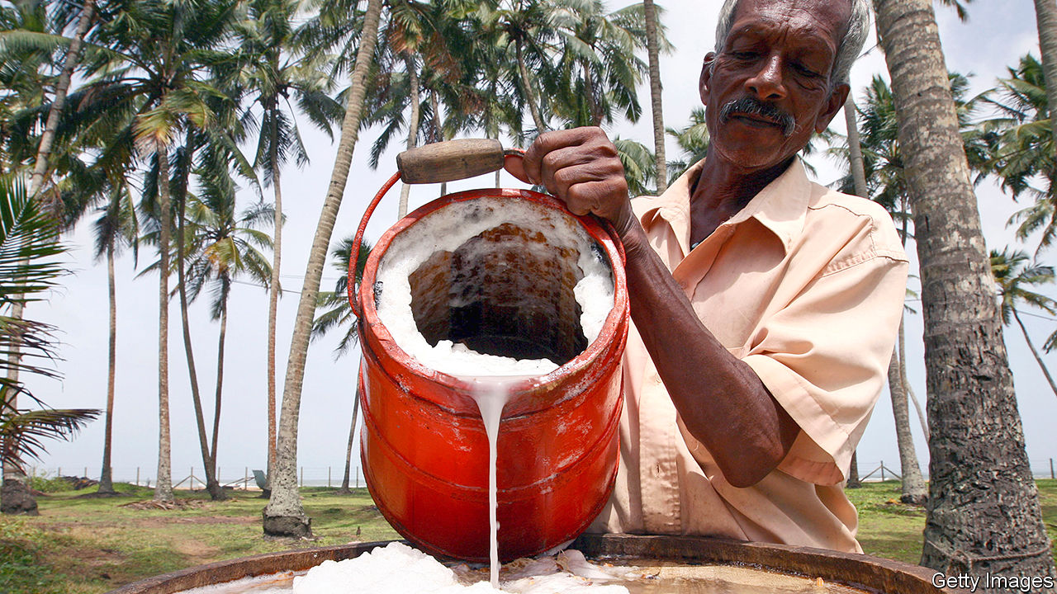

Editor’s note: The Economist is making some of its most important coverage of the covid-19 pandemic freely available to readers of The Economist Today, our daily newsletter. To receive it, register [here](https://www.economist.com/newslettersignup). For our coronavirus tracker and more coverage, see our [hub](https://www.economist.com/coronavirus)

“DATES, JAGGERY?” asked the grocer, offering the main ingredients for brewing palm wine. His customer bought both, tucking them away with his onions and lentils before disappearing down a narrow lane in a suburb of Colombo, Sri Lanka’s capital.

On March 21st the government closed all bars and liquor shops as part of a series of restrictions to curb the spread of covid-19. The intention, it said, was to prevent “drink parties” at which the virus might spread and to reduce unnecessary shopping trips. Small wonder: when the government first began introducing countrywide measures to slow the spread of the disease, “wine shops”—ubiquitous small stores selling mainly beer and liquor—were mobbed (social distancing be damned) by customers frantically stocking up.

Since then, booze has been hard to obtain. Supermarkets offer deliveries, but few have a licence to sell alcohol. For a time, enterprising distributors arranged deliveries of liquor, too, until the authorities made it clear that these were banned. A black market has sprung up, but sellers are hard to find and prices are prohibitive. A bottle of “gal”, which is distilled from coconut-palm sap, goes for almost three times its normal price of about 1,850 rupees ($9.75).

The obvious, albeit illegal, solution is home-brewing. Sri Lankans desperate for a tipple are mixing everything from beets to pineapple with sugar, water and yeast, and leaving the cocktail to ferment. The result can be cloudy, fizzy and sickly sweet, but is at least mildly alcoholic. The more ambitious are trying to distil these brews into something stronger. One home-distiller describes fending off inquiries from the man who delivers cooking-gas canisters, who wants to know why his consumption has shot up. The next wave of hospital admissions, a common joke runs, won’t be victims of the virus, but of alcohol poisoning.

The police say they have uncovered 18,000 instances of illicit alcohol production. On April 13th, for instance, officials arrested two men making liquor in 36 barrels in a swamp. Home-brewers are harder to catch. The government, which is losing some 500m Sri Lankan rupees ($2.6m) a day in forgone tax, has asked the telecoms regulator to find some way to stem the sharing of recipes on social media. “They are using Grade Six science knowledge to manufacture alcohol at home,” complains Kapila Kumarasinghe of the excise department. All the same, he admits, “We can’t very well go house to house, raiding kitchens.”

Dig deeper:  
For our latest coverage of the covid-19 pandemic, register for The Economist Today, our daily [newsletter](https://www.economist.com/newslettersignup), or visit our [coronavirus tracker and story hub](https://www.economist.com/coronavirus)

This article was downloaded by calibre from <https://www.economist.com/asia/2020/04/23/faced-with-a-ban-on-booze-sri-lankans-have-been-making-moonshine>

|  |  |  |  |
| --- | --- | --- | --- |
| Previous | Articles | Sections | Next |

|  |  |  |  |
| --- | --- | --- | --- |
| Previous | Articles | Sections | Next |

#### Impossible sums

# India’s lockdown has brought unexpected benefits

And dizzying costs

Apr 23rd 2020 | DELHI

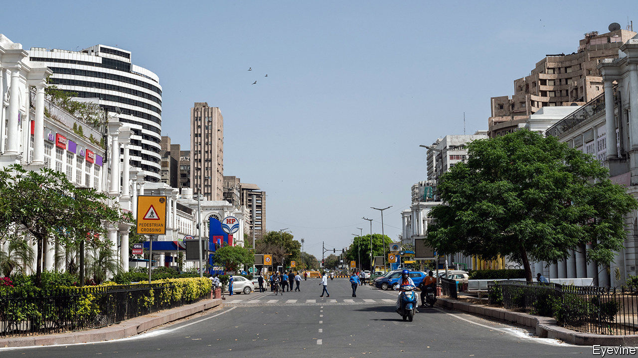

Editor’s note: The Economist is making some of its most important coverage of the covid-19 pandemic freely available to readers of The Economist Today, our daily newsletter. To receive it, register [here](https://www.economist.com/newslettersignup). For our coronavirus tracker and more coverage, see our [hub](https://www.economist.com/coronavirus)

REPORTERS IN INDIA’S capital recently discovered hundreds of stranded migrants, their jobs lost in the coronavirus lockdown, living under a bridge on the banks of the Yamuna river. Even though the scene was tragic, the surroundings were much more pleasant than usual. In the current dry season the river is normally a fetid, inky sewer. At the moment, however, it is miraculously clean. The closure of industries upstream, says the city’s water board, means that for the first time in years the Yamuna has enough oxygen to sustain life.

With more than 20,000 confirmed cases and close to 700 dead, India is not yet one of the worst-hit countries. That distinction may still come, but the strict lockdown imposed since March 25th has slowed the spread of the virus markedly. Without it, some half a million Indians would now have the disease, reckons Jayaprakash Muliyil, an epidemiologist. By mid-June, he surmises, covid-19 could have killed 2.5m people, about as many as would normally die from all causes over the period. From doubling every three days, the number of active cases is now doubling every eight. V.K. Paul, a government health expert, says that by May that rate should drop to every ten days. “We have bought time,” says a weary doctor in Mumbai, India’s hardest-hit city, describing efforts to build up medical capacity. “We started with a broken bicycle, but we’ve got a wobbly motorbike going now, and might even bang together a workable auto-rickshaw.”

It is not just to the potential victims of covid-19 that the lockdown has brought a reprieve. In ordinary times, air pollution kills at least 1.2m Indians a year. That is more than it kills in China, where research by Marshall Burke, an environmental scientist at Stanford University, suggests that cleaner air during its own covid-19 lockdown may have saved 17 times more lives than the (official) number lost to the virus. Another study in China, measuring the effect on health of Beijing’s curbs on pollution during the 2008 Olympics, reckons that every 10% fall in pollution led to an 8% drop in deaths from all causes. The plunge in air pollution in India has been no less dramatic. At one monitoring station in central Delhi, levels of nitrogen dioxide are 85% lower than in recent years. NASA, America’s space agency, says that across India levels of suspended aerosols are lower than at any time since it started measuring them twenty years ago.

Then again, the lockdown has had a crippling effect on many Indians’ livelihoods. Unemployment has shot up shockingly, from 8% at the beginning of March to 26% in mid-April, according to the Centre for Monitoring the Indian Economy, a research group. Nomura, an investment bank, has reduced its expectations for GDP growth from a limp 4.5% to a painful -0.5%. One estimate suggests an extra 100m people could fall below the World Bank’s poverty line of $3.20 a day.

Such are the contradictions of India’s battle with the epidemic. While there may well be a plunge in the 20,000 Indians who die every month in car accidents, there may also be a jump in the 30,000 who perish from tuberculosis, since the lockdown has made it much harder to get treatment. Crime has fallen dramatically; reported rapes in Delhi are down by 83%.

Indians themselves seem to think the lockdown is sensible. A poll conducted by the National Council of Applied Economic Research, a think-tank, found that 55% of respondents in Delhi had seen their incomes shrink sharply since it began, and another 30% somewhat. Yet a resounding 87% also said they still supported the government when it recently extended the controls by three weeks.

Indeed, the government may be the one unquestionable beneficiary of the policy. Before covid-19 it faced mounting discontent over the weak economy, as well as protests over policies that were seen as an assault on secularism. But then the epidemic forced protesters off the streets, and saved the government’s face when it suspended a controversial tally of citizens that might have prompted further unrest. And now, of course, all India’s economic troubles, including those resulting from bad government policies, can be blamed on a deadly virus from China. ■

Dig deeper:  
For our latest coverage of the covid-19 pandemic, register for The Economist Today, our daily [newsletter](https://www.economist.com/newslettersignup), or visit our [coronavirus tracker and story hub](https://www.economist.com/coronavirus)

This article was downloaded by calibre from <https://www.economist.com/asia/2020/04/23/indias-lockdown-has-brought-unexpected-benefits>

|  |  |  |  |
| --- | --- | --- | --- |
| Previous | Articles | Sections | Next |

|  |  |  |  |
| --- | --- | --- | --- |
| Previous | Articles | Sections | Next |

#### What pandemic?

# Life carries on as usual in Tajikistan and Turkmenistan

Both countries claim, improbably, to have suffered no cases at all of covid-19

Apr 23rd 2020 | ALMATY

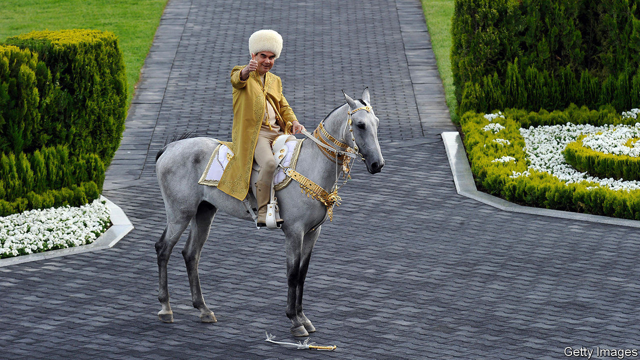

Editor’s note: The Economist is making some of its most important coverage of the covid-19 pandemic freely available to readers of The Economist Today, our daily newsletter. To receive it, register [here](https://www.economist.com/newslettersignup). For our coronavirus tracker and more coverage, see our [hub](https://www.economist.com/coronavirus)

IT TAKES MORE than a global pandemic to faze the sports-mad, world-record-obsessed president of Turkmenistan. Last year, at his instigation, the gas-rich desert country marked World Bicycle Day by setting a record for the longest cycling parade. This month, to celebrate World Health Day on April 7th, Gurbanguly Berdymukhamedov, who is known to Turkmenistan’s 6m citizens as Arkadag, or “the Protector”, wheeled out 7,000 cyclists for what may yet qualify as the most reckless celebration of public health ever undertaken. Even as he sent his own people to pedal in huge packs, however, the Protector was protective of his own health, whizzing around a deserted track in Ashgabat, his marble-clad capital, first in splendid isolation and then in the company of a few select officials.

Turkmenistan is one of only a handful of countries in the world that claims to have no cases of covid-19. Also present on that exclusive list is Tajikistan, another Central Asian state ruled by a narcissistic president who likes to present his country as a trouble-free paradise. In March Emomali Rahmon cocked a snook at social-distancing norms by herding thousands of his countrymen together for an all-singing, all-dancing spectacle to celebrate Nowruz, a holiday marking the spring equinox. Similar festivities had been cancelled all across the region—apart from Turkmenistan, of course. Tajikistan and Turkmenistan are also allowing football matches to continue. In Tajikistan they take place without spectators, but in Turkmenistan hundreds of fans crowded into a stadium in Ashgabat when the season resumed last weekend after a brief covid-related hiatus.

Turkmenistan is not in complete denial: it has closed its borders to foreigners (they were never that open in the first place) and quarantined returning travellers, in some cases in tents in the desert. Tajikistan has also isolated travellers and conducted thousands of tests, all of which have officially returned negative results. It admits there has been a spike in respiratory ailments, but says that the cause is bad weather, not the coronavirus. One particular death that had been the subject of rumours was the result of swine flu and pneumonia, it insists.

Mr Rahmon has suggested that Tajiks’ high standards of hygiene will stand them in good stead in the battle against the coronavirus, should it ever arrive in their country. The panoply of prophylactics recommended by Mr Berdymukhamedov, a former health minister who has written a book on folk remedies, includes fumigation with yuzarlik, a local herb which he touts as impregnable armour against infectious disease. It is for insights like these that Turkmenistan “loves you with all its heart”, as a poet called Gozel Shagulyyeva put it in a new ode to the president recently published by local media.

Elsewhere in Central Asia normal life has come to a standstill since the first coronavirus cases were detected in mid-March. Kazakhstan, Kyrgyzstan and Uzbekistan have closed public places, restricted internal travel and ordered citizens to leave home only to buy essential provisions from nearby shops. (Residents of the Uzbek city of Namangan are supposed to stray no farther than 100 metres from their homes). Kazakhstan, which is using drones to enforce its lockdown, has banned family gatherings and told those over 65 or under 18 to remain indoors at all times. In some Kazakh cities residents are allowed outside only once every two days, a measure policed with colour-coded cards. Enforcement is draconian by Western standards: Kazakhstan has detained more than 5,000 people and jailed more than 1,600 for violations of the new rules.

Turkmenistan, meanwhile, is gearing up for another sporting event: Horse Day on April 26th, which celebrates the Akhal-Teke, a local breed. The Protector has been known to join in the fun by competing in horse races. He will presumably think twice about rubbing shoulders with the other jockeys this year. Then again, he is such a gifted rider that he always wins by a big margin—a form of social distancing. ■

Dig deeper:  
For our latest coverage of the covid-19 pandemic, register for The Economist Today, our daily [newsletter](https://www.economist.com/newslettersignup), or visit our [coronavirus tracker and story hub](https://www.economist.com/coronavirus)

This article was downloaded by calibre from <https://www.economist.com/asia/2020/04/23/life-carries-on-as-usual-in-tajikistan-and-turkmenistan>

|  |  |  |  |
| --- | --- | --- | --- |
| Previous | Articles | Sections | Next |

|  |  |  |  |
| --- | --- | --- | --- |
| Previous | Articles | Sections | Next |

#### Banyan

# Japan wants to catch whales. But who will eat them?

Whalers depend on subsidies, as there is little demand for their catch

Apr 23rd 2020 |

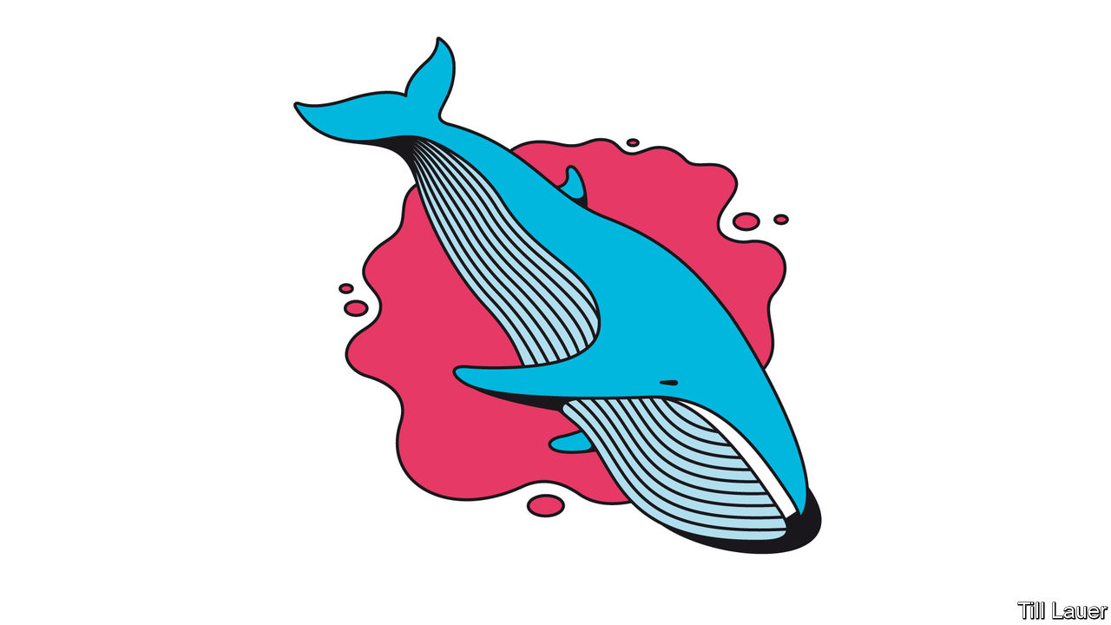

FROM BEHIND the counter of their tiny restaurant in Shimonoseki, Kojima Junko and her octogenarian mother place before Banyan some of the very last bits of the very last fin whale mankind is ever likely to catch. In the background, Billie Holiday is singing “No Regrets”. The four thin slices look and taste like well-done beef—wolfed down with microgreens and a baguette in the name of objective inquiry.

Scientific “research” was also the reason Japan’s government gave for continuing to kill whales in the vast Southern Ocean after a global moratorium on commercial whaling came into force in 1985. But international criticism along with environmental groups’ attempts to sabotage the annual hunt proved too costly to Japan’s reputation and purse (the government bankrolled the hunt). In late 2018 Japan declared it was giving up killing in the Southern Ocean, where the fin whale on which Banyan snacked had been caught.

For environmentalists, it is a great victory. The Southern Ocean is now a sanctuary. But it comes at a cost. Japan walked out of the International Whaling Commission (IWC), accusing the anti-whaling members of failing to appreciate the cultural significance of whaling in Japan and of imposing their values on others. Freed from the IWC’s strictures, the government said commercial whaling would resume in Japan’s own extensive waters.

The government rightly calculated that this would attract far less attention (Japan has a tiny anti-whaling lobby). But from a conservation standpoint, whaling in home waters is troubling. Most whale populations in the Southern Ocean are healthy. In Japanese waters, stocks are less bountiful—and far less researched.

This grim irony was borne out earlier this year. From Shimonoseki in western Japan, the state-owned whaling company, Kyodo Senpaku, sent out its two ships in search of their quota of Bryde’s whales. After fossicking for weeks, the vessels finally stumbled on some whales on the hunt’s last day. Regrettably, says the government’s pointman on whaling, Moronuki Hideki, the three animals killed were very thin. Was Mr Moronuki disappointed or embarrassed? “Both,” he replies.

One obvious lesson is not to kill Bryde’s whales when, hungry after breeding, they are on their way north to their summer feeding grounds around the Sea of Okhotsk. Far better to get them, fit and fat, on their way back in the autumn. Yet whaling, like much else in Japan, follows the logic of the fiscal year, which ends in March. Whalers had to spend their allocated ¥5bn ($46.5m) before then.

The whaling lobby is powerful—Shimonoseki sits within the parliamentary district of the prime minister, Abe Shinzo. In the Southern Ocean the fleet counted on subsidies: commercial sales of meat were never enough to keep it afloat. For now, the subsidies continue, supposedly to help ease the switch to nakedly commercial whaling. But, Mr Moronuki predicts, they will be gone in two or three years. Other fleets complain that whaling gets far more than its fair share of subsidies for fisheries.

Once the whalemen get to know Japanese waters better, hunting close to home will cut costs. Southern Ocean whaling was expensive. The fleet had to guard against saboteurs. And to maintain an air of research, vessels followed predetermined zigzag courses, taking nearly everything in their path. In future they can just steam out and make their kill.

Yet the challenges are immense. Whalemeat consumption has fallen from 230,000 tonnes a year in the early 1960s to 3,000 tonnes today, and whale is no longer cheap. Local whales have higher accumulations of toxins than those in the Southern Ocean. One packager of sashimi admits he sources his whale meat from Norway.

Morishita Joji, a former whaling diplomat at Tokyo University of Marine Science and Technology, says Kyodo Senpaku is hampered by government requirements to distribute whalemeat to all regions, even though demand is concentrated near a few ports with long traditions of hunting and eating whales. In such places, tiny operators never stopped catching small species of whale that did not fall under the IWC’s remit. These local enterprises are more likely to survive, Mr Morishita predicts.

As for the national fleet, perhaps it was just a piece of kabuki theatre to bring it back with such fanfare from the Southern Ocean. In reality, the prospects of the whales look slightly better than those of their predators.

This article was downloaded by calibre from <https://www.economist.com/asia/2020/04/23/japan-wants-to-catch-whales-but-who-will-eat-them>

|  |  |  |  |
| --- | --- | --- | --- |
| Previous | Articles | Sections | Next |

|  |  |  |
| --- | --- | --- |
| Asia | Sections | Middle East and ... |

China

Politics in Hong Kong: The long arm of Beijing

.

Table manners: Safer ways to use chopsticks

.

Chaguan: When children say #MeToo

.

|  |  |  |
| --- | --- | --- |
| Asia | Sections | Middle East and ... |

|  |  |  |  |
| --- | --- | --- | --- |
|  | Articles | Sections | Next |

#### The long arm of Beijing

# China moves to squeeze Hong Kong’s freedoms

Democrats are detained; the Basic Law is punctured

Apr 23rd 2020 | HONG KONG

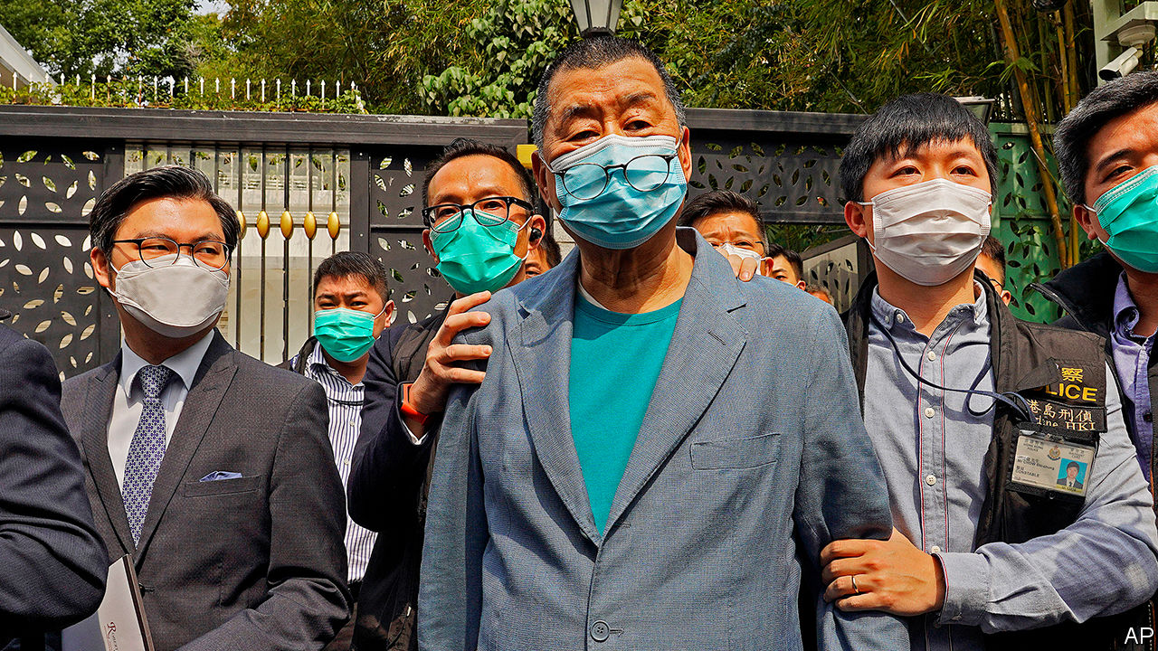

ANNOUNCING THE biggest shake-up of her cabinet since an explosion of unrest last year, Hong Kong’s leader, Carrie Lam, tried to sound confident. A major goal of the reshuffle on April 22nd, she said, was to “help Hong Kong get out of this difficult situation as soon as possible”.

She was referring to the economic crisis caused by covid-19. But Hong Kongers have political worries, too. In recent days several prominent democrats have been arrested, and the central government has rejected what had been widely regarded as a constitutional restraint on its behaviour in Hong Kong. Political turmoil—which had appeared to ebb in recent weeks—looks set to flare anew. The changes to Ms Lam’s team will not reduce tensions.

Since June 2019, when protests erupted over a since-abandoned extradition law, more than 7,000 people have been arrested for taking part in the riots and unauthorised demonstrations that roiled the territory for the rest of the year. But no round-up by the police has caused as much shock as the one on April 18th, during which 15 of Hong Kong’s best-known campaigners for democracy were charged with promoting, organising and joining illegal demonstrations. Among them were Martin Lee, a barrister and former legislator who is often called the “father” of Hong Kong’s pro-democracy movement, and Jimmy Lai (pictured), the publisher of Apple Daily, a popular pro-democracy tabloid.

Last year’s protests mainly involved young people acting without any formal leadership. Some of them turned to violence, throwing petrol bombs and vandalising property. Mr Lee, however, is 81 and a moderate who, like many veteran democrats, largely remained aloof from the unrest—sympathising with the protesters’ motives but not encouraging their confrontations with the police. If peaceful old men like him are being arrested, many Hong Kongers worry, the Communist Party must be pressing the territory’s government to cast the net wider. Mr Lee has been an outspoken critic of the party since long before the British withdrawal in 1997.

After being freed on bail, Mr Lee said he was proud. “Over the months and years, I’ve felt bad to see so many outstanding youngsters being arrested and prosecuted, but I was not charged,” he told reporters. Mr Lee and Margaret Ng, another elderly barrister and former legislator, were among nine who have been accused of “organising” and “knowingly participating in” a huge illegal march on August 18th. Police had given approval, but only for a small rally in a park. All 15 are out on bail. They are due to appear in court on May 18th.

In response to suggestions that those arrested had been singled out unfairly, Hong Kong’s security bureau insisted that everyone was “equal before the law”. But the simultaneous targeting of so many well-known figures, including several other former legislators, showed that this was an unusual operation. Some, like Mr Lee and Ms Ng, had never been charged before.

The protests have died down since January, not least as a result of covid-19. But, with the number of new infections down to a handful of imported cases each day, the authorities worry about the possibility of renewed unrest as normal life resumes. The arrests will not help them maintain calm. Neither will the controversy of the past few days related to the central government’s latest assault—as many Hong Kongers see it—on the “high degree of autonomy” that the territory is supposed to enjoy.

It began on April 14th when the central government’s Liaison Office in Hong Kong, along with the Hong Kong and Macau Affairs Office, which is based in Beijing, accused opposition legislators of abusing their oaths of office by using “malicious filibustering” to “paralyse” the Legislative Council. Their complaints relate to the work of a committee that decides on the timing of debates about bills. It is presided over by Dennis Kwok, a democratic legislator who is accused of wanting to block laws that the Communist Party may use to tighten its control in Hong Kong. One would allow the jailing of people for insulting the national anthem. Another, not yet drafted, would outlaw “secession” and “subversion”—new concepts in local law. On April 15th Luo Huining, the head of the Liaison Office, urged Hong Kong to get on with passing such a law. Indeed, Article 23 of the Basic Law, Hong Kong’s mini-constitution, requires it to do so.

But Article 22 of the Basic Law says that no central-government department may “interfere” in matters that Hong Kong has a right to administer on its own (the central government is supposed to run only the territory’s foreign affairs and defence). When democrats accused the Liaison Office of meddling, it retorted that Article 22 did not apply to it. This contradicted what Hong Kong’s government had been saying for years. But the local authorities, after appearing at first to stick to their guns, quickly fell in line with the new interpretation.

The central government may be mindful of Legislative Council elections that are due to be held in September. With the pro-establishment camp holding just under two-thirds of seats, now may be an opportune moment to get the anthem and security bills passed. If the democrats can repeat the success they achieved last November in district-level elections, the government may find its control in the Legislative Council considerably undermined.

It will be risky either way. In 2003, when the government last tried to pass the security legislation mandated by Article 23, objectors staged a huge protest. This led to the bill’s withdrawal and eventually the stepping down of Hong Kong’s then leader, Tung Chee-hwa. But the government may decide to ignore public opinion this time. Democrats fear that the central government may lean on Hong Kong to bar some of them even from running in September. The Liaison Office’s accusation that filibustering legislators are violating their oaths (a sackable offence) already suggests that the pressure is growing. ■

This article was downloaded by calibre from <https://www.economist.com/china/2020/04/23/china-moves-to-squeeze-hong-kongs-freedoms>

|  |  |  |  |
| --- | --- | --- | --- |
|  | Articles | Sections | Next |

|  |  |  |  |
| --- | --- | --- | --- |
| Previous | Articles | Sections | Next |

#### Revolution at the dinner party

# China asks: what’s the safest way to use chopsticks?

Officials fret that people are sharing more than Peking duck

Apr 23rd 2020 | BEIJING

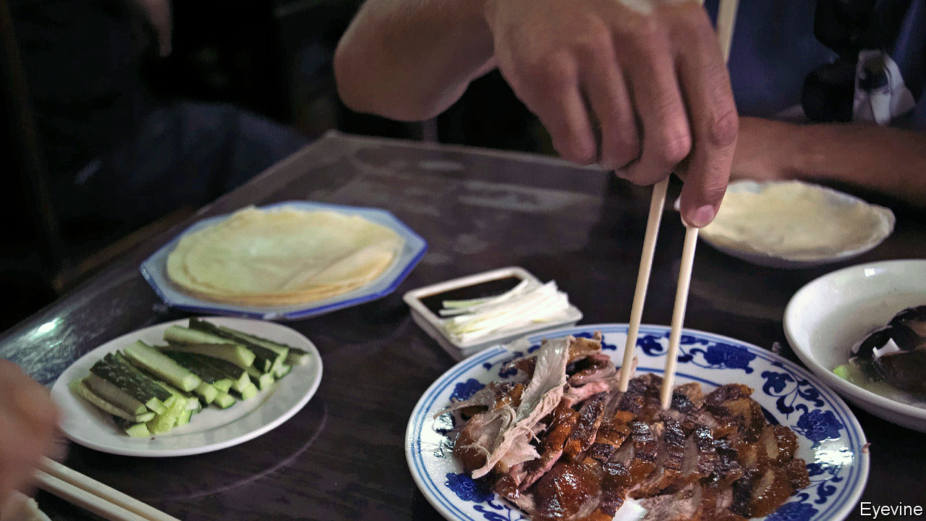

Editor’s note: The Economist is making some of its most important coverage of the covid-19 pandemic freely available to readers of The Economist Today, our daily newsletter. To receive it, register [here](https://www.economist.com/newslettersignup). For our coronavirus tracker and more coverage, see our [hub](https://www.economist.com/coronavirus)

AT DINNER IN China, a courteous host uses her chopsticks to take the tastiest morsel from a communal dish and put it on the plate of an honoured guest. At a family meal, an elder does so for a child. Friends do it for each other. And all help themselves, taking bite-sized pieces again and again from plates of food in the middle of the table. So it has been for centuries. And then came covid-19.

In few other countries has the pandemic raised such painful questions about cherished cultural traditions as it has in China with respect to dining customs. Stories abound in Chinese media of people catching the coronavirus after sharing a meal. There is no proof that the chopsticks were to blame. People who share a meal tend to breathe on each other, too. But experts in China warn that transmission by chopstick is possible. As restaurants reopen, local governments are urging diners to adjust what Health Times, a newspaper controlled by the Communist Party’s mouthpiece, the People’s Daily, called their “bad dining habits”.

The aim of this “tongue-defence war”, as state media have dubbed the campaign, is to change the way chopsticks are used. Diners are encouraged to use designated communal ones for divvying up shared food. These extra chopsticks—often longer than usual and specially labelled or coloured—are not to be placed in the mouth. They are common in other chopstick-using societies, such as Japan and Taiwan, but swapping from one set of chopsticks to another is often considered a nuisance in mainland China. It is rarely done except in very formal settings.

In Hubei, the province worst affected by covid-19, schools are giving online lessons on how to be a good “communal-chopsticks pioneer”. A shopping mall in Shanghai is offering free parking to customers who agree to use them at its restaurants. Staff use red ink to stamp the bills of compliant customers, who redeem the perk on their way out. The city government in Beijing is drafting new rules on “civilised” behaviour. They require using separate chopsticks for serving (the penalty, if any, for violators has not been specified). State media are also promoting the Western practice of giving diners their own servings.

Concerns that infected saliva from a utensil can pass from one person to another via a shared dish are at least a century old, says Q. Edward Wang, author of “Chopsticks: A Cultural and Culinary History”. Among the first in China to campaign for dining-habit reform was a Malaysian-born doctor who saw hope in the “lazy Susan”—a rotating platform placed on a table so diners can spin the food to each other. He believed the device would reduce the spread of disease because each dish would have its own serving spoon. Lazy Susans eventually took off in China, but the spoons did not.

How different things might have been if people had paid attention to Hu Yaobang. In 1984 Mr Hu, then the Communist Party’s general secretary, suggested that, for the sake of hygiene, they “eat Chinese food the Western way” with knives and forks. “Peking has seen the future—and it lacks chopsticks”, was the headline in the New York Times. But Mr Hu’s idea was never likely to stick. Hardliners despised him as a Westernising liberal. Mr Hu’s death in 1989 sparked the Tiananmen Square upheaval, the crushing of which all but erased him from official history books, along with his radical idea. Recently state media have been drawing on antiquity to bolster their case. Eating separate portions, they claim, was the practice for 3,000 years until the Tang dynasty (618-907).

While calling for a “dining-table revolution”, state media are careful to respect the view of many Chinese that dish-sharing is a sign of intimacy. “Divide food, not love,” a common new slogan urges. In the capital, a Peking-duck restaurant offers serving chopsticks to any guest who asks for them. But a waitress says there are few requests. In a social-media poll of about 210,000 netizens, 27% said they would use serving utensils, but 30% said they would not, because it was “too much trouble”. ■

Dig deeper:  
For our latest coverage of the covid-19 pandemic, register for The Economist Today, our daily [newsletter](https://www.economist.com/newslettersignup), or visit our [coronavirus tracker and story hub](https://www.economist.com/coronavirus)

This article was downloaded by calibre from <https://www.economist.com/china/2020/04/23/china-asks-whats-the-safest-way-to-use-chopsticks>

|  |  |  |  |
| --- | --- | --- | --- |
| Previous | Articles | Sections | Next |

|  |  |  |  |
| --- | --- | --- | --- |
| Previous | Articles | Sections | Next |

#### Chaguan

# The push to raise China’s age of consent from 14

A case of alleged child-abuse spurs debate

Apr 23rd 2020 |

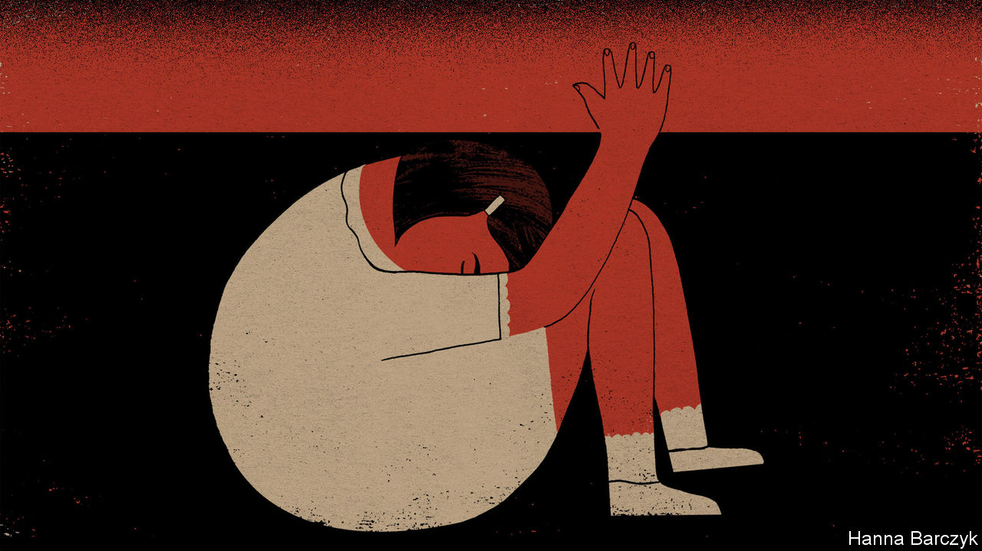

CHINESE SOCIETY is locked in a dispiriting argument, worthy of a more callous age. The public is debating whether a 14-year-old girl was a victim of rape by her wealthy guardian—three decades her senior—or a willing partner, trading sex for gifts and attention. Bored and fractious after weeks of quarantine, many have followed the case eagerly. With each twist in the tale, the public mood has swung. In their hundreds of millions, social-media users have condemned the accused man, a successful lawyer, and expressed disgust at police in the coastal city of Yantai, who declined to pursue rape charges despite several complaints by the girl, who also brought them semen- and blood-stained sanitary pads. On April 13th the central government responded, dispatching prosecutors and detectives to probe Yantai’s handling of the case. Three employers—an oil company, a large technology firm and a university—severed ties with the lawyer, who is on bail pending a fresh investigation. More recently the public has tut-tutted over seemingly affectionate telephone calls between the teenager and her guardian that caused some to doubt her story. Others have scorned the girl’s birth mother for handing her child to a middle-aged bachelor offering to be an unofficial foster father.

China’s news industry has not covered itself in glory. Spotting a story that stokes readers’ indignation, while skirting overtly political themes sure to draw the censors’ wrath, outlets have carried prurient interviews with the alleged rapist. He calls himself a man wronged by an ungrateful lover, and shares recorded phone calls from his accuser to back his claims. Quote-seeking reporters have hounded the teenager, now 18, though she has tried to take her own life more than once. They have visited the anonymous girl’s hometown, revealing her identity to relatives and neighbours.

Still, reformist lawyers and advocates for children’s rights wonder whether some good might emerge from this horrible tale. Notably, they hope that fresh light is being cast on the contradictory tangle of Chinese laws that regulate sexual activity and the young.

At least superficially, China is a conservative country, where rural and small-town elders still chide girls to save themselves for an eligible man. The legal age of marriage in China is high: 20 for women and 22 for men. Before 1980 it was even higher. Towards the end of the Maoist era, when the state sought total control over citizens’ bodies and minds, late marriage was used as a tool of population control. Urban couples needed permission from work units to wed. In the 1970s if a couple’s combined ages did not add up to 50 they were told to wait, or be denied housing and ration coupons needed to furnish a home. Yet since 1949, when the Communist Party took power, the effective age of sexual consent—as fixed by judicial rulings and then by the law—has been 14. The alleged assaults in Yantai began weeks after the girl reached that age.

Chinese laws do not define a stand-alone age of consent. Instead, the age is derived from rape-related laws. The tradition dates back at least 800 years, when the Southern Song dynasty deemed intercourse with a child under 10 to be statutory rape. Put another way, China’s age of consent does not reflect debate about when the young can be trusted to control their own bodies. Instead, it is based on judgments, amended many times over the centuries, about whether men who seek sex with children are always culpable or may have arguments to offer in their defence.

There is nothing new about girls facing harsh and unfair questions about why they let men, including foster fathers, assault them. China’s final imperial dynasty, the Qing, required raped women to prove that they had struggled violently throughout their assault, even at the risk of death. If they had ceased resisting at any point, women faced 80 strokes with a heavy cane for consenting to “illicit intercourse”. The Qing tolerated the use of adoption as a cover for buying young girls as brides, or for forcing them into prostitution. Even Qing laws on child rape rested on judgments about female lust. A textbook from 1878 cites a commentator opining in tones of prim approval that girls of 12 and under “have no capacity for licentiousness”. Not until 2015, after scandals involving officials assaulting under-age girls, did China’s legislature revoke a statute from 1979 that defined sex with child prostitutes as a lesser crime than child rape. The law had offered a loophole by allowing men to claim to have paid to assault children.

## When the real problem is men with impunity

Guo Jianmei founded Qianqian, a law firm which is representing the victim in the Yantai case. Together with fellow lawyers she has drafted amendments to raise the age of consent, and is seeking legislators willing to help. In a country like China, where feudal morality retains some sway, she asks: “What does a girl at 14 know about sex?” China also needs a debate about coercion and abuses of power, adds Ms Guo. Chinese judges find it easy to decide rape cases involving violent attacks by strangers. But her firm sees too many cases of children sexually abused by authority figures they know well, from schoolteachers to fathers, elder brothers and uncles. The victims struggle to obtain justice.

Another public-interest lawyer, Wang Yongmei, argues for still larger reforms. She would like to see adults barred from sex with anyone under 18. Ms Wang would allow some provision for consenting sex between teenagers, for she has seen cases where angry mothers have unjustly accused their daughter’s boyfriend of rape. China needs a child-protection agency and female police trained to support rape victims, she adds.

It takes courage to accuse people in authority of sexual assault. A fledgling #MeToo movement has faced official pressure after young women challenged university professors, television presenters and other powerful men. Ms Wang sees such courage in a new generation of women who refuse to blame themselves for being assaulted. Their bravery is grounds for hope, if the law ever changes to keep up with them. ■

This article was downloaded by calibre from <https://www.economist.com/china/2020/04/23/the-push-to-raise-chinas-age-of-consent-from-14>

|  |  |  |  |
| --- | --- | --- | --- |
| Previous | Articles | Sections | Next |

|  |  |  |
| --- | --- | --- |
| China | Sections | Europe |

Middle East and Africa

The Gulf’s outbreak: Covid in the camps

.

Israeli politics: Bibi wins again

.

Food distribution: The race to feed Africa

.

Abba Kyari: The parable of the bag of cash

.

|  |  |  |
| --- | --- | --- |
| China | Sections | Europe |

|  |  |  |  |
| --- | --- | --- | --- |
|  | Articles | Sections | Next |

#### Covid in the camps

# Migrant workers in cramped Gulf dorms fear infection

Governments have been slow to help them

Apr 23rd 2020 | BEIRUT

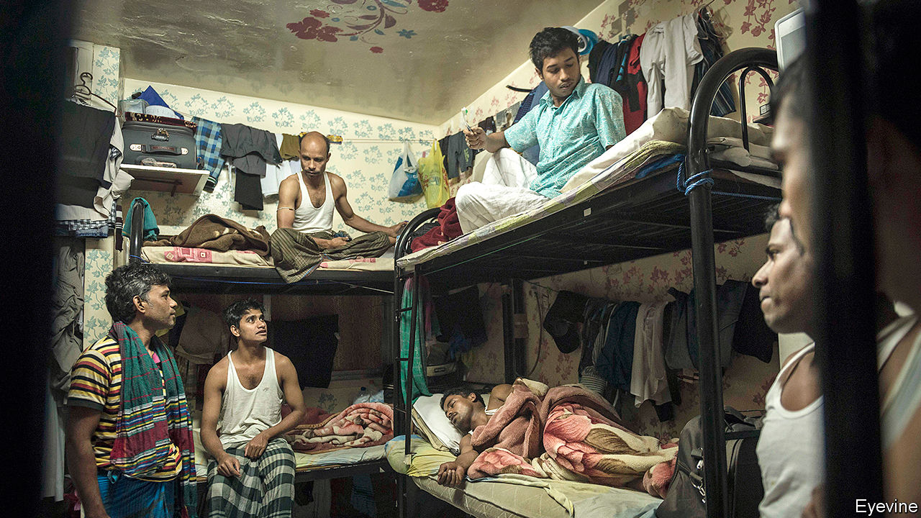

Editor’s note: The Economist is making some of its most important coverage of the covid-19 pandemic freely available to readers of The Economist Today, our daily newsletter. To receive it, register [here](https://www.economist.com/newslettersignup). For our coronavirus tracker and more coverage, see our [hub](https://www.economist.com/coronavirus)

FOR WELL-OFF foreigners in Qatar, as in other Gulf states, social distancing is almost a way of life. Comfortable salaries pay for suburban villas or seaside flats; private cars are ubiquitous. For the labourers who make up the bulk of Qatar’s 2.8m people, though, it is all but impossible. In the Industrial Area, a working-class district south-west of Doha, the capital, some residents sleep eight to a room, with scores of men sharing bathrooms and kitchens. Such living conditions are the perfect environment for a virus to spread.

The six members of the Gulf Co-operation Council (GCC) acted early to contain the novel coronavirus. By mid-March most had begun to impose restrictions on movement and travel. But after weeks of slow growth, new cases are rising quickly. Confirmed infections in Saudi Arabia more than doubled in the week from April 14th. Qatar has more cases than Ukraine, which is 16 times more populous. Although GCC governments do not release data on the nationalities of those infected, anecdotal evidence suggests that the virus is spreading fastest among labourers.

Qatar has received most attention. On March 11th it reported 238 cases of the virus in a single residential compound in the Industrial Area, home to more than 360,000 people. It sealed off dozens of streets, an area of nine square kilometres (3.5 square miles). Workers, put on leave, were allowed out only to buy food or other essentials.

State media in Saudi Arabia and the United Arab Emirates (UAE), which have been in a diplomatic spat with Qatar since 2017, enthusiastically covered the outbreak as proof of Qatari callousness. But the situation is the same in other Gulf states. The Saudi health ministry said on April 5th that 53% of confirmed cases involved foreigners. The share is probably higher now: migrants account for about four in five recent cases. The holy city of Mecca, with a large population of foreigners, has more confirmed infections than Riyadh, a city three times the size. Doctors in the UAE report a similar trend among migrants.

Governments have taken some laudable steps. Testing is free for labourers, and health ministries have been serious about expanding it. Qatar has carried out 70,000 tests. The UAE is doing more than 25,000 a day. Most countries have also pledged to pay for covid-19 treatment regardless of the patient’s nationality. But they have done far less about the teeming environments in which millions of migrants live and work.

Almost everything in Dubai is closed. Anyone leaving home must apply for a permit granted for a few essential purposes. Only one family member may travel; speed cameras on the highways are used to catch outlaws. Construction workers are exempted from the lockdown, however. They pile onto buses to and from job sites. Contractors have limited the number of passengers, but it is hard to keep two metres apart. Workers on Qatar’s football World Cup stadiums and Dubai’s World Expo facilities have been diagnosed with the virus.

Other workers have the opposite problem. Entire sectors of the economy, from hospitality to retail, are closed. Thousands of employees have already been dismissed or furloughed. Their numbers will grow: migrants are the first to lose their jobs during a downturn. The IMF’s latest forecast is a 2% contraction in Saudi Arabia this year and 4% in Bahrain, Qatar and the UAE. It was released before the recent meltdown in oil markets, so even those numbers may prove too rosy. Charities are already answering calls from migrants who struggle to afford food.

Gulf states would like to send the newly unemployed home. But their home countries are not always eager to take back (and quarantine) thousands of jobless citizens. India, which supplies millions of workers to the Gulf, went into lockdown on March 25th and halted all commercial flights. It says it cannot bring back all its citizens until the measures end, no earlier than May 3rd. The UAE’s labour ministry has threatened to limit the number of future work visas for countries that “have not been responsive” about repatriating their citizens. Ethiopia is quietly grumbling about a wave of deportations from Saudi Arabia.

State media have tried to downplay any discrimination. One gauzy ad from the UAE tells foreigners that they are part of a “family” of 10m. But some prominent figures have denounced migrants as a vector for disease. Hayat al-Fahad, a Kuwaiti actress, said in a television interview that the country was “fed up” with the foreigners who make up two-thirds of the population and suggested putting them in the desert. An Emirati social-media personality defended her comments by explaining that she only meant Asian labourers: “Do you expect that we…equate a Bengali worker with an Egyptian worker? God forbid!” (Many Gulf citizens criticised both their remarks.)

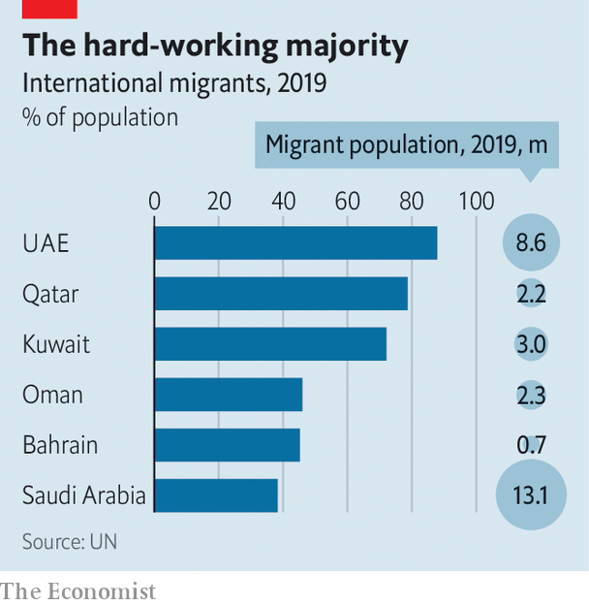

The social contract in the GCC has always been transactional. Foreigners are paid more than they would earn in their home countries. Even unskilled labourers toiling in the heat make enough to send back remittances. In return they accept a state of permanent transience. Residency is tied to employment: no matter how long you work in the Gulf, you will probably have to leave once you cease being useful. Even wealthy expats are being reminded that they are outsiders. Many of those who happened to be travelling when the lockdown began now cannot get back to their homes in Qatar or Dubai. Some are separated from spouses or parents. Far from bringing people together, the virus underscores how far apart they are. ■

Dig deeper:  
For our latest coverage of the covid-19 pandemic, register for The Economist Today, our daily [newsletter](https://www.economist.com/newslettersignup), or visit our [coronavirus tracker and story hub](https://www.economist.com/coronavirus)

This article was downloaded by calibre from <https://www.economist.com/middle-east-and-africa/2020/04/23/migrant-workers-in-cramped-gulf-dorms-fear-infection>

|  |  |  |  |
| --- | --- | --- | --- |
|  | Articles | Sections | Next |

|  |  |  |  |
| --- | --- | --- | --- |
| Previous | Articles | Sections | Next |

#### Bibi wins again

# Israel has a new government at last

And Binyamin Netanyahu has got most of what he wanted

Apr 23rd 2020 | JERUSALEM

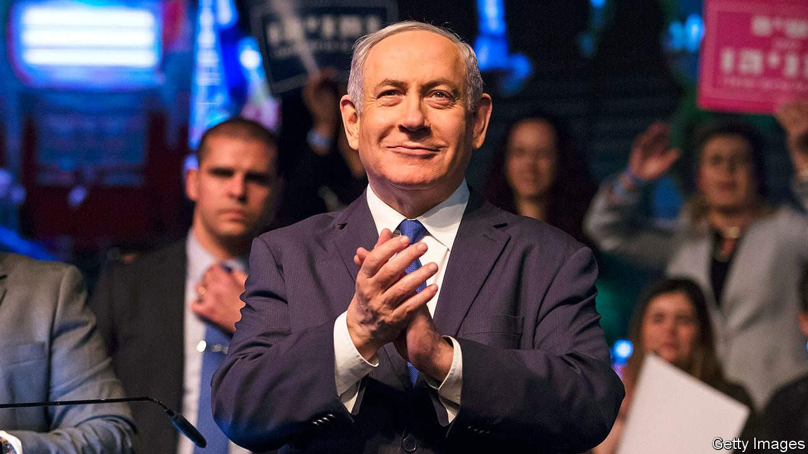

COVID-19 HAS caused much misery. But on April 20th it helped end Israel’s political deadlock. After three inconclusive elections in the span of a year, the country’s two biggest parties, Likud and Blue and White, put aside their differences and agreed to form a “national-emergency unity government”. Under the deal, Binyamin Netanyahu, the long-serving prime minister (pictured), remains in the post for another 18 months. Then he will hand over to Benny Gantz, the leader of Blue and White, who will serve as deputy prime minister and defence minister in the meantime.

The agreement was signed just two weeks before the deadline that would have triggered a fourth election. The relief is palpable. According to one poll, only 31% of the public believe that Mr Netanyahu will honour the agreement and make way for Mr Gantz when his time is up. But the alternative—yet another bitter election campaign, while the country is under lockdown and entering a recession—sounded worse. Nearly two-thirds of the public supports the new government, with only about a fifth opposing it.

Entering the coalition talks, Mr Gantz held a strong hand. A majority of lawmakers in the Knesset (Israel’s parliament) endorsed him to be prime minister and he had control of parliamentary business. But his supporters were divided on much else and refused to sit together in government. Some wanted Mr Gantz to threaten Mr Netanyahu, who faces corruption charges, with a law banning indicted politicians from forming a government. He refused, instead signalling that he would break his biggest campaign promise and team up with the prime minister, causing a split in the opposition (and within his own party).

Mr Gantz has tried to put a brave face on his decision. “The sad truth is that an entire country has been paralysed for two years under a caretaker government,” he said, while chastising his former partners for “preferring political victories over winning the battle against coronavirus”.

The prime minister was surely pleased. Mr Netanyahu, who heads a bloc of religious and nationalist parties, is likely to remain the real power in Israel even if he does give up the premiership in November 2021. He commands the allegiance of nearly three-quarters of the governing coalition. One of Mr Gantz’s colleagues will control the justice ministry, ensuring that Mr Netanyahu’s corruption trial proceeds as scheduled on May 24th (virus permitting). But it is expected to drag on—and will certainly be followed by an appeal to the Supreme Court if Mr Netanyahu loses. In the meantime, he has retained the power to veto senior judicial appointments, including those of Supreme Court judges.

The agreement delays any move to annex the occupied territories, as envisaged by President Donald Trump’s peace plan, until July at the earliest. Mr Netanyahu campaigned on moving aggressively; Mr Gantz opposed unilateral annexation. The deal says it should proceed in a way that does not harm Israel’s interests, “including the needs for preserving regional stability, protecting existing peace agreements and aspiring for future ones.” Mr Netanyahu will probably have the final say.

The outbreak of covid-19 has led to more co-operation between Israelis and Palestinians. But annexation of territory that the Palestinians regard as part of their future state would probably kill any hope of a two-state solution to the Israeli-Palestinian conflict and could ignite violence. Mr Netanyahu will obviously want to avoid that, but he may feel he needs to move before November, when his chum Mr Trump may be voted out of office.

At home Mr Netanyahu faces a weak and fragmented opposition. Blue and White has split into four different parties. One of them, Yesh Atid, is led by Yair Lapid, who apologised “to everyone who I convinced over the past year to vote for Benny Gantz and Blue and White. I didn’t believe your votes would be stolen.” Once-dominant Labour, the party of Israel’s founders, is down to three members of the Knesset, two of whom will be joining the government. Mr Gantz, meanwhile, is now bound to protect Mr Netanyahu—or risk not becoming prime minister. ■

This article was downloaded by calibre from <https://www.economist.com/middle-east-and-africa/2020/04/23/israel-has-a-new-government-at-last>

|  |  |  |  |
| --- | --- | --- | --- |
| Previous | Articles | Sections | Next |

|  |  |  |  |
| --- | --- | --- | --- |
| Previous | Articles | Sections | Next |

#### A bumpy road from plot to plate

# The race to feed Africa during a pandemic

There is plenty of food, but getting it to people is a challenge

Apr 23rd 2020 | GOMA AND KAMPALA

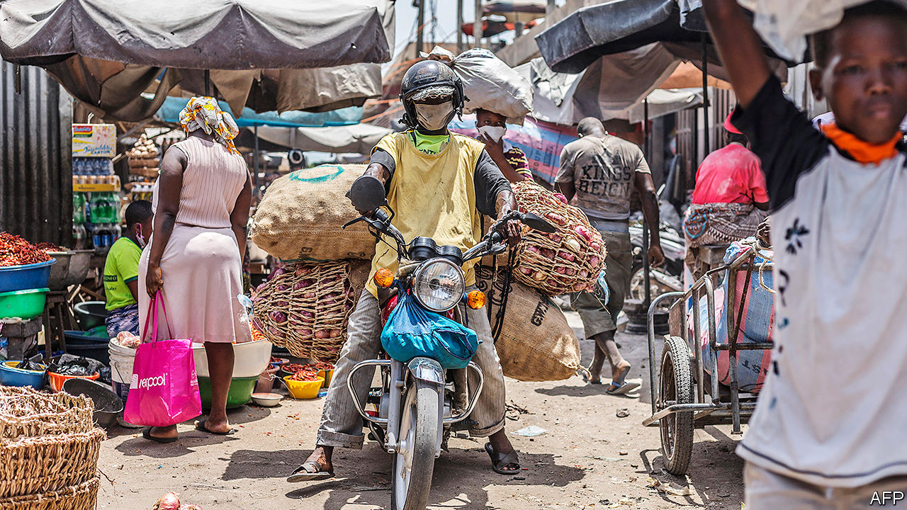

Editor’s note: The Economist is making some of its most important coverage of the covid-19 pandemic freely available to readers of The Economist Today, our daily newsletter. To receive it, register [here](https://www.economist.com/newslettersignup). For our coronavirus tracker and more coverage, see our [hub](https://www.economist.com/coronavirus)

“ONCE THE market was closed, all my knowledge was over,” sighs Brian Kayongo, a spare-parts trader from Kampala, Uganda’s capital. Until the covid-19 lockdown he spent most of his time in the city. He knew about spark plugs, not seeds. But now he is planting maize and beans on a patch of land he has rented in a nearby village. Everybody there is digging, he says. Even the young people who turned up their noses at farming have “surrendered” to the tyranny of the hoe.

Mr Kayongo is less worried about the virus than how to eat. And he is not alone. The UN’s World Food Programme (WFP) warns that the number of people who are “acutely hungry”, most of them in Africa, could double this year. The World Bank forecasts that agricultural production in sub-Saharan Africa will fall by 3-7%, and food imports by 13-25%, depending on how freely trade flows. Yet there is plenty of food in the world. If the pandemic creates hunger, it will be policy failures, not crop failures, that are mainly to blame.

The nightmare scenario would be a repeat of the food crisis in 2007-08, when the world’s governments hoarded staple grains, making prices soar. Africa imports more than a quarter of its cereals. Much of the rice that Ghana gobbles up comes from Vietnam—which has restricted exports. Shiploads of Indian rice bound for Senegal and Benin have been stranded in gridlocked ports. In normal times several west African countries spend more than half their export earnings buying food. As the prices of their own commodities fall and their currencies weaken, they will have even less purchasing power than before.

Fortunately world food systems today are “in a very different situation” from the crisis of 2007-08, says David Laborde of the International Food Policy Research Institute (IFPRI), a think-tank in Washington. Back then export restrictions blocked about 11% of the calories that flowed through global markets. In the pandemic similar measures have affected only 3% of supplies. The oil price was rocketing in 2007; now traders cannot give it away. World food stocks are high. Prices for rice are up, but not to crisis levels. South Africans can partly shift consumption to home-grown maize after a bumper crop, says Ferdi Meyer of the Bureau for Food and Agricultural Policy, a research group.

Instead, covid-19 is hitting people’s pockets. In African cities the average household allocates half its expenditure to food. That budget has shrunk as economies nosedive and lockdowns close the informal businesses in which most workers hustle. The IFPRI estimates that 80m more Africans, mostly in cities, could see their incomes drop below the equivalent of $1.90 a day (though its model does not account for domestic stimulus packages).

Several governments have tried to help by handing out food or regulating prices. But there have been problems. In Uganda four officials overseeing distribution were arrested on suspicion of fraudulently inflating prices. In Kibera, a slum in Kenya’s capital, Nairobi, women were trampled and police fired tear-gas as thousands of people jostled for a giveaway from well-wishers. It would be simpler just to give cash, which can be sent to people on their mobile phones.

The other priority is to keep food moving. Only a fifth of the food in Africa is eaten by the families that grow it, calculate researchers at Michigan State University. The rest moves down long supply chains, via lorries, processors and wholesale markets, before trickling out through millions of informal traders. Those with land can fall back on their own crops for a time. But even the poorest rural households buy nearly half their food (by value). Many are only part-time farmers, topping up their earnings with transport, trade or wage labour.

Hastily devised lockdowns are clogging up this system’s capillaries. Queues of lorries have jammed border posts and some local prices have spiked, perhaps because of hoarding. Governments designate food as an essential service, but security forces still beat up street vendors. Nigerian police have put up the bribes they extort from drivers. The Kenyan force has shot market traders. In Zimbabwe they have confiscated and burned produce, apparently to punish farmers for breaking a travel ban.

As lockdowns persist, food systems have settled into new patterns. Some Nigerian markets open for four hours at a time, on alternate days, to allow for cleaning in between. In Uganda vendors sleep in their stalls. Meanwhile, subtle disruptions have appeared. A trader in Uganda says it has become costlier to transport maize, because trailers which would normally ferry cement in the other direction travel empty. Bukola Osuntade of Babcock University in Nigeria says some poultry farmers are thriving, since most abattoirs for slaughtering cows and goats have closed down.

Less fortunate are the petty traders who carry food across African borders. On a normal day over 30,000 of them shuttle between Goma, in the Democratic Republic of Congo, and Gisenyi, in Rwanda, lugging sacks of potatoes and herding goats. Now only lorries can cross. Enterprising traders have clubbed together to hire them, but must pay the taxes that they previously dodged. Prices of rice, beans and foufou (maize or cassava flour) on the Congo side have doubled; bananas are going for three times the usual rate.

Processors are stretched, too. Bernard Wainaina, who manages a Kenyan flour mill, describes an initial rush, then a sudden drop in demand. To maintain social distancing he has sent half his workers home. A survey of 106 food processors in seven African countries by TechnoServe, a non-profit in Washington, found that fewer than a third were operating with a full staff. Over half had been hit by disrupted supplies of raw materials, packaging and spares, and had distribution problems.

The strongest link is production itself: farmers can always keep digging. A few commercial operations, such as Ethiopian vegetable growers, are struggling to find workers. But there is no sign of a big labour shortage, as on west African farms when Ebola hit. Input markets are another matter. Narcis Tumushabe, the boss of one of Uganda’s biggest seed companies, says he has sold only a fifth of what he expected this season. “We may be forced to sell the seed as flour for food,” he warns.

The most vulnerable parts of Africa are those already reeling from war, pests or drought. “Covid-19 is like a crisis within a crisis,” says Abebe Haile-Gabriel of the UN’s Food and Agriculture Organisation. In east Africa a plague of locusts that ravaged crops earlier this year is returning, many times bigger than before. Pesticides to fight them have been delayed in transit.

The WFP says more than 5m people in the central Sahel will go hungry in the coming lean season. In Zimbabwe, cursed with drought and recession, over a quarter of the population get food handouts. In Uganda rations for 1.4m refugees have been cut by 30%. The funding shortfall was not caused by the pandemic, but shows what happens when donors lose focus.

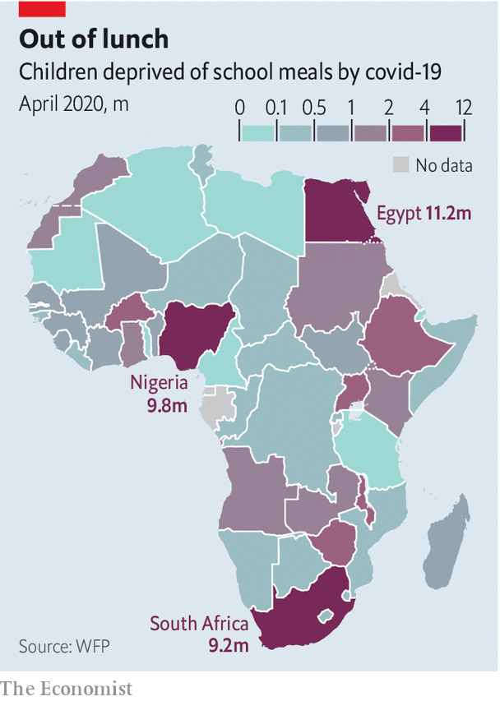

Away from crisis zones the threat is not starvation, but a slow-burning struggle which may last long after lockdowns are lifted. More than 50m children in sub-Saharan Africa are missing school meals (see chart). As hardship bites, many families will switch to less nutritious diets, cutting out things like fruit and vegetables, or simply eating less. Claude Bahati, a laid-off cleaner in Goma, gulps down water every morning to fill his empty stomach. “We used to eat twice a day, now we only eat once,” he says. “If this confinement continues then we will die.”

That need not happen. Most African countries locked down early, so may be able to ease up quickly. In the meantime new initiatives are sprouting, from delivery apps connecting vendors with customers to an efflorescence of mutual aid. Markets are being redesigned. Traders’ associations, customs officials and TradeMark East Africa, a donor-funded outfit in Nairobi, are piloting “safe trade zones” at borders, with temperature checks, masks and sanitisers. Policymakers on the continent and beyond should keep food flowing. They must not let an unprecedented shock become a hunger crisis. ■

Dig deeper:  
For our latest coverage of the covid-19 pandemic, register for The Economist Today, our daily [newsletter](https://www.economist.com/newslettersignup), or visit our [coronavirus tracker and story hub](https://www.economist.com/coronavirus)

This article was downloaded by calibre from <https://www.economist.com/middle-east-and-africa/2020/04/23/the-race-to-feed-africa-during-a-pandemic>

|  |  |  |  |
| --- | --- | --- | --- |
| Previous | Articles | Sections | Next |

|  |  |  |  |
| --- | --- | --- | --- |
| Previous | Articles | Sections | Next |

#### The parable of the bag of cash

# Abba Kyari, who tried to clean up Nigeria, dies of covid-19

The president’s chief of staff was dismayed by the state’s decay

Apr 23rd 2020 |

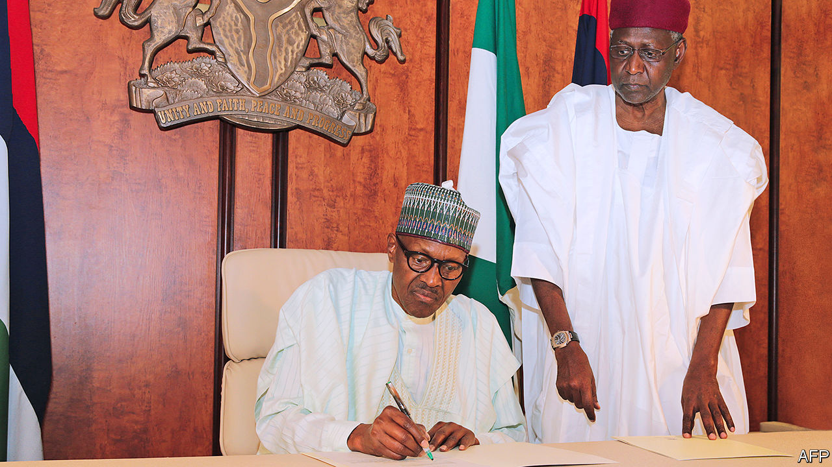

Editor’s note: The Economist is making some of its most important coverage of the covid-19 pandemic freely available to readers of The Economist Today, our daily newsletter. To receive it, register [here](https://www.economist.com/newslettersignup). For our coronavirus tracker and more coverage, see our [hub](https://www.economist.com/coronavirus)

IT WAS A rare display of emotion by Muhammadu Buhari, Nigeria’s phlegmatic president. In a written tribute to Abba Kyari, his chief of staff, who died in Lagos on April 17th after catching covid-19, Mr Buhari told of how his “dearest friend” of more than 40 years tried to improve governance and reduce corruption in Africa’s most populous country. He was “the very best of us”, wrote the president.

While Mr Kyari was alive, others were much less kind. Many saw him as the figurehead for a shadowy cabal that controlled policy and appointments, and granted favours and contracts. Cabinet ministers grumbled that they could not get past his door to discuss important issues with a distant and apathetic president. Mr Kyari’s economic thinking, which seemed stuck in the 1970s, was also criticised.

There was some truth to these accusations. Yet there is also a broader parable of Mr Kyari. It is one of a largely honourable man who went to the heart of a thoroughly corrupt and dysfunctional system, aiming to reform it—but who struggled to overcome its inertia amid a series of crises.

Like his ascetic boss (pictured, seated), Mr Kyari (standing) was a man of modest habits, at least by the standards of Nigeria’s elite. He was known to turn down offers of free upgrades to first class (he thought it vulgar) before taking his seat in business class on British Airways flights. His weaknesses were for books on political economy and plates of well-done kippers at the Dean Street Townhouse in London.

The corruption and decay of Nigeria’s state, and the inequality they bred, dismayed and worried him. Nigeria had to change, he argued. The question was whether it would be through orderly reform or chaotic breakdown.

When seeing your correspondent one evening in Abuja, Mr Kyari pointed to a bag stuffed with $100 bills. It had been “forgotten” by an earlier visitor—the boss of an energy company—who sheepishly came to collect it after getting an earful. “Much too much of our work is spent on stopping our own people stealing,” Mr Kyari said.

The chief of staff, who had studied law at Cambridge University and been in charge of a successful bank before Mr Buhari hired him in 2015, thought the state should play a big role in the economy. He would speak fondly of British Rail in the 1970s before it was privatised (an era of strikes and awful food, as Brits remember it). And he clashed with the IMF when it urged Nigeria to liberalise its fixed exchange rates. But he was, in essence, a pragmatist who thought ideology was a distraction from the bigger tasks of enforcing the rule of law and improving governance.

He was also cursed with bad luck. Mr Buhari took power after a crash in oil prices that pushed the country into recession and starved it of the money needed to fight the jihadists of Boko Haram. Mr Kyari had hoped that Mr Buhari’s second term would provide an opportunity to liberalise the corrupt oil and gas industries by making contracts and licences more transparent and taking them out from under the thumb of politicians. Yet covid-19 may well dash those plans, just as it has deprived Mr Buhari’s administration of its rudder. ■

Dig deeper:  
For our latest coverage of the covid-19 pandemic, register for The Economist Today, our daily [newsletter](https://www.economist.com/newslettersignup), or visit our [coronavirus tracker and story hub](https://www.economist.com/coronavirus)

This article was downloaded by calibre from <https://www.economist.com/middle-east-and-africa/2020/04/23/abba-kyari-who-tried-to-clean-up-nigeria-dies-of-covid-19>

|  |  |  |  |
| --- | --- | --- | --- |
| Previous | Articles | Sections | Next |

|  |  |  |
| --- | --- | --- |
| Middle East and ... | Sections | Britain |

Europe

Germany and covid-19: Top of the class?

.

A French conundrum: Rush-hour running

.

Turkey, refugees and covid-19: A crisis within a crisis

.

NATO in Europe: Yankees go home

.

Charlemagne: Testing the faith

.

|  |  |  |
| --- | --- | --- |
| Middle East and ... | Sections | Britain |

|  |  |  |  |
| --- | --- | --- | --- |
|  | Articles | Sections | Next |

#### Top of the covid class?

# Germany excels among its European peers

But the chancellor, Angela Merkel, still faces some tricky obstacles

Apr 25th 2020 | BERLIN

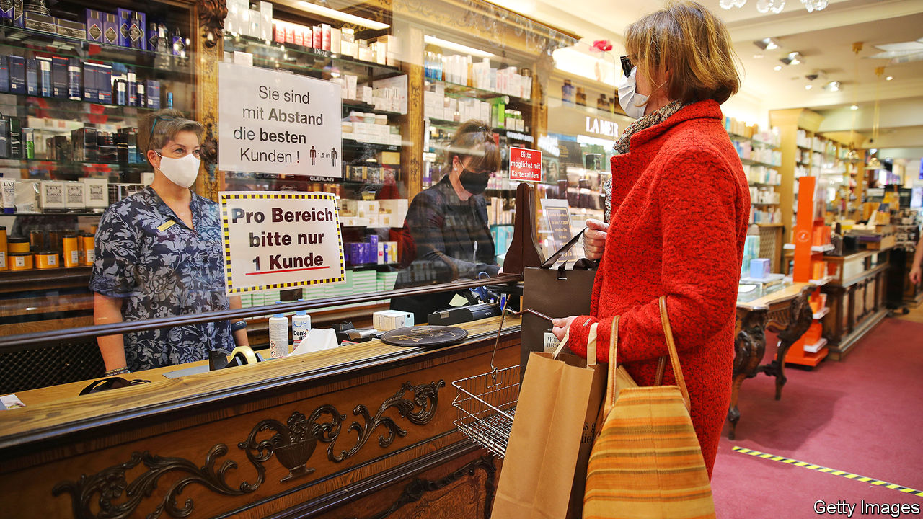

Editor’s note: The Economist is making some of its most important coverage of the covid-19 pandemic freely available to readers of The Economist Today, our daily newsletter. To receive it, register [here](https://www.economist.com/newslettersignup). For our coronavirus tracker and more coverage, see our [hub](https://www.economist.com/coronavirus)

IF ANY BIG European country can be said to have so far had a good corona crisis, it is Germany. Deaths are fewer than in other countries, the state helps ailing firms and workers and the politicians seem level-headed and competent. Places with more erratic leadership have noted the contrast. British journalists ask their politicians why they can’t emulate Germany’s testing rates. American television networks urge Jens Spahn, the health minister, to reveal Germany’s secrets. One columnist even mused that Angela Merkel, the chancellor, might serve as Joe Biden’s running-mate.

The true picture is more complicated. “We can’t say we’re perfect and everything was planned,” says Jonas Schmidt-Chanasit, a virologist at the University of Hamburg. Testing was crucial, but relied on an existing network of nearly 200 private and public laboratories that ramped up capacity after a Berlin hospital developed a test in January, before politicians knew a crisis was coming. “Other countries had to build labs, we already have them,” says Evangelos Kotsopoulos, the boss of the German arm of Sonic Healthcare, a private lab network. Germany now conducts 350,000 tests a week, and could do many more.

Second, while national politicians and health officials dithered, local authorities acted quickly to close public places and track contacts of the infected when early outbreaks were detected in parts of Bavaria and the Rhineland. Germany was also lucky, says Karl Lauterbach, an MP and epidemiologist. It received an “early warning” from Italy, and many of the first to be infected were young, which kept hospitalisations and deaths down (though they are now climbing). Germany used the time this bought to flatten the curve of infections.

Building on its early success in isolating cases will be crucial as Germany moves to the next stage of the crisis. Mrs Merkel wants to track every chain of infection. That means yet more tests—reportedly up to 4.5m a week if supply constraints can be overcome—and rigorously chasing contacts of the newly infected. Apps may help, notwithstanding privacy worries (see [article](https://www.economist.com/europe/2020/04/25/privacy-in-a-pandemic)), but most work will be done by thousands of “containment scouts” in Germany’s 400-odd overworked and underfunded public-health offices.

The fiscal response also builds on old foundations. To protect workers’ income, Germany has ramped up Kurzarbeitergeld (money for short-time work), an established system under which the state covers 60-87% of the forgone wages of workers whose hours are cut. It has pledged hundreds of billions in guarantees for bridging loans, and set up a €50bn ($54bn) fund for freelancers and small companies. After a few hiccups, implementation has been largely smooth. Yet as recession bites, more is needed. On April 22nd the cabinet agreed a further €10bn stimulus package.

The measures smash Germany’s hallowed no-deficit rule. But for Olaf Scholz, the finance minister, this is a feature, not a bug: Germany can spend in bad times because it saved in good. The size of its response, says Oliver Rakau at the Oxford Economics consultancy, means Germany may muddle through better than other EU countries. And though its car industry ceased production for a while (see [article](https://www.economist.com/briefing/2020/04/25/the-worlds-car-giants-need-to-move-fast-and-break-things)), sectors like chemicals and steel kept working. Electricity usage and mobility data suggest the slowdown has been less acute than in France, Spain or Italy. Still, the Bundesbank expects a “severe” recession and the IMF forecasts a 7% contraction this year, deeper than in 2009. The openness of its economy leaves Germany especially vulnerable to severed supply chains and slumping foreign demand, even once domestic consumption resumes.

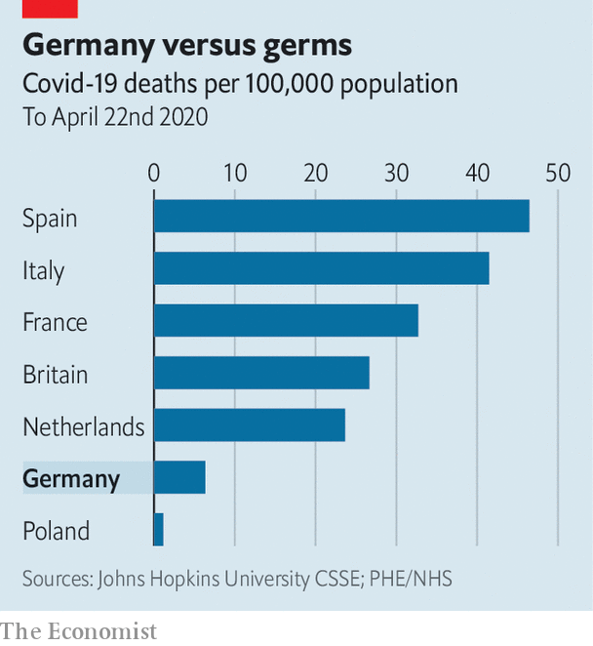

The pace of recovery will also depend on how quickly restrictions are eased. With the number of recorded infections now rising by only 1-2% each day Germany is tentatively opening up, starting with smaller shops, and classes for children facing exams. By European standards the lockdown was late and lenient. But perhaps because Germany was less affected than its neighbours, the consensus behind it is crumbling. Larger retailers are chafing. So are working parents facing kindergarten closures that may last for months. Such rows play out in the fractious negotiations Mrs Merkel must conduct with the leaders of Germany’s 16 states. This week she was reported to have lamented the “orgies” of debate over who may open when, fearing they cloud the risks of fresh waves of infection.

The chancellor, a scientist fluent in the argot of reproduction rates and risk management, is “perfect” for this situation, says Karin Prien, a minister in the state of Schleswig-Holstein and a party colleague. Mrs Merkel’s approval ratings are nudging 80% and her Christian Democratic Union is soaring in the polls; some quietly hope she may break her pledge to stand down at next year’s election. Yet, notes Thorsten Benner of the Global Public Policy Institute, a think-tank, her talents may have been better suited to the first stage of the crisis, which demanded calm competence, rather than the awkward trade-offs of the next. Unlike Sebastian Kurz, chancellor of Austria, which locked down early and hard and is now easing more quickly, she has not found a vision of recovery to leaven her message of caution.

There have been wobbles as well as wins. The government has struggled to step up production of face-masks, for example, although all 16 states now mandate their use. And the cross-party consensus forged in adversity is now starting to crack. Yet Germany’s successes in managing the outbreak are undeniable. The fact that it is now arguing vigorously about what comes next is not the least among them. ■

Dig deeper:  
For our latest coverage of the covid-19 pandemic, register for The Economist Today, our daily [newsletter](https://www.economist.com/newslettersignup), or visit our [coronavirus tracker and story hub](https://www.economist.com/coronavirus)

This article was downloaded by calibre from <https://www.economist.com/europe/2020/04/25/germany-excels-among-its-european-peers>

|  |  |  |  |
| --- | --- | --- | --- |
|  | Articles | Sections | Next |

|  |  |  |  |
| --- | --- | --- | --- |
| Previous | Articles | Sections | Next |

#### Rush-hour runners

# The curious etiquette of jogging in Paris

Sweaty people in shorts are everywhere. Philosophers disapprove

Apr 23rd 2020 | PARIS

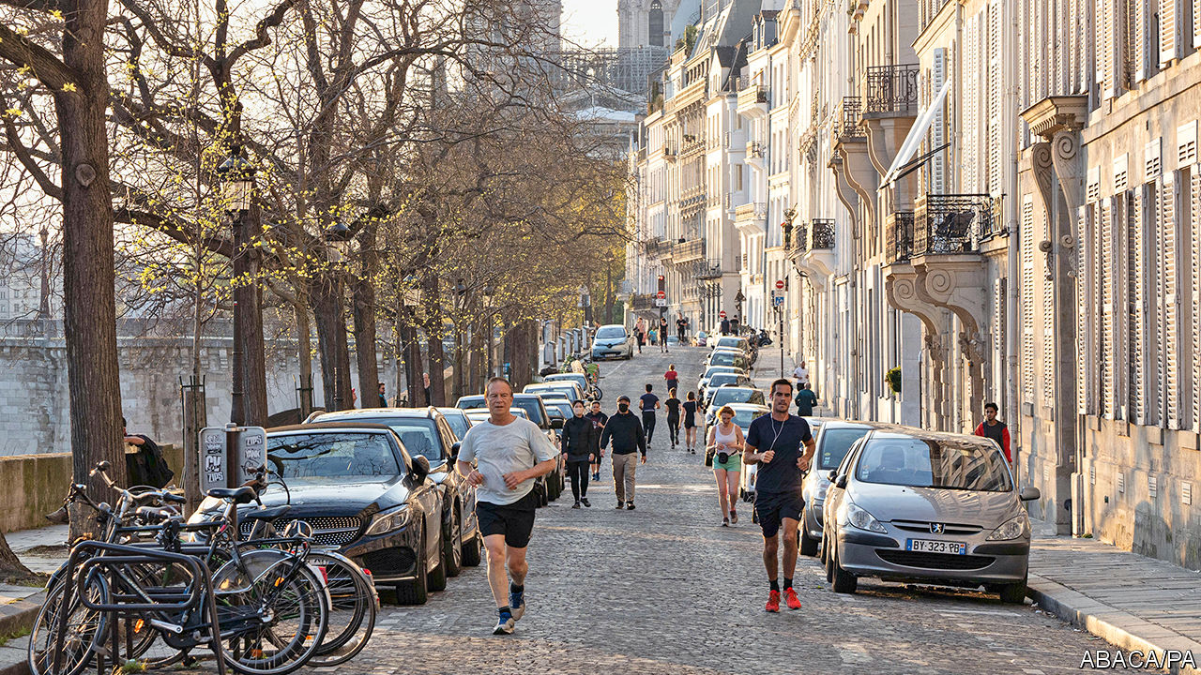

Editor’s note: The Economist is making some of its most important coverage of the covid-19 pandemic freely available to readers of The Economist Today, our daily newsletter. To receive it, register [here](https://www.economist.com/newslettersignup). For our coronavirus tracker and more coverage, see our [hub](https://www.economist.com/coronavirus)

FIRST THE Paris town hall shut the city’s gyms, on national orders. Next it locked the parks and closed riverside paths. Then it banned running during the day, between 10am and 7pm. This latest ruling was designed to separate joggers from daytime shoppers queuing for essentials on the city’s narrow pavements. But the result has been an evening rush hour, as joggers emerge from confinement all at the same time to squeeze in a run before supper.

Paris has imposed some of Europe’s tightest rules on outdoor exercise. In Amsterdam or Berlin joggers can run when they like, so long as they respect social distancing. In most regions Italians can go jogging, even if just in a tight circle around their homes. Only Spain has enforced truly drastic rules, having banned all outdoor exercise (and kept children inside for the past six weeks).

Has confinement revealed a hitherto hidden French passion for le jogging? A poll suggests that in normal times only 10% of the French go running regularly. A mere 6m people belong to a gym in France, well below the 11m in Germany or 10m in Britain. Parisians are expected to be shaped by nature, not machines. During lockdown some improbably dressed joggers have been spotted pounding the streets, complete with the occasional jaunty silk scarf.

When in 2007 Nicolas Sarkozy broke with the formality of presidential tradition by leaving the Elysée palace in running shorts, one commentator linked it to his politics: “Jogging is of course about performance and individualism, values that are traditionally ascribed to the right.” Purists deplored the casual look. Intellectuals sniffed at the vulgarity. Jogging, said Alain Finkielkraut, a philosopher, did nothing for the soul or the mind; it was mere “body management”. Instead he praised la promenade, as practised by Aristotle or Rimbaud. A meditative walk, argued Mr Finkielkraut, is a “sensitive, spiritual experience”. Perhaps this explains the Paris rules. For now, daytime jogging may be banned, but people can still walk—even if only for an hour, around their homes—at any time of the day. Whatever they are thinking.

Dig deeper:  
For our latest coverage of the covid-19 pandemic, register for The Economist Today, our daily [newsletter](https://www.economist.com/newslettersignup), or visit our [coronavirus tracker and story hub](https://www.economist.com/coronavirus)

This article was downloaded by calibre from <https://www.economist.com/europe/2020/04/23/the-curious-etiquette-of-jogging-in-paris>

|  |  |  |  |
| --- | --- | --- | --- |
| Previous | Articles | Sections | Next |

|  |  |  |  |
| --- | --- | --- | --- |
| Previous | Articles | Sections | Next |

#### From persecution to pandemic

# As Turkey locks down, refugees are the first to suffer

Laid off fast and excluded from relief, many are now desperate

Apr 23rd 2020 | ISTANBUL

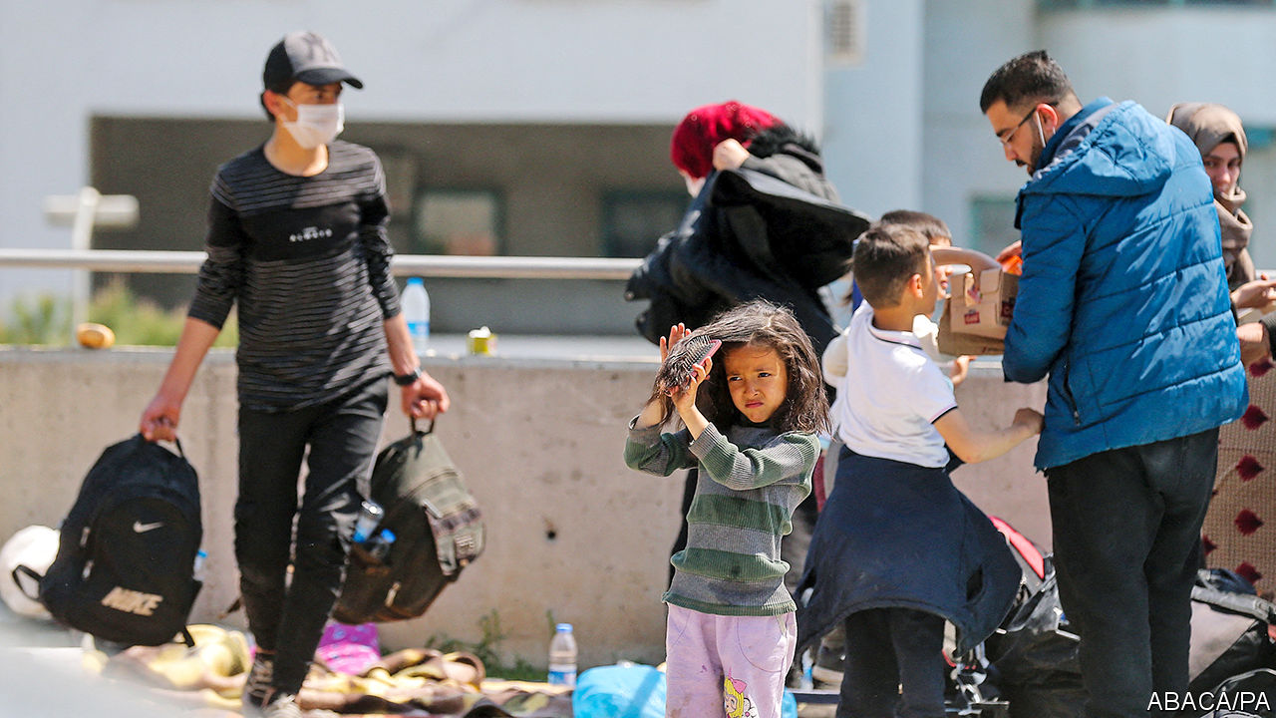

Editor’s note: The Economist is making some of its most important coverage of the covid-19 pandemic freely available to readers of The Economist Today, our daily newsletter. To receive it, register [here](https://www.economist.com/newslettersignup). For our coronavirus tracker and more coverage, see our [hub](https://www.economist.com/coronavirus)

AT THE END of February, when Turkey’s President Recep Tayyip Erdogan announced he would open his country’s borders with Greece to migrants and refugees, Salih, an Afghan living in Istanbul, heeded the call, as did thousands of others. But the Greek side of the border was closed. For ten days, Salih waited and slept rough near the main crossing. Eventually, Turkish police drove him and a few others to a river separating the two countries and ordered the group to cross by boat, threatening them with batons. Greek guards then captured him, took his cash and phone, and sent him back. By the time he returned to Istanbul, where he had earned a living fixing windows since escaping the Taliban, the covid-19 pandemic was in full swing. His job was gone. The company he worked for had closed. Salih, who lives with his wife and two children, can no longer pay rent and faces eviction. “We ran out of money,” he says. “We have nothing left.”

Across Turkey, the pandemic is taking an increasingly heavy toll in lives and in jobs. For the second time in as many years, a recession beckons, this one more severe than the last. The IMF expects the economy to contract by 5% this year. An avalanche of lay-offs has already started to swell. It will hit the millions of migrants and refugees living in Turkey hardest, and it will hit them first.

Mr Erdogan would like to prevent mass loss of life without risking economic collapse. But he may end up with both. His government has suspended all international flights, closed schools, cancelled communal prayers at mosques, and ordered people above 65 and below 20 to remain at home. But it has also kept the economy running, albeit in low gear.

This piecemeal approach is starting to backfire. On April 10th the government imposed a weekend curfew in the country’s biggest cities with only two hours’ notice. Within minutes, hundreds of thousands of people stormed supermarkets and bakeries to stock up on food. Turkey’s infection rate was already rising rapidly. In the first three weeks of April, confirmed cases spiked from under 16,000 to over 90,000. The botched curfew will have made things even worse.

The economy, which rebounded late last year, is reeling again. Exports in March were down by 18% compared with the same period in 2019. Tourism, which generated $35bn last year, is bracing for a lost summer. The central bank, having burned through billions of dollars to prop up the Turkish lira, has nearly run out of foreign reserves. The currency is sliding, placing yet more pressure on companies with foreign-currency debt.

No one is more vulnerable than the migrants and refugees who have made Turkey their home over the past decade. Some 70% of the 3.7m Syrians in Turkey are poor or nearly poor. The vast majority work informally, which makes them ineligible for compensation or unemployment benefits. A recent survey revealed that only 3% of employed Syrians had official work permits. “They were hired for being the cheapest labour and they will be the most disposable ones,” says Omar Kadkoy, a researcher at TEPAV, a think-tank in Ankara.

Scores have already been sacked. Maysarah, an Egyptian who worked at a stall selling dried fruit in Istanbul’s once bustling Grand Bazaar, says his bosses fired him and dozens of other migrants when the bazaar closed in March. Waseem, a Syrian who drives a food-delivery truck, says he managed to hold on to his job. Four of his five Syrian flatmates have lost theirs. Because refugees generally work off the books, there is no telling how many have been laid off since the start of the crisis. The jobless rate is 14%, but that figure dates back to January. Economists fear it will easily pass 20% by the summer.

The government has tried to help the economy weather the storm with a 100bn- lira ($15bn) stimulus package, which allows affected businesses to defer loan and tax payments and offers support to households in need. Parliament has also passed a law banning companies from sacking workers over the coming three months and offering those forced to take unpaid leave roughly $6 a day. None of this applies to migrants or refugees.

Turkey may soon turn to a familiar source for additional funding. In 2015 the EU offered Turkey $6bn if it agreed to look after the refugees and prevent them from crossing to Greece. Mr Erdogan deserves no reward for playing with their hopes to put pressure on European governments. But the migrants and refugees knocking on Europe’s doors do deserve better. Against the approaching storm, many of them are defenceless. Once again, the EU will probably be obliged to clench its teeth, loosen its purse-strings and entrust Turkey’s leader with lots more money. ■

Dig deeper:  
For our latest coverage of the covid-19 pandemic, register for The Economist Today, our daily [newsletter](https://www.economist.com/newslettersignup), or visit our [coronavirus tracker and story hub](https://www.economist.com/coronavirus)

This article was downloaded by calibre from <https://www.economist.com/europe/2020/04/23/as-turkey-locks-down-refugees-are-the-first-to-suffer>

|  |  |  |  |
| --- | --- | --- | --- |
| Previous | Articles | Sections | Next |

|  |  |  |  |
| --- | --- | --- | --- |
| Previous | Articles | Sections | Next |

#### Yankees go home

# America’s dry run to defend Europe is derailed by covid-19

But NATO generals are figuring out how to work with the European Union

Apr 23rd 2020 |

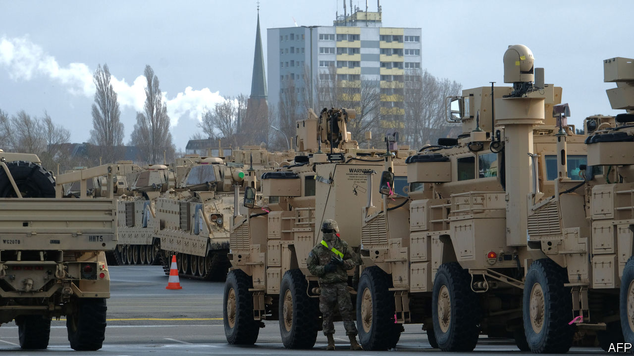

Editor’s note: The Economist is making some of its most important coverage of the covid-19 pandemic freely available to readers of The Economist Today, our daily newsletter. To receive it, register [here](https://www.economist.com/newslettersignup). For our coronavirus tracker and more coverage, see our [hub](https://www.economist.com/coronavirus)

IT WAS TO be America’s largest deployment of troops across the Atlantic since the cold war. Instead, “Defender 20”, an exercise designed to test America’s ability to move a division (20,000 or so soldiers) into and across Europe, was stricken by covid-19 and cancelled in March. But the lessons of the truncated drill are vital for Western war plans, which depend on armies being able to dash east over Europe’s disjointed road and rail system in a crisis.

After Russia’s invasion of Ukraine in 2014, a revived NATO strung 5,000 or so troops in four modest battlegroups through the Baltic states and Poland to deter more adventurism. These would slow rather than halt a Russian advance. If attacked, they would need massive reinforcement, and fast. So the allies agreed that by this year they would have 30 battalions, 30 warships and 30 air squadrons—all available to NATO within 30 days.

But shoring up the frontline depends not only on having units ready but also on whether they can get to where they are needed, something planners call military mobility. Ben Hodges, a retired general who commanded American army forces in Europe in 2014-17, says shifting troops and equipment across borders was a bureaucratic and logistical headache. It still is, according to a recent report he co-wrote, published by the International Centre for Defence and Security and the Centre for European Policy Analysis, think-tanks in Estonia and Washington respectively.

Some obstacles are procedural, like border checks on military goods. Others are to do with infrastructure. The difference in European and Baltic rail gauges requires switching trains at the Polish-Lithuanian border, for instance, while the key Poznan-Warsaw highway, like many roads in eastern Europe built to handle lighter Warsaw Pact armour, cannot take America’s M1 Abrams tanks. All told, it would take 60 days to get a heavy division from America to the Baltic region and five to six months for a corps (up to 45,000 troops), says the report. By that time, Russian invaders could be well ensconced.

General Hodges says he eventually realised that European interior ministries and border agencies were better interlocutors than his fellow generals. “I also discovered that the European Union was actually the better institution for addressing most of the challenges,” he says. While NATO had the plans, “they had the authorities and processes and money.” In recent years the EU has been working more closely with NATO. In 2018 it put the Dutch in charge of a project to improve military mobility.

Even so, under current EU rules it could still take a leisurely five days to issue “movement permissions” for most units. “Europe is in a bad place,” concludes Bruno Lété of the German Marshall Fund, another think-tank. He points out that the European Commission’s latest budget proposal suggests that funds for military mobility could shrink from €6.5bn ($7.1bn) to zero.

“Scaling back Defender 20 is really a lost opportunity to effectively test that logistical knowledge of Europe’s infrastructure,” says Mr Lété. The planning efforts “were a huge success”, insists Rear-Admiral Pete Stamatopoulos, the director of logistics for US European Command. But only 6,000 or so American troops had arrived in Europe when the plug was pulled. The fact that America was prepared to spend hundreds of millions of dollars in an election year on an exercise is a sign of commitment and a signal to the Kremlin, says General Hodges. But whether American troops could get east in a hurry remains unproven. ■

Dig deeper:  
For our latest coverage of the covid-19 pandemic, register for The Economist Today, our daily [newsletter](https://www.economist.com/newslettersignup), or visit our [coronavirus tracker and story hub](https://www.economist.com/coronavirus)

This article was downloaded by calibre from <https://www.economist.com/europe/2020/04/23/americas-dry-run-to-defend-europe-is-derailed-by-covid-19>

|  |  |  |  |
| --- | --- | --- | --- |
| Previous | Articles | Sections | Next |

|  |  |  |  |
| --- | --- | --- | --- |
| Previous | Articles | Sections | Next |

#### Charlemagne

# Privacy in a pandemic

Coronavirus is the first trial of the EU’s unofficial religion

Apr 23rd 2020 |

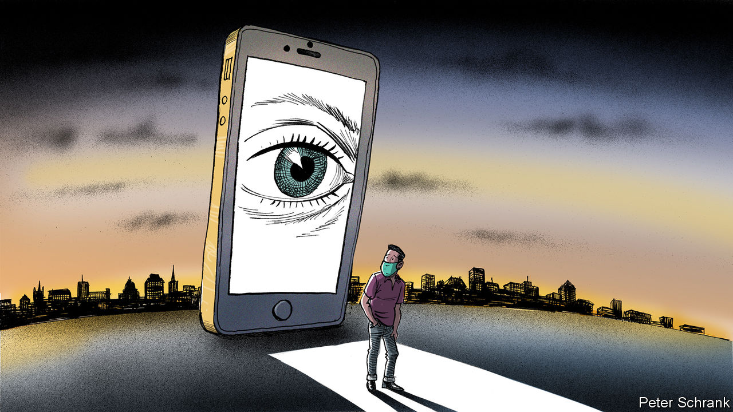

Editor’s note: The Economist is making some of its most important coverage of the covid-19 pandemic freely available to readers of The Economist Today, our daily newsletter. To receive it, register [here](https://www.economist.com/newslettersignup). For our coronavirus tracker and more coverage, see our [hub](https://www.economist.com/coronavirus)

IF THE EU had an official religion, it would be privacy. A devout priesthood of EU officials and politicians preach that only their privacy laws can lead to salvation. Holy texts, such as the General Data Protection Regulation or the ePrivacy Directive, are held up as wisdom the whole world would be better off following. Such is the regulatory clout of Brussels that much of it often does. Those who break such strictures are smitten (or whacked with fines of up to 4% of global turnover). In an age of coronavirus, as policymakers ponder ways of ending the lockdown, this belief is being tested.

A crisis of faith has taken root among once-true believers. “It is a trade-off,” warned Austria’s right-wing chancellor, Sebastian Kurz. “What is more important to us? Data protection or that people can return to normal? Data protection or saving lives?” Even German politicians, hitherto the high priests of the faithful, have joined in. Jens Spahn, the German health minister, suggested tracking people’s phones in order to contain the virus, before backing down after an outcry. It is as if the pope began a sermon by admitting that perhaps Martin Luther had a point.

Countries full of privacy heathens have enthusiastically put the state’s surveillance capacity to use. In Hong Kong, new arrivals can be required to wear a tracking bracelet. Israel has enlisted its intelligence agencies to track people who may have the virus. In South Korea officials root through everything from taxi receipts to credit-card records to hunt for those infected. Now the EU is mulling where to draw the line between safety and surveillance.

Whether Europe veers from its righteous path is a political question, rather than a legal one. Though its laws are strict, exemptions for public-health crises are written into EU rules on, say, data protection. But these are far from a carte blanche. Any use of data must be proportionate and fall away once the crisis has passed. When it comes to pandemics, Europe’s privacy laws are a seatbelt rather than a handbrake, says Eduardo Ustaran, a lawyer at Hogan Lovells, a British-American law firm. Governments can still get where they need to go, but they experience less chance of a catastrophic accident—such as an entire country’s medical data being sprayed onto the internet—on the way.

It is Europe’s citizens, not its lawyers, who will decide how much intrusion they are willing to bear. Most European governments are toying with tracing apps, where smartphones would tell users whether they interacted with someone who had covid-19. But such apps work well only when large proportions of the population download them. No matter how technically ingenious a solution may appear, it is little use without mass consent. Other governments have gone further. Poland, for instance, enforces a quarantine of those suffering from covid-19 with the aid of an app. (Those under quarantine must submit regular selfies to prove they are staying at home.) For the bulk of EU citizens, covid-19 is the first time that the EU’s piety on privacy could come with a cost borne by themselves rather than by business. During the pandemic, people have willingly—and occasionally grudgingly—sat at home for weeks on end, surrendering their freedom in the process. Sacrificing privacy for the sake of liberty may appeal after a long enough period of de facto house arrest.

Such choices have not been put to voters before. In the EU privacy has long been a top-down pursuit, waged against fierce opposition from gigantic corporations by politicians and bureaucrats who do not have to worry about security, but tend to believe that citizens will love them for protecting their privacy. Enthusiasm for the topic in Brussels is also boosted by two not entirely high-minded considerations. First, it helps the EU project power externally. Strict standards combined with the EU’s enormous market are enough to bully even the largest global business into following Brussels’s rules, a phenomenon known as the “Brussels effect”. Rather than operating to different standards globally, big companies save themselves the bother and work to the EU’s usually higher standard. Second, it gives Brussels more power internally, too. When the EU limited itself to the nitty-gritty of business, the rulings of the EU’s Court of Justice in Luxembourg carried little interest for ordinary citizens. Regulations on, say, chemicals affected only the chemicals industry. But issues such as data protection cut across vast swathes of people’s lives, from browsing habits to freedom of expression, and judges tend to meddle.

## Privacy has a price

For most European citizens, arguments about privacy have been about as intelligible as a mass in Latin. A consequence of the coronavirus could be a more comprehensible debate. Any trade-offs between health and privacy will be subject to public scrutiny, just like the ever-shifting balance between civil liberties and counter-terrorism, argues Bruno Maçães, an author and former Europe minister of Portugal. Norms are still being settled. Data protection, the jewel in the EU’s regulatory crown, dragged the once-arcane world of privacy into the sphere of high politics. The virus provides voters with the topic’s first real public reckoning.

A nervous discourse has already started among Europe’s decision-makers, who were in a funk about the EU’s place in the world even before covid-19 devastated the bloc’s economy and left nearly 100,000 of its citizens dead, with doubtless much more disaster still to come. If other systems of governance, whether outright autocracy or “managed” democracy, are seen to handle the virus better, it could push them into a crisis of confidence. Their lofty ambitions on privacy could well be jettisoned in such circumstances. Defending a political system by ditching one of its fundamental tenets may seem self-defeating. But politics is a results business. EU governments will be judged on how quickly life returns to normal, with states that used heavy-handed surveillance the obvious comparison. If a gap emerges, even the apostles of privacy may find it hard to keep the faith. ■

Dig deeper:  
For our latest coverage of the covid-19 pandemic, register for The Economist Today, our daily [newsletter](https://www.economist.com/newslettersignup), or visit our [coronavirus tracker and story hub](https://www.economist.com/coronavirus)

This article was downloaded by calibre from <https://www.economist.com/europe/2020/04/23/privacy-in-a-pandemic>

|  |  |  |  |
| --- | --- | --- | --- |
| Previous | Articles | Sections | Next |

|  |  |  |
| --- | --- | --- |
| Europe | Sections | International |

Britain

The BBC’s future: The next episode

.

Politics: Jolly difficult

.

The price isn’t right: Not just a problem for economists

.

Covid communities: Neighbourhood watch

.

Food and the economy: Pret A Ouvrir

.

Freemasons: Out of the shadows

.

Bagehot: Back to abnormal

.

|  |  |  |
| --- | --- | --- |
| Europe | Sections | International |

|  |  |  |  |
| --- | --- | --- | --- |
|  | Articles | Sections | Next |

#### The next episode

# The BBC is having a good pandemic

But the loss of young audiences poses a mortal threat to its funding

Apr 25th 2020 |

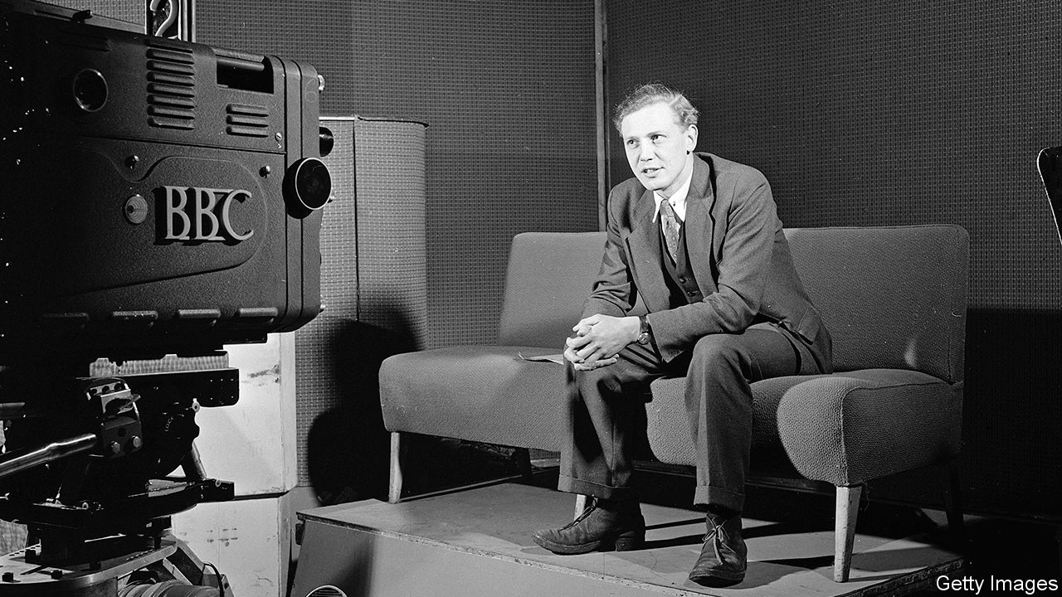

Editor’s note: The Economist is making some of its most important coverage of the covid-19 pandemic freely available to readers of The Economist Today, our daily newsletter. To receive it, register [here](https://www.economist.com/newslettersignup). For our coronavirus tracker and more coverage, see our [hub](https://www.economist.com/coronavirus)

“HEY GANG, good morning! Hope you feel real good,” bellows Derrick Evans, marching on the spot in a dayglo spandex leotard. The 67-year-old fitness instructor, better known as Mr Motivator, has been brought out of retirement to help Britons stay trim during their covid confinement. As he pants through a slot on daytime television, he answers viewers’ questions. One couple say their heating has broken down and they are cold. “Get up now, and move the body!” he orders them.

As the country battles covid-19, the British Broadcasting Corporation has joined the war effort. Plans to lay off 450 of its journalists are on hold, as new programmes like “HealthCheck UK Live” (home of Mr Motivator) are rushed out. Its local radio stations are pitching in, one arranging the live-streaming of a funeral to the home of a quarantined relative. With public worship banned for the first time since 1208, the BBC is broadcasting virtual sermons. Bitesize, its educational arm, has roped in stars such as Sir David Attenborough to teach online lessons to home-schooled children, as the BBC food website highlights quick lunches for home-working parents. “As the national broadcaster, the BBC has a special role to play at this time of national need,” the corporation’s director-general, Lord Hall, declared after the outbreak.

The pandemic has given the BBC a potentially life-saving answer to a question asked with growing frustration in government: what is the point of the corporation? Two months ago a Downing Street source told the Sunday Times of plans to “whack” the 97-year-old broadcaster. Long-simmering resentment among Conservatives about what they see as its left-liberal bias had boiled over during the Brexit campaign of 2016 and the two general elections that followed. Tory complaints were amplified by allied newspapers—which have their own motives for attacking a rival that receives a subsidy of £3.6bn ($4.4bn) a year, courtesy of a £157.50 licence fee levied on households that watch live TV.

After winning his large majority in December Boris Johnson, who has dubbed the BBC the “Brexit Bashing Corporation”, set out plans to decriminalise licence-fee evasion, which the broadcaster says would cost it more than £200m a year. He has also leant on it to “cough up” and waive the fee for elderly viewers, which would cost it another £745m. (The BBC has agreed to let them off until at least August, during their quarantine.) Some senior Tories have even bigger designs on the corporation, whose 11-year royal charter is up for a mid-term review in two years. In January Julian Knight, who is chairing a parliamentary inquiry into the future of public-service broadcasting, called the licence fee “an anachronism in a world of choice”. In March Oliver Dowden, the culture secretary, warned that “the old model simply cannot sustain.”

So the covid crisis is helpfully timed. “There’s nothing like a situation like this to remind politicians of the value of the institution,” admits one senior BBC executive. Television viewership is up by a third since the outbreak, and the BBC’s 6pm news bulletin is reaching more than 20m people a week, nearly a third of the population. A broadcast by Mr Johnson last month was watched by 27m (the bulk via the BBC). The government has been forced to end its boycott of the “Today” radio programme, so that ministers can provide updates. Eight out of ten people say they are getting their news on covid-19 from the BBC, making it by far the most popular source. And its influence will only grow as a covid-related collapse in advertising hobbles commercial news outlets.

Amid the struggle against the virus, the corporation has slipped into something like wartime rules. Its website carries articles that gently reinforce public-health messages, such as an interview with a chastened 25-year-old entitled: “I thought because I was young it wouldn’t affect me.” (It very much did, he reveals.) Unofficial rules of engagement with interviewees have subtly loosened, to give subjects more breathing space. And there is a faint unwillingness to dwell on official missteps, of which there have been plenty. “The BBC does have a responsibility to provide what the nation needs,” says one senior journalist. “It needs to know what’s being done about testing [for covid-19]. It doesn’t need a great bust-up about what’s gone wrong in the recent past.” It is a fine balance, but “the bosses are keen that we come out of this with the sense that we looked after the interest of the nation, not just our journalistic values.”

This is uncomfortable. Yet the crisis has shown how a public broadcaster can help squash false stories. Mr Knight acknowledges the BBC’s role as “a bulwark against fake news”. Countries with public-service media have more hard news and better-informed populations than those without, according to a review of evidence by the Reuters Institute at the University of Oxford. Whereas 29% of Americans report seeing misleading news on covid-19, only 18% of Britons do. “I searched Netflix to see what public information it’s giving people during the crisis. Still searching…”, tweeted Nick Robinson, a “Today” presenter.

Yet even if the virus has averted a “whacking”, the BBC should worry about a slower-burning problem. The licence fee, in effect a near-universal tax, has endured on the basis that the corporation’s output is consumed near-universally too. As Lord Hall put it recently: “If you are paid for by everybody then you’ve got to give something to everyone.” But the BBC is finding that harder to do, for two reasons.

The first concerns the alleged bias in its output. The corporation is either “stacked full of right-wingers” (as a Guardian columnist complained) or so lefty that even its “Sherlock” detective drama contains anti-Tory messages (as claimed by the Daily Mail). Yet polling by the Reuters Institute finds that the BBC reaches an audience that is broadly in the middle of the political spectrum. This contrasts with its main commercial rivals, ITV and Sky, whose viewers lean to the right, and with public broadcasters in other countries, whose audiences usually lean left (see chart 1).

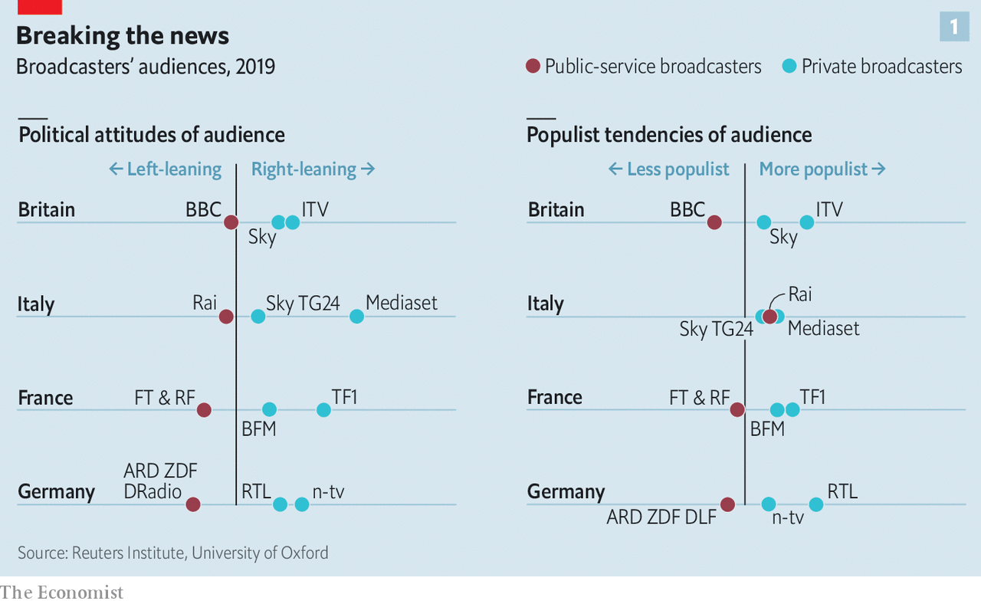

However, the question of bias has become harder to navigate. Digital technology has exposed audiences to new outlets like YouTube that are not required to follow impartiality rules. Unregulated online ranters should make the BBC look unbiased by comparison. But there is a danger that viewers draw the opposite conclusion: that everyone has a bias, and the BBC is merely concealing its own. In 2005 Michael Grade, the BBC’s then-chairman, predicted that “in the context of this new world of opinionated, value-laden broadcasting, the BBC [could] be perceived not as fundamentally different from other providers, but as fundamentally the same.”

## Universal studios?

At the same time, the old left-right divide has been superseded by a cultural one that is harder for the BBC to bridge. Consider Brexit, the fiercest battle in this new culture war. Britain voted to Leave by 52% to 48%. But working-age graduates—ie, the BBC’s recruitment pool—backed Remain by two to one. In London they backed it by four to one. Mr Dowden, the culture secretary, has warned the broadcaster it must not project a “narrow, urban outlook”. It has beefed up its presence outside the capital, with a big base in Salford, in north-west England, and is hiring more non-graduate apprentices.

But the Reuters study found that on a “populism” spectrum, the BBC’s audience leant anti-populist. It struggles to reach the less-educated, who are 20% less likely than graduates to tune in to the BBC and little more than half as likely to consume its content online. “In our sensibilities, in our delicacies of speech, we are super-serving upper-middle-class people,” admits one well-known journalist. “The cultural battle isn’t made up by Dominic Cummings [the prime minister’s adviser]. It’s real.”

The second threat to the BBC’s universality is that young people are switching off. Whereas over-65s watch nearly six hours of live TV a day, the same as a decade ago, viewing among 16- to 24-year-olds has fallen by half, to just 85 minutes (see chart 2). Though they consume about four-and-a-half hours of video daily, the same as the average Briton, an explosion in new ways to watch has pulled them away from broadcast TV. More than half of households subscribe to a streaming service like Netflix, a figure that is rising under lockdown (see [article](https://www.economist.com/business/2020/04/25/how-technology-shapes-tv-shows-narrative-arcs)). Those aged 16-24 spend more time on YouTube than live TV, according to Ofcom, the regulator. If that is worrying for BBC executives, the next generation should terrify them. Children aged 12-15 are more likely to have heard of Netflix than the BBC.

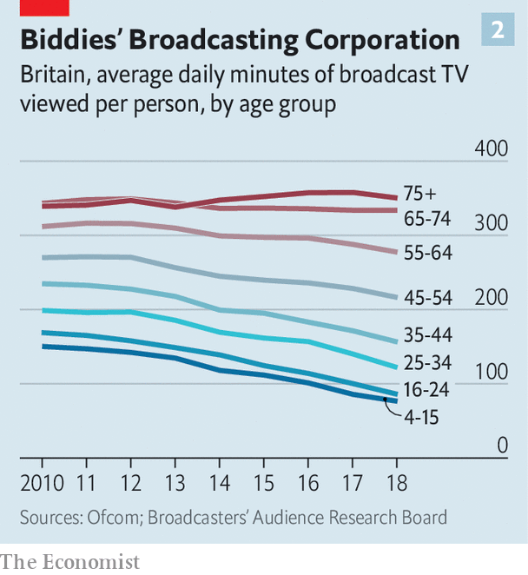

The risk to the BBC, like other old media companies, is that its “mode of delivery or style of content gets stuck with existing audiences and it fails to attract the young”, says Mark Thompson, who ran the corporation from 2004 to 2012 and is now chief executive of the New York Times. “It’s a challenge for the New York Times, The Economist, all of us—but it’s existential for the BBC because its funding is predicated on its ability to appeal to everyone, young as well as old,” he explains.

The widening gulf between older, richer audiences who spend half their waking hours consuming BBC content, and younger, poorer ones who seldom tune in, raises the question of whether it is fair that every household pays the same. One alternative would be to replace the flat fee with a progressive tax. In 2013 Finland swapped its licence fee of €252 ($275) per household for a tax of between zero and €140 per adult. The BBC dislikes this idea, fearing the erosion of its independence under the constant threat of tax cuts. But the licence fee itself has hardly been immune to political interference, rising steeply under Labour in 1997-2010 before falling hard under the Tories more recently.

Another option would be to make the BBC rely on advertising, like publicly owned Channel 4. Ad-supported public broadcasting is common in Europe. But the idea has few supporters in Britain. Letting the BBC run ads would suck revenue away from others—“like dropping a nuclear bomb on UK media,” shudders the head of one big media group.

The most radical proposal is to turn the BBC into a Netflix-esque subscription service, letting viewers opt out. This would be impossible with Britain’s current broadcast infrastructure, which has no “conditional access” capability. But in time more video and audio will be streamed by broadband. The BBC’s free iPlayer streaming app already requires users to sign in. It would just need to add a paywall.

That would be blasphemy at the BBC, whose first director-general, John Reith, rejoiced that “the same music rings as sweetly in mansion as in cottage.” Yet the corporation has privately looked into how subscription might work. A draft internal report in 2013, seen by The Economist, recommended a “‘divorce settlement’ with the state”, in which the licence fee would no longer be compulsory and the BBC would be free to charge viewers and raise finance in the markets. The proposal was rejected by Lord Hall and the report watered down.

The corporation has nonetheless gone on to experiment with some paid-for services. In 2017 in America, together with ITV, it launched BritBox, which for $6.99 a month offers streaming access to both channels’ back catalogues. BritBox has since opened in Canada and Britain; Australia is next. Channel 4 joined this month. With 1m subscribers in North America, it has a lot of ground to catch up with Netflix, which has 70m. For the BBC and ITV this is galling: they proposed a similar venture in 2009, when Netflix was still sending out DVDs by post, but British antitrust regulators vetoed it, fearing it would limit competition. Today that looks like a mistake.

Lord Hall will depart in the summer. Though he steadied the ship after the disastrous 54-day tenure of George Entwistle, the consensus is that his successor must take more risks. They will need political nous to deal with frustrated Tories, administrative skill to manage more than 20,000 staff and journalistic experience to make the daily editorial judgments that amount to “whether you have shit cover your ankles, knees, waist or head”, as one former decision-maker puts it. Tim Davie, the boss of BBC Studios; Alex Mahon, who runs Channel 4; and Charlotte Moore, the BBC’s head of content, are among those tipped. The hostile political environment has put some candidates off, and the £450,000 salary is not high by industry standards, remarks an executive at another channel. “But,” he concedes, “it’s a big train set”. ■

Dig deeper:  
For our latest coverage of the covid-19 pandemic, register for The Economist Today, our daily [newsletter](https://www.economist.com/newslettersignup), or visit our [coronavirus tracker and story hub](https://www.economist.com/coronavirus)

This article was downloaded by calibre from <https://www.economist.com/britain/2020/04/25/the-bbc-is-having-a-good-pandemic>

|  |  |  |  |
| --- | --- | --- | --- |
|  | Articles | Sections | Next |

|  |  |  |  |
| --- | --- | --- | --- |
| Previous | Articles | Sections | Next |

#### Jolly difficult

# Covid-19 exposes flaws in Britain’s good-times government

Boris Johnson promised prosperity and levity. Now he just hopes to deliver enough virus tests

Apr 25th 2020 |

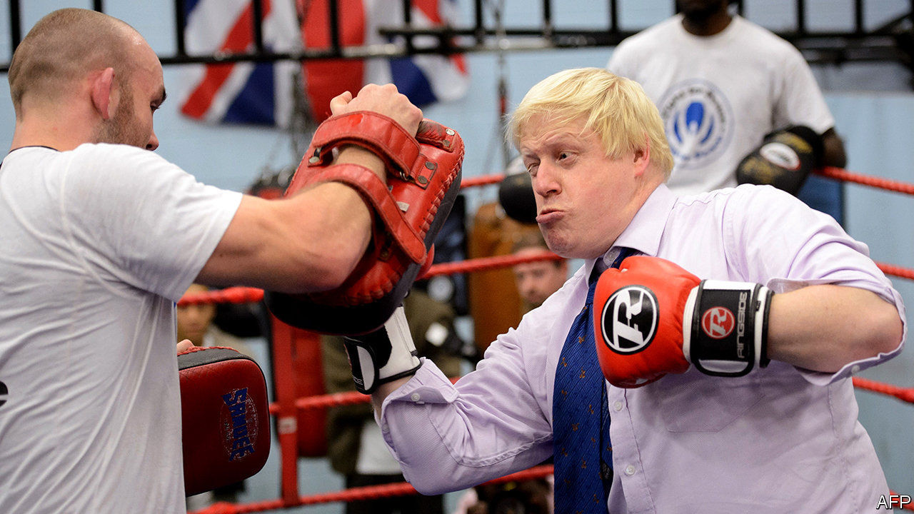

Editor’s note: The Economist is making some of its most important coverage of the covid-19 pandemic freely available to readers of The Economist Today, our daily newsletter. To receive it, register [here](https://www.economist.com/newslettersignup). For our coronavirus tracker and more coverage, see our [hub](https://www.economist.com/coronavirus)

IT WAS AN unusual error for a diplomat of Sir Simon McDonald’s experience. On April 21st the foreign-office boss told MPs that ministers had spurned an EU scheme to procure ventilators and protective kit. “It was a political decision,” he said. Later, he “clarified” that Britain had in fact missed the invitation thanks to a mix-up. This repeated a claim first made by Downing Street in March, but which is still met with incredulity in Brussels. Britain has now, somewhat belatedly, joined the scheme.

Boris Johnson’s team have not had a good week. The Sunday Times angered ministers with a story concluding that a complacent government, led by an absent prime minister, had squandered five weeks when it should have prepared for the pandemic. An airlift of protective kit from Turkey arrived days later than had been promised due to paperwork hitches. Despite some progress, the government remains far short of its target of carrying out 100,000 tests a day by April 30th. And it continues to resist calls to clarify how the country will leave lockdown.

At first glance, the prime minister is politically strong. As with other leaders, his approval ratings jumped immediately after the covid-19 lockdown. His own hospitalisation has wedded him to the struggle—and to the National Health Service. He commands a mighty majority. Yet the pandemic is beginning show up flaws in his government that could dog it for a long time to come.

The first stems from the prime minister’s character. The charge that early this year he was preoccupied with country weekends and his private life corresponds, fairly or not, with a view common among critics that he is work-shy and resents the burdens of office. At the election, Mr Johnson’s gameness for a pint and a laugh was an asset after Theresa May’s mirthlessness. It could now become a liability.

The second is his agenda. Mr Johnson idolises Winston Churchill, Britain’s wartime leader, of whom he has written a biography. But he campaigned as a peacetime prime minister, offering prosperity, stability and levity rather than good governance in a crisis. Mr Johnson’s promise to end “arguing about arguing” over Brexit, reverse austerity and “unleash Britain’s potential” resembles not the Churchill of the second world war, but that of the general election of 1951, who promised to end “evenly balanced party strife”, uphold the welfare state and allow Britain’s “native genius to flourish and fructify”.

The government’s about-turn on the EU scheme shows how quickly the political weather has changed. So did Rishi Sunak’s budget on March 11th. Delivered just as the World Health Organisation declared a pandemic, and 12 days before Britain’s lockdown, it earmarked £12bn ($15bn) to deal with covid-19, and £640bn for infrastructure spending over five years. Yet spending on covid-19 already stands closer to £100bn. The original agenda will be difficult to resuscitate. Indeed, Mr Johnson may have to scale back his ambitions, with cash and optimism in shorter supply.

Then there is Mr Johnson’s governing philosophy: that voters should get what they want, when they want it. Supporters say this is humility before the wisdom of the electorate. Critics call it populism. In policy, it points to things such as tougher penalties for sex offenders, a hard Brexit, and the reopening of dismantled rural railways, whatever the Treasury may think. Covid-19 exposes the limits of such an approach. Though simple to understand, Mr Johnson’s philosophy is not an easy one by which to govern. The struggle to find gowns and masks shows how ostensibly simple tasks can prove complex. A government adept at sloganeering now faces delicate trade-offs with imperfect evidence.

Rushing to build field hospitals and ventilators chimed with Mr Johnson’s ideal of a fast and muscular government. But unwinding the shutdown will be a frustrating process. Mr Johnson, his scientific advisers and public opinion are aligned behind the lockdown today. Over time they will probably diverge. Mr Johnson is said to fear a second spike in cases if social distancing is relaxed too soon. Thanks to covid-19, his supporters who voted for a return of the good times will be waiting rather longer. ■

Dig deeper:  
For our latest coverage of the covid-19 pandemic, register for The Economist Today, our daily [newsletter](https://www.economist.com/newslettersignup), or visit our [coronavirus tracker and story hub](https://www.economist.com/coronavirus)

This article was downloaded by calibre from <https://www.economist.com/britain/2020/04/25/covid-19-exposes-flaws-in-britains-good-times-government>

|  |  |  |  |
| --- | --- | --- | --- |
| Previous | Articles | Sections | Next |

|  |  |  |  |
| --- | --- | --- | --- |
| Previous | Articles | Sections | Next |

#### The price isn’t right

# The impossibility of measuring inflation in a pandemic

Inaccurate data is not just a problem for economists

Apr 25th 2020 |

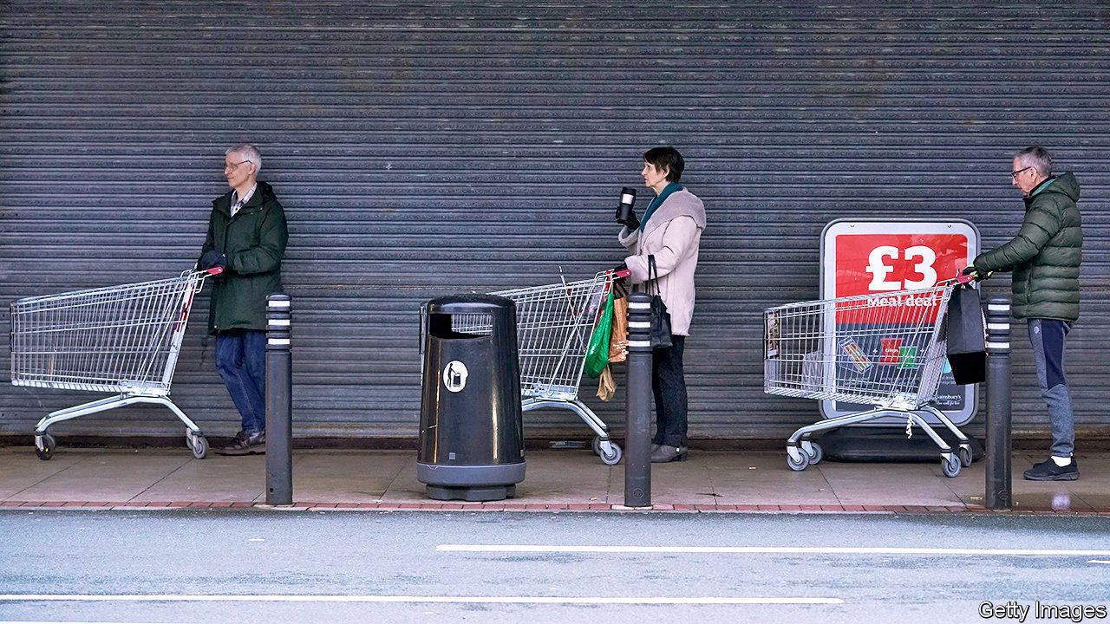

Editor’s note: The Economist is making some of its most important coverage of the covid-19 pandemic freely available to readers of The Economist Today, our daily newsletter. To receive it, register [here](https://www.economist.com/newslettersignup). For our coronavirus tracker and more coverage, see our [hub](https://www.economist.com/coronavirus)

PEOPLE CAN tolerate their central heating failing in summer. They tend to miss it rather more when it goes in the depths of winter. Accurate and timely economic statistics are similar: British economists have long grown used to the Office for National Statistics (ONS) providing reliable data; now, at the time of greatest need, the data are about to become considerably dodgier. On April 22nd the ONS reported that consumer-price inflation fell to 1.5% in March, down from 1.7% in February. The numbers over the next few months will bear less relation to reality.

To measure inflation the ONS tracks the prices of goods (including booze and shoes) and services (including haircuts and car repairs) in a basket of items thought to resemble the spending of a “typical consumer”. The data for March were mostly collected by the middle of the month, and are thus relatively free of pandemic-related disruption. The same will not be true next month, however. Nearly half the data are collected by physically visiting stores in 140 places across Britain, many of which have shut as a result of the lockdown. Even in March, empty shelves meant estimates of the prices of flour, pasta and eggs were based on fewer than half the number of observations made the month before.

The ONS will try to circumvent the problem by making more use of online data and information given to them directly by retailers. A bigger problem may be the weighting of the basket itself. Spending on restaurants and hotels, for example, accounts for 12% of the current basket; recreational and cultural activities for 17%. But nowadays eating in a restaurant is impossible and few people are rushing to book their summer holidays. When restaurants and hotels open again they are likely to have lower prices than before the lockdown, which will drag down official inflation measures.

A further problem comes from how the ONS handles bulk-buying discounts. At the moment, buy-one-get-one-free offers are excluded from the calculations on the assumption that their use by retailers doesn’t vary much. That assumption no longer holds: supermarkets have been dropping such offers at an unprecedented pace, branding them “irresponsible” as they may encourage hoarding. Tesco, Britain’s largest supermarket chain, cut the number of promotions by 14% in March. By not taking their disappearance into account, future inflation measures will understate price rises. A paper published in 2009 found that poor households tend to benefit more than rich ones from such offers.

This will have long-term ramifications for government policy. In April 2021 consumer-price inflation from this autumn will be used to adjust tax thresholds and benefit payments. Measured inflation, dragged down by factors like the high weighting for social activities and holidays, is likely to understate the cost-of-living increases, particularly those faced by people at the bottom of the income distribution. Poor households may thus end up facing a double whammy: a more expensive weekly shop, followed by less government support to pay for it. ■

Dig deeper:  
For our latest coverage of the covid-19 pandemic, register for The Economist Today, our daily [newsletter](https://www.economist.com/newslettersignup), or visit our [coronavirus tracker and story hub](https://www.economist.com/coronavirus)

This article was downloaded by calibre from <https://www.economist.com/britain/2020/04/25/the-impossibility-of-measuring-inflation-in-a-pandemic>

|  |  |  |  |
| --- | --- | --- | --- |
| Previous | Articles | Sections | Next |

|  |  |  |  |
| --- | --- | --- | --- |
| Previous | Articles | Sections | Next |

#### The new neighbourhood watch

# Official data suggest Britons are learning to help each other

But even in an age of civic-mindedness, some are left out

Apr 25th 2020 |

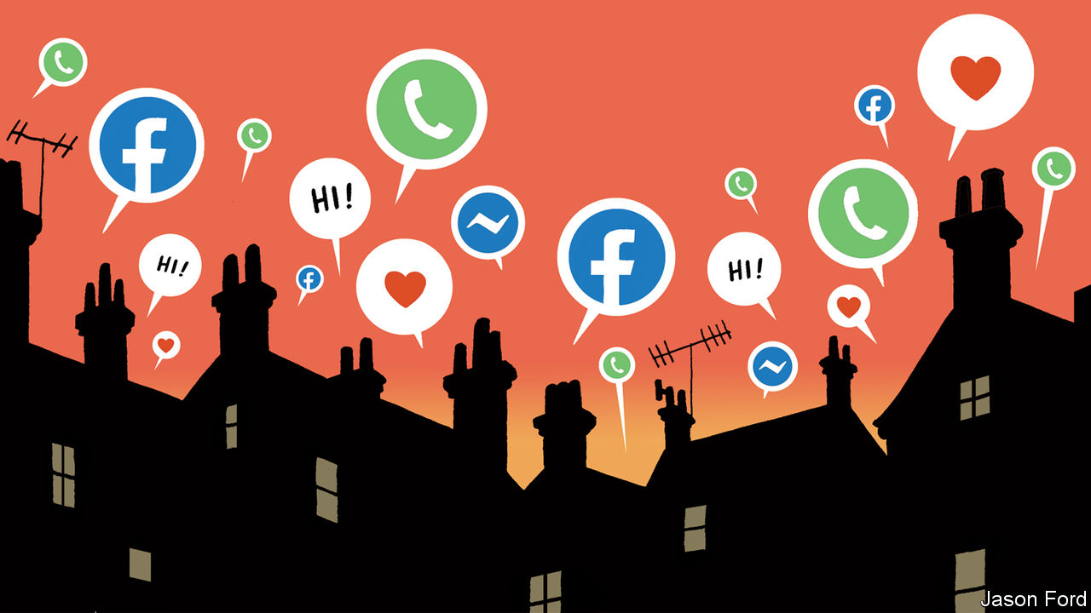

Editor’s note: The Economist is making some of its most important coverage of the covid-19 pandemic freely available to readers of The Economist Today, our daily newsletter. To receive it, register [here](https://www.economist.com/newslettersignup). For our coronavirus tracker and more coverage, see our [hub](https://www.economist.com/coronavirus)

WHEN THE rest of Britain was ordered to stay at home on March 23rd, Jane Kinder-Williams was already growing accustomed to isolation. The 66-year-old, who lives on her own in a Buckinghamshire village, was doing her best to avoid others after treatment for cancer. But, with everyone at home, this new form of lockdown is different. Friends and family are in touch even more, via apps like Houseparty, WhatsApp and Zoom. And her street’s WhatsApp group buzzes with endless offers to help. Neighbours have done all her shopping for the past month. “Everybody is making far more of an effort towards each other,” says Ms Kinder-Williams. “We’ve realised how vulnerable we can be.”

This outbreak of neighbourliness is widespread. Official statistics show that 22% of Britons now belong to some form of community support group, with more than a third of them joining since covid-19 began to spread. About 2m people have joined local support networks on Facebook and the number of daily users of Nextdoor, a hyperlocal social network, has risen by 90% during the crisis. All kinds of wheezes, like national street parties and befriending schemes, have tried to induce such fellow feeling, says Harry Hobson, director of Neighbourly Lab, a think-tank. “A crisis accelerates it much more than well-meaning interventions,” he reckons.

Take Chapel-en-le-Frith, a small town in the Peak District. An eighth of its 8,000 residents belong to a covid-19 Facebook group, set up by a dozen volunteers just before the lockdown began. They collect shopping for vulnerable locals but also raise each others’ spirits. Some organised a virtual pub quiz; others put soft toys in their windows so that young children could treat their daily exercise as a “teddy-bear hunt”. Charles Lawley, who helped to set up the group, hopes it will rekindle a neighbourhood spirit left behind as the town has grown. In Warwickshire, Molly Bufton Stear, a recent university graduate, has enlisted an army of volunteers to cook free meals for 30 elderly locals every day. “They write me little notes and I write them things back,” she says.

Such groups have their limitations. Many vulnerable Britons, especially the elderly, are also the most likely to struggle with the internet and smartphones. And neighbourhood groups may not reach the neediest. Polling by Onward, a think-tank, suggests people are most willing to help their neighbours in places where they already feel they can trust each other. Will Tanner, its director, worries about “a virtuous circle in already relatively cohesive and integrated areas”, leaving behind places without such a social fabric. Mr Hobson spoke to a woman who had meticulously checked off all the households on her street to ensure they had the help they needed, but had not leafleted the housing estate over the road.

Others are sceptical that this civic-mindedness will outlast the pandemic. Despite much hype at the time, the London Olympics in 2012 did little to inspire a legacy of volunteering. The bonhomie of street parties is tricky to sustain once the final cupcake has been wolfed down. But, says Mr Hobson, neighbourliness is best thought of as a ratchet. “Once you meet someone, you can’t unmeet them.” Conversation is easier once you know your neighbour’s name. Paradoxically, social distancing and isolation may be just what is needed to bring people together. ■

Dig deeper:  
For our latest coverage of the covid-19 pandemic, register for The Economist Today, our daily [newsletter](https://www.economist.com/newslettersignup), or visit our [coronavirus tracker and story hub](https://www.economist.com/coronavirus)

This article was downloaded by calibre from <https://www.economist.com/britain/2020/04/25/official-data-suggest-britons-are-learning-to-help-each-other>

|  |  |  |  |
| --- | --- | --- | --- |
| Previous | Articles | Sections | Next |

|  |  |  |  |
| --- | --- | --- | --- |
| Previous | Articles | Sections | Next |

#### Pret A Ouvrir

# British fast-food chains are slowly restarting business

How they operate in the new world offers a preview of the long, slow reopening that awaits

Apr 25th 2020 |

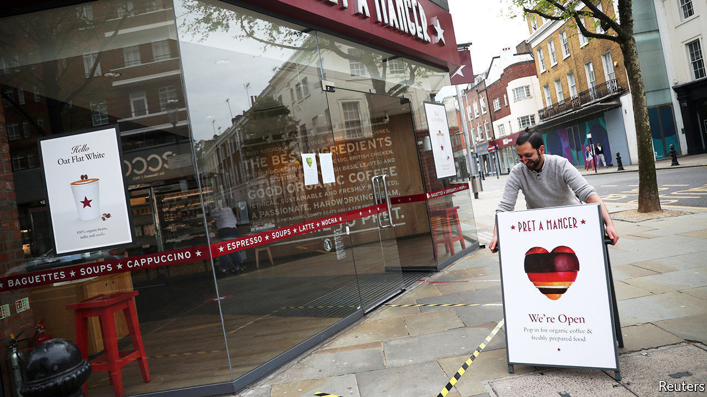

Editor’s note: The Economist is making some of its most important coverage of the covid-19 pandemic freely available to readers of The Economist Today, our daily newsletter. To receive it, register [here](https://www.economist.com/newslettersignup). For our coronavirus tracker and more coverage, see our [hub](https://www.economist.com/coronavirus)

GONE ARE the crowds, the conviviality and the smashed avo on gluten-free bread. At the Warren Street branch of Pret A Manger, a purveyor of sandwiches and salads, they have been replaced by six-people-at-a-time rules, plastic screens separating customers from cashiers, and a reduced menu. It’s Pret, but not as we know it.

Over the past few days, a handful of fast-food chains have begun to restart operations. Pret has opened ten branches out of more than 400, and only for half the day. Some 15 KFCs are back. And Burger King has opened four branches, chosen for their large kitchens and drive-through facilities. At a time when the government is refusing to lay out its plans for ending the lockdown, the private sector offers a glimpse of how the economy may begin to open up.

The first problem is the pause itself. Stopping and starting a business is tricky, especially when suppliers are going under. “If you lose one ingredient, you might lose three dishes,” says Sarah Humphreys of Deloitte, a consultancy. Even in normal circumstances supply chains are delicate. In 2018 KFC switched logistics companies and managed to run out of chicken.

Once supply chains have been restarted, the next task is to overhaul processes that have been carefully calibrated over years, perhaps decades. Commercial kitchens are frantic, tightly-packed places. No more. The Warren Street Pret would once have had six to eight people preparing food. Now it has just two. Staff used to scurry back and forth between the tills and the kitchen; now that is one person’s job.

With new processes in place, a third problem remains, one that chief executives can do little about: the attitude of the public. Even if all businesses were to open tomorrow, people may be unwilling to risk their health and that of their families for a burger, no matter how delicious. “I think you will see people less keen to do anything where there is unnecessary contact” says Paula MacKenzie, KFC’s boss in Britain. People may not want to queue up, or to use the touchscreen menus now common in fast-food restaurants. Such concerns apply as much to public transport and bustling city centres as they do to casual dining.

The rules around Britain’s lockdown have been less restrictive than elsewhere in Europe, allowing many independent restaurants and cafés to choose whether to remain open for takeaway and delivery. But consumers expect different things from small businesses than they do from big chains whose primary offering is consistency. Many of these concerns are particularly pressing in Britain, which has far greater population density and less of a drive-through culture than America.

Bosses seem resigned to scaling down their ambitions. Alasdair Murdoch of Burger King fears this may be the “death knell” for the high street, with deliveries replacing eating out. Still, they are also hopeful. Restarting “gives us the opportunity to look at things much more holistically”, says Pano Christou, Pret’s chief executive. “I think our operating model will have to change…we are going to have to be very nimble.” As the country negotiates a changed landscape in the months to come, it will have to do the same. ■

Dig deeper:  
For our latest coverage of the covid-19 pandemic, register for The Economist Today, our daily [newsletter](https://www.economist.com/newslettersignup), or visit our [coronavirus tracker and story hub](https://www.economist.com/coronavirus)

This article was downloaded by calibre from <https://www.economist.com/britain/2020/04/25/british-fast-food-chains-are-slowly-restarting-business>

|  |  |  |  |
| --- | --- | --- | --- |
| Previous | Articles | Sections | Next |

|  |  |  |  |
| --- | --- | --- | --- |
| Previous | Articles | Sections | Next |

#### Out of the shadows

# The freemasons want to be known for hand wash, not handshakes

Covid-19 offers a chance for some good publicity

Apr 25th 2020 |



Editor’s note: The Economist is making some of its most important coverage of the covid-19 pandemic freely available to readers of The Economist Today, our daily newsletter. To receive it, register [here](https://www.economist.com/newslettersignup). For our coronavirus tracker and more coverage, see our [hub](https://www.economist.com/coronavirus)

THE FREEMASONS, a centuries-old network of fraternal lodges, have long provided fodder for thriller writers and folk with overactive imaginations. Suggestions of conspiracy range from the outlandish to the banal. Steve White, a former chairman of the Police Federation, a cops’ union, claimed they blocked reforms to the service. Masons roll their eyes at such claims. “There is ‘The Da Vinci Code’ and the keyboard warriors going crazy,” sighs Matt Felgate, a freemason from Lincolnshire’s Provincial Grand Lodge. “But much to my disappointment, it’s mainly about making yourself a better person.”

Covid-19 gives Mr Felgate and his fellow masons the chance to step into the limelight, and demonstrate another side to their institution. He has transformed his gin distillery into a factory pumping out hand sanitiser. Masons in Scunthorpe have made more than 1,000 facemasks for carers. Other lodges have bought thousands of masks from China or are lending nurses their car parks. For once, being able to call in favours from a network of contacts seems positively altruistic. In Belfast masons managed to find some 3,000 packs of loo roll. “I got together with someone I knew who owned a toilet-roll factory,” says Leslie Weir of the local lodge. “It’s just nice to be seen. We may have some secrets but it’s not a secret society.”

Masons emphasise that such charitable efforts are nothing new. Indeed, they claim their brotherhood is the second-biggest institutional donor in Britain. As well as being a good in itself, such public acts of philanthropy help to counter the brotherhood’s reputation for secrecy. David Staples, chief executive of the United Grand Lodge of England, the lodges’ governing body, says dispelling the public’s misconceptions about freemasons is a priority.

That includes dismissing the idea that the organisation is set on advancing an agenda. “We’ve got trade-union leaders right through to captains of industry,” he points out. “I wouldn’t have a clue what our members’ political leanings are.” He nevertheless hopes that their efforts during the current crisis will be rewarded by a boom in initiations—including, perhaps, your correspondent. “When all this is over, please do come and visit us,” he urges.

Dig deeper:  
For our latest coverage of the covid-19 pandemic, register for The Economist Today, our daily [newsletter](https://www.economist.com/newslettersignup), or visit our [coronavirus tracker and story hub](https://www.economist.com/coronavirus)

This article was downloaded by calibre from <https://www.economist.com/britain/2020/04/25/the-freemasons-want-to-be-known-for-hand-wash-not-handshakes>

|  |  |  |  |
| --- | --- | --- | --- |
| Previous | Articles | Sections | Next |

|  |  |  |  |
| --- | --- | --- | --- |
| Previous | Articles | Sections | Next |

#### Bagehot

# The Virtual Parliament brings a welcome return to scrutiny

It comes just as the government is losing its halo

Apr 25th 2020 |

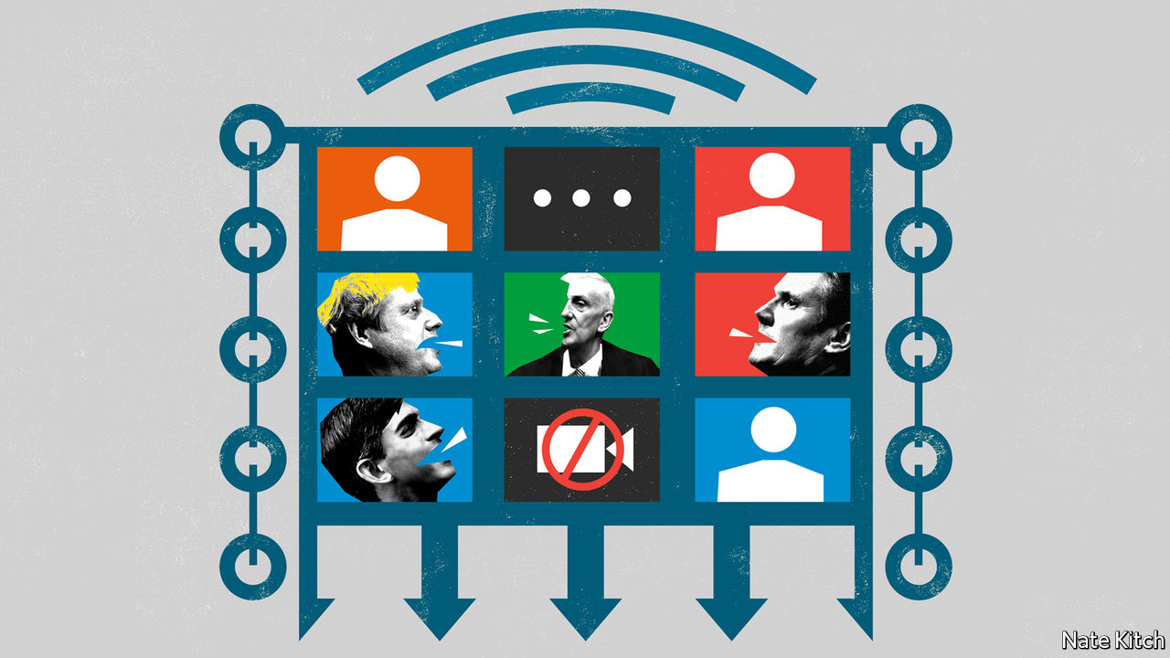

Editor’s note: The Economist is making some of its most important coverage of the covid-19 pandemic freely available to readers of The Economist Today, our daily newsletter. To receive it, register [here](https://www.economist.com/newslettersignup). For our coronavirus tracker and more coverage, see our [hub](https://www.economist.com/coronavirus)

IN THE 17TH CENTURY parliaments gloried in names such as the Blessed Parliament, the Addled Parliament, the Happy Parliament and the Useless Parliament. The British have long since dropped the habit of naming parliaments—perhaps because too many deserved the sobriquet “useless”—but there is surely a case for reviving it to commemorate the institution’s first collision with cyberspace. The parliament which met on April 21st could be known as the Zoom Parliament or the Virtual Parliament or, to be strictly accurate, the Hybrid Parliament.

The returning parliament is like no other. The Speaker, Sir Lindsay Hoyle, presides over a sepulchral chamber. Only 50 MPs are allowed in at any one time. Giant screens hang from the empty galleries. Ministers and other politicians have a choice over whether to appear in person or virtually. In the first Prime Minister’s Questions (PMQs) of the new age on April 22nd, both Dominic Raab, standing in for Boris Johnson, and Sir Keir Starmer, making his debut appearance as leader of the opposition, turned up in person. Along with most questioners, Ian Blackford, leader of the Scottish National Party in Westminster, chose to Zoom in.

There will inevitably be technological glitches with the new system. Screens will freeze. MPs will forget to press the mute button. Speakers will drone on for too long (there is nothing like the virtual floor to put wind into the windbag). The screens will encourage viewers to become obsessed with trivia. Which MPs seem to have employed professional barbers during the lockdown? Which Tories are burnishing their northern credentials by displaying copies of Viz magazine on the shelves behind them?

The unique atmosphere of British politics has been lost. Parliament is designed to create as much pressure as possible: the government and the opposition face each other just two sword blades apart; there are more MPs than available seats; the noise shakes the rafters. The pressure is particularly high at PMQs when the most powerful person in the country is subjected to mob mauling. Good government types like to deride PMQs as Punch-and-Judy politics. But some of Britain’s most powerful prime ministers, including Tony Blair and Margaret Thatcher, have been humbled by clever questions. This week’s were tame by comparison.

Still, even a parliament without the blood and noise is better than none. For the past month Britain has witnessed some of the most dramatic events in peacetime without any parliamentary scrutiny whatsoever. In Parliament’s absence a daily press conference has filled the scrutiny void. But these conferences have been more about messaging than public accountability. Journalists lack the most important tools in MPs’ armouries: the power to ask written questions which the relevant ministers are obliged to answer; a detailed knowledge of their local constituencies; and, above all, the ability to speak on behalf of voters.

The evidence from the one bit of Parliament that has continued over the long Easter break is positive. The select committees have subjected both ministers and experts to highly effective virtual grilling. Greg Clark, chairman of the science committee, questioned witnesses on why they had not learned from other country’s successes, particularly South Korea’s approach to testing. Jeremy Hunt, chairman of the health committee, focused on why Britain has been slow to introduce track-and-trace. It is regrettable that the most important of the select committees, the Liaison Committee, which has the power to call the prime minister and ask questions that cut across ministerial fiefs, is not sitting because the government has infuriated Parliament by trying to impose its own man, Sir Bernard Jenkin, as chairman.

The arrival of the Virtual Parliament is part of a general return of scrutiny to British politics. The government is losing the halo that naturally surrounded it in the early days of the crisis. The Labour opposition is at last a force to be reckoned with now that Jeremy Corbyn has stood down and the party’s interminable leadership election has been resolved. The number of urgent questions that people want answered has increased during the period of parliamentary inactivity. Why did Mr Johnson fail to preside over the first five COBRA meetings? Why didn’t the government respond to initial news of the virus in China by buying tests and kit on the global market? And—the one Sir Keir focused on at PMQs—why has Britain been so slow to introduce mass testing?

This is all to be welcomed on the condition that scrutiny does not degenerate into gotcha-style condemnation. The case for scrutiny of the government—particularly during a crisis—is not that it gives people a chance to vent their collective fury. Bashing the government is as idiotic as grovelling before it. It is that it gives the government a chance to adjust its behaviour in the light of new evidence. MPs are particularly well equipped to bring this evidence to light for both obvious reasons (they represent people in every corner of the country) and less obvious ones (they bring a wide variety of experiences to bear). Several MPs, including Labour’s Rosena Allin-Khan, an A&E doctor, are working on the front line in the National Health Service.

## A running start

With that proviso, Parliament needs to do everything it can to increase its powers of scrutiny. Laura Kuenssberg, the BBC’s political editor, talks of Parliament putting its “digital toe” in the water. The rest of the body needs to follow. The Liaison Committee should get to work quickly under an independent chairman. Government ministers have enjoyed some big successes during this crisis. Most important, the NHS has not collapsed under the weight of the epidemic despite predictions to the contrary. But they have also made some unnecessary mistakes. Better scrutiny, whether physical or virtual, should improve ministers’ chances of avoiding more mistakes or, if they can’t avoid them, their chances of correcting course as quickly as possible. ■

Dig deeper:  
For our latest coverage of the covid-19 pandemic, register for The Economist Today, our daily [newsletter](https://www.economist.com/newslettersignup), or visit our [coronavirus tracker and story hub](https://www.economist.com/coronavirus)

This article was downloaded by calibre from <https://www.economist.com/britain/2020/04/25/the-virtual-parliament-brings-a-welcome-return-to-scrutiny>

|  |  |  |  |
| --- | --- | --- | --- |
| Previous | Articles | Sections | Next |

|  |  |  |
| --- | --- | --- |
| Britain | Sections | Business |

International

Covid-19 and autocracy: Protection racket

.

|  |  |  |
| --- | --- | --- |
| Britain | Sections | Business |

|  |  |  |  |
| --- | --- | --- | --- |
|  | Articles | Sections | Next |

#### Protection racket

# Would-be autocrats are using covid-19 as an excuse to grab more power

Strong measures are needed to keep the public safe, they insist

Apr 23rd 2020 | DELHI, ISTANBUL, JOHANNESBURG, KAMPALA AND SINGAPORE

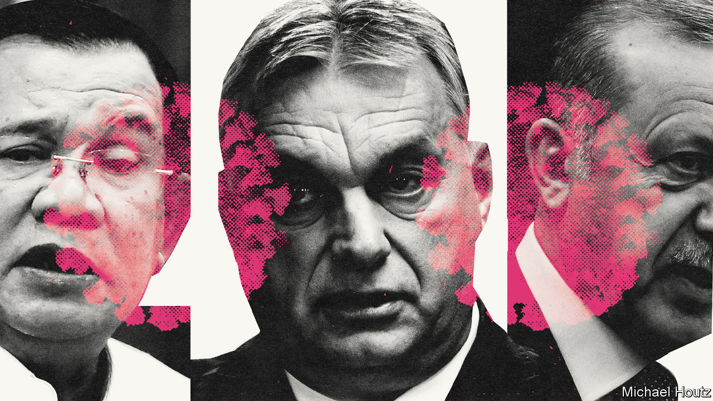

Editor’s note: The Economist is making some of its most important coverage of the covid-19 pandemic freely available to readers of The Economist Today, our daily newsletter. To receive it, register [here](https://www.economist.com/newslettersignup). For our coronavirus tracker and more coverage, see our [hub](https://www.economist.com/coronavirus)

ON APRIL 13TH, during a discussion about when and how America should ease covid-19 lockdowns, Donald Trump claimed to have “absolute power” to decide, overriding state governors. Within a day, he was forced to retreat. No serious legal scholar agreed with him—America’s constitution is admirably clear on the limits to presidential authority.

Contrast that with Viktor Orban’s efforts. On March 30th Hungary’s parliament issued a “coronavirus law”, giving the prime minister almost unlimited powers to rule by decree, with no expiry date. Parliament can repeal Mr Orban’s new powers, but since his party has an impregnable majority, it probably won’t. Mr Orban has in effect become a dictator—in the heart of Europe. He may relinquish some of his new powers after the pandemic, just to prove his critics wrong, but perhaps not all.

Covid-19 is creating opportunities for autocrats and would-be autocrats to tighten their grip. They must assume extraordinary powers, they insist, to protect public health. No fewer than 84 countries have declared a state of emergency since the pandemic began, says the Centre for Civil and Political Rights, a watchdog in Geneva. Some will surrender these powers when the emergency is over. Others plan to hang on to them. The danger is greatest not in mature democracies with strong checks and balances, such as America, but in places where such safeguards are weak, such as Hungary.

Mr Orban has spent the past decade eroding checks on his power, nobbling the courts, tilting the electoral system and urging his cronies to gobble up independent radio and television stations. Mr Trump’s claim of absolute power was laughed at; Hungarian media welcomed Mr Orban’s corona coronation, and Hungarian institutions did nothing to block it.

Unscrupulous politicians have seen opportunity in disaster before. Vladimir Putin grabbed extra powers after a school siege involving terrorists in Beslan, a town near Russia’s border with Georgia. Turkey’s President Recep Tayyip Erdogan imposed a state of emergency after a failed coup in 2016, and has since ruled like a sultan. This pandemic presents an even greater opportunity for mischief, because it is raging everywhere at once. The world’s attention is on the virus. No repressive act in a far-off land is likely to make headlines elsewhere.

China chose now to arrest Hong Kong’s leading pro-democracy activists and puncture its Basic Law (see article). “Dictators and others may think there’s no better time to take repressive measures,” says Rob Malley of the International Crisis Group, an NGO in Brussels.

Serbia’s president is in effect in sole charge. Togo’s has the power to rule by decree, though in theory it runs out in a few months. Cambodia’s emergency law gives the government the power to take any “measures that are deemed appropriate” to fight the disease. It can restrict people’s movement, ban public gatherings, censor social media, seize property and declare martial law. Anyone who fails to “respect” the law faces up to ten years in prison. The prime minister, Hun Sen, can act without any real oversight. Though his ministers say the measures will last for only three months, they can be extended indefinitely.

Such powers far exceed any that democratic governments have assumed to fight covid-19, but the regimes in question try to portray them as normal. “The purpose of making this law for Cambodia is not unique, as there is this law already in many other democratic countries,” says a spokesman for the ministry of justice.

Some curbs on freedom are reasonable given the scale of the emergency. Large gatherings can spread infection, so limiting them for a while makes sense. But it also helps regimes keen to snuff out protests. Algeria banned street marches that have lasted, off and on, for a year, threatening the elderly ruling elite. India’s lockdown has squashed nationwide rallies against the government’s mistreatment of Muslims. In Russia even lone protesters against Mr Putin have been arrested.

Social-distancing rules can be applied selectively. Azerbaijan’s president says the “isolation” of members of the opposition may “become a historical necessity”. Several have been locked up for supposedly violating a lockdown. Unpopular minorities are also at risk. In Uganda police raided a shelter housing 20 gay and transgender people and later charged them with “congesting in a school-like-dormitory setting within a small house”.

Defeating the virus will require tracking who has been infected, tracing their contacts and quarantining them. This may involve intrusive surveillance. Most people will surrender some privacy temporarily to save lives. Good governments will take only the data they need from their citizens and do so only when they need it. Others will not.

Cambodia’s emergency law allows for unlimited surveillance of private citizens. Moscow is mulling a scheme whereby everyone would have to register their personal details on an official website. Every time they want to go out, they would have to provide a reason and the address of their destination. They will then be sent an electronic message to show to the police if they are stopped. The authorities would monitor everyone’s geolocation and even financial records to make sure they comply. The potential for abuse is obvious.

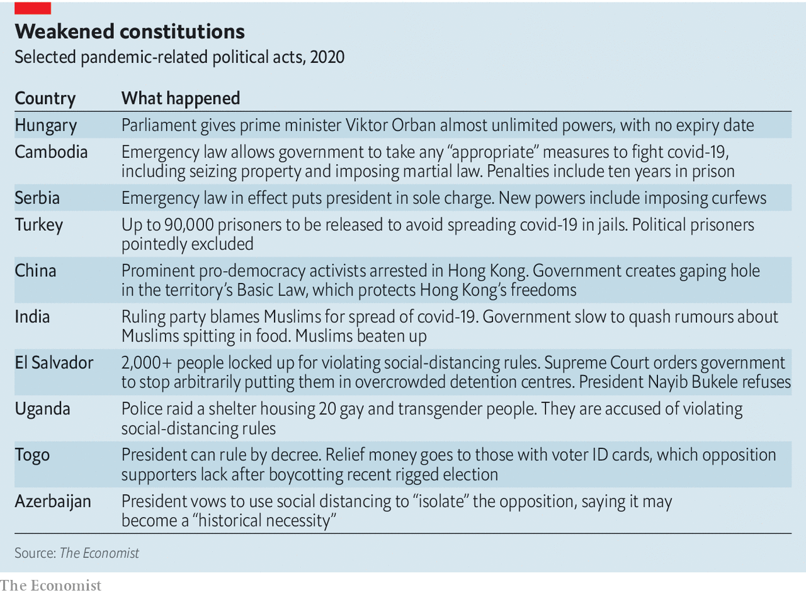

Spreading rumours during a pandemic can be dangerous. Many regimes have used this as an excuse to crack down on critics. Reporters without Borders, a watchdog, cites 38 countries that have used covid-19 as a pretext to harass the media. It stresses that the list is not exhaustive.

In Turkey at least eight journalists have been arrested on charges of “spreading misinformation”. Hundreds of others have been investigated for critical posts on social media. In Bolivia the interim president, Jeanine Áñez, decreed that those who “misinform or cause uncertainty to the population” can be jailed for one to ten years. Since she has a record of forcing opposition radio stations off the air, critics fear this will become a tool to lock them up.

Some governments have criminalised almost any disparagement of their response to the pandemic. A Thai artist called Danai Ussama faces up to five years in prison after griping that no one took his temperature at Bangkok airport.

“Censorship kills,” says Kenneth Roth of Human Rights Watch. “When governments suppress the free flow of information, it is terrible for public health, as we saw in Wuhan. The Chinese government’s muzzling of the doctors who sounded the warning gave the virus a three-week head-start to go global.” A study by the University of Southampton found that if interventions in China had started three weeks earlier, the number of coronavirus cases would have been 95% lower at the end of February, “significantly limiting the geographical spread of the disease.”

Some governments are enforcing lockdowns harshly. Several Indian states now allow the police to arrest people without charge. In Fiji there have been more coronavirus-related arrests than diagnostic tests. Kenyan cops have beaten health workers on their way to work.

In El Salvador more than 2,000 people have been locked up for violating strict social-distancing rules, often defeating their purpose. Its Supreme Court has told the government to stop arbitrarily detaining people in inhumane conditions that are likely to spread the disease. But its fiery president, Nayib Bukele, has refused (via Twitter) to obey it. Thus, covid-19 has precipitated a constitutional crisis in one of Latin America’s most violent countries.

## Getting la grippe

Indonesia and the Philippines have given the army prime responsibility for fighting the novel coronavirus. In some ways this is pragmatic: only the armed forces can operate effectively across these two archipelago states. They are also popular. “They abhor useless debates. They are silent workers, not voracious talkers. They act without fanfare. They get things done,” said a spokesman for Rodrigo Duterte, the president of the Philippines. Even so, there are worries. Mr Duterte has publicly urged the security forces to shoot troublemakers dead. Fortunately, they appear to have ignored him, but in the long run, turning to the men in uniform during a public-health crisis risks weakening civilian oversight.

The pandemic is seriously disrupting elections. South Korea showed in April that a well-governed rich country can organise a vote while maintaining social distance. Poorer, less orderly places find it harder. For some leaders, that is a welcome excuse to delay their reckoning with voters.

Court-ordered re-runs of rigged elections in Bolivia have been postponed. Those in Malawi could be delayed, too. That would leave the presidency with Peter Mutharika, whose victory last year was ruled invalid after his supporters used Tipp-Ex to alter vote tallies.

Some leaders are holding votes on schedule, knowing that the opposition will barely be able to campaign, whereas the incumbent can look statesmanlike on television. Poland’s ruling party wants to go ahead with a presidential election in May for this reason, though it could still be delayed. Guinea held a referendum on March 22nd to allow President Alpha Condé to run for two more terms. The proposal passed easily. Guinea now has almost 700 covid-19 cases and possibly 12 more years of Mr Condé, who has advised Guineans to inhale menthol and drink hot water to ward off the virus.

Ethiopia’s elections, which are set for August, were supposed to herald the dawn of a new democratic era. They have been postponed and the government has assumed emergency powers. During previous states of emergency in 2016 and 2018, tens of thousands of dissidents were locked up in re-education camps or tortured. The current prime minister, Abiy Ahmed, has promised that such abuses are all in the past. But if elections are not held by September, his government will no longer have a mandate, and Ethiopia’s ethnic insurgencies could explode.

## Strongman flu

Some governments have used the disease itself to intimidate the opposition. Crowded jails are hotbeds of infection. Dissidents understand that detention could be lethal. Turkey has ordered a mass release of up to 90,000 prisoners to spare them from contracting covid-19. The country’s thousands of political prisoners are conspicuously excluded from the amnesty.

Some governments are looking for scapegoats. In India that means Muslims. After it was discovered that a Muslim religious meeting on March 15th was the source of more than 1,000 infections, the Hindu nationalist government made every effort to publicise this fact. For several days the ministry of health counted separately covid cases tied to the event. A cabinet member likened it to a crime by the Taliban. Health authorities assiduously traced every single case from the Delhi meeting, ultimately putting some 25,000 people under quarantine. They have made no such effort with any other vector, such as the huge wedding party of a ruling-party bigwig. #CoronaJihad proliferated on social media, along with rumours that Muslims were spitting in people’s food to spread the virus. Muslims have been attacked in the streets. A cancer hospital in Meerut said that it would not take Muslim patients unless they tested negative for covid-19.

Blaming Muslims is a handy way to fire up Hindu nationalist voters and distract attention from the fact that, at the time of the notorious Muslim prayer meeting, the government had yet to take the virus seriously. “Having spent years painting [Muslims] as a demographic, cultural, sexual, and security threat, it is now busily painting them as a biohazard,” complains Mitali Saran in the Deccan Herald.

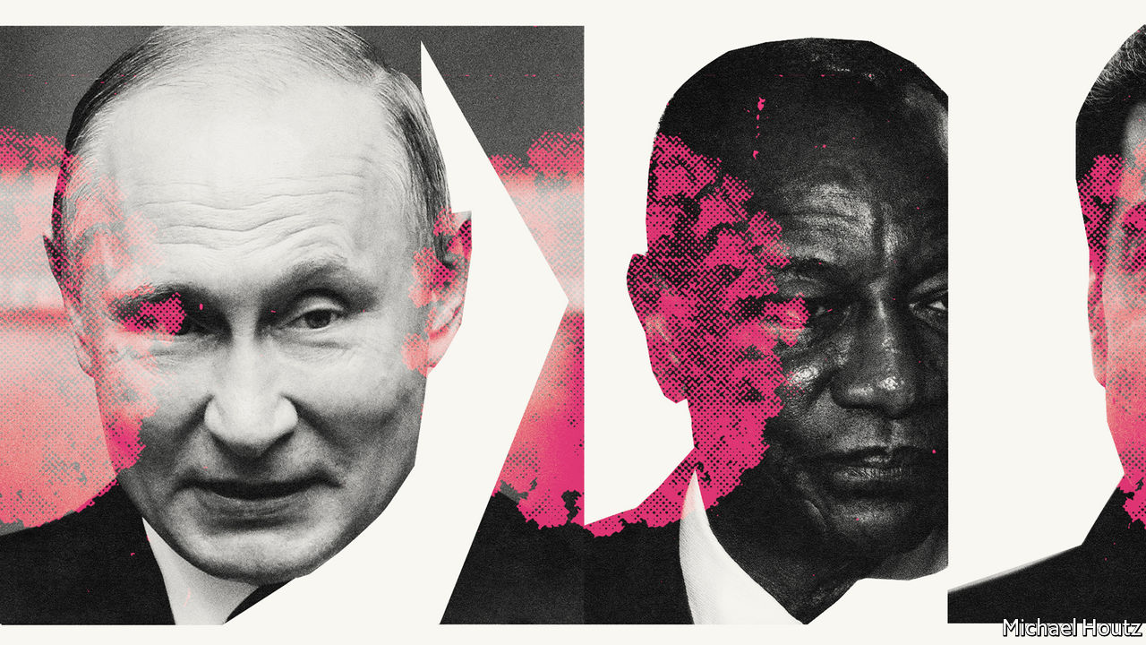

Such bigotry not only stokes violence; it also harms public health. Many Muslims are now so suspicious of the government that they are unwilling to co-operate with quarantine rules. In Muslim slums medics have been attacked because of rumours that they are gathering data on Muslims in order to harm them. It was not until April 19th that the prime minister, Narendra Modi, made any effort to soothe sectarian tempers. “Covid-19 does not see race, religion, colour, caste, creed, language or borders,” he tweeted. “We are in this together.”

Many leaders want credit for handing out taxpayers’ cash to tide people over during the crisis. Mr Modi is leaning on rich Indians as well as government workers to donate to a special “PM-CARES” relief fund. It is unclear how the new pot differs from an emergency relief fund that Indian prime ministers have run since 1948, except that it has less oversight and Mr Modi can claim to have launched it.

Some rulers are equally keen that their opponents should get no credit for helping the needy. Turkey is investigating the opposition mayors of Istanbul and Ankara for trying to raise funds to fight covid-19. Mr Erdogan likened them to terrorists. In Uganda President Yoweri Museveni cautions that “opportunistic politicians who try to distribute food will be arrested and charged with attempted murder.” His government claims that chaotic food distribution will draw crowds that will spread the virus. His foes think he wants to stop them from looking good by doing good.

For now, covid-19 is helping autocrats grab more power. But it poses big risks for them, too. The damage it wreaks will be vast and painful, especially in poor countries. Many despots will struggle to protect their subjects from disease and deprivation. Mr Putin is losing popularity because of his aloof response to the virus. Brazil’s Jair Bolsonaro, who scoffs at lockdowns and recently led a rally where placard-wavers called for a coup, could be impeached for incompetence after this crisis. Some are flailing. President Alexander Lukashenko of Belarus said the best way to fight the virus was to drink vodka and drive a tractor.

Some regimes may run out of money. Venezuela’s dictator, Nicolás Maduro, looks particularly vulnerable. The combination of covid-19 and an oil-price crash may leave his regime without enough cash to fund its patronage network—and to keep the army loyal. Covid-19 challenges many regimes that rely on the security forces to suppress dissent.

Where governments are seen as legitimate, and where they try to ease the economic pain, people are more likely to comply with lockdowns. In many countries, however, the state is seen as predatory and the police as bullies. In them a backlash is brewing that thuggish cops will struggle to control. Protests against lockdowns have erupted in many countries, including parts of China. More may follow if the pandemic lasts for months, as it probably will.

## Pandemocrats

Many autocrats fear losing control. An incident in Cambodia is suggestive. Mr Hun Sen admitted in an unguarded moment that his government lacks the money to tide people over during the outbreak. “If motorbike-taxi drivers go bankrupt, sell your motorbikes for spending money,” he said. When a director of a news site accurately quoted this insensitive comment, it was shut down and he was arrested.

Seven years ago Mr Hun Sen was rattled by huge protests by disgruntled factory workers. Cambodia’s garment factories are now laying off workers, who are more desperate and angry than before. In many countries covid-19 may foster instability. Autocracies have no immunity. ■

Dig deeper:  
For our latest coverage of the covid-19 pandemic, register for The Economist Today, our daily [newsletter](https://www.economist.com/newslettersignup), or visit our [coronavirus tracker and story hub](https://www.economist.com/coronavirus)

This article was downloaded by calibre from <https://www.economist.com/international/2020/04/23/would-be-autocrats-are-using-covid-19-as-an-excuse-to-grab-more-power>

|  |  |  |  |
| --- | --- | --- | --- |
|  | Articles | Sections | Next |

|  |  |  |
| --- | --- | --- |
| International | Sections | Finance and ... |

Business

Corporate innovation: Crucible of creative disruption

.

Facebook in India: Jiostrategic

.

Television: Medium and message

.

The data economy: Tear down this wall

.

Bartleby: Play’s the thing

.

Schumpeter: Minting it

.

|  |  |  |
| --- | --- | --- |
| International | Sections | Finance and ... |

|  |  |  |  |
| --- | --- | --- | --- |
|  | Articles | Sections | Next |

#### Creative disruption

# The pandemic is liberating firms to experiment with radical new ideas

Some of these will persist after the crisis passes

Apr 25th 2020 | NEW YORK

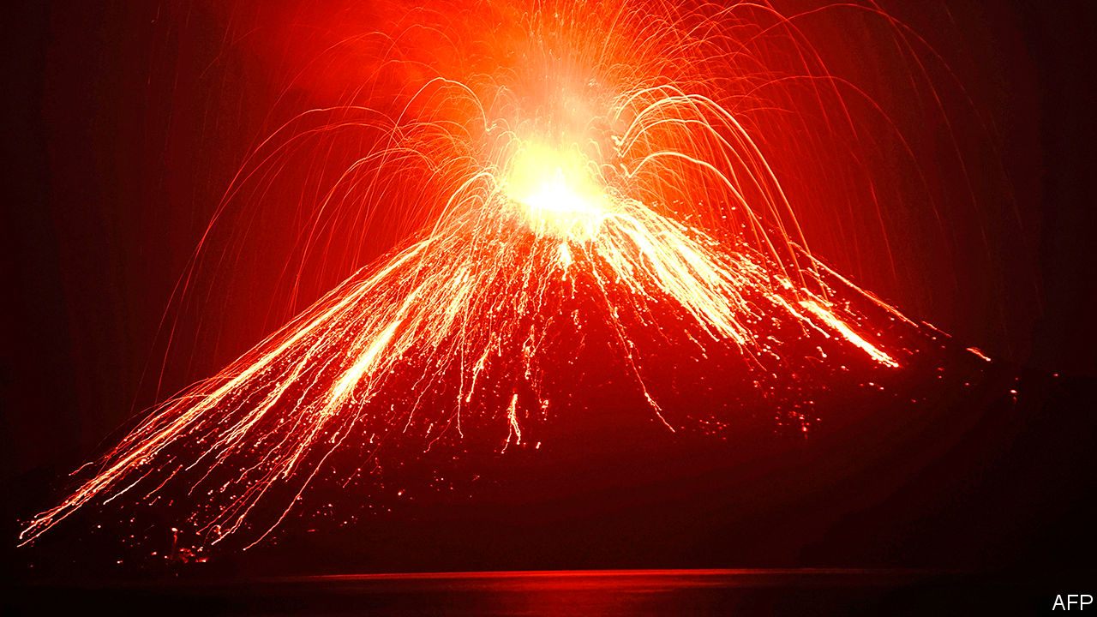

Editor’s note: The Economist is making some of its most important coverage of the covid-19 pandemic freely available to readers of The Economist Today, our daily newsletter. To receive it, register [here](https://www.economist.com/newslettersignup). For our coronavirus tracker and more coverage, see our [hub](https://www.economist.com/coronavirus)

WHEN MOUNT TAMBORA erupted in April 1815 the dust and ash from the volcano in what is now Indonesia blotted out the sun and lowered global temperatures, hurting harvests everywhere. As food prices soared, tens of thousands of people died from famine and disease. So did thousands of horses, because their owners could no longer afford to feed them oats. It was against this dismal backdrop that Karl von Drais, a German inventor, dreamed up the Laufmaschine to replace equine locomotion. Today his “running machine” is known as the bicycle.

The pandemic is, like Tambora, an unmitigated calamity. But in some quarters it, too, is spurring innovation, as firms come up with new ways to keep making existing products despite disrupted supply chains, or, as demand collapses amid self-isolation, create new ones. Some are changing the very way they innovate.

The first thing about corporate innovation that the pandemic has changed is its cost. Doing anything novel at large firms typically involves oodles of capital. Right now, while companies preserve cash to stay liquid as revenues dry up, fresh investments are the last thing on most bosses’ minds. Some are discovering ways to do things differently without huge outlays.

The chief executive of a big European food retailer explains how his firm managed to increase online fulfilment by more than 50%, with no new capital investments, thanks to all-night picking and packing at stores. Evergrande, a big Chinese property firm, encouraged its sales force to use social media and virtual-reality technology to promote homes during the country’s covid shutdown; its sales more than doubled in February to $6.4bn. One foreign buyer recently paid £6m ($7.4m) for a home in London after only a 3D virtual tour. Matterport, a Californian firm, says its 3D cameras are selling like loo rolls.

Besides being expensive, corporate innovation has also historically been insular. This closed approach carries an opportunity cost, notes Henry Chesbrough of the Haas School at the University of California, Berkeley. Most large companies do not use or license most of their patents, save their “crown jewels”. Some of these vaults are being opened up, and their contents shared with others.

Usually prickly pharmaceutical rivals are working arm in arm in the race to develop drugs and vaccines against the coronavirus. IBM is leading a consortium that will pool supercomputing resources to help in the search for therapies. On April 21st Microsoft, once a staunch advocate of the “walled garden” approach to software, declared its support for the open-data movement (see [article](https://www.economist.com/business/2020/04/25/facebook-bets-on-a-different-sort-of-e-commerce-in-india)).

Big companies have largely favoured the advice of insiders and elite consultancies over the wisdom of the crowds, notes Karim Lakhani of Harvard Business School. This, too, is changing. Ericsson, a Swedish telecoms-equipment firm, is now investing more in open-source software and engaging customers in open-innovation efforts to speed up the adoption of its 5G kit.

Firms’ embrace of outsiders is boosting businesses like Tongal, a marketplace for creative video work used by multinationals including Lululemon, a Canadian athletic-wear firm, and Lego, a Danish toy company. Its new creator registrations were five times higher in March than in February, and monthly activity rose by 150%. Topcoder, which provides on-demand tech talent, has also seen a surge.

But the defining feature of the latest innovation revolution is breakneck speed. Companies are being forced to raise their corporate metabolism and overcome “analysis paralysis”, an affliction caused by top managers having pored over the same irrelevant case studies at business school. In a recent briefing consultants at Bain urged companies to throw out old data, test quickly and often, and assume you will be in testing mode for some time to come.

Confronted with the sudden closures of its primary distribution channel to restaurants and institutions, Sysco, a big American food-distribution firm, built an entirely new supply chain and billing system to serve grocery stores in less than a week. Long-delayed initiatives have suddenly been rolled out at scale overnight. A global standards body converted one of its main customer offerings from in-person to online in two weeks, says a person close to it.

The crisis has emboldened managers to move faster and to try out risky new ideas on larger groups of customers. As the boss of a Fortune 500 firm recently put it, “We are learning more by testing than [from] months spent [with] analysts and endless meetings.” Despite a worldwide retail apocalypse, Nike saw global internet sales of its sporting goods rise by over a third in the three months to February, thanks to a deft digital pivot inspired by its early covid-19 experience in China. Revenues from its Chinese online offering grew by triple digits in January and February, year on year, as consumers shared workouts through WeChat and other social media. Its sweat-inducing masterclass is being streamed more than 800,000 times a week on YouTube.

The desire for speed is reflected in the performance of firms that make 3D-printing equipment, which slashes the time from prototype to final product and, by replacing faraway suppliers with nearby 3D contractors, speeds up distribution. HP is accelerating the roll-out of “3D as a service”, which allows customers to pay just for what they print rather than purchasing the pricey kit and supplies. Early customers include Wallbox, which makes electric-vehicle chargers, and HIPP Medical, which makes tools for orthopaedists and dentists.

Companies are also experimenting with new distribution channels. With workers scarce and customers happier to get a delivery from a machine rather than a human these days, automated deliveries have been embraced by Chinese e-commerce giants such as Alibaba, JD.com and Meituan. Edward Tse of Gao Feng, a consultancy, believes that autonomous delivery will be widespread within 12-18 months, much faster than he previously thought possible. Zipline, a Californian startup that is already delivering blood and medical samples by drone in Africa, now wants to do the same with coronavirus samples in America. Google has expanded the use of its Wing drones to deliver medicines and other necessities in rural Virginia.

Weighed down by legacy assets and protected by oligopolistic profits, many big firms are not natural innovators. Most corporations that have them relegate geeky innovationistas to skunk works that besuited types steer from the C-suite. In quiet, predictable times this command-and-control approach to innovation works fine, says Darrell Rigby of Bain. And, adds Gary Hamel of the London Business School, “In a small crisis power moves to the centre.” But, he reflects, in a big one “it moves to the periphery”. It may stay there for a while after the pandemic passes.■

Dig deeper:  
For our latest coverage of the covid-19 pandemic, register for The Economist Today, our daily [newsletter](https://www.economist.com/newslettersignup), or visit our [coronavirus tracker and story hub](https://www.economist.com/coronavirus)

This article was downloaded by calibre from <https://www.economist.com/business/2020/04/25/the-pandemic-is-liberating-firms-to-experiment-with-radical-new-ideas>

|  |  |  |  |
| --- | --- | --- | --- |
|  | Articles | Sections | Next |

|  |  |  |  |
| --- | --- | --- | --- |
| Previous | Articles | Sections | Next |

#### Jiostrategic

# Facebook bets on a different sort of e-commerce in India

The deal also helps a struggling conglomerate

Apr 23rd 2020 |



RUMOURS OF INDIA’S debt-sodden firms receiving a cash infusion from a foreign buyer swirl regularly, but rarely become reality. With the country in lockdown and oil prices crashing, worries have grown that the most touted such investment—the $15bn purchase of 20% of Reliance Industries’ refining arm by Saudi Aramco, the kingdom’s oil colossus—may be delayed or cancelled. That deal had been seen as a way to ease the pressure from loans used to build Reliance’s Jio telecoms arm: concerns that it was under strain certainly did not help as Reliance’s share price tumbled by more than 40% between mid-February and mid-March amid pandemic panic. But all is not lost for the Indian conglomerate—thanks to Mark Zuckerberg.

On April 22nd Facebook agreed to buy 9.9% of Jio for $5.7bn. With the swipe of a pen, Reliance has a new financial cushion and, possibly, a partner for transforming Indian business. For Mr Zuckerberg’s social network, the bet is one-tenth of its rapidly expanding pool of cash, placed on an intriguing market.

The deal’s value lies in the crossover between the hold each partner has on aspects of India. Since its launch in 2016 Jio has crushed domestic competition in mobile telecoms with ultra-low prices. With 388m users, and funds from Facebook, it is much better placed than rivals to invest in 5G technology.

Reliance also controls a vast retail empire, with 11,300 stores from groceries to electronics and fashion, including joint ventures with well-known foreign brands. So far, margins have been thin, but the individual components are seen as pieces in an incomplete platform that, with Jio, could compete with Amazon and Flipkart (owned by Walmart).

In a quieter way, Facebook has built a formidable presence in India through WhatsApp, which has over 400m users there (and has helped link locked-down Indians to food supplies). In February, after a long struggle, tentative approval was granted for WhatsApp to handle payments in India. If unfettered by bureaucratic hurdles, it is expected quickly to become among the largest payment-processors in the country, with all the data that comes with it.

The combined efforts of WhatsApp and Jio, said Reliance’s boss, Mukesh Ambani, would enable India’s 30m Kirana stores (small neighbourhood shops) to become critical components of e-commerce, able to receive orders and offer quick delivery—in contrast to the online-shopping business model that has made many local shops elsewhere in the world obsolete. It may be the deal’s biggest selling point.

This article was downloaded by calibre from <https://www.economist.com/business/2020/04/23/facebook-bets-on-a-different-sort-of-e-commerce-in-india>

|  |  |  |  |
| --- | --- | --- | --- |
| Previous | Articles | Sections | Next |

|  |  |  |  |
| --- | --- | --- | --- |
| Previous | Articles | Sections | Next |

#### Medium and message

# How technology shapes TV shows’ narrative arcs

Streaming is only the latest technology and business model to influence what television looks like

Apr 23rd 2020 | LOS ANGELES

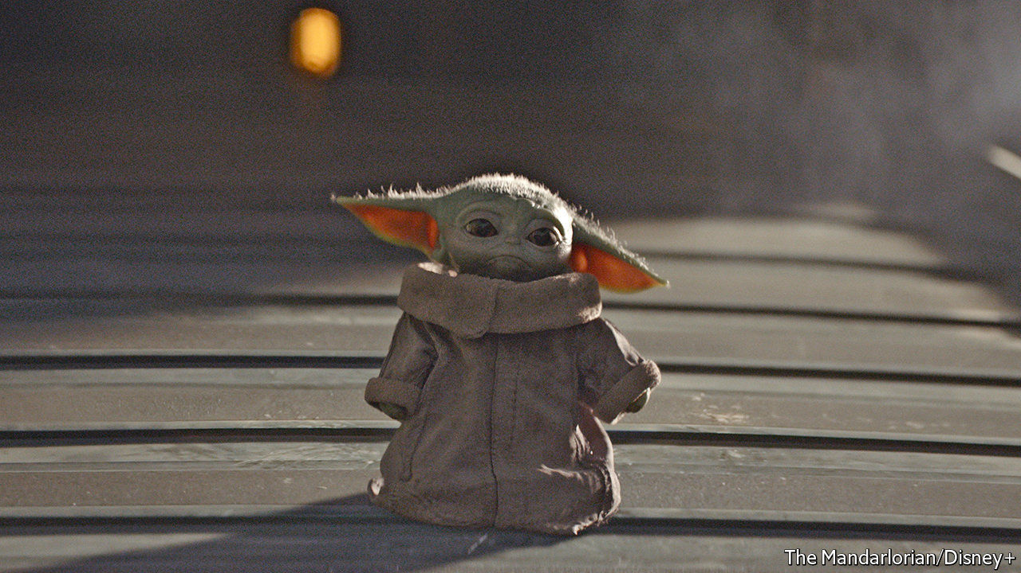

“LES AMOURS de la reine Élisabeth” (The Loves of Queen Elizabeth), starring Sarah Bernhardt, had four acts. So do many dramas—but in this case the narrative arc was partly dictated by pedestrian concerns. When the film opened in New York’s Lyceum theatre in 1912 it came in four reels. Projector operators needed intervals to switch from one to the next. In the past century technology and business models have helped shape the message in moving pictures—nowhere more so than in television. Online streaming is no different.

As TV conquered Western homes in the 1950s shows came in two main durations: half-an-hour and an hour. In America this gave producers 20-odd or 40-odd minutes to play with after setting aside time for ads; of the 173 episodes of “Seinfeld”, a sitcom that ran from 1989 to 1998, all but the two-episode finale were 22 or 23 minutes long. Commercial breaks, for their part, shaped episode cadence: you could expect a mini-cliffhanger ahead of one. Like HBO and other pay-TV channels, most streaming services earn money from subscriptions, not ads, so creators enjoy more artistic licence to determine episode length and structure, says Jonathan Dunn of McKinsey, a consultancy. “Tiger King”, Netflix’s latest hit true-crime series, about exotic-cat breeding, comes in chunks lasting anywhere between 40 minutes and 48 minutes.

The medium also determines the structure and number of shows’ seasons. As the number of American commercial TV stations increased from fewer than 600 in 1965 to 1,600 in 2000, they needed more shows to fill schedules. Since new ones are risky bets, broadcasters preferred to stick to existing programmes. Episode counts went up, boosted by syndication contracts, which generally stipulated that after a show had aired for a certain number of episodes, usually 88 (or four seasons), the rights to air it could be sold to third parties.

Streaming services like Netflix take the opposite tack to syndication, luring viewers with fresh content that cannot be found elsewhere (see article). Many of the 10m people who signed up for Disney’s new streaming platform by its first day last November probably did so to watch “The Mandalorian”, a Star Wars spin-off. In the first nine months of 2019 seven of Netflix’s ten most-watched original shows were in their debut season. Unless a show is a mega-hit like HBO’s “Game of Thrones”, explains Leigh Brecheen, an entertainment lawyer in Hollywood, it now makes more financial sense to produce something new rather than renew something old.

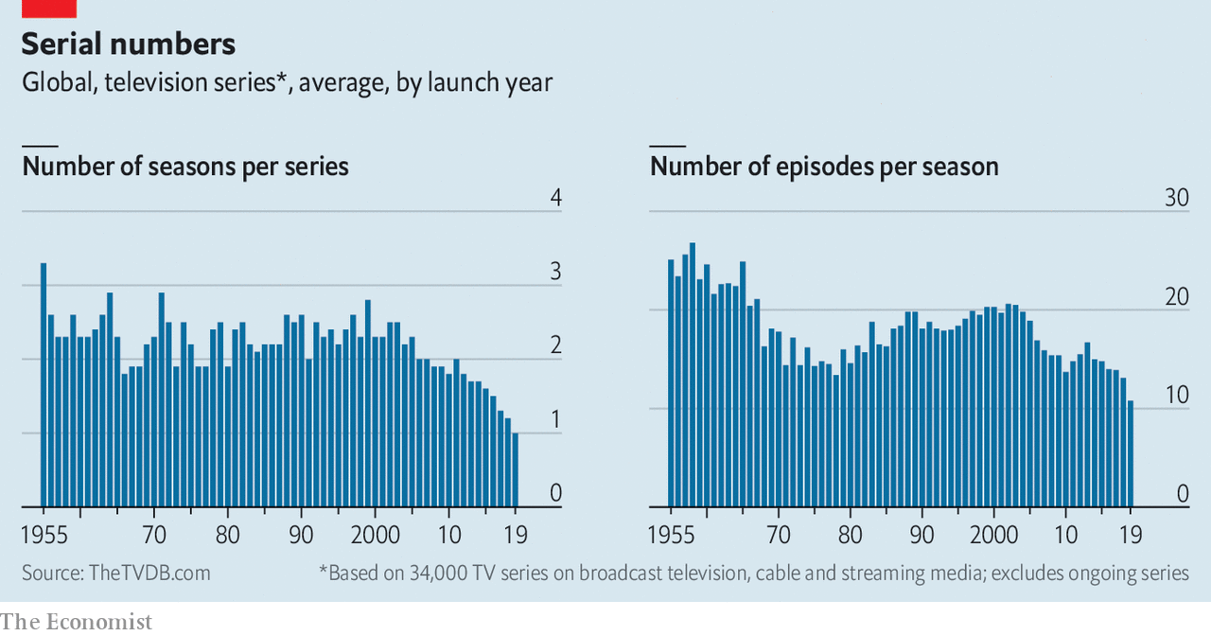

The upshot of the shift away from syndication and towards streaming has been a decline in the average number of episodes per season. Based on figures for 34,000 TV shows worldwide that debuted between 1955 and 2018, compiled by the TVDB, a website, this fell from over 20 to under 11 (see chart). The number of seasons per series dropped, too, by nearly 70%.

Many actors, producers and writers love these abridged runs because they give them the flexibility to take other jobs. Creators also no longer need to worry that their shows will one day be aired sporadically through syndication, so are free to let plots unspool over multiple episodes. Sitcom episodes remain mostly self-contained but serialised drama is “uniquely suited” for streaming, says Sandra Stern of Lionsgate, a production company. The internet has also enabled “binge-watching”, which Netflix pioneered with the release of the entire first season of “House of Cards”, a political thriller, on February 1st 2013. Binge-friendly platforms allow viewers to skip the opening and final credits—and encourage creators to start with a bigger bang and end hanging on a steeper cliff. ■

This article was downloaded by calibre from <https://www.economist.com/business/2020/04/23/how-technology-shapes-tv-shows-narrative-arcs>

|  |  |  |  |
| --- | --- | --- | --- |
| Previous | Articles | Sections | Next |

|  |  |  |  |
| --- | --- | --- | --- |
| Previous | Articles | Sections | Next |

#### Tear down this wall

# Microsoft embraces big data

Once a walled garden, the world’s biggest tech firm wants to liberate digital information

Apr 23rd 2020 | SAN FRANCISCO

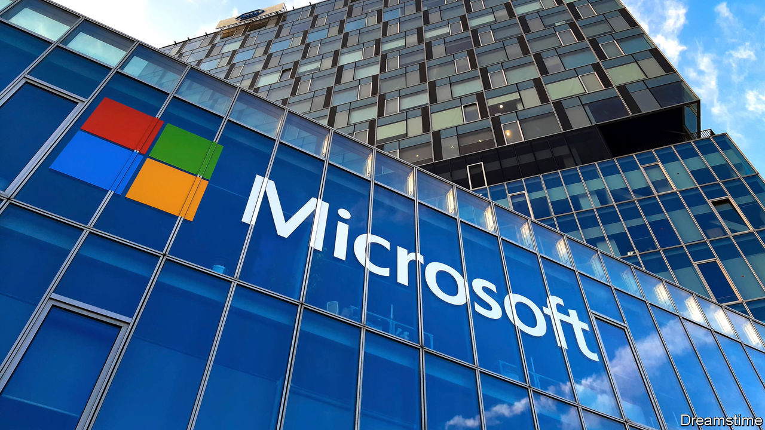

TWO DECADES ago Microsoft was a byword for a technological walled garden. One of its bosses called free open-source programs a “cancer”. That was then. On April 21st the world’s most valuable tech firm joined a fledgling movement to liberate the world’s data. The company plans to launch 20 data-sharing groups by 2022 and give away some of its digital information, including data it has gathered on covid-19.

Microsoft is not alone in its newfound fondness for sharing in the age of the coronavirus. “The world has faced pandemics before, but this time we have a new superpower: the ability to gather and share data for good,” Mark Zuckerberg, the boss of Facebook, a social-media giant, wrote in the Washington Post on April 20th. Despite the EU’s strict privacy rules, some Eurocrats now argue that data-sharing could speed up efforts to fight the virus.

The case for sharing data predates the pandemic. The OECD, a club mostly of rich countries, reckons that if data were more widely exchanged, many states could enjoy gains worth 1-2.5% of GDP. The estimate is based on heroic assumptions (such as putting a number on opportunities for startups). But economists agree that readier access to data is broadly beneficial, because data are “non-rivalrous”: unlike oil, say, they can be used and re-used without being depleted, to power various artificial-intelligence algorithms at once, for example.

Many governments have recognised the potential. Cities from Berlin to San Francisco have “open data” initiatives. Companies have been cagier, says Stefaan Verhulst, who heads the Governance Lab at New York University, which studies such schemes. Firms fear losing intellectual property, imperilling users’ privacy and hitting technical obstacles. Standard data formats (eg, JPEG images) can be shared easily, but much that a Facebook’s software collects would be meaningless to a Microsoft, even after reformatting. Less than half of the 113 “data collaboratives” identified by the lab involve corporations. Those that do, including initiatives by BBVA, a Spanish bank, and GlaxoSmithKline, a British drugmaker, have been small or limited in scope.

Microsoft’s campaign is the most consequential by far. Besides encouraging non-commercial sharing, the firm is developing software, licences and (with the Governance Lab and others) rules frameworks to let firms trade data or provide access without losing control. Optimists believe that the giant’s move could be to data what IBM’s embrace in the late 1990s of the Linux operating system was to open-source software. Linux went on to become a rival to Microsoft’s own Windows and today underpins Google’s Android mobile software and much of cloud-computing.

Brad Smith, Microsoft’s president, notes that fewer than 100 firms collect more than half of all data generated online. More sharing would, in his view, counteract the concentration of economic—and political—power. Bridging the “data divide”, as he calls it, won’t be easy. Data are more complex than code. Most programmers speak the same language and open-source collectives mainly solve technical problems. People in charge of data often come from different industries without a common vocabulary and talk business.

Indeed, like IBM before it, Microsoft has reasons other than altruism to champion open data. It makes most of its money not by extracting value from hoarded data through targeted advertising, like Alphabet or Facebook, but by selling services and software to help others process digital information. The more data that are shared, the better for Microsoft. Mr Smith argues that this makes his firm the perfect campaigner for open data. “If you want to know who to trust”, he says, “you should look at the company’s business model.”

That may be so. But this also points to a bigger hurdle. Even if technical and legal barriers to sharing could be removed, many data-rich firms will be reluctant to loosen their lucrative grip on user information. Mr Zuckerberg’s declarations notwithstanding, don’t expect Facebook to follow Microsoft’s lead any time soon.■

This article was downloaded by calibre from <https://www.economist.com/business/2020/04/23/microsoft-embraces-big-data>

|  |  |  |  |
| --- | --- | --- | --- |
| Previous | Articles | Sections | Next |

|  |  |  |  |
| --- | --- | --- | --- |
| Previous | Articles | Sections | Next |

#### Bartleby

# Play’s the thing

Creative ways of training staff

Apr 23rd 2020 |

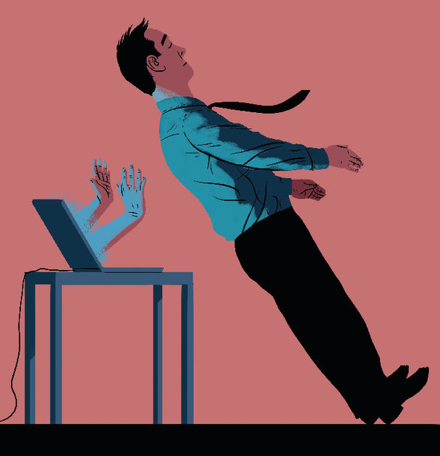

ANYONE WHO has spent a long time in an office job will have suffered the indignities of a training day. The group-bonding exercise where workers fall into each other’s arms, as if they were part of a 1960s encounter group. The overenthusiastic guest lecturer who constructs a lengthy and banal presentation out of a series of random nouns. The debate about the company’s future which turns into an exercise in Stalinist self-criticism. It all resembles one of those nightmares when you find yourself marooned back in the school classroom.

If there is one good thing about the current pandemic, it is that no one is being sent to an awayday event at a seaside resort or a country retreat. Perhaps the whole idea will become less fashionable. Thankfully, there are inventive ways to undergo training online.

One management course uses the skills of an improvisational-comedy troupe, the Second City. “People are rarely taught to be a boss,” says Kelly Leonard of the Chicago-based outfit, and the course attempts to guide them in the right direction. The philosophy is based on a book called “Radical Candour” by Kim Scott, which argues that managers need to deliver and accept constructive feedback. She says that a “difficult but necessary part of being a boss [is] telling people clearly and directly when their work wasn’t good enough”. Of course, some bosses are too quick to criticise and never offer praise. So praise is also needed but it has to be “specific and sincere”.

The approach works, Ms Scott argues, only if employees believe that their managers care about them personally. And managers need to solicit and accept criticism from their subordinates.

The training was originally designed for use in workshops, something that would be impossible at a time of social distancing. Fortunately, the actors at the Second City created a sitcom, “The Feedback Loop”, to illustrate the ideas. In the video, people are made to endure a version of “Groundhog Day”, in which they keep reliving the same situations until they learn from their mistakes. The fictional workers learn not to be “obnoxiously aggressive” and “manipulatively insincere”; managers realise it is hopeless to be “ruinously empathetic”.

The show can be downloaded and discussed by staff and managers from the comfort of their own homes. Some people may feel that humour is inappropriate at a time of a global pandemic. But comedy can be a source of solace in a crisis. (Bartleby would insert a coronavirus joke here, but it will be days before you get it.)

Another creative way of imparting information is poetry. Gary Turk is a poet who has worked in British TV alongside Ricky Gervais and Richard Curtis, the man behind “Love Actually”. When Mr Turk’s then girlfriend complained that he spent too much time on the phone, he tried to take a break. He noticed how much time others spent with their devices and that inspired him to make a short film, which he narrated in rhyming verse. When he uploaded the film, called “Look Up”, to YouTube, it struck a chord, receiving 1m views within five days, and then, on the sixth day, getting another 10m.

After the video’s success, Mr Turk was contacted by other organisations which wanted to tap into his skills. Some of this work was promotional, such as for British Airways. But much was in the realm of public information (a campaign in Western Australia to stop people texting and driving) and some was for compliance training (notably a video on corruption and another on sexual harassment).

These can be difficult issues to cover. It is all too easy for the tone to become either too flippant or too preachy. Mr Turk’s videos get the message over in two to three minutes and may lead to a more open discussion than if the subjects were presented more formally. “Spoken-word videos are great at grabbing people’s attention—the rhyming patterns and lyrical structures make you listen carefully to every word,” Mr Turk argues. “It is also something fresh that most employees have never seen in their annual training or work presentations before.”

Columns should be set in proseAnd this is often one of those.But a fleeting burst of verseMight not make the readers curse.Though the hardest part will beFinding rhymes for Bartleby.

A little bit of poetry and comedy goes a long way. One wouldn’t want an entire training day to consist of jokes or rhymes. But online or offline, these kinds of innovative techniques can enliven those endless seminars when the clock never seems to reach 5pm.

This article was downloaded by calibre from <https://www.economist.com/business/2020/04/23/plays-the-thing>

|  |  |  |  |
| --- | --- | --- | --- |
| Previous | Articles | Sections | Next |

|  |  |  |  |
| --- | --- | --- | --- |
| Previous | Articles | Sections | Next |

#### Schumpeter

# Netflix will remain a blockbuster hit beyond the covid-19 era

Minting it

Apr 23rd 2020 |

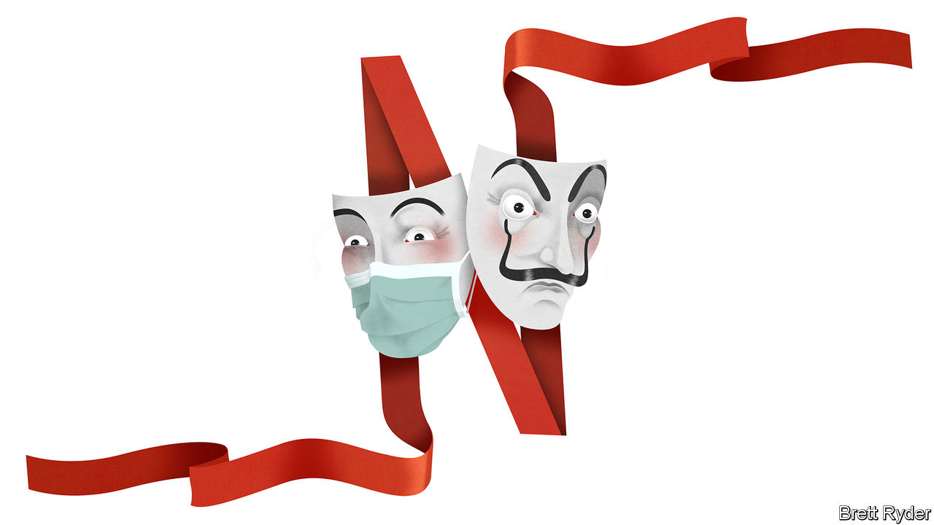

Editor’s note: The Economist is making some of its most important coverage of the covid-19 pandemic freely available to readers of The Economist Today, our daily newsletter. To receive it, register [here](https://www.economist.com/newslettersignup). For our coronavirus tracker and more coverage, see our [hub](https://www.economist.com/coronavirus)

TO UNDERSTAND NETFLIX, forget the mullet-haired Joe Exotic and his antics in “Tiger King”. Think instead of the bearded El Profesor and the other rogues who populate “Money Heist”, the streaming firm’s exhilarating Spanish-language crime drama about stealing €2.4bn ($2.6bn) from the national mint in Madrid. Like the hijackers, Netflix is taking advantage of the lockdown in many countries to print money. Like El Profesor, the company’s goateed boss, Reed Hastings, is usually a step ahead of everyone. And like the heist’s perpetrators, it has always had one golden rule: stick to the plan. So far it has pulled it off. As one analyst puts it, Netflix is as much a household essential in the covid-19 age as Clorox. Its market value, at more than $190bn, has for the time being risen above Disney’s. Yet, as usual with Netflix (and with “Money Heist”), just when you think you can breathe easily, trouble starts.

Netflix’s story has had a Tinseltown quality to it since its founding in 1997. Even in its early, DVD-dispatching days Netflix won its subscribers’ hearts and minds—and so their wallets—with plentiful content and great customer service. In contrast to Blockbuster, it had a “long tail” of tens of thousands of DVDs for all tastes. It made recommendations to viewers based on their previous choices. It also had a clear-cut vision.

Mr Hastings believed from the start that films would eventually be downloaded from the internet. But instead of taking on the media incumbents, be they TV networks or film studios, he sidestepped them with novel approaches to distribution and film-making. In the process, he has built Netflix’s brand, customer base and ability to fund growth. Now the firm has gone global, in a way none of its media rivals has matched. Ben Thompson of Stratechery, an online newsletter, explains that Netflix moved from DVDs to streaming rights to original content, each time building on a user base acquired in the previous step. This “ladder strategy” enabled the firm to clamber into many of the world’s homes just in time to provide distraction during a global pandemic.

On April 21st it became clear just how sturdy the ladder is. As it reported its first-quarter earnings, Netflix said subscriber numbers had soared by 15.8m in the first three months of the year, more than double its previous forecast. They now total 183m. Most of the growth came from Europe and Asia. Though production of new shows has stalled in the pandemic, Netflix played down fears that people will binge through its catalogue. Its producers and animators are busily editing series in their bedrooms and kitchens. The firm is confident that the pandemic will not affect its planned releases this year. It also offered a response to those who say that its model of borrowing heavily to finance film-making is unsustainable. It generated free cashflow in the quarter for the first time since 2014, and said it would burn $1bn of cash or less this year, down from $3.3bn in 2019. This helps explain why junk-rated Netflix now borrows at similar interest rates to A-rated Disney.

Of course, no good plotline is without setbacks. Netflix acknowledges that subscriptions may simply have been accelerated by lockdown. If so, they may slow again when restrictions are eased. Cash burn could then tick up. The company needs money to bankroll new content but has yet to lay to rest a long-standing concern that its rising international revenues will not offset slowing subscriber growth in America, its biggest market. In the first quarter its foreign revenues were crushed by the surging dollar. At the same time Netflix faces new competition, both at home and abroad. Disney+, launched last November, has attracted 50m subscribers globally. Mr Hastings admits he has never seen an incumbent learn new tricks so quickly.

Look beyond covid-19 and the worry is not just that Netflix subscribers will flee to other streamers. It is that as other big media companies shift to streaming, they will refuse to sell it new shows (as Disney has done as it launched Disney+) or license it old stuff (as happened this year with “Friends”, bought by WarnerMedia in 2019). That would force Netflix to spend ever more to keep up.

## Running and streaming

Yet this ignores the devastating impact of the pandemic on media conglomerates in general. WarnerMedia (owned by AT&T, a telecoms giant) has just announced it will launch HBO Max, its streaming service, on May 27th. But lockdown restrictions mean it must forgo the razzle-dazzle reunion of “Friends” cast members. Because of the pandemic, NBCUniversal (which is part of Comcast, a cable operator) has staggered the start of its Peacock streaming service, giving Netflix more time to consolidate its lead. On April 22nd AT&T reported falling revenues at WarnerMedia owing to a meltdown in advertising. Both it and Comcast are weighed down by debts. A recession may convince their dwindling base of lucrative cable subscribers to cut the cord in favour of streaming, further depressing revenues. Disney is likely to be the first of the covid-stricken media titans to get back on its feet when lockdowns end. But right now it is ailing. Its theme parks, the biggest source of its profits, are shut in America and Europe. Its ESPN sports TV network has almost no live competitions to broadcast. And like everyone in show business apart from Netflix, it relies on advertising.

That sets the stage for an endgame to the “streaming wars” that will unfold sooner than anyone might have imagined. Rather than starving Netflix of content, some of its rivals will struggle to survive. Their debt-laden parents may be forced once more to license shows to Netflix. Disney, its most formidable nemesis, will lack the financial muscle to kill it off completely. Amazon and Apple, whose streaming services have nothing like the depth of Netflix or Disney+, have bags of cash to shake up the contest. Meanwhile, Netflix will try to entrench its global lead, not least by banging out more international smash hits like “Money Heist”. When El Profesor declares, prophetically, “We are the Resistance”, he could be channelling Mr Hastings. ■

Dig deeper:  
For our latest coverage of the covid-19 pandemic, register for The Economist Today, our daily [newsletter](https://www.economist.com/newslettersignup), or visit our [coronavirus tracker and story hub](https://www.economist.com/coronavirus)

This article was downloaded by calibre from <https://www.economist.com/business/2020/04/23/netflix-will-remain-a-blockbuster-hit-beyond-the-covid-19-era>

|  |  |  |  |
| --- | --- | --- | --- |
| Previous | Articles | Sections | Next |

|  |  |  |
| --- | --- | --- |
| Business | Sections | Schools brief |

Finance and economics

Hedge funds: Back in the game

.

Risk parity: Under the weather

.

Commodities: Tick tock

.

Financial technology: Virtually money

.

Buttonwood: Hard money

.

Free exchange: Tough love

.

|  |  |  |
| --- | --- | --- |
| Business | Sections | Schools brief |

|  |  |  |  |
| --- | --- | --- | --- |
|  | Articles | Sections | Next |

#### Back in the game

# Hedge funds hope the slump will make them relevant again

Seismic shifts in capital allocation have contributed to a rotten decade

Apr 25th 2020 | NEW YORK

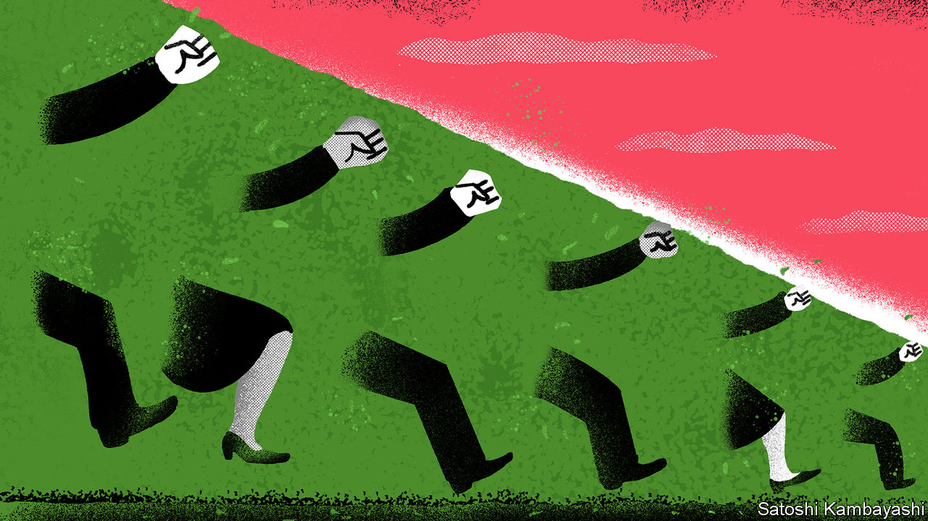

Editor’s note: The Economist is making some of its most important coverage of the covid-19 pandemic freely available to readers of The Economist Today, our daily newsletter. To receive it, register [here](https://www.economist.com/newslettersignup). For our coronavirus tracker and more coverage, see our [hub](https://www.economist.com/coronavirus)

HEDGE FUNDS have had a rotten decade. Star managers were once perceived to be infallible “masters of the universe” who made money for wealthy individuals and big institutional investors in both good times and bad. But steep losses during the global financial crisis of 2007-09 tarnished that reputation, and subsequent returns have failed to resurrect past success. The result has been a humbling comedown. Many of the hedge-fund industry’s biggest names—like Leon Cooperman, who ran Omega Advisors, and Eric Mindich, once the youngest-ever partner at Goldman Sachs—have thrown in the towel, returned investors’ capital and converted their hedge funds into family offices.

These woes have been exacerbated by seismic shifts in the allocation of capital. As hedge-fund profits wilted, institutional investors—such as pension funds and university endowments, which make up the bulk of hedge funds’ clientele—saw little reason to pay meaty fees for mediocre performance. Investors turned to cheap index funds instead, or sought out the juicier returns dangled by private-equity and property funds. Having managed more capital than their private-equity peers for much of the past decade, by 2019 the hedge-fund industry was a fifth smaller than private equity (see chart 1). Index funds, or “passive” investors, have eclipsed both. The Bank for International Settlements, a club of central banks, estimates that almost half of the roughly $30trn invested in American equities is now passively managed.

Hedge-fund managers have long warned that these trends in investment allocation might pan out poorly for investors in a crisis. The financial-market chaos wrought by the pandemic has tested that claim, and hedge funds have been vindicated, though only partially. They have not made big gains. And they have experienced outflows: figures released by Hedge Fund Research on April 22nd suggest that these amounted to 1% of assets under management in the first quarter. Still, they have, so far, lost less than the market. And there are early signs that the crisis could benefit the industry in the longer term, if it causes investors to appreciate the benefits of hedging their equity exposure, and to shift away from illiquid assets.

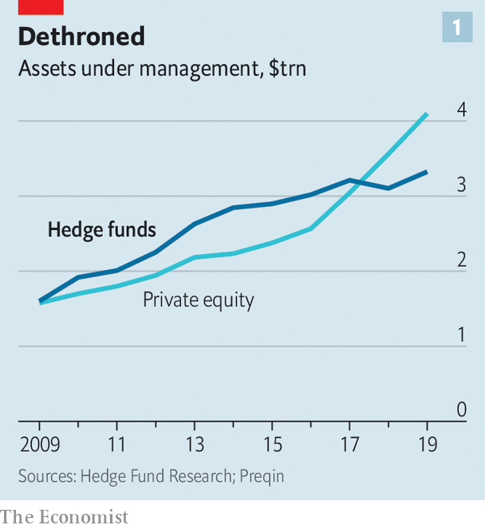

How you think hedge funds have performed during the market turmoil depends on how stern a test you apply. If you think their purpose is to make steady returns, regardless of how markets fare, then most have failed. On average, the value of their portfolios has fallen by 10.5% (see chart 2). But they have at least beaten the market: the S&P 500 fell by 20% in the first three months of the year. True, average annualised returns of the S&P 500 in the past five years, at 4.6%, still beat those of the average hedge fund, at 3%. But the goal for most institutional investors is not to achieve the juiciest returns; it is to generate good returns that are steady and low-risk. If hedge funds beat the market during times of stress, they become a source of portfolio diversification that is useful to endowments and pension schemes.

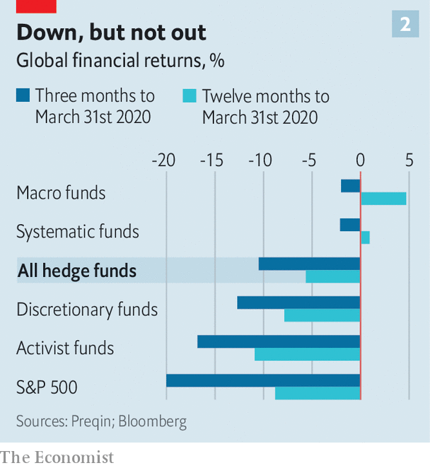

By and large, machines have done better than humans. Around a third of hedge-fund assets are managed in so-called “systematic” funds, which write investment rules based on historical-data analysis and use algorithms to execute trades. On average, these have done best: systematic investors have seen the value of their assets slip by only 2.1% this year. The Medallion fund, the flagship fund run by Renaissance Technologies and set up by Jim Simons in 1988, was up by 24% in March. By contrast, discretionary funds, which are run by human managers picking and choosing trades, are down by 12.7%.

Systematic-fund managers offer a few explanations for their better relative performance. Carter Lyons of Two Sigma, one such fund, claims that systematic investments have done well because they can diversify more. “A systematic fund may take several thousand positions, whereas a discretionary manager may only have 100.” That helps keep systematic portfolios’ losses down when markets are tumbling. Others claim that consistency has helped. “The great thing about systematic processes is that they stick to their knitting,” says Luke Ellis, the chief executive of Man Group, the third-biggest hedge-fund manager in the world. Some of its discretionary funds have done well, but its best performing ones have been systematic.

Some bets have come off better than others. Macro strategies, which place bets on economic developments, have fared best on average, down just 2%. But Bridgewater Associates, a big macro fund, has done poorly, brought down by its risk-parity strategy (see article).

At the bottom of the heap are activist funds, which buy stakes in companies in the hope of changing their strategies or management. These were down 16.8% on average at the end of March. Activists may have suffered as a result of loading up on shares at lofty valuations earlier in the year. According to Lazard, an investment bank, activists deployed $2.8bn of capital per week in February. With corporate deals off the table and shareholder meetings postponed, they might spy fewer opportunities to take on company bosses.

Varied though their performance has been, hedge funds still look appealing when compared with many private-equity funds. The pandemic seems likely to pose the most financial danger to highly leveraged businesses—precisely the type of firm that private-equity funds tend to invest in. Buy-out firms themselves do not disclose returns, but some of their investors—like banks—must. This month one of America’s largest lenders admitted to writing down its private-equity investments by 20% in the first quarter.

Another drawback of private equity may prove to be its illiquidity. Pension funds and university endowments have outgoings that are more or less fixed. Stable cash flows in normal times meant that they became more comfortable with illiquid assets. Few will be prepared for a situation in which the economy is shuttered and pension contributions and tuition payments dry up. Large institutional investors might face an unprecedented need for cash.

It is still too soon to know which funds will navigate the crisis best, let alone how the pandemic will reshape investment decisions in the longer term. “Returns in March will end up being just one piece of the puzzle,” says Mr Ellis. Many investors claim they are using the turmoil to make long-term bets that may not have lifted returns yet. But the early signs are that hedge funds might not come out too badly. The pendulum seems likely to swing back towards holding liquid assets, and hedge funds appear to be doing well enough that they might benefit from the reallocation.

If hedge funds were once a flashy way to generate extra returns for rich individuals, they have since become more pedestrian—reliable sources of diversification for big institutional investors. In turbulent times, perhaps that is enough. ■

Dig deeper:  
For our latest coverage of the covid-19 pandemic, register for The Economist Today, our daily [newsletter](https://www.economist.com/newslettersignup), or visit our [coronavirus tracker and story hub](https://www.economist.com/coronavirus)

This article was downloaded by calibre from <https://www.economist.com/finance-and-economics/2020/04/25/hedge-funds-hope-the-slump-will-make-them-relevant-again>

|  |  |  |  |
| --- | --- | --- | --- |
|  | Articles | Sections | Next |

|  |  |  |  |
| --- | --- | --- | --- |
| Previous | Articles | Sections | Next |

#### Under the weather

# How risk-parity investment strategies unravelled

The value of portfolios plunged when bond and stock prices began to move in tandem

Apr 25th 2020 |

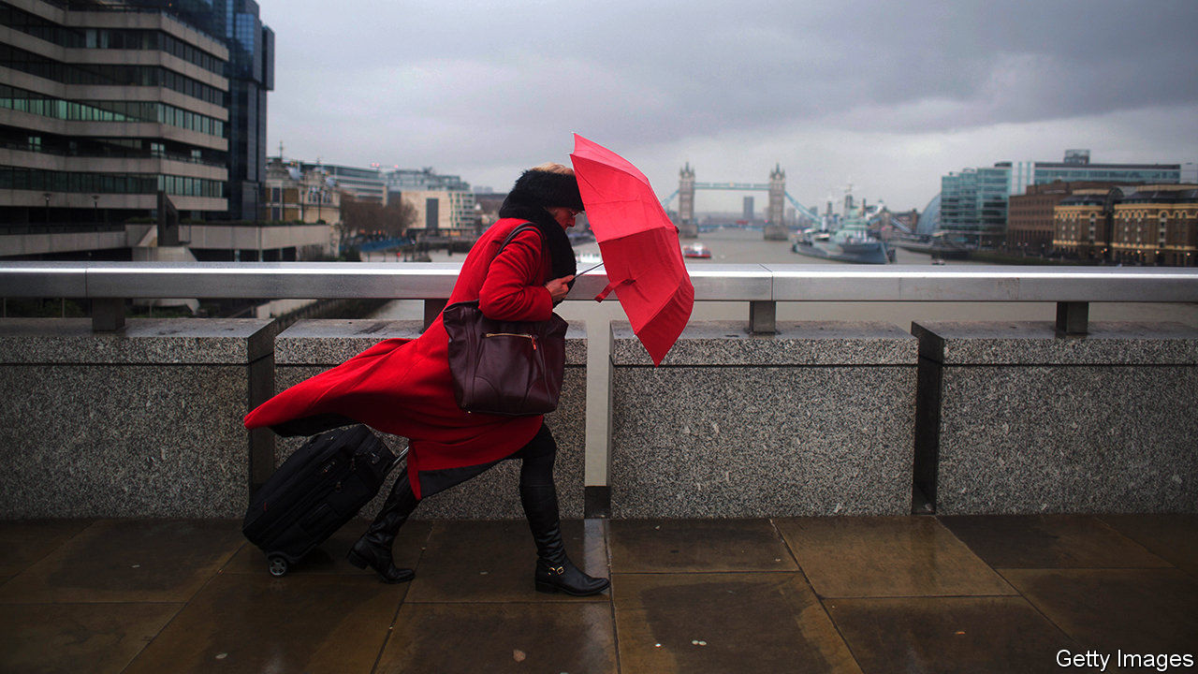

Editor’s note: The Economist is making some of its most important coverage of the covid-19 pandemic freely available to readers of The Economist Today, our daily newsletter. To receive it, register [here](https://www.economist.com/newslettersignup). For our coronavirus tracker and more coverage, see our [hub](https://www.economist.com/coronavirus)

“THE PANDEMIC was a strange beast that I didn’t have an edge wrestling with,” says Ray Dalio, founder of Bridgewater Associates, the world’s largest hedge fund, explaining his losses in the first quarter. For years Bridgewater’s famed risk-parity strategy produced high returns for low risk, and was widely adopted by others. But things soured when covid-19 hit. Mr Dalio reported losses of 7-21% across his funds in the first quarter, his biggest since late 2008.

Bridgewater created the first risk-parity portfolio in 1996, when it launched its All Weather fund. It was intended to be insulated from market-wide shocks. A typical way to do this is to balance holdings of relatively volatile stocks with government bonds—in times of market stress bonds usually rise in value, offsetting losses from stocks. But that means less exposure to equities, which tend to have higher returns. Bridgewater’s innovation was to keep a high allocation of stocks, but to borrow to buy safe long-dated bonds. If the long-dated interest rate is higher than the borrowing rate, as has generally been the case, this raises the total return on the portfolio, without adding extra risk.

The strategy’s success led others to follow. Assets allocated to the strategy probably exceeded $1trn in March, according to David Zervos of Jefferies, an investment bank. Risk parity’s outperformance during the global financial crisis was its making. The average annual return in the S&P risk-parity index in 2006-10 was 8%; by contrast, the S&P 500 equity index made nothing.

At first risk parity fared well during the corona-crisis. Between January 1st and March 13th the MSCI world share-price index fell by 20%. Safe assets were in high demand. In America the yield on the ten-year Treasury, which moves inversely to the price, dipped to a record low of 0.3% on March 9th. But then bond and share prices began to fall in tandem. Faced with an intense cash crunch, some investors sold their holdings of even liquid assets such as Treasuries. Risk-parity portfolios plunged in value.

With yields on Treasuries still low, proponents of risk parity are on the lookout for other ways to hedge risk. Mr Dalio reckons that government borrowing undertaken to support the economy during the pandemic will stoke inflation, making bonds less attractive to hold. Mr Zervos argues that investment-grade corporate bonds, which offer a return that is around two percentage points higher than government bonds, could be a substitute. The search for a new way to outperform begins.

Dig deeper:  
For our latest coverage of the covid-19 pandemic, register for The Economist Today, our daily [newsletter](https://www.economist.com/newslettersignup), or visit our [coronavirus tracker and story hub](https://www.economist.com/coronavirus)

This article was downloaded by calibre from <https://www.economist.com/finance-and-economics/2020/04/25/how-risk-parity-investment-strategies-unravelled>

|  |  |  |  |
| --- | --- | --- | --- |
| Previous | Articles | Sections | Next |

|  |  |  |  |
| --- | --- | --- | --- |
| Previous | Articles | Sections | Next |

#### Tick tock

# Oil markets have a timing problem

As crude inventories rise, so does the pressure on the market

Apr 25th 2020 | NEW YORK

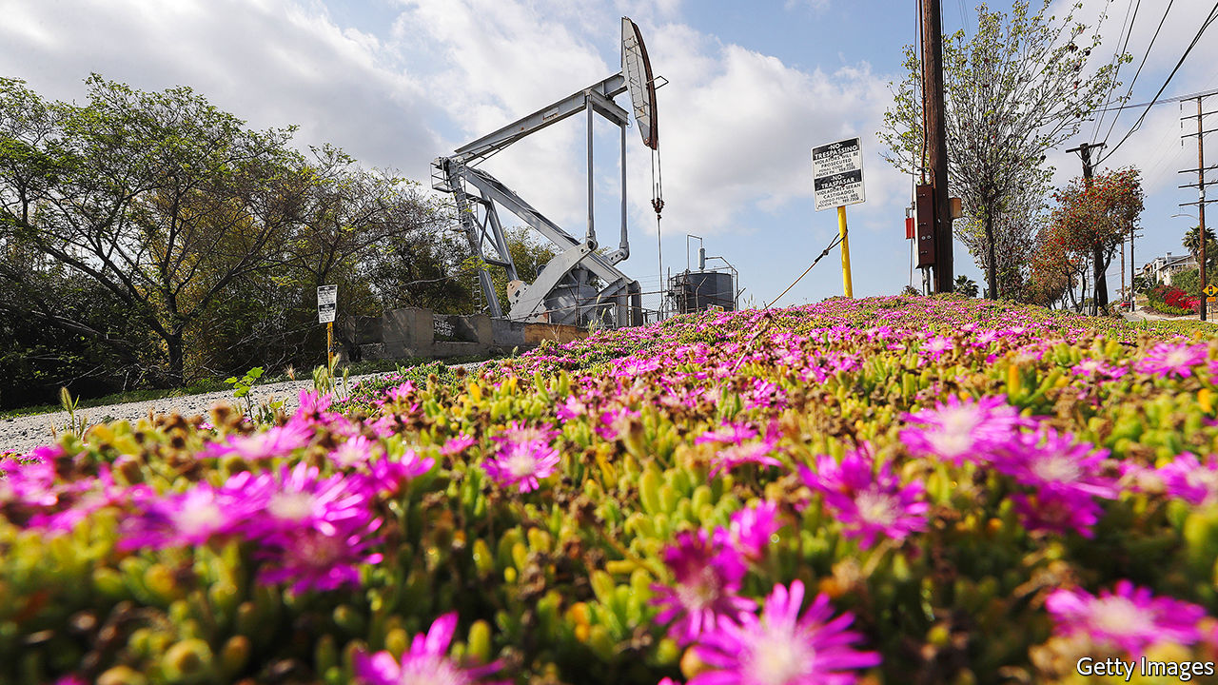

Editor’s note: The Economist is making some of its most important coverage of the covid-19 pandemic freely available to readers of The Economist Today, our daily newsletter. To receive it, register [here](https://www.economist.com/newslettersignup). For our coronavirus tracker and more coverage, see our [hub](https://www.economist.com/coronavirus)

FOR MORE than a century, oil has been among the world’s most vital commodities. On April 20th it became less than worthless. The price of the May futures contract for West Texas Intermediate (WTI) crude plunged to the hitherto unfathomable level of -$40. The price of Brent crude, the international benchmark, sank too, before both seemed to recover, with the front-month contracts settling at $13.78 for WTI and $20.37 for Brent on April 22nd. But oil markets still have a timing problem.

As governments try to contain the spread of covid-19, demand for oil has fallen faster and farther than at any point in history. Production has been slower to ebb, so storage tanks are filling up. The Organisation of the Petroleum Exporting Countries (OPEC) and its allies this month announced a historic deal to cut production. On April 20th America’s president, Donald Trump, said his government might buy as much as 75m barrels of crude for America’s strategic reserve. But output is unlikely to drop quickly enough to bring oil markets into balance in May, June or even later this summer. As crude inventories rise, so does the pressure on the market.

The May contract for WTI, though idiosyncratic in some ways, exemplifies the disaster scenario. The contract’s last day of trading was April 21st. The price plunged on April 20th, as traders realised they owned crude to be delivered to Cushing, Oklahoma, in May, but that Cushing would probably have no available tanks to store it.

The pressure on the global market is less extreme, but not entirely dissimilar. On April 12th OPEC and its allies promised to restrain output by 9.7m barrels a day in May and June, their biggest ever cut. The accord was too late, though, to deal with the implosion of demand in April. The International Energy Agency expects oil demand to sink by 29m barrels a day this month, compared with April 2019, equivalent to a third of global supply.

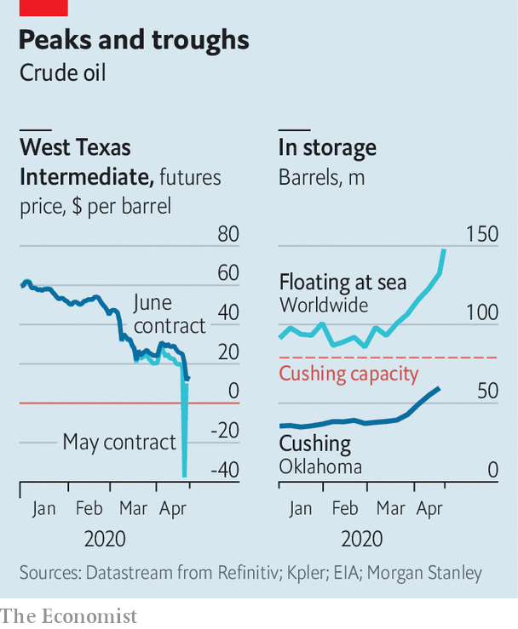

The agreement may be insufficient to deal with continued declines in demand in May, too, not least because the actual cuts are less impressive than the headline suggests. Not all of the more than 20 parties to the deal may comply. Moreover, Saudi Arabia, Russia and others in the group agreed to cut output not from the levels of February, but from an even higher base. The collective cut, compared with February of this year, is therefore closer to 7.5m barrels a day, reckons Bernstein, a research firm.

It is unclear if or when deeper cuts will come. Mr Trump helped broker the OPEC deal—America is now the world’s biggest crude producer—and is weighing further measures to support prices. But any purchase for America’s strategic reserves would require the approval of Congress. Regulators in Texas are mulling a cap on that state’s production, but a meeting on April 21st ended without agreement.

Market-driven declines in production are more likely, particularly after the nightmare of the May WTI contract. But so far companies’ declared cuts have been too tepid: they are often loth to stop production, as restarting a well can be costly. Bernstein therefore expects global supply to exceed demand in the second quarter by more than 13m barrels a day.

In the meantime, storage across America is filling up rapidly, and could reach tank tops in June. On April 22nd the country’s Energy Information Administration reported that crude inventories had reached 519m barrels, close to the record of 535m set in 2017. Brent crude is seaborne and therefore less vulnerable to transport and storage problems than landlocked WTI. But it too faces constraints. The volume of oil stored on ships has jumped by 70% since the beginning of March, according to Kpler, a market-data firm. And even more oil is borne on ships still steaming towards onshore crude tanks, which Reid I’Anson of Kpler estimates are already about 85% full.

Unprecedented circumstances are bringing unprecedented behaviour. Oil is usually stored in giant ships such as a Suezmax, or the aptly named Very Large Crude Carrier, or onshore near big ports or population centres, such as Rotterdam or New York. Ben Luckock of Trafigura, a big trader, says firms such as his are now considering rail cars, small barges or even parked trucks. The price of a contract for a major crude benchmark may not sink again to -$40. But as inventories rise, oil markets continue to test the realm of possibility. ■

Dig deeper:  
For our latest coverage of the covid-19 pandemic, register for The Economist Today, our daily [newsletter](https://www.economist.com/newslettersignup), or visit our [coronavirus tracker and story hub](https://www.economist.com/coronavirus)

This article was downloaded by calibre from <https://www.economist.com/finance-and-economics/2020/04/25/oil-markets-have-a-timing-problem>

|  |  |  |  |
| --- | --- | --- | --- |
| Previous | Articles | Sections | Next |

|  |  |  |  |
| --- | --- | --- | --- |
| Previous | Articles | Sections | Next |

#### Virtually money

# China aims to launch the world’s first official digital currency

Little by little, the central bank will acquire more power to track how money is used

Apr 23rd 2020 | SHANGHAI

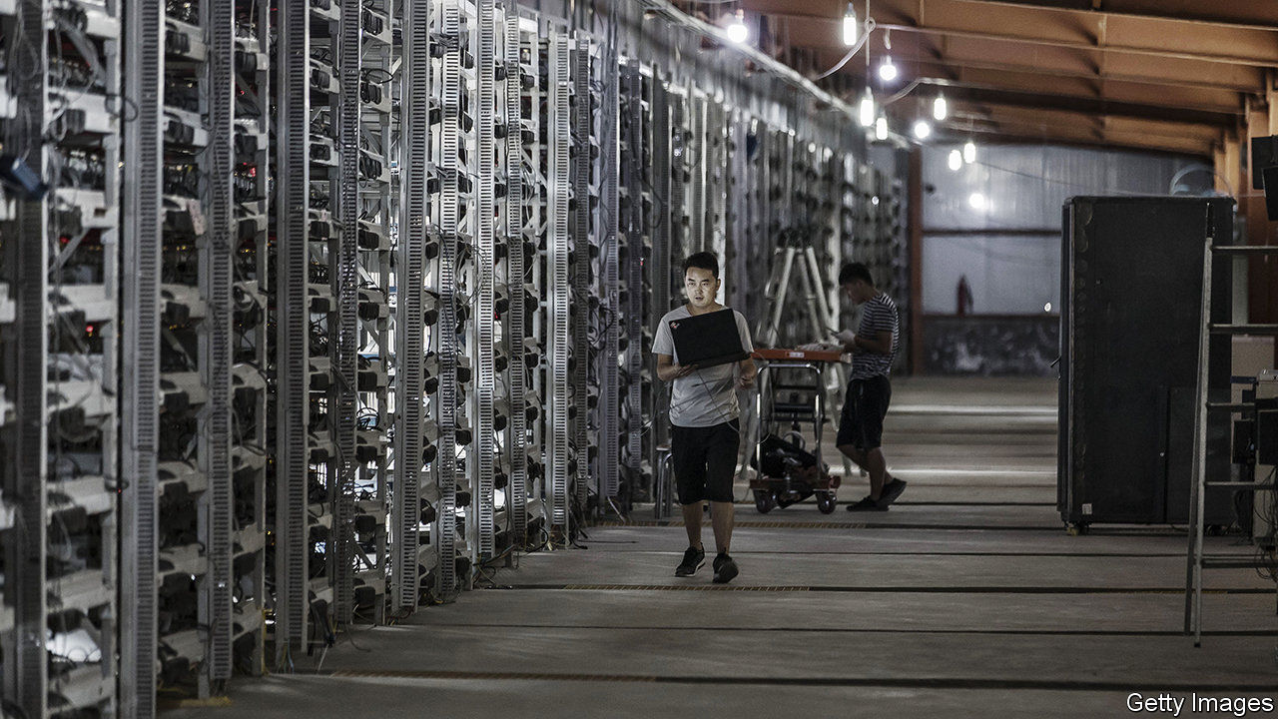

CENTRAL BANKS have had a busy pandemic. Along with injecting vast amounts of money into the financial system, they have cleaned vast amounts of it—literally. From America to South Korea, central banks have quarantined and disinfected potentially contaminated banknotes. This hassle should make them all the more interested in a digital-currency pilot now under way in China. If successful, it could change how central banks manage both liquidity and physical cash.

Dozens of central banks have started looking at whether to issue digital currencies. But only a few have run trials and none has gone as far as China, which appears set to become the first country to put a central-bank digital currency (CBDC) into limited use. China’s four largest commercial banks began internal tests this month. The city of Suzhou will give some to government employees next month to cover transportation costs, according to state media. Citic Securities, a brokerage, forecast on April 16th that China would formally launch the digital yuan later this year.

China began exploring the concept in 2014 because of the technological upheaval in its financial system. A decade ago it was cash-dominated; last year mobile transactions reached 347trn yuan ($49trn), accounting for four of every five payments. An official digital currency could help address a risk from this transition. Were mobile-payment systems to fail or a crisis to erupt, people might want cash. But there is less and less of it in circulation. Enter the CBDC: people could move into “official” digital money in central-bank-authorised mobile wallets. They would also be able to transfer cash even when offline—for instance, via Bluetooth. A screenshot of one mobile wallet in testing recently spread online. It looked sufficiently reassuring, showing an image of a one-yuan note stamped with a central-bank serial number.

But the bigger prize for China is the new powers that would come with a CBDC. China’s version will be a centralised currency, rather like the anti-bitcoin. Officials will be able to track all digital cash in circulation, making it much harder to launder money or evade taxes. The central bank could also use coding to control how the money is used. For example, if it issues CBDC to a commercial bank for lending on to small businesses, it could ensure that the money is activated only once transferred to a small firm. And China might find it easier to make nominal interest rates negative: cash would no longer be an alternative to bank deposits because negative interest rates could apply to digital cash itself.

These powers are still some way off. Given the risks inherent to such a transformation, China will phase in the CBDC very gradually. Citic Securities estimates that it will take several years for the digital yuan to replace just about 10% of all physical cash in China. For now central banks must continue to worry about money-laundering—both illegal and antiviral.■

This article was downloaded by calibre from <https://www.economist.com/finance-and-economics/2020/04/23/china-aims-to-launch-the-worlds-first-official-digital-currency>

|  |  |  |  |
| --- | --- | --- | --- |
| Previous | Articles | Sections | Next |

|  |  |  |  |
| --- | --- | --- | --- |
| Previous | Articles | Sections | Next |

#### Buttonwood

# Why the euro is more durable than it looks

The commitments of a shared currency are not so easily shaken off

Apr 25th 2020 |

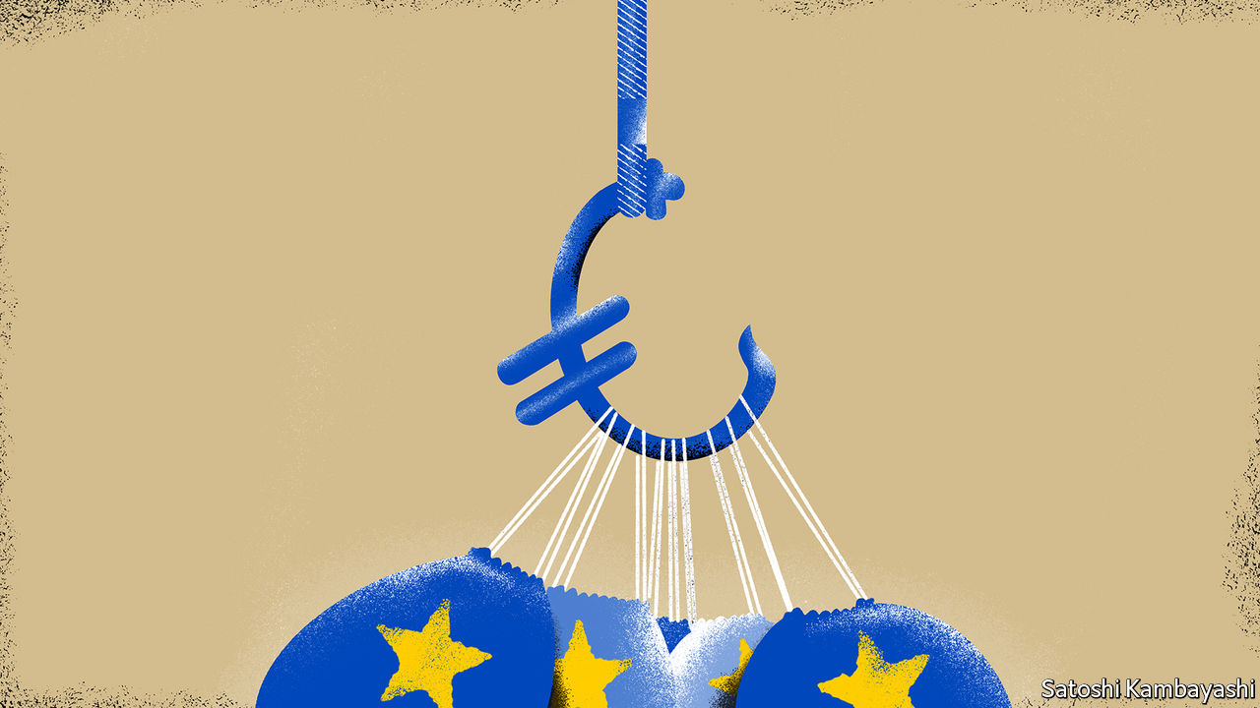

Editor’s note: The Economist is making some of its most important coverage of the covid-19 pandemic freely available to readers of The Economist Today, our daily newsletter. To receive it, register [here](https://www.economist.com/newslettersignup). For our coronavirus tracker and more coverage, see our [hub](https://www.economist.com/coronavirus)

IN THE WEEKS following the bankruptcy of Lehman Brothers in 2008, there was naturally concern about the security of deposits. Many judged cash was safer kept in hand than parked with a wobbly bank. Demand for banknotes surged. Discerning German hoarders were said to be stuffing their mattresses with euros with serial numbers prefixed by an “X”, indicating they were printed in Germany. Numbers starting with a “Y” (Greece) or an “S” (Italy) were shunned.

This made little sense. A euro banknote is a euro banknote, wherever it is printed. But in troubled times people look to strong states for security. “Europe” doesn’t cut it. Tellingly, in the present crisis, sovereign prerogatives—to close borders; to backstop businesses; to spend freely—have been asserted, regardless of the European Union’s rules. This has left Europe looking weak. Whenever that happens, a bout of anxiety about the euro can’t be far off.

A widely held view is that a common currency cannot survive without a common budget. But the burden-sharing that would strengthen the euro always seems too big a step. Low-debt countries, notably Germany, do not fully trust high-debt ones, such as Italy, to play fair. Eurosceptics believe the lack of a fiscal centre will tear the currency zone apart. This downplays the pull of a monetary union. It has been sufficient in Europe to ensure that enough fiscal union follows—hesitantly, grudgingly, murkily—in its train. The euro is a lot more durable than it sometimes looks.

History says that political union is the essential glue of any currency union. This invariably entails a centralised system of taxation and public spending. It offers a way to deal with economic disruptions that have an uneven effect across the currency zone. A shared fiscal policy automatically directs support to where the economic hurt is greatest. The coronavirus is one such “asymmetric shock”. It hit Italy and Spain first, and hardest, within Europe. A country with its own money could in principle absorb such shocks through a weaker currency or with a monetary policy tailored to its needs. This is not possible in a currency union.

The picture becomes fuzzier in today’s setting. A bond is a government liability; but so is money. In a world of near-zero interest rates, cash and bonds are indistinct. As central banks print money to buy ever more bonds the lines between fiscal and monetary policy become increasingly blurred. This is true even in the euro zone, which has tried hard to keep the lines clear. Quantitative easing by the European Central Bank (ECB) is, in effect, mutualisation: a shared liability (cash) has been swapped for the sovereign bonds of individual euro-zone countries. The ECB is a collective endeavour. An explicit fiscal union of some kind would of course be helpful. But some implicit burden-sharing already takes place.

None of this makes the euro zone a powerhouse. Its bourses are laden with the stocks of seemingly doomed industries, such as carmaking and banking. But the euro itself is not obviously doomed. Indeed it is not too fanciful to imagine a future in which it survives even if the EU loses its sway.

The commitments of a shared currency are not easily shaken off. The complexity of the financial super-structure built upon the euro makes break-up a terrifying prospect. And the ECB, the institution at the heart of the euro, has muscle. It can swiftly bring to bear powerful tools in a crisis. The EU, by contrast, is a rule-setter. The exigencies of the present crisis led to the suspension of many of its strictures: on the free movement of labour; on state aid to industry, and spending limits. But people have not stopped using the euro. Its reach is a lot harder to reverse.

The sight of politicians squabbling over who should bear the budgetary cost of coronavirus is not a great advertisement for Europe. But for once the euro zone is ahead of the game. Who bears the fiscal burden incurred by the recession is a question that all economies must answer eventually. Some combination of taxpayers, consumers and bondholders will have to foot the bill in the end.

In most places, this reckoning will take place within a country’s borders. In the euro zone, by contrast, the burden-sharing would ideally be across borders. Some countries will lose; others will win. That is what makes the argument so bitter. For all the bickering, the euro zone has become good at lasting another day. It never quite does enough to resolve all its contradictions. But they have never quite proved fatal.

Dig deeper:  
For our latest coverage of the covid-19 pandemic, register for The Economist Today, our daily [newsletter](https://www.economist.com/newslettersignup), or visit our [coronavirus tracker and story hub](https://www.economist.com/coronavirus)

This article was downloaded by calibre from <https://www.economist.com/finance-and-economics/2020/04/25/why-the-euro-is-more-durable-than-it-looks>

|  |  |  |  |
| --- | --- | --- | --- |
| Previous | Articles | Sections | Next |

|  |  |  |  |
| --- | --- | --- | --- |
| Previous | Articles | Sections | Next |

#### Free exchange

# How to think about moral hazard during a pandemic

Economists are rightly relaxed about the risks for now

Apr 25th 2020 |

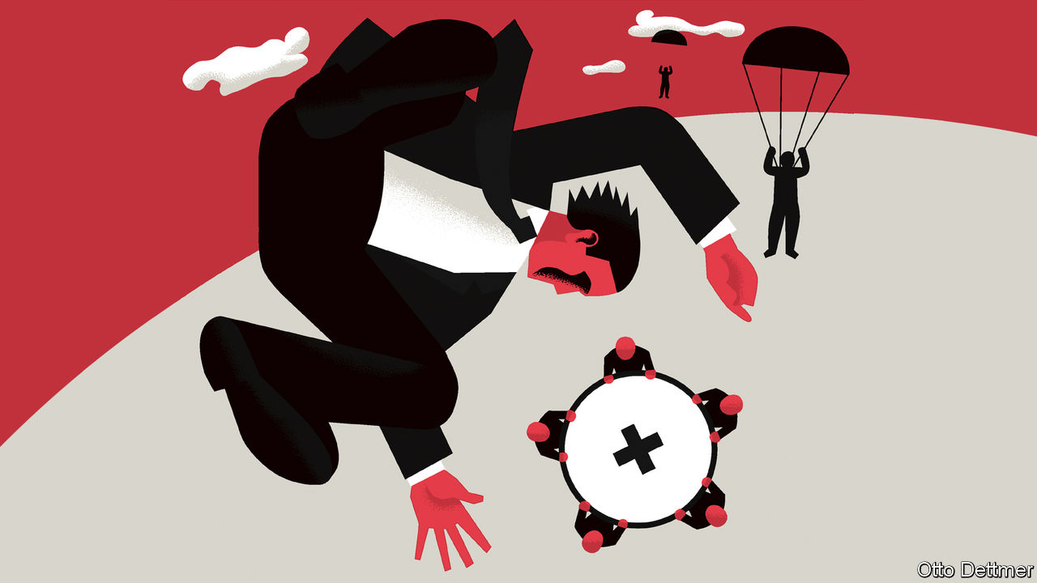

Editor’s note: The Economist is making some of its most important coverage of the covid-19 pandemic freely available to readers of The Economist Today, our daily newsletter. To receive it, register [here](https://www.economist.com/newslettersignup). For our coronavirus tracker and more coverage, see our [hub](https://www.economist.com/coronavirus)

COVID-19 CONFRONTS humanity with a host of testing moral decisions. When hospital capacity is limited, which patients should get access to life-saving equipment? For how long should virus-limiting restrictions on public activity remain in place, given the immense cost of such measures? To this list, some add another: how generous should public assistance to struggling households and firms be, when such aid could encourage the abuse of state-provided safety-nets? Worries like these, concerning what social scientists call moral hazard, have been relatively muted during the pandemic, and appropriately so. But hard questions about risk and responsibility cannot be put off for ever.

Moral hazard describes situations in which the costs of risky behaviour are not entirely borne by those responsible for that behaviour, so encouraging excessive risk-taking in the future. A fire-insurance policy, for example, might lead homeowners to behave more recklessly—say, by not changing the batteries in their smoke detectors—because the cost of any damage is partly covered by the insurer. Moral-hazard worries often arise during crises, when governments face pressure to save struggling institutions for the sake of the economy as a whole. Overly generous support for teetering banks might limit the short-term cost of a crisis but could lead to more risk-taking and worse crises in the future, if financiers bet that the government will save their skins again the next time. Walter Bagehot, a former editor of this newspaper, coined his famous rule for lenders of last resort—to lend freely against good collateral in times of crisis, but at a penalty rate—in an effort to balance these competing concerns.

Rarely has the scope for moral hazard seemed as massive as now. To slow the spread of covid-19, countries have shuttered much of their economies. And in order to prevent lost sales and jobs from translating into spikes in bankruptcies and poverty, governments have pumped huge amounts of aid to households and firms. Economists at the IMF reckon that governments across advanced economies could run fiscal deficits that, on average, exceed 10% of GDP in 2020. America’s deficit is projected to widen to as much as 15% of GDP. On top of direct spending measures, many countries have made available a vast amount of loans and loan guarantees. Rich countries have also extended assistance to others, by allowing some poor countries to delay their debt payments, for example.

Central banks, too, have acted. For the first time, America’s Federal Reserve is buying risky high-yielding debt and bonds issued by state and local governments. It has done so in order to prevent markets from seizing up and leading to cascading defaults and economic catastrophe. But its involvement in new markets could shift perceptions of risk in the future. Lending standards for some debt securities had already deteriorated in the years before the pandemic. The possibility of a standing Fed backstop could lead to far more borrowing on dubious terms. State governments facing long-term budget crunches may tackle those problems with less urgency in the expectation of Fed help, increasing the cost of any future default or bail-out. Robert Kaplan, president of the Federal Reserve Bank of Dallas, has expressed concern that the Fed’s extraordinary actions could let institutions that had borrowed recklessly before the pandemic off the hook. Similar worries have arisen in other contexts. A handful of Republican senators, for instance, have fretted that more generous unemployment-insurance payments could create a mob of workers eager to be laid off.

## Risky business

Economists, though, have been remarkably relaxed about the risks of moral hazard from pandemic-fighting measures, for a number of reasons. For a start, these policies shield people and institutions from the full costs of the pandemic by design. Without them, people and firms might try to get by as they normally do, spreading the virus and prolonging the outbreak. Timing matters, too. Preventing economic devastation and market panic as lockdowns were imposed required massive, urgent action. Interventions crafted to minimise moral hazard—by directing help to the most deserving individuals and firms, and closely monitoring their actions to detect and stop bad behaviour—would have distributed aid too slowly, and stingily, to avert catastrophic economic harm.

Moreover, moral-hazard worries apply to risks that may reasonably be reduced—by putting batteries in the smoke detector, say. Even the most prudent firm or household, though, would struggle to withstand a shock that deprives them of nearly all their income for months on end. Assistance in these times is less likely to distort future behaviour than are bail-outs during more mundane periods of hardship. Governments can claim that the help is a one-off, warranted by an unprecedented disaster.

Questions of moral hazard cannot be put off for ever, though. Some will become more pressing as the pandemic ebbs. Economies will need plenty of support to recover. Aid at that point will have to be crafted carefully in order to provide reasonable assistance while also establishing when special, pandemic-era rules no longer apply. If some guarantees or public assistance cannot be rolled back, new oversight and regulatory capacity might be needed to prevent bad behaviour.

In the years after the pandemic, even harder choices loom. Covid-19 may seem a uniquely devastating and global disaster. But the threat posed by climate change means that such extraordinary natural calamities might not be so infrequent. It might thus become harder for governments to credibly declare that aid provided during such disasters is a one-off, as is needed to discourage reckless behaviour and to stop dangerous risks from accumulating. Governments are right to help without hesitation now, but the years ahead will force societies to demand more personal, and collective, responsibility. ■

Dig deeper:  
For our latest coverage of the covid-19 pandemic, register for The Economist Today, our daily [newsletter](https://www.economist.com/newslettersignup), or visit our [coronavirus tracker and story hub](https://www.economist.com/coronavirus)

This article was downloaded by calibre from <https://www.economist.com/finance-and-economics/2020/04/25/how-to-think-about-moral-hazard-during-a-pandemic>

|  |  |  |  |
| --- | --- | --- | --- |
| Previous | Articles | Sections | Next |

|  |  |  |
| --- | --- | --- |
| Finance and ... | Sections | Science and ... |

Schools brief

Tackling climate change: The challenge without precedent

.

|  |  |  |
| --- | --- | --- |
| Finance and ... | Sections | Science and ... |

|  |  |  |  |
| --- | --- | --- | --- |
|  | Articles | Sections | Next |

#### The problematic politics of climate change

# Why tackling global warming is a challenge without precedent

The first of six weekly climate briefs looks at the history of efforts to limit greenhouse-gas emissions

Apr 23rd 2020 |



IN JUNE 1988 scientists, environmental activists and politicians gathered in Toronto for a “World Conference on the Changing Atmosphere”. The aspect of its changing that alarmed them most was the build-up of carbon dioxide, a greenhouse gas. In the late 1950s, when systematic monitoring of the atmosphere’s carbon-dioxide level began, it stood at around 315 parts per million (ppm). By that summer, it had reached 350ppm—and a heatwave was bringing record temperatures to much of North America.

The week before the Toronto conference James Hansen, a climate scientist at NASA, had pointed to the heatwave when telling the US Senate that it was time “to stop waffling…and say that the evidence is pretty strong that the greenhouse effect is here”. The Toronto conference took a similar view, calling for an international effort to reduce global carbon-dioxide emissions by 20% by 2005.

A mere four years later a global compact against climate change had been signed. Even with a boost from the end of the cold war, which made global action on shared concerns seem newly possible and provided an opening for a new eschatology to replace that of nuclear Armageddon, that seemed like a remarkable political success on the part of those pressing for action.

Unfortunately, a global agreement to act is not the same thing as global action. Fossil fuels are the bedrock of industrial society. Even though the alternative of renewable energy has, since 1988, become far more plausible, a decisive move away from fossil carbon still means a wrenching and unprecedented shift.

To many convinced environmentalists that shift seems self-evidently worthwhile. It fits with an ideology that commits them to lives that have less impact on the natural world. But in the face of climate change, individual willingness to sacrifice the fruits of a high-energy lifestyle is not enough. People, and countries, that do not share such motivations must act, too.

The challenge of climate politics is to overcome these differences by negotiating ways forward that can gain general assent. It is a challenge that, despite those remarkable four years, has not been met. Instead of emissions in 2005 being 20% lower than they were in 1988, they were 34% higher. By 2017 they were 22% higher still.

## Think global, act global

The Toronto attendees’ belief that an international agreement could bring down carbon-dioxide emissions rested in part on an agreement reached a year before to limit the production of ozone-destroying chemicals, most notable among them the chlorofluorocarbons (CFCs) used in fridges and spray-cans. That Montreal protocol looked like a template in two ways.

The first was that it was global. Since the 1960s the environmental movement had increasingly taken “saving the planet” as its rhetorical focus. But practical environmental protections, such as clean-air regulations, almost all worked on a national, or at most regional, basis. Because the world’s CFCs are thoroughly mixed together before they reach the stratosphere’s ozone layer, the Montreal protocol had to be genuinely global, and thus balance the needs of developed and developing countries.

The second was that the Montreal protocol required remarkable faith in science. Unlike most pollution controls, which try to reduce harm already being done, it called for expensive action to deal with a problem that, despite the dramatic discovery of the Antarctic ozone hole in 1985, was not yet hurting people. It was based instead on the likelihood of future catastrophe.

Climate scientists realised that an emissions-reduction agreement on greenhouse gases would need a similarly strong consensus on their dangers. This led to the creation in late 1988 of the Intergovernmental Panel on Climate Change (IPCC). Including researchers from governments, academia, industry and non-governmental organisations, the processes of the IPCC required governments to sign off on its conclusions, so reducing their ability to ignore them.

The IPCC’s first assessment of climate-change science, published in 1990, predicted that if greenhouse-gas emissions continued to rise unchecked, the world would warm by 0.2-0.5°C (0.4-0.9°F) every decade over the course of the 21st century, and that sea-level would rise 3-10cm a decade. Changes in the three decades since fit with the low end of both predictions.

Two years later, at an “Earth Summit” in Rio de Janeiro, the UN’s members agreed on a framework convention on climate change (UNFCCC) which committed them to the “stabilisation of greenhouse-gas concentrations…at a level that would prevent dangerous anthropogenic interference with the climate system”.

Despite the fact that such stabilisation implied impressive cuts in emissions, the treaty set no targets along the lines of Toronto’s 20% by 2005. They were to be worked out later. In years to come those negotiations on emission cuts came to dominate discussions between the parties to the treaty, sidelining the vital question of how to help countries, especially poor ones, adapt to the now inevitable changes. To talk of such adaptation was equated with capitulating on emission cuts.

Specific emission cuts were agreed upon five years after Rio, in Kyoto. They were not global in extent, applying only to developed countries, which were responsible for most of the emissions. They were not ambitious either. And the Kyoto protocol was never ratified by America, then the largest global emitter.

The UN imprimatur gave the UNFCCC universal legitimacy. But fashioning a treaty that all could accept had meant producing one with little practical power. The UNFCCC lacked any mechanism for making countries commit to ambitious action, let alone binding them to such commitments.

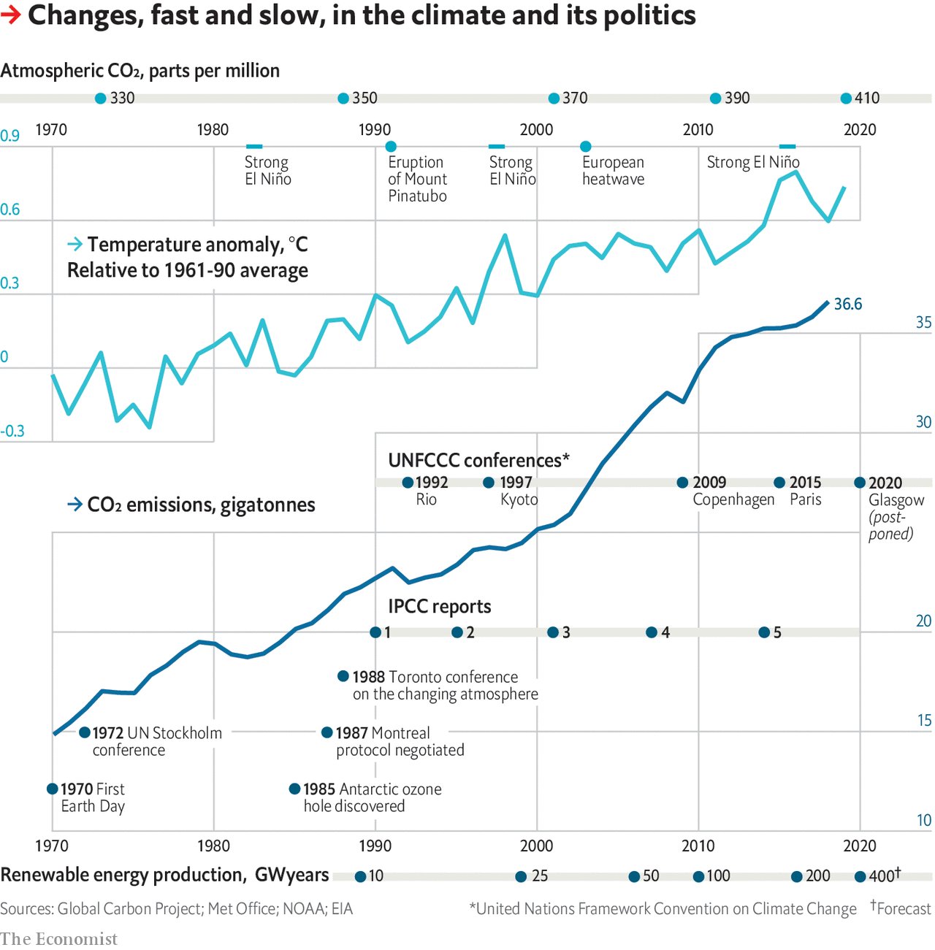

If all countries had shared an urgent interest in action, those shortcomings would not have mattered. But they did not. The costs of environmental improvements tend to fall on a few groups—typically, those doing the polluting. In domestic environmental politics, progress typically relies on going some way to placate those groups while increasing the enthusiasm for action among others and the public.

If emissions had been down to just a few companies, as with CFCs, or sectors of the economy, as with the smogs tackled by clean-air acts, such trade-offs might have been possible internationally. But fossil-fuel use permeated rich economies. Those countries knew the cost of reducing them could be severe—and that the benefits would accrue mostly to people in other countries and future times.

These difficulties were exacerbated by attempts to weaken public support for climate action. Fossil-fuel companies and their political allies, understood how important a scientific consensus on future damage was to the case for action. The result was a campaign to make the science look at best dubious, and at worst fraudulent, which went beyond noting that many environmental scientists were committed environmentalists and pointing out truly open questions (the wide range of the uncertainties in the first IPCC report has been slow to narrow). In doing so it helped produce an environment in which some right-wing politicians felt able to oppose all cuts to emissions, with notable successes in America and Australia.

## Future targets beat present action

Another source of resistance to emissions reduction was the rise of China. Its GDP, measured at purchasing-power parity and in real terms, increased sevenfold in the 20 years after Rio. Its carbon-dioxide emissions more than tripled, from 2.7bn to 9.6bn tonnes. China showed no real interest in curbing this world-changing sideeffect, and because it was a developing country it was not even notionally obliged to do so by the Kyoto protocol—despite the fact that, before that protocol was ten years old, China was a bigger emitter than America. Resentment over this was one of the reasons some developed countries became increasingly unhappy with their commitments. China’s unwillingness to offer real action contributed to the near collapse of attempts to move beyond Kyoto at the Copenhagen summit of 2009.

Six years after Copenhagen, though, the UN process made its biggest step forward since Rio: the Paris agreement. This, at last, set a specific global target. Atmospheric greenhouse-gas levels were to be stabilised by the second half of this century at a level that would see an increase of the average global temperature over its preindustrial level well below 2°C, with strenuous efforts made to keep it down to 1.5°C. All the countries, developed and developing, that signed were required to commit to domestic actions towards that aim.

There were several reasons for the success: prior talks between America and China; skilful French diplomacy; canny negotiation by developing countries. Perhaps the most important one, though, was that the cost of renewable energy was tumbling and investments in the field booming. Reducing emissions while continuing high-energy lifestyles felt newly possible.

Perhaps it will be. But the reductions the countries offered in Paris were too small to meet the 2°C target. That insufficiency has seen a new generation of climate activists demand greater ambition at the next big UNFCCC meeting, originally to be held this year in Glasgow but now postponed because of the covid-19 pandemic. There remains no way for them to force action on people and countries who do not share their passion and commitment. ■

This article was downloaded by calibre from <https://www.economist.com/schools-brief/2020/04/23/why-tackling-global-warming-is-a-challenge-without-precedent>

|  |  |  |  |
| --- | --- | --- | --- |
|  | Articles | Sections | Next |

|  |  |  |
| --- | --- | --- |
| Schools brief | Sections | Books and arts |

Science and technology

Covid-19: Tests of reason

.

Pandemics past and present: A lesson from history

.

|  |  |  |
| --- | --- | --- |
| Schools brief | Sections | Books and arts |

|  |  |  |  |
| --- | --- | --- | --- |
|  | Articles | Sections | Next |

#### Covid-19

# How to build and deploy testing systems at unprecedented scale

Countries will have to do it to end their lockdowns safely

Apr 23rd 2020 |

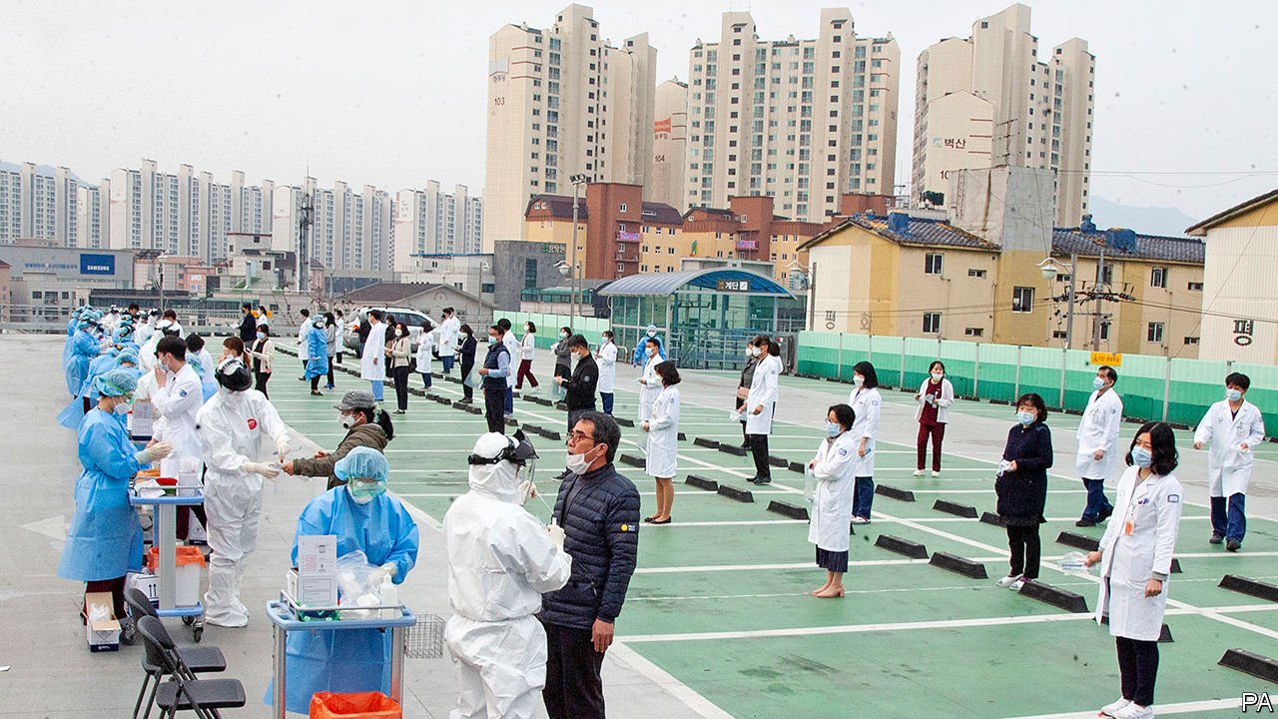

Editor’s note: The Economist is making some of its most important coverage of the covid-19 pandemic freely available to readers of The Economist Today, our daily newsletter. To receive it, register [here](https://www.economist.com/newslettersignup). For our coronavirus tracker and more coverage, see our [hub](https://www.economist.com/coronavirus)

SARS-CoV-2, the virus that causes covid-19, is an unobtrusive piece of biological machinery. It spreads parasitically through the respiratory tracts of human beings, often without provoking symptoms in those who carry it. Yet for some, particularly the old, it is deadly. This combination of properties make the pandemic both dangerous and difficult to stop. As of April 22nd it had killed 182,000 people.

So far, every country that has reduced covid-19 infection to low levels has relied to some degree on “social distancing”—that is, either encouraging or forcing people to stay at home, and to keep well apart if they find that they have to go out—to prevent the virus from spreading. On top of this many are in any case fearful to go out, lest they catch the illness. Without a vaccine or therapeutic drugs, neither of which is guaranteed, countries therefore face a future of bouncing in and out of lockdown every few months, with infection rates ebbing and flowing in response. The result will be mounting death tolls, depressed economies and confidence-sapping uncertainty. This can, however, be partly ameliorated by extensive testing for the virus. Testing enables the government to keep tabs on the disease, reveals which social-distancing measures work, and, if those testing positive remain at home, instils confidence in the public that it is safe to go out.

## Economies of scale

America is in a particularly tight spot. Parts of its government responded slowly to the pandemic to start with, and it now faces high levels of infection that are spread across the country. In response, a consensus is emerging among its scientists, economists and public-health officials that a massive increase in testing capacity—creating a system that can test millions of people a day for the virus—will be needed to get the place out of lockdown safely. A testing system of this kind has never been built before. It will be expensive, costing tens, possibly hundreds of billions of dollars in America alone. But it offers a way to return to something approaching normal life with a degree of confidence that the pandemic is under control.

The goal of this new testing regime would be to track down every carrier of the virus so that those at risk of spreading it could be isolated. The contacts of anyone who tested positive would be traced and tested as soon as possible, to cut off further chains of transmission. Trevor Bedford, who studies viruses and immunity at the Fred Hutchinson Cancer Research Centre in Seattle, has said that what is currently known about the virus suggests that the system must track down and isolate all of an infected person’s contacts within 48 hours of their positive test if the transmission chain is to be broken. If testing and tracing can do this, then people can go safely about their lives.

Currently, the test employed to find out if someone is infected looks for the virus itself using a technique called reverse transcription-polymerase chain reaction (RT-PCR). This starts by sticking a Q-tip-like swab deep into the nose or throat of the individual to be tested, to retrieve a sample of mucus that may or may not contain the virus. This sample is then run through a process (reverse transcription) that copies any fragments of viral RNA (the molecule in which SARS-Cov-2’s genes are written) into DNA, a chemical more easily handled by established testing methods. These first amplify the quantity of DNA present (the polymerase chain reaction), and then run it through a detector to find out what it is. Other tests, which look for antibodies produced when someone comes into contact with the virus, are being devised as well. These will also be able to find out who has been infected in the past.

The number of tests of all kinds that America needs in order to lift its lockdown safely is a matter of debate. Plans floated in recent weeks by various think-tanks have come up with vastly different figures. All are large. That by a working group at the Edmond J. Safra Centre for Ethics at Harvard University, published on April 20th, suggests America will need to test between 5m and 20m people per day, which is 2-6% of the population. Another, put forward on April 21st by experts convened by the Rockefeller Foundation, outlines ideas that could get America to 30m tests per week in eight months’ time.

## Ignition sequence start

That would not be easy. By the time this edition of The Economist is published, America will have carried out more than 4.5m SARS-CoV-2 tests since it began the process in February. Over the first two weeks of April, the average number of tests per day was around 1m a week. The country has struggled to get to even this level of testing, so expanding it ten or 100 times will be a big challenge.

The Rockefeller plan suggests current testing numbers in America can be tripled by bringing into the programme laboratory capacity that exists already, but which is not being used. That would involve identifying all American high-throughput laboratories that can be adapted for the task, sorting out the regulatory approvals they will need and stumping up the money.

Some states are already doing this. Those with big research universities, such as Massachusetts (home to Harvard and the Massachusetts Institute of Technology, MIT, among others), have an advantage here. The Broad Institute, a joint MIT-Harvard enterprise run by Eric Lander, one of the leaders of the Human Genome Project, has begun doing SARS-CoV-2 tests and might, when up to speed, be able to manage to do 1m of them a day. In other places commercial laboratories could be put to the task. In Wisconsin Exact Sciences, a firm that specialises in cancer tests, has rejigged a large part of its laboratory to process 20,000 covid-19 tests a week.

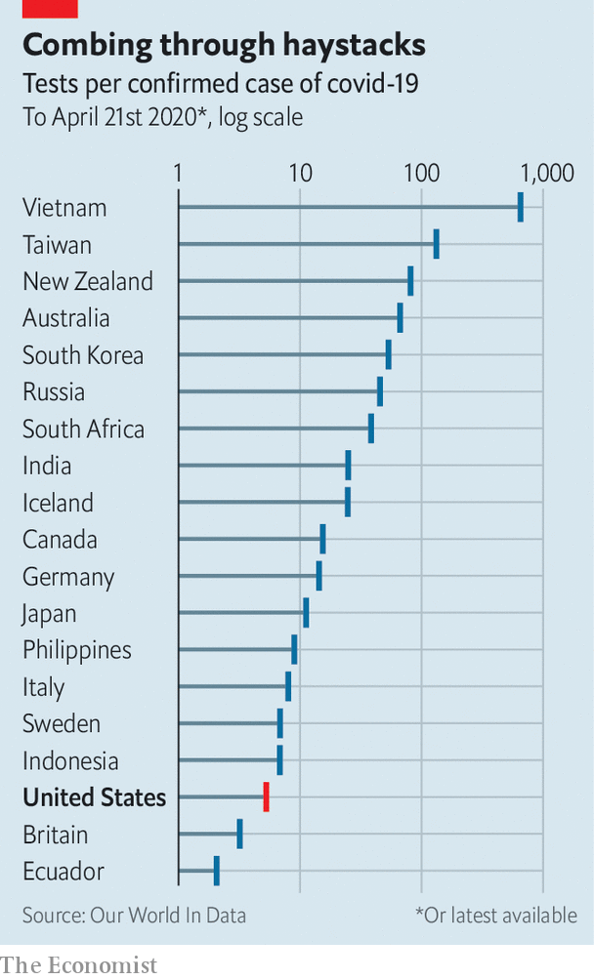

Making more use of so-called point-of-care machines would be another way to increase testing capacity. These small boxes are already used to test for viruses in thousands of hospitals and clinics around the world, and adapted versions have recently been introduced to detect SARS-CoV-2. Point-of-care machines can process throat swabs in around 15-30 minutes. Ramping up production of them would be useful in bringing testing capacity to, say, rural areas where collecting and returning throat swabs to a big central laboratory might take too long. The supply chains for electronics and reagents for these machines, however, rely heavily on China, and so building more of them now might not be easy.

The jump from 3m tests per week to 30m will need big, new labs on the scale of the Broad to be dotted around the country. Each of these would process hundreds of thousands of tests a day, using robotics and automation. Testing needs to become simpler, too. Collecting samples for RT-PCR tests is invasive, and the tests themselves are complicated. Scaling the process up to millions a day is an “impossible” mission according Severin Schwan, the boss of Roche, a Swiss pharmaceutical giant that makes point-of-care testing machines.

Other testing methods are possible, but as yet unproven. Scientists at Rutgers University in New Jersey recently demonstrated a way to look for signs of the virus in spit samples (which are easy to obtain) instead of throat swabs (which are notoriously difficult and uncomfortable to collect). On April 13th America’s Food and Drug Administration (FDA) granted spit tests an emergency-use authorisation. Generic spit kits that can be tweaked to do this are already widely available and can be transported to processing laboratories at ambient temperatures.

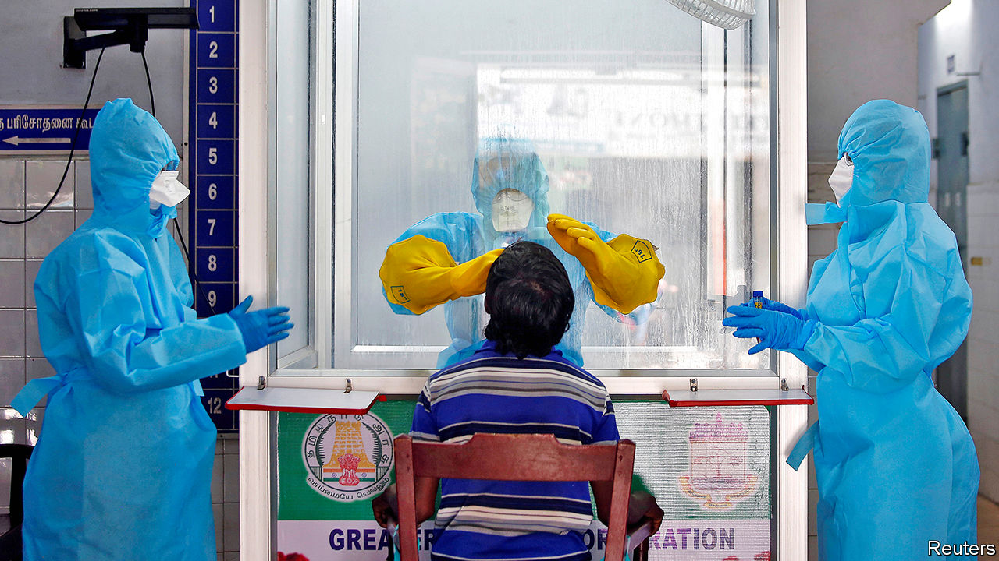

All this new testing infrastructure will require trained people to run it, says Scott Becker of America’s Association of Public Health Laboratories. Much of the handling of samples in laboratories is routine stuff, so people can be trained quickly to do it. But analysing the results needs highly trained experts—and in some states such people must be licensed, too. Those analysts who currently exist are already putting in extended shifts, says Mr Becker, and this cannot be sustained over a pandemic that will be “a long, long haul”.

Swabbing the noses or throats—or even collecting the spittle—of millions of people a day would also require a huge number of new hires. For now, teams from America’s National Guard have been helping with that in outbreak hotspots, such as some prisons, and at drive-through testing sites. And then there are the 300,000 contact-tracers that America would need, according to another group of experts who assessed that matter recently, to get in touch with those who have been in recent proximity to people who test positive. New contact-tracers can, however, be trained in a day, so lots of those who have suddenly found themselves without a job might be redeployed as such. San Francisco, for example, has put librarians to the task. The thousands of members of America’s Peace Corps who have had to return from duty abroad because of the pandemic might also usefully be deployed for this purpose.

The supply of reagents and components needed to run millions of tests a day must be secured, too. Until now, one of the main obstacles to their mass production has been the lack of a strong signal from the federal government that more are needed—though that changed on April 21st when Congress approved the spending of $25bn on testing. The two main suppliers of nasal swabs in America, Copan and Puritan, make just 6m a week between them. Roche says that it is currently capable of supplying “millions” of tests per month. That a firm like Roche is still thinking in terms of tests per month, rather than tests per day or per week, does, though, suggest there is a long road ahead.

Paul Romer, a professor at New York University and winner of the 2018 Nobel prize in economics, who also advised on the Rockefeller Foundation’s work, says that university laboratories have already shown they could get around supply issues in the ramping-up of testing. “If you look at reagent bottlenecks, people have found other reagents that they can swap out instead of the FDA-approved ones. They’ve shown you don’t even need to include the RNA extraction [from throat-swab samples] that requires these reagents.” Freeing universities and research institutions from red tape would be crucial, he believes, in ensuring any efficiencies and new discoveries that simplify or speed up testing are able to spread rapidly.

## Don’t stop me now

Scaling up testing infrastructure will also face regulatory hurdles. For example, swabs on their way to be tested are classified as a biohazard in the United States, and require special containers and shipping protocols. Building and managing such an unprecedented amount of testing capacity in such a short space of time will also need co-ordination. The Harvard group proposes the formation by the federal government of a Pandemic Testing Board to oversee these decisions. It would be composed of leaders from business, government and academia, among others, and would be given powers to oversee the construction of laboratory capacity and to ensure the supply and distribution of the materials needed to carry out the tests themselves.

The cost for all this? The Harvard group estimates around $15bn per month and that it would need to be in operation for a year or more, depending on when (and if) treatments and vaccines became available. That price tag may seem eye-watering, but lockdown costs far more. Estimates place the cost to America of the pandemic at up to $400bn a month. Given the alternative, building the largest medical-testing system the world has ever seen is a steal. ■

Dig deeper:  
For our latest coverage of the covid-19 pandemic, register for The Economist Today, our daily [newsletter](https://www.economist.com/newslettersignup), or visit our [coronavirus tracker and story hub](https://www.economist.com/coronavirus)

This article was downloaded by calibre from <https://www.economist.com/science-and-technology/2020/04/23/how-to-build-and-deploy-testing-systems-at-unprecedented-scale>

|  |  |  |  |
| --- | --- | --- | --- |
|  | Articles | Sections | Next |

|  |  |  |  |
| --- | --- | --- | --- |
| Previous | Articles | Sections | Next |

#### Pandemics past and present

# A peculiarity of Spanish flu may shed light on covid-19

Age-related mortality is not always what might be expected

Apr 25th 2020 |

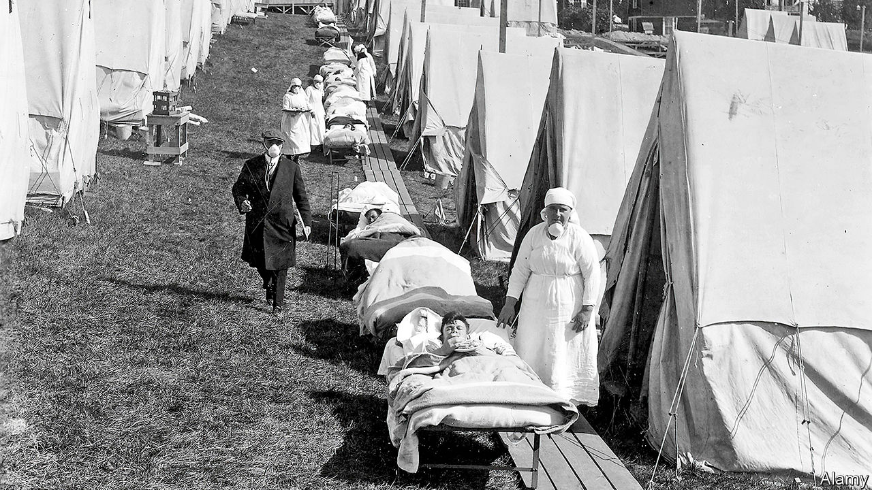

Editor’s note: The Economist is making some of its most important coverage of the covid-19 pandemic freely available to readers of The Economist Today, our daily newsletter. To receive it, register [here](https://www.economist.com/newslettersignup). For our coronavirus tracker and more coverage, see our [hub](https://www.economist.com/coronavirus)

IT IS NOW well established that developing the symptoms of covid-19 when you are old is extremely dangerous, but not so risky when you are young. That might seem unremarkable. Old people are less resilient, and more likely to have specific confounding health problems like diabetes. However, this pattern—that the young live through infection while the old die—is by no means the norm. The influenza outbreak of 1918-19, known (unfairly to Spaniards) as the “Spanish” flu, for example, proved particularly harmful to those aged between 20 and 40, and thus apparently in their prime. Some suspect that fact may cast light on the, albeit different, age-related susceptibility to covid-19.

One suggestion to explain what happened in 1918 is that those older than 40 tended to survive because they had acquired protective immunity from an earlier round of influenza to which younger generations had not been exposed. A second is that the more potent immune systems of the young overreacted to the 1918 virus for some reason, and that this triggered in them a cataclysmic, frequently fatal, immune response known as a cytokine storm. (Cytokine storms, as it happens, are sometimes a cause of death in cases of covid-19.)

Alain Gagnon, a demographer at the University of Montreal, in Canada, has been studying the matter for several years. It was he who spotted, in 2013, that within the two-decade cohort of susceptible individuals in 1918 there was a particular spike in mortality among those exactly 28 years old. Even members of the cohort younger or older than this did considerably better.

Working with a team of immunologists, microbiologists and infectious-disease experts, Dr Gagnon pointed out that cytokine storms were unlikely to be solely responsible for this spike, since the immune systems of 28-year-olds are just as likely to overreact in such a manner as those of 20-year-olds. He also argued that the notion of older generations having developed immunity through exposure to earlier viruses does not hold up, since this, too, would have left those under 28 just as vulnerable as 28-year-olds.

Instead of these ideas Dr Gagnon and his colleagues support an alternative hypothesis, developed by Dennis Shanks of the Australian Army Malaria Institute, in Queensland, and John Brundage of the Armed Forces Health Surveillance Centre, in Maryland. This is that, in some circumstances, early exposure to a virus can harm subsequent immune responses rather than helping them.

## Learning the wrong lesson

Dr Shanks and Dr Brundage observed that in 1890, the birth year of those who were 28 in 1918, a different and less lethal strain of influenza, known as Russian flu, spread around the world. They also knew from experiments on pigs, conducted by others, that exposure to one virus during early life has the potential to make infections of other, quite different, viruses later on much more severe than they otherwise would have been. Based on these observations they argued that the immune systems of those exposed to Russian flu as newborn babies—a period of life when immune systems are especially attuned to learning about which pathogens are circulating—learnt about Russian flu all too well. As a consequence, when faced 28 years later with Spanish flu viruses they mounted the wrong response (ie, to Russian flu rather than to the real threat).

Nor is the example of 1918 unique. According to Dr Gagnon, people who were themselves born during that epidemic showed increased vulnerability to the Hong Kong flu of 1968. And those born during the Asian flu of 1957 showed higher mortality in the face of swine flu in 2009. He therefore wonders if something similar is going on now, with elderly people mounting inappropriate immune responses that reflect the infections of their youth. Since all of his examples relate to influenza viruses, which are different beasts from coronaviruses, this is speculation. But it is a line of inquiry that might be worth following once the immediate crisis is over.■

Dig deeper:  
For our latest coverage of the covid-19 pandemic, register for The Economist Today, our daily [newsletter](https://www.economist.com/newslettersignup), or visit our [coronavirus tracker and story hub](https://www.economist.com/coronavirus)

This article was downloaded by calibre from <https://www.economist.com/science-and-technology/2020/04/25/a-peculiarity-of-spanish-flu-may-shed-light-on-covid-19>

|  |  |  |  |
| --- | --- | --- | --- |
| Previous | Articles | Sections | Next |

|  |  |  |
| --- | --- | --- |
| Science and ... | Sections | Economic and ... |

Books and arts

The solace of Tolstoy: Unhappy in the same way

.

Power in Russia: Made men

.

Coffee and capitalism: The big grind

.

Dutch fiction: Cold comfort farm

.

Home Entertainment: “The Shining” is perfect quarantine viewing

.

Home Entertainment: Try painting in watercolours

.

Perspectives: How previous contagions changed cities

.

|  |  |  |
| --- | --- | --- |
| Science and ... | Sections | Economic and ... |

|  |  |  |  |
| --- | --- | --- | --- |
|  | Articles | Sections | Next |

#### Unhappy in the same way

# Readers across the world are finding solace in “War and Peace”

The rhythm of the epic novel is eerily suited to life in lockdown

Apr 25th 2020 | SAN FRANCISCO AND TWITTER

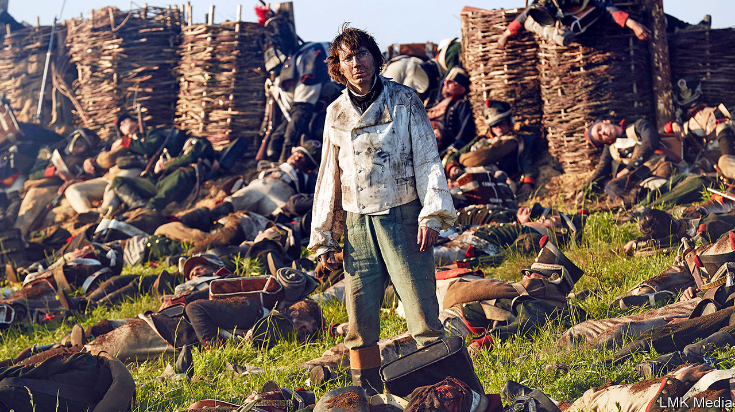

Editor’s note: The Economist is making some of its most important coverage of the covid-19 pandemic freely available to readers of The Economist Today, our daily newsletter. To receive it, register [here](https://www.economist.com/newslettersignup). For our coronavirus tracker and more coverage, see our [hub](https://www.economist.com/coronavirus)

OVER THE past 15 years Yiyun Li, a Chinese-American author, has read “War and Peace” at least a dozen times. Her hardback copy of Leo Tolstoy’s 1,200-page saga bristles with coloured notes, like some exotic lizard’s spine. The novel is not just a masterclass in fiction, Ms Li believes, but a remedy for distress. At the most difficult times in her life, she says, she has turned to it again and again, reassured by its “solidity” in the face of uncertainty.

“War and Peace”—originally titled “The Year 1805”—is widely considered the world’s greatest novel. It is also among the most daunting, acknowledged Richard Pevear, one of its translators, “as vast as Russia itself”. Its huge canvas encompasses not just Napoleon’s wars against the Russian and Austro-Hungarian empires from 1805 to 1812, but a cast whose actions and emotions span the breadth of human consciousness. As James Wood, a literary critic, has noted, Tolstoy is the supreme novelist of human contradiction. His epic is an unparalleled examination of how people respond to the pressures of both war and ordinary life.

So large is Tolstoy’s world, Ms Li reckoned, that there could be no better companion for people trapped in isolation. She conceived of a virtual book club to sustain readers through the lockdown. Participants around the globe would plough through this doorstopper together and share their thoughts on social media. With Brigid Hughes of “A Public Space”, a literary review based in Brooklyn, she christened the project #TolstoyTogether. It would be an anchor in unsettling times. To their amazement, when it began in mid-March 3,000 people on six continents signed up.

Other book clubs have sprung up to discuss great literature during the pandemic. Some are reading Boccaccio’s “Decameron”, a story cycle set amid the Black Death; others, “The Plague”, an allegorical tale by Albert Camus. But Tolstoy’s novel reflects the atmosphere of life in quarantine better, if more obliquely. Its alternating structure, toggling between battlefields and the salons of Russian high society, mirrors the disorienting split in readers’ own attention—between their own personal, stilled states and the calamity unfolding outside. Those who have begun the book before might have skimmed the war sections; now they seize the foreground, the main and awful action which, like the news from Wuhan, Bergamo and New York, overshadows the drawing-room intrigues.

Parallels with today’s crisis are inescapable. On the very first page, Anna Pavlovna, a St Petersburg hostess, comes down with “la grippe”—a flu—but holds her soirée nonetheless. Amid talk of Napoleon and war, she exclaims: “Can one be calm in times like these if one has any feeling?” Pauline Holdsworth, a reader in Toronto, shared the quote on Twitter, noting drily that it cut “a bit close to the bone”.

The rhythm of the readathon, too, is analogous to the woozy movement of epidemic time. At a prescribed 30 minutes a day (some 12 to 15 pages), readers move at a peculiar, slowed pace through battles and duels, deaths and marriage proposals and balls. If, as Ms Li claims, the book “contains everything about life”, it also mimics the temporal experience of real lives. There are none of the leaps and flashbacks that many modern novelists go in for. “Everything just goes on,” she explains, “time just goes on, exactly like how we live.” She has planned the readings to last for three months. And though the endpoint of the fictional action may be distant, it is still somehow plausible, like the eventual lifting of the lockdown.

Most strikingly, readers have instantly recognised themselves in the seesawing emotions that course through all Tolstoy’s characters. None is ever really stable: Prince Andrei Bolkonsky swings abruptly between arrogance and euphoria; Pierre Bezukhov is forever thinking one thing and saying another; young Nikolai Rostov, enamoured of the tsar, is eager to die, then bolts away like a terrified hare.

“The amplified extremities of emotion during extreme times,” tweeted Kristin Boldon, a reader in Minneapolis. “I can relate.” Tolstoy’s genius is to capture these confused internal battles, which are never more evident than amid the cabin fever of quarantine—the oscillating closeness and exasperation with loved ones, claustrophobia jostling with odd hints of liberation. “He shows us we can be many things at once,” says Ms Hughes, who compiles the observations of Ms Li and others into a weekly newsletter. People are always complicated, Tolstoy insists; all must constantly find new footing in a shifting world.

## Borodino to Bergamo

As great art can, the novel is helping its readers adjust to their own uncertain reality. As George Saunders, another American novelist, puts it, Tolstoy observes humankind “the way God sees us”, with empathy and forgiveness, implicitly encouraging readers to view themselves with the same generosity. The book club itself embodies the common humanity that the coronavirus has pointed up: a paradoxically rich connection with strangers who are widely dispersed yet linked by their predicaments and imaginations.

Whether listening to an audiobook while walking or curling up at the end of an exhausting homeschooling day, thousands of isolated souls are on the same page (as a side-benefit, struggling bookshops have seen a welcome run on the novel). The readers are an entertaining, highly literate bunch, weighing in every day with erudite analyses and favourite quotes. There are line-by-line comparisons of different translations, and revelations about Tolstoy and his miserable marriage to Sofia, who while bearing and bringing up several children edited the manuscript seven times. There are selfies with the book, photos of pets with the book, a bowl of borscht with the book, links to films and paintings and poems, even a Tolstoy tattoo featuring the comet of 1812. It is not too late to start: there are still hundreds of pages to go.

Art imitates life and life responds in kind. One reader tweeted the famous chart made by Charles Minard of Napoleon’s losses in his campaign of 1812—the same chart to which, a day later, a critical-care doctor in New York referred to illustrate the winnowing of hospital supplies as the pandemic struck. Another reader shared a line from a letter that Vasily Grossman, sometimes called “the Soviet Tolstoy”, wrote to his daughter from the battle of Stalingrad. “Bombers. Shelling. Hellish thunder,” Grossman reported. “It’s impossible to read anything except ‘War and Peace’.” ■

Dig deeper:  
For our latest coverage of the covid-19 pandemic, register for The Economist Today, our daily [newsletter](https://www.economist.com/newslettersignup), or visit our [coronavirus tracker and story hub](https://www.economist.com/coronavirus)

This article was downloaded by calibre from <https://www.economist.com/books-and-arts/2020/04/25/readers-across-the-world-are-finding-solace-in-war-and-peace>

|  |  |  |  |
| --- | --- | --- | --- |
|  | Articles | Sections | Next |

|  |  |  |  |
| --- | --- | --- | --- |
| Previous | Articles | Sections | Next |

#### Made men

# The enduring grip of the men—and mindset—of the KGB

A meticulous account of Vladimir Putin’s consolidation of power in Russia

Apr 23rd 2020 |

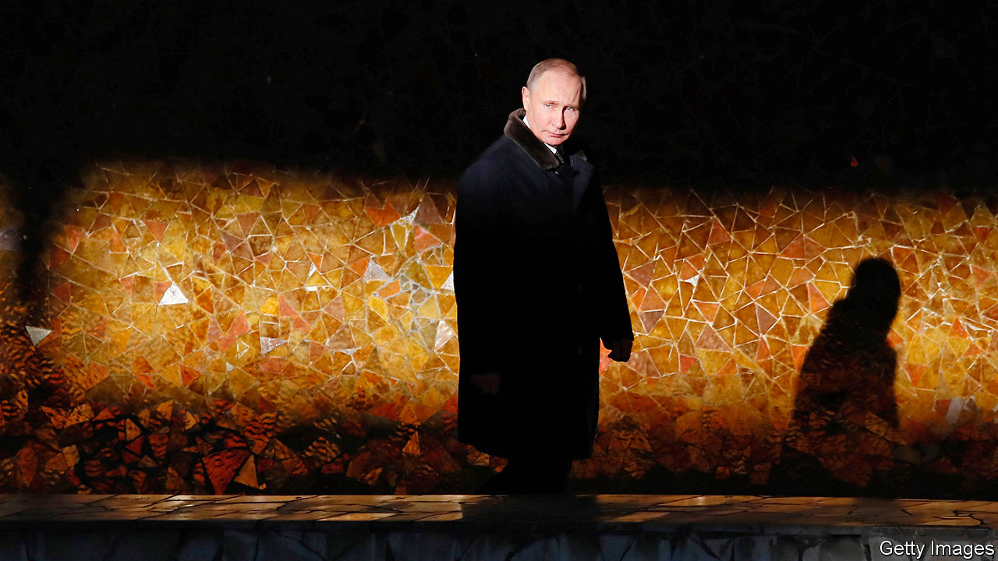

Putin’s People. By Catherine Belton. Farrar, Straus and Giroux; 640 pages; $35. William Collins; £21.99.

WHEN A BEDRAGGLED Russian phoenix emerged from the Soviet ashes, Western pundits were divided. Would the new creature sink into chaos, as often seemed inevitable; or, with Western help, would it resurface as a diminished but coherent state? A decade later, when an energetic Vladimir Putin succeeded an ailing Boris Yeltsin, Russia-watchers were seduced by a different false binary. Some thought Mr Putin would press on with creating a law-based, outward-looking market system. Others expected corruption and criminality to keep Russia poor and weak.

Such debates often say more about the biases of futurologists than about the future. As Catherine Belton’s powerful and meticulously reported new book shows, the apparent anarchy of the post-Soviet world has instead given way to a massive concentration of wealth and power, which is used by the new Russian elite to quash dissent at home and project force abroad.

Her subtitle is blunt and revealing: “How the KGB Took Back Russia and then Took on the West.” It also raises questions. For starters, what exactly is the KGB? Literally the “Committee for State Security”, one of the two pillars (with the Communist Party) of the Soviet state, whose successor agencies, above all the FSB, which focuses on domestic security, have been ever more dominant. More broadly, Russia’s intelligence community includes military espionage—and shadowy individuals who have grown rich through their proximity to this spooky world.

But as Ms Belton shows, the continuity between the Soviet agency that nurtured Mr Putin as a young officer, and the security-based behemoths that bestride today’s Russia lies less in institutions than in mentality. It is a mindset that believes anybody can be turned; that advantage can be sought in any situation, including anarchy; and that collaboration on ever-shifting terms is possible with any partner, from organised crime to Christian clergy.

Drawing on many interviews and diligent perusal of documents, Ms Belton, formerly a Moscow correspondent for the Financial Times, traces the links between Mr Putin’s formation in the KGB world, his early career as a cold warrior in East Germany and his increasingly open confrontation with the West. Instead of exhorting Russia to take its liberal medicine, many Westerners now worry about protecting their own politics from Russian subversion.

The book charts the milestones of this process, including the string of lethal bombings that coincided with Mr Putin’s ascent in 1999; later acts of terror in the Caucasus and Moscow; the crash of 2008 that hit Russia hard; Mr Putin’s re-election in 2012; and the intervention in Ukraine in 2014 and ensuing sanctions. In a narrative tour de force, Ms Belton explains how these developments affected the Russian elite. The pivotal event, she thinks, was the downfall in 2003 of Mikhail Khodorkovsky, boss of the Yukos oil company. She recounts his trial, and the appropriation of his assets, with passionate precision.

As she shows, Russia’s masters covered these seizures in a cloak of legal procedure which, in its sheer complexity, helped transform the Russian judiciary into an organ of the superstate. Those masters also thought (rightly) that Western objections could be parried by offering investors some nuggets from the energy giant they were creating. Indeed, all the current or former insiders in this book assume that, beneath a thin layer of democratic bluster, Western elites are biddable and buyable.

For all her insights into ruthless minds, Ms Belton does at least raise the possibility that some of those who surrounded Mr Putin in his early years in office sincerely believed in something: that the capitalist model of the 1990s had conceded too much to a hostile West. One who stands out is Sergei Pugachev, a businessman and erstwhile adviser, who claims credit for guiding the switch to state capitalism with a nationalist tinge. He fell foul of the authorities after 2012 but makes no apology for his previous role. Only his efforts to turn Mr Putin into a sincere Christian were a waste of breath, he tellingly concludes. ■

This article was downloaded by calibre from <https://www.economist.com/books-and-arts/2020/04/23/the-enduring-grip-of-the-men-and-mindset-of-the-kgb>

|  |  |  |  |
| --- | --- | --- | --- |
| Previous | Articles | Sections | Next |

|  |  |  |  |
| --- | --- | --- | --- |
| Previous | Articles | Sections | Next |

#### The big grind

# The story of coffee is a parable of global capitalism

In “Coffeeland”, Augustine Sedgewick focuses on a single plantation in El Salvador

Apr 23rd 2020 |

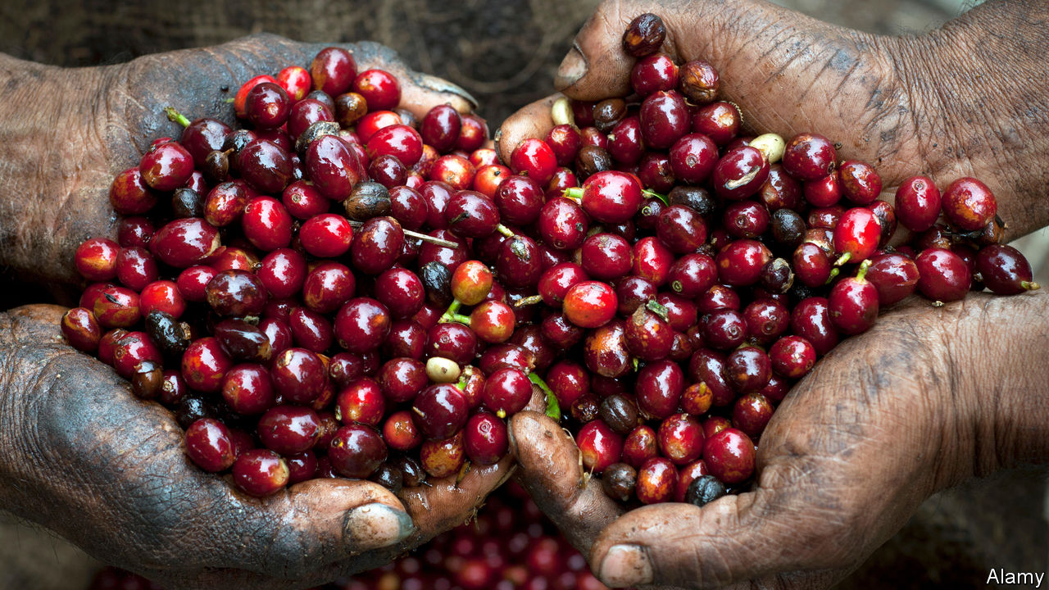

Coffeeland. By Augustine Sedgewick.Penguin; 444 pages; $30 and £25.

WHAT BEGAN as an obscure berry from the highlands of Ethiopia is now, five centuries later, a ubiquitous global necessity. Coffee has changed the world along the way. A “wakefull and civill drink”, its pep as a stimulant awoke Europe from an alcoholic stupor and “improved useful knowledge very much”, as a 17th-century observer put it, helping fuel the ensuing scientific and financial revolutions. Coffeehouses, an idea that travelled with the refreshment from the Arab world, became information exchanges and centres of collaboration; coffee remains the default drink of personal networking to this day.

The focus of Augustine Sedgewick’s book is not coffee’s effect on drinkers but its role in the story of global capitalism, as a commodity that links producers in poor countries with consumers in rich ones. Coffee does more than merely reflect this divide, he argues—it has played a central role in shaping it. It is, he notes, “the commodity we use more than any other to think about how the world economy works and what to do about it”.

To illuminate this history, and the web of connections between workers on plantations and coffee-sipping consumers, Mr Sedgewick focuses on a single planter in one country: James Hill, a British emigrant who by the 1920s had established himself as “the coffee king of El Salvador”. By telling the story of El Salvador’s emergence as the world’s most intensive coffee economy, and following coffee beans from Hill’s plantation to American consumers’ cups, Mr Sedgewick painstakingly shows how shifts in the global coffee market have affected conditions for workers on the ground. The result is a portrait of the political and economic consequences of the world’s addiction to coffee.

He tucks many fascinating details into his narrative. Contrary to popular belief, for example, it was not the Boston Tea Party that led to tea’s dethronement as America’s favourite hot drink: it was the abolition of tariffs on coffee imports in the early 19th century, as the United States sought to build trade ties and buy influence across Latin America. Imports doubled every decade between 1800 and 1850; during the civil war the average Union soldier consumed five cups of coffee a day. By the turn of the 20th century consumption per person in America was roughly double the level in France and ten times that in Italy. Most of this coffee came from Latin America.

A secondary theme is the relationship between food and labour, and the effort to measure human food consumption and energy output. Hill applied ideas from industrial Manchester, the city of his birth, to wring as much work as possible from his team. By paying mostly in food, and removing all other sources of it (such as wild fruit trees), he could manipulate the degree of hunger among local workers, and thus the availability of labour. The resulting coffee was then used to optimise the efficiency of workers in America, as bosses realised that formal coffee breaks improved productivity. Both coffee producers and consumers, Mr Sedgewick scathingly implies, are mere cogs in the remorseless machinery of global capitalism.

After all this readers might expect his conclusion to be a ringing endorsement of the “fair trade” model (coffee is by far the leading fair-trade product), which adds a small premium to the price of certified coffees to fund projects to improve workers’ welfare. In fact, Mr Sedgewick thinks the arguments over fair trade obscure a more fundamental issue, which is the lack of other opportunities in places where the local economy is dominated by coffee. In El Salvador’s “dictatorship of coffee”, where coffee planters enjoyed a virtual monopoly on politics, the only alternatives were migration or revolution, leading to decades of strife during the 20th century that pitted coffee growers against their overlords.

Artfully blending together all these strands, and juggling a wide cast of characters, Mr Sedgewick’s book is a parable of how a commodity can link producers, consumers, markets and politics in unexpected ways. Like the drink it describes, it is an eye-opening, stimulating brew. ■

This article was downloaded by calibre from <https://www.economist.com/books-and-arts/2020/04/23/the-story-of-coffee-is-a-parable-of-global-capitalism>

|  |  |  |  |
| --- | --- | --- | --- |
| Previous | Articles | Sections | Next |

|  |  |  |  |
| --- | --- | --- | --- |
| Previous | Articles | Sections | Next |

#### Cold comfort farm

# A prizewinning poet’s haunting debut novel

In “The Discomfort of Evening”, a Dutch farming family is struck by tragedy

Apr 23rd 2020 |

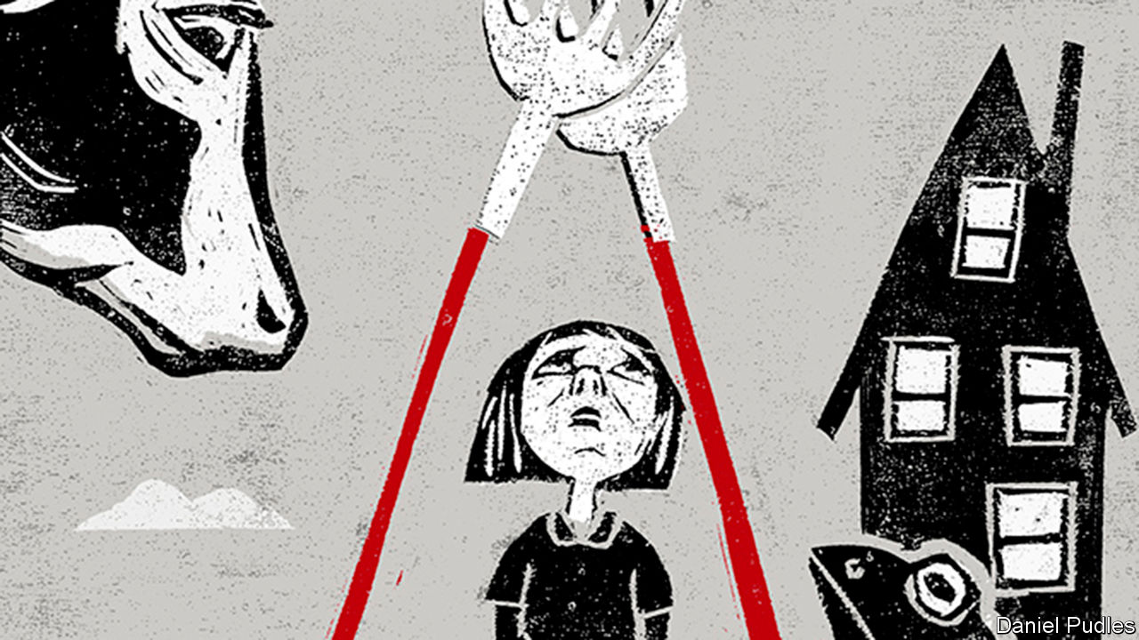

The Discomfort of Evening. By Marieke Lucas Rijneveld. Translated by Michele Hutchison. Faber & Faber; 296 pages; £12.99. To be published in America by Graywolf Press in September; $16.

THE 29-YEAR-OLD author of this impressive Dutch debut, Marieke Lucas Rijneveld, grew up on a dairy farm in North Brabant. Cows, in this telling, are sensitive creatures; sick cows are the sweetest kind. “You could stroke them gently without them suddenly kicking back at you.” The meagre comfort in “The Discomfort of Evening” comes from these beasts; the humans in this searing novel, shortlisted for the International Booker prize, are too numb with pain to be able to console anyone.

Ten-year-old Jas, the narrator, and her devout family live on a small farm in rural Holland. Theirs is a stern God rather than a loving one. When the family vet arrives at the homestead just before Christmas to report that Jas’s oldest brother has drowned, having fallen through the ice on a skating trip, Jas’s mother believes God is punishing her for being a bad parent. The Christmas tree is taken down, the decorations put away. The adults turn inward; the children face their grief on their own. “We are growing up with the Word, but words are lacking more and more frequently at the farm.”

Jas and her two surviving siblings embark on a series of rituals to try to hold the family together. She keeps two toads in a pail, hoping that if the animals can somehow be induced to mate, her parents will love one another again. After the farm is overwhelmed by foot-and-mouth disease, though, and the family herd has to be destroyed, the story takes an even darker turn.

The author, a prizewinning poet, is deft with words. “Kissing with tongues”, the narrator reflects, “always makes me think of those slimy, purplish-red cooking pears that Mum makes.” Out in the farmyard, “Two forks lie with their teeth through each other…like hands praying.” It is the strange, haunting observations through which the child, Jas, tries to make sense of the grown-up world that give this novel of grief its particular power. A book to read—and to remember.

This article was downloaded by calibre from <https://www.economist.com/books-and-arts/2020/04/23/a-prizewinning-poets-haunting-debut-novel>

|  |  |  |  |
| --- | --- | --- | --- |
| Previous | Articles | Sections | Next |

|  |  |  |  |
| --- | --- | --- | --- |
| Previous | Articles | Sections | Next |

#### Home Entertainment

# “The Shining” is perfect quarantine viewing

Not least because you will never work out what it means

Apr 25th 2020 |

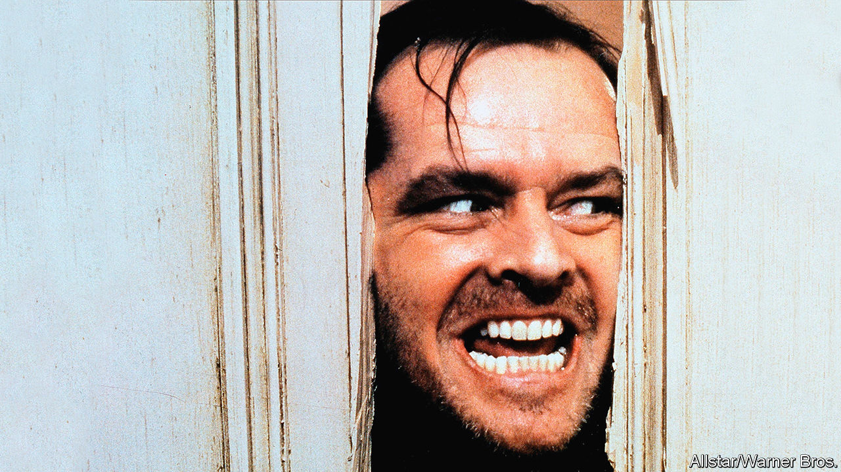

Editor’s note: The Economist is making some of its most important coverage of the covid-19 pandemic freely available to readers of The Economist Today, our daily newsletter. To receive it, register [here](https://www.economist.com/newslettersignup). For our coronavirus tracker and more coverage, see our [hub](https://www.economist.com/coronavirus)

IN STANLEY KUBRICK’S horror classic, “The Shining”, Jack Torrance (Jack Nicholson) is hired as the winter caretaker of the cavernous Overlook Hotel, miles from anywhere in the Colorado Rockies. “Physically it’s not a very demanding job,” the manager tells him before the start of what is supposed to be a five-month stint. “The only thing that can get a bit trying up here during the winter is a tremendous sense of isolation.” Adapted from Stephen King’s bestseller, “The Shining” was released 40 years ago in May, but it is spookily relevant to the world’s predicament today.

Jack dismisses the manager’s warning. When he is left alone in the Overlook with his wife, Wendy (Shelley Duvall), and their son, Danny (Danny Lloyd), he is elated: he plans to knock out a novel in the peace and quiet. But like so many people who imagine that they will tick off a long-postponed project or two during the lockdown, Jack is mistaken. As far removed as “The Shining” is from Kubrick’s philosophical science-fiction masterpiece, “2001: A Space Odyssey”, the message of both films is that if three people are stuck in a confined space in the middle of nowhere, one of them will go mad and try to murder the others.

In 1980 “The Shining” was not as well received as “2001” had been in 1968; Mr King himself was unimpressed. But the film’s reputation improved with age. You need not have seen it to be aware of its brightly nightmarish images: the phantom sisters in blue dresses; the tidal wave of blood gushing from the lifts. The carpet pattern of red, orange and brown hexagons was reproduced in the foyer of the Design Museum in London for its Kubrick retrospective last year. No other floor covering in cinema history is so recognisable.

Famous imagery aside, the film is revered now for the same reason it was initially criticised: it refuses to spell out its themes or explain its plot twists. Is Danny summoning ghosts with his psychic powers? Is Jack insane before he comes to the Overlook? Is he the reincarnation of someone who was there 60 years earlier? And how come the vast hotel stays so gleamingly clean when nobody ever dusts?

Kubrick is known as an obsessive perfectionist, and so some fans believe that he answers all those questions and more in the movie—it is just that they can’t agree on what the answers are. A documentary released in 2012, “Room 237”, compiles some of the more imaginative interpretations, from the plausible (it’s about the slaughter of Native Americans) to the eyebrow-raising (it’s a cryptic confession that Kubrick faked the Apollo Moon landings).

That is why “The Shining” is ideal viewing now. Not only is the Torrances’ tremendous sense of isolation a gothic caricature of the lockdown, but you can watch the film again and again without ever working out what it all means. ■

Dig deeper:  
For our latest coverage of the covid-19 pandemic, register for The Economist Today, our daily [newsletter](https://www.economist.com/newslettersignup), or visit our [coronavirus tracker and story hub](https://www.economist.com/coronavirus)

This article was downloaded by calibre from <https://www.economist.com/books-and-arts/2020/04/25/the-shining-is-perfect-quarantine-viewing>

|  |  |  |  |
| --- | --- | --- | --- |
| Previous | Articles | Sections | Next |

|  |  |  |  |
| --- | --- | --- | --- |
| Previous | Articles | Sections | Next |

#### Home Entertainment

# Try painting in watercolours

Above all a technique for the open air, it can be done just as well from a window

Apr 23rd 2020 |



TO THOSE WHO spend their days working with pens and keyboards, a watercolour paintbrush can induce a faint anxiety. Its very lightness and delicacy suggests that great skill is needed to deploy it. Names of the master watercolourists rise troublingly to mind: Cotman for his wooded hills, Ravilious for his cliffscapes, Audubon for his birds. The amateur who merely wants to while away long hours can easily feel inadequate to the task. No matter, for even the attempt to paint in watercolour brings many rewards.

They begin with the pleasure of the materials themselves. The brush, of sable, which immediately conjures up some semi-mythical creature of the Russian forests. The cartridge paper, snowy, heavy and very slightly rough, better to hold the paint. A glass jar of water, quietly attendant. And then the paintbox. Possibly this is new, with the stout little colour-blocks lining up untouched, full of possibility. Or it may be old, full of histories of past outings: the viridian and cobalt blue deep-worn and depleted, the unloved cadmium red only a little dimpled, the inside lid a riot of try-outs for this exact shade, or that.

Watercolour often seems the poor cousin of more imposing oils. It can appear too fleeting and insubstantial or, alternatively, too flat and bright. But to paint in watercolour, even clumsily, is to find that it has two great virtues. On the one hand, being so quick to apply, it can catch the briefest passing effects of light, or water, or leaves. It has a transparency that glows even when dabbed on by not-very-expert hands. A small pad of cartridge paper can act as a notebook or a camera; a few strokes can record, with real force, one particular morning or the play of sunshine in one particular tree. And though it is above all a technique for the open air, it can be done just as well from a window.

In a state of social isolation, however, it is watercolour painting’s second virtue that comes into its own. When applied to a subject that is still, rather than constantly shifting—an apple, a cup, a stone—it becomes a deeply meditative practice. To describe a flower or a shell in words often fails, merely skating the surface. To try to paint it is to engage on an altogether different level: to look at structure and texture, to note the subtleties of colour and the effects of passing time, to feel its weight or weightlessness; to understand it. Gerard Manley Hopkins, a would-be painter as well as a poet, wrote of finding the inscape, the thisness of things. To focus on that is to begin to touch the heart of creation.

In this meditation the brush slows, and becomes careful. Colours and mixtures silently suggest themselves. Surplus paint curls down beautifully through the water. You do not need to be painstakingly accurate; too much care can kill the life and motion that dwell even in inanimate things. What matters is to look as a painter does, contemplatively, fully. You may well still feel you are no good at it, and you might tear up your effort afterwards, but almost certainly you will find that even failure is not a waste of time. ■

This article was downloaded by calibre from <https://www.economist.com/books-and-arts/2020/04/23/try-painting-in-watercolours>

|  |  |  |  |
| --- | --- | --- | --- |
| Previous | Articles | Sections | Next |

|  |  |  |  |
| --- | --- | --- | --- |
| Previous | Articles | Sections | Next |

#### Perspectives

# Covid-19 might not alter cities as much as previous pandemics

Covid-19 might not alter them as much as plague, cholera and tuberculosis did

Apr 25th 2020 |

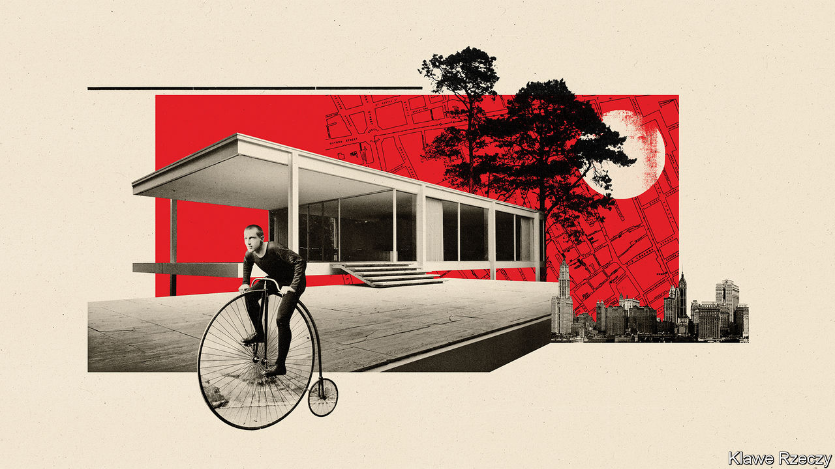

Editor’s note: The Economist is making some of its most important coverage of the covid-19 pandemic freely available to readers of The Economist Today, our daily newsletter. To receive it, register [here](https://www.economist.com/newslettersignup). For our coronavirus tracker and more coverage, see our [hub](https://www.economist.com/coronavirus)

APART FROM the occasional wailing siren, New York City is eerily quiet—so quiet that you may be woken by birdsong, says Beatriz Colomina, an architectural historian. The city looks different, too. Pedestrians have taken to the roads, which are almost empty of moving cars. Those widely spaced walkers can look up and see things that they missed before. For Ms Colomina, it is an ideal time to appreciate buildings.

New York is an excellent place for that, both in terms of aesthetics and of history. Not only does it contain much fine architecture. It also displays the scars of previous contagions, some of them far deadlier than covid-19. From the tenements of the Lower East Side to Central Park to the subway system, New York has been shaped by disease and attempts to contain it.

The “city of living death”, as one commentator dubbed it in the early 20th century, is not the only one so affected. Some of the other cities hardest hit by covid-19, such as London and Milan, previously battled plague, cholera and tuberculosis, and changed as a result. In all sorts of places architecture has been shaped by disease. Looking at the history of urban contagions makes it a little easier to predict how covid-19 will change cities. Past experience suggests that the pandemic will have only a short-lived impact—briefer than some people now hope.

Until about a century ago many cities levied such a heavy “mortality penalty” on their inhabitants that they would have shrunk had migrants not kept pouring into them. In 1847 a Scottish doctor, Hector Gavin, estimated that Londoners gave up eight years of life compared with the English average, whereas the inhabitants of Liverpool lost 19. This was probably an underestimate, he added.

Cities were deadly, Gavin went on to explain, because their air was so bad. He did not mean the coal and wood smoke that hung over them. “The poison which causes death is not a gas,” he said, “but a sort of atmosphere of organic particles, undergoing incessant transformations.” Gavin was reiterating the centuries-old orthodoxy that bad air, or “miasma”, caused a host of diseases. This theory dominated secular thinking about disease from the Middle Ages to the second half of the 19th century, when it was gradually displaced by germ theory. Miasmas explained why cities, with their narrow alleys, fetid streams and stinking piles of animal waste, were so much sicker than villages.

If you believe that disease is caused by such miasmas, you naturally try to purify the air. During outbreaks of plague, which periodically ravaged European cities from the 14th to the 18th centuries, urban officials cleared the streets of rotting rubbish, lit bonfires and even fired guns. Walled cities stopped travellers and burned soft goods that might harbour miasma. Plague victims were shut in their homes, lest their emanations infect others. Their doors were marked with crosses, as a protection and a warning.

A few tried to do more. By the 15th century the great Italian cities were creating “lazzaretti”, or pesthouses, to quarantine the sick during epidemics. Milan’s could hold 16,000 people, packed into small rooms with chimneys to vent noxious emanations. Conditions there were dreadful. In 1629 a public-health official “went into a dead faint for the stinking smells that came forth from all those bodies and those little rooms”. The complex was demolished in the late 19th century and replaced with homes. But its church remains, and the outline of the lazzaretto can still be seen in the city’s street plan.

Not all cities followed suit. In the 1660s a Parliamentary bill that would have forced English parishes to build pesthouses was defeated in the House of Lords, their lordships not being keen on plague victims massing near their mansions. Pestilence did, however, encourage people to upgrade their homes. In 1652 the London bricklayers argued, self-interestedly, that plague could be held off by replacing wooden structures. They reasoned that wooden houses with overhanging storeys stifle the air, contributing to miasma—but also, in an argument that modern science would approve, that brick homes are less verminous.

In the early 19th century the cities of Europe and America faced for the first time a disease long familiar in Asia: cholera. City officials responded by deploying the old anti-plague techniques—clearing the streets of rubbish and carting people off to pesthouses. This time the popular reaction was swift and violent. Many cities, including Paris, rioted. In 1831 a furious crowd invaded a St Petersburg hospital, killed a doctor and liberated the people who had been taken there. Sir Richard Evans, a historian who has studied these episodes, argues that the authorities were so spooked by the violent reaction to their measures that they hesitated to use them again. Instead they began to think differently. To break the cycle of disease and disorder, they would have to make cities healthier.

In France an official report written in 1834 noted that cholera had struck the poor hardest, and argued that was partly a result of their environment. Disease was festering in Paris’s narrow streets and alleys; to prevent it from erupting again, wider streets and public squares with trees were needed. These would “finally spread light and life in those obscure quarters where half the population vegetates so sadly, where dirt is so widespread, the air so infected”. The wide boulevards of the Second Empire were for grandeur and social control, but also for the control of disease.

In Europe and America sewers and drinking fountains proliferated. So did large parks—which were viewed not merely as desirable urban amenities but as machines for purifying air and water. In New York the competition to design Central Park was won in 1858 by Frederick Law Olmsted and Calvert Vaux. Wanting to create a “mechanically improved” park on what was then marshland, they turned to George Waring, an expert on farm drainage and a firm believer in the miasma theory of disease. Waring brought in huge quantities of earth to raise the low-lying areas and laid an enormous network of underground pipes to ensure that the grass would drain freely.

Ideally, Olmsted thought, urbanites would not merely have access to parks but would live in places that resembled them. “It is an established conclusion”, he wrote to landowners near Chicago in 1868, that “the mere proximity of dwellings which characterises all strictly urban neighbourhoods, is a prolific source of morbid conditions of the body and mind”. Only low-density suburbs, with winding roads and lots of green space, could keep people safe.

Others were reaching the same conclusion. By the late 19th century American urban reformers were focused on the densely packed rooming-houses known as tenements. These were regarded as breeding grounds for cholera and, especially, tuberculosis—a disease that by the 1880s was known to be caused by a bacterium. New York insisted on the construction of air shafts, which led to buildings that were wide in front, facing the street, and wide at the back, but narrow in the middle—known as dumbbells. The law tightened in 1901, when builders were obliged to create large courtyards. They responded by building higher, especially on corner plots. All this can still be seen in Manhattan’s old residential neighbourhoods.

It was not enough for the reformers. In 1908 an exhibit known as the “Congestion Show” toured New York’s museums. This aimed to persuade the authorities that overcrowding itself was facilitating the spread of tuberculosis; it seems to have convinced the state governor, who declared himself “oppressed and depressed”. Plans for an extensive subway system were accelerated. Within a decade New York was covered by a zoning plan, which ensured that the fast-growing suburbs of Brooklyn and Queens would never quite resemble Manhattan’s human anthills.

In Europe tuberculosis had a still greater, though indirect, effect on buildings. Ms Colomina’s book “X-ray Architecture” shows that modernist architects were influenced by the sanatoriums that had sprung up in towns like Davos, in Switzerland. These had white walls and floor-to-ceiling windows to maximise light, which was known to kill germs (as the popular saying went, “thirty years in the dark but thirty seconds in the sun”). They also had flat roofs, mostly to prevent ice from falling and hitting people below. White paint, glass walls, flat roofs—all became features of modernist architecture.

The Finnish architect Alvar Aalto designed a celebrated sanatorium in Paimio, then went on to create libraries, churches and apartment buildings. Others, like Le Corbusier and Ludwig Mies van der Rohe, borrowed the sanatorium aesthetic. One of Mies’s masterpieces, the Farnsworth house in Illinois, was described by one occupier as “transparent, like an X-ray… There is already the local rumour that it’s a tuberculosis sanatorium.” Modernist architecture has sometimes been called sterile. It is supposed to be.

## Fitter, happier, more productive

Some observers now predict, or hope, that covid-19 will transform cities. Cycling advocates point to roads that have been closed to cars and argue that they should stay that way. Joel Kotkin, an urbanist at Chapman University in California, believes the coronavirus will speed “the end of the megacity era”. He argues that germy cities like New York will lose their appeal.

History suggests that it is foolish to bet against big cities. Repeated terrible outbreaks of plague and cholera barely delayed the growth of London or Paris. Richard Florida, an urbanist at the University of Toronto, points out that the flu pandemic of 1918-19 did not interrupt the ascendancy of Chicago, New York or Philadelphia. Covid-19 is not only less deadly than these pandemics; it is also notably wayward in its aim. It has hit some large, dense cities. But it has also struck ski resorts and suburban care homes.

If covid-19 can be run to ground in a couple of years, the urban fabric might not change much. Plague, cholera and tuberculosis worked on cities slowly. They forced change because people believed they would return or never leave. By contrast, many people hope that coronavirus will be defeated fairly quickly. In the first country it attacked, some urban adaptations have already been undone. In China many apartment blocks acquired shelves where delivery drivers could leave food and other goods. Almost as soon as the lockdowns lifted, they were taken down. ■

Dig deeper:  
For our latest coverage of the covid-19 pandemic, register for The Economist Today, our daily [newsletter](https://www.economist.com/newslettersignup), or visit our [coronavirus tracker and story hub](https://www.economist.com/coronavirus)

This article was downloaded by calibre from <https://www.economist.com/books-and-arts/2020/04/25/covid-19-might-not-alter-cities-as-much-as-previous-pandemics>

|  |  |  |  |
| --- | --- | --- | --- |
| Previous | Articles | Sections | Next |

|  |  |  |
| --- | --- | --- |
| Books and arts | Sections | Graphic detail |

Economic and financial indicators

Economic data, commodities and markets

.

|  |  |  |
| --- | --- | --- |
| Books and arts | Sections | Graphic detail |

|  |  |  |  |
| --- | --- | --- | --- |
|  | Articles | Sections | Next |

# Economic data, commodities and markets

Apr 25th 2020 |

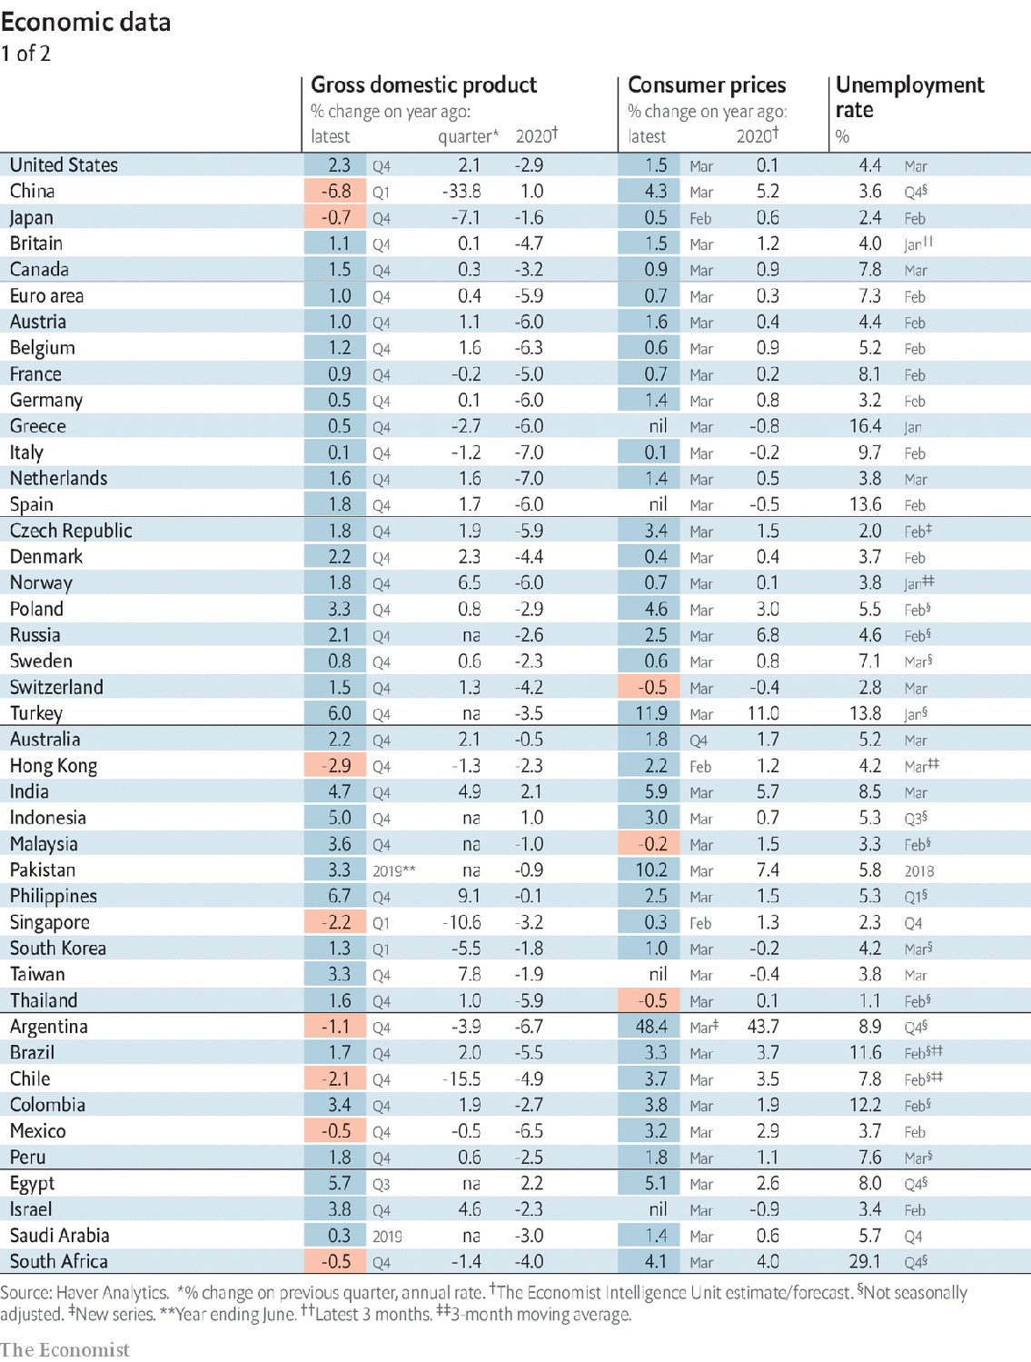



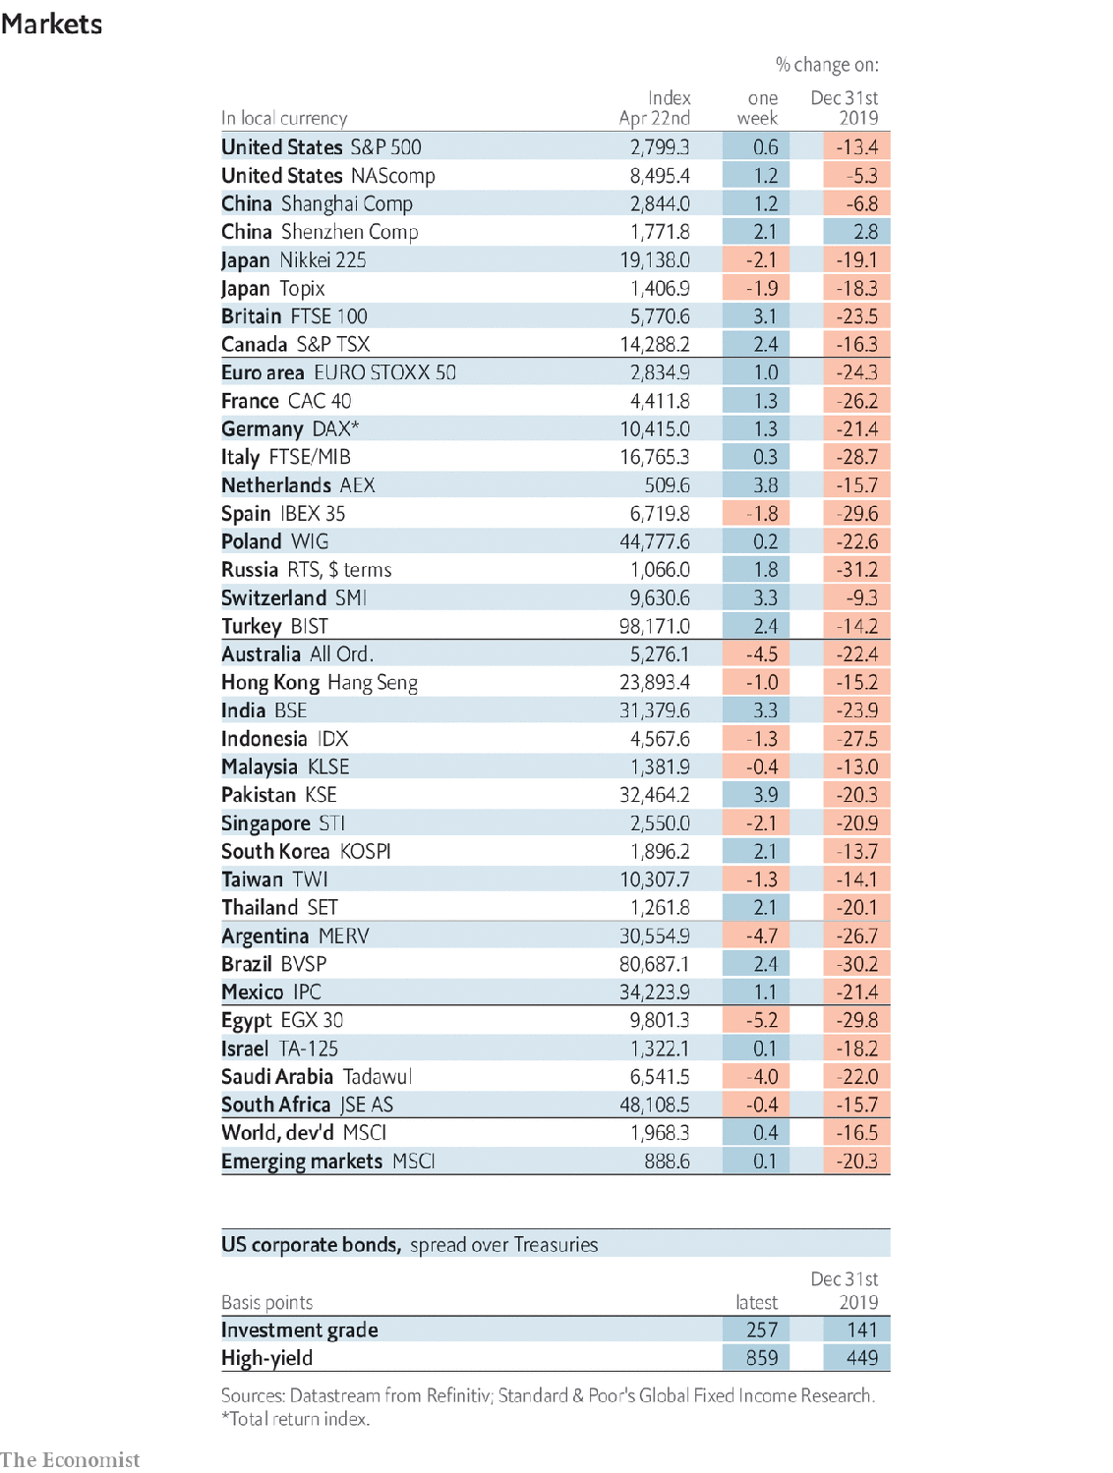

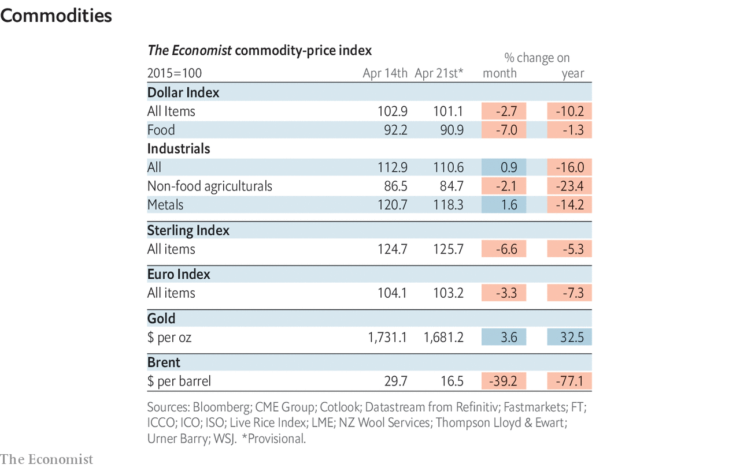

This article was downloaded by calibre from <https://www.economist.com/economic-and-financial-indicators/2020/04/25/economic-data-commodities-and-markets>

|  |  |  |  |
| --- | --- | --- | --- |
|  | Articles | Sections | Next |

|  |  |  |
| --- | --- | --- |
| Economic and ... | Sections | Obituary |

Graphic detail

Vulnerability to covid-19: Dixie in the crosshairs

.

|  |  |  |
| --- | --- | --- |
| Economic and ... | Sections | Obituary |

|  |  |  |  |
| --- | --- | --- | --- |
|  | Articles | Sections | Next |

#### Dixie in the crosshairs

# The South is likely to have America’s highest death rate from covid-19

It has unusually unhealthy residents and few ICU beds

Apr 25th 2020 |

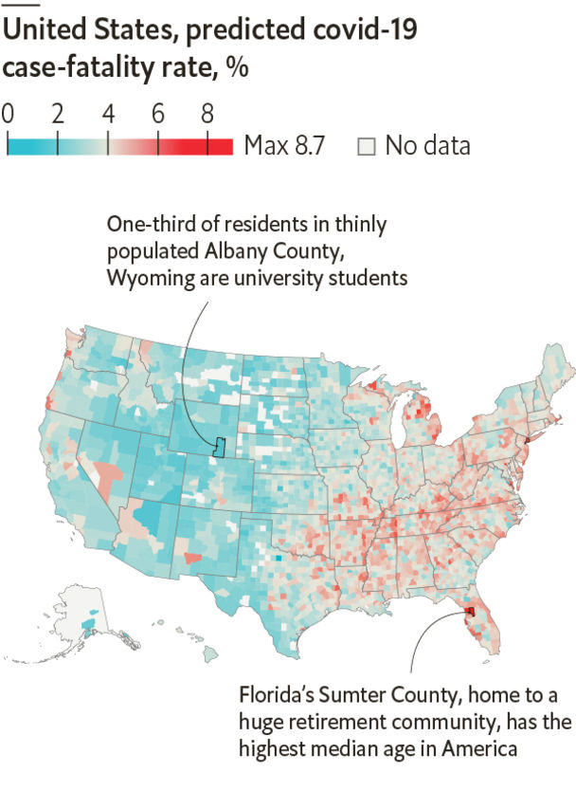

AMERICA DOES not face one covid-19 crisis, but rather dozens of different ones. A few places have been walloped; others remain unscathed. So far, SARS-CoV-2 has claimed most of its victims in areas where it has spread the fastest. Lockdowns have geographically contained most outbreaks. However, once social distancing is relaxed, the virus will accelerate its spread, and could infect a majority of Americans. If that happens, the places it hits hardest may not be those it struck first. Instead, the vulnerability of local populations will determine its death toll in each region.

Covid-19’s true infection-fatality rate (IFR, the share of infected people who die) is unknown, because most carriers are not tested. However, testing is more common for people whose cases are bad enough to endanger their lives: in New York 67% of people with covid-19 on their death certificate had tested positive. If the share of people without grave symptoms who still get tested were similar everywhere, places with high case-fatality rates (CFRs)—the death rate among people testing positive—would be likely to have high IFRs as well.

In fact, testing practices vary widely. And given two states with the same rate of infections and deaths, one that tests only the severely ill will report a higher CFR than will one that tests more broadly. However, within any given state, testing protocols are likely to be more uniform. As a result, we have built a model to identify the traits shared by counties with CFRs far above or below their own state’s average—and predict which places not yet ravaged by the virus will suffer most if it arrives in earnest.

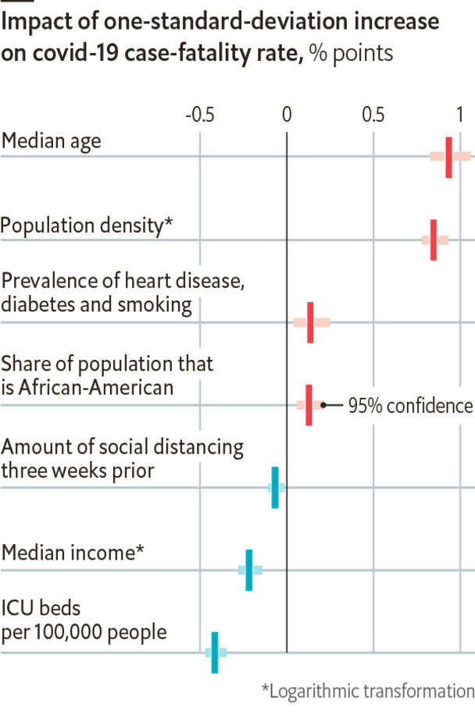

Some factors that affect viral spread also predict the CFR. It tends to be higher in cities than in rural areas, and lower where social distancing, as measured by traffic to workplaces and transit stations, is greater. One explanation is that health-care quality drops when caseloads surge. Places with few intensive-care-unit (ICU) beds also have high CFRs, bolstering this hypothesis.

However, demography is just as important. Places with older residents and more diabetes, heart disease and smoking have higher CFRs. Race and income also play a role. Counties with lots of poor or black people tend to have more health problems, less social distancing and fewer ICU beds. Yet CFRs in such areas are even higher than you would expect from these factors alone.

Together, these variables leave a geographic footprint. If covid-19 does infect most Americans, the highest death rates will probably not be in coastal cities—whose density is offset by young, healthy, well-off populations and good hospitals—but rather in poor, rural parts of the South and Appalachia with high rates of heart disease and diabetes. Worryingly, the three states that announced plans this week to relax their lockdowns (Georgia, Tennessee and South Carolina) are all in this region. ■

Sources: US Census Bureau; New York Times; Covid Tracking Project; Global Health Data Exchange; University of Washington; Google Health; Unacast;The Economist

This article was downloaded by calibre from <https://www.economist.com/graphic-detail/2020/04/25/the-south-is-likely-to-have-americas-highest-death-rate-from-covid-19>

|  |  |  |  |
| --- | --- | --- | --- |
|  | Articles | Sections | Next |

|  |  |  |
| --- | --- | --- |
| Graphic detail | Sections |  |

Obituary

John Conway: The game of maths

.

|  |  |  |
| --- | --- | --- |
| Graphic detail | Sections |  |

|  |  |  |  |
| --- | --- | --- | --- |
|  | Articles | Sections | Next |

#### The game of maths

# John Conway died on April 11th

The mathematician and inventor of the Game of Life was 82

Apr 23rd 2020 |

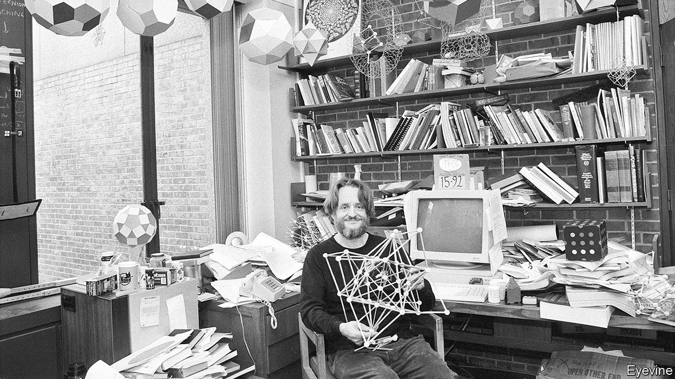

AS HE STROLLED in his dishevelled, friendly way through the hallways and common rooms of Cambridge and, later, Princeton, John Conway liked to feel he had about him everything he might require. Pennies in his pockets, to set spinning on the edge of a table to prove that more would fall heads than tails. A pen and paper for his game of Sprouts, which required spots to be joined up with curves that passed neither through old spots nor old curves. A board with a grid and stones, or peanuts at a pinch, to plot more of the games that fizzed from him continually. A couple of bits of rope for Twists and Turns, where four players, each holding an end, would change places turn by turn into nicely tangled permutations. And possibly as a party piece a wire coat-hanger, to bend into a square and whirl round his head, while ensuring that a coin balanced on the hook did not fly away. With any of these he would waylay the unwary, and challenge them to play.

The game for which he had become world-famous, though, needed no players and never ended. It was called the Game of Life, and was played out on a grid where “live” or “dead” cells interacted with their neighbours, second by second, according to three rules. If a cell had four or more neighbours, it died of overcrowding. If it had no neighbours, or only one, it died of isolation. If a dead cell had three live neighbours, it became a live cell. As cells lived and died, the formation moved. The game had taken 18 months of coffee-times to think up, plotting with pen and paper, but when it was described in 1970 in Scientific American it became a sensation. Legend had it that in the early 1970s a quarter of the world’s computers were playing it. A whole new field of mathematics, cellular automata, also sprang out of it, and celebrity descended.

That didn’t please him. The fame was all right; he was a natural show-off, roaring like a lion to get his students’ attention, throwing off his sandals at the start of a lecture, swinging from pipes when the mood took him, reciting pi to 1,111+ places and devising a Doomsday algorithm that allowed him to increase the speed at which he could tell, for any date, what day of the week it was. (To keep his mind agile, he programmed his computer to ask him ten random dates before he could log on.) But the Game of Life came to overshadow the more important things he had done in mathematics. He had made contributions to algebra, geometry, knot theory and coding theory, as well as game theory, and in two respects he had certainly got further than anyone had before.

The first was his discovery of surreal numbers, a universal ordered field that included the infinitely large and the infinitesimally small, and contained all the reals, fractions, rationals, superreals and hyperreals. He found ways to use them in arithmetic, adding, subtracting, multiplying and dividing with them. The second was his work in group theory. In 1966 he took on the challenge of finding the exquisite symmetry which was presumed to belong to the Leech lattice, a dense packing of spheres in 24 dimensions with the lattice formed by joining their central points. He deduced that the lattice contained 8, 315, 553, 613, 086, 720, 000 symmetries, a group which was given his name and made his reputation. It also led him further, to his “Atlas of Finite Groups”, written over 15 years, and his happy theorising about the Monster group, a “thing”—he could not find another simple name for it—which existed in 196,883 dimensions. It frustrated him that he couldn’t see the beauty of such symmetries, as he admired the almost-lattice-points of the stars, until he had done the calculations, often on rolls of wallpaper-lining that spooled for yards across the floor. But his work in the field earned him fellowship of the Royal Society, in the same big book as Newton and Einstein.

He was worthily there, he felt, and his route had been impressively single-minded: reciting the powers of two at the age of four, deciding to read maths at Cambridge at the age of 11, a doctorate in set theory, assistant lecturer, professor at Cambridge by 1983, lured to Princeton in 1987. But his approach was, as he admitted, lazy. He was poor at publishing his work, and simply liked to go wherever curiosity took him. In his younger years this bothered him, but the Leech-lattice work cleared his head, and he made “The Vow”: “Thou shalt stop worrying and…do whatever thou pleasest.”

Vow taken, he had fun. For his students he made abstruse theorems simple and everyday, such as by carving a turnip into a 20-triangular-faced icosahedron, snacking on it as he went, to illustrate Platonic solids. In his subject he became a magpie. While his colleagues laboured at research in their rooms, he would be folding bits of paper into flexagons or collecting pine cones, to see how many had a Fibonacci number of spirals (2, 3, 5, 8) and how many had a Lucas number, which would approach the golden ratio. Or, ensconced in some hallway nook, he would just observe a game. It had been while watching Go players that he realised each game contained many sub-games; and this had led him, first, to surreal numbers, and second to the light-bulb thought that playing games was not a distraction from mathematics. It wasmathematics.

As a magpie, though, hopping after any bit of plastic papered with gold, he drew back from some of the vaster ideas his “thinkering” touched on. Enthusiasts often said the Game of Life modelled not merely life but the universe, anything and everything. He doubted that. He hoped that surreal numbers might lead to something “greater”, but did not pursue that path himself. From 2004 he worked on the Free Will Theorem, which proposed that if experimenters had free will to decide what quantities to measure in an experiment, then elementary particles could choose how to spin. He threw out the provocation and left it there.

The question that dogged him most concerned the Monster group. Its enormous number of dimensions was not arbitrary. So what was it all about, and why was it there? On and off, he would have a think about it. He would like to have known. But meanwhile, no one had quite solved his Piano Problem: what was the largest object that could be manoeuvred round a right-angled corner in a fixed-width corridor? That would be good to know, too. ■

This article was downloaded by calibre from <https://www.economist.com/obituary/2020/04/23/john-conway-died-on-april-11th>

|  |  |  |  |
| --- | --- | --- | --- |
|  | Articles | Sections | Next |